**normalize.css** => in order to make a cross browser reset. To make every browser render the exact same page

but it is not necessary as browser are supporting more.

**Universal selector:** it selects each and every element on the page and then apply mentioned declarations.

**box-sizing:** it changes the box model so that the borders and paddings are no longer added to the total width or height that we specify for the box

**Universal font:** we added fonts to *body* instead of *universal selector*, because properties added to font are *usually inherited*. We used the google font ‘**Lato’**

**Line-height: 1.7 =** means, it is 1.7 times bigger than the predefined line-height

**STYLING HEADER**

**Height: 95vh:** it says that every point the height of the box of this element should be 95% of the view port height.

Shortcut for background image: just type backimg, it will show you hint

**background-image:**  order of the property matters. The gradient will be over the image as we added first.

**background-height: cover:** it says whatever the width of the view port or the element, it always tries to fit the element.

**background-image:** linear-gradient (*lightColor*, *darkColor*): we add it to background-image also, and the order of the image and gradient is important.

This CSS gradient colors top to bottom like this.

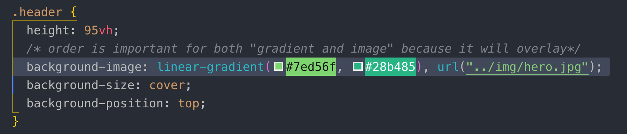



We can specify the direction of the gradient left-to-right or *top-to-bottom* which is default.



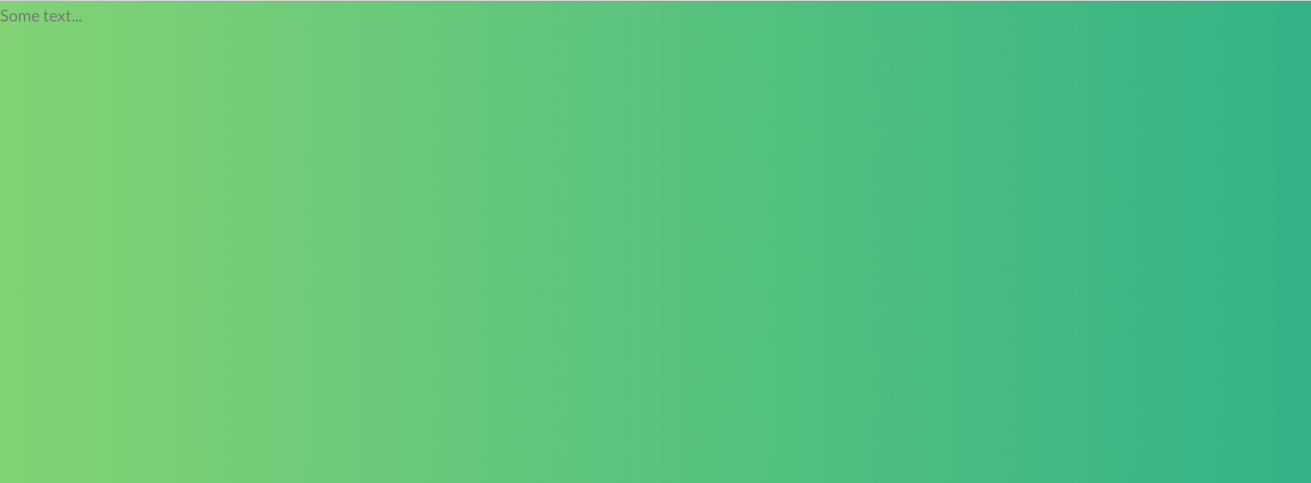

we can even specify 2 directions, it seems like diagonal





For adding the opacity to gradient, we need to use rbg() colors instead of hex number

**background-position: top:** it says whatever the width of the view port is, the top edge of the image stays top

**background-position: center:** it says whatever the width of the view port is, left and right side of the image remains same, but top and bottom it is cropped out.

**padding:** it does not inherit, it just applies to the specific element.

**clip-path: cover:** it is a modern CSS property and uses to shape the image. We specify a polygon () function in which the image or the element will still be visible. The property moves clock wise

top left, top right, bottom right, bottom left

you can check for CSS clip-path maker for more shapes

<https://bennettfeely.com/clippy/>

**007 Building the Header - Part 2**

*It is best practice* to add a container to an image that you want to place on the page.

**<h1> tag:** It is the single most important heading on the page which is important for Google or for any other search engine to figure out what our web page is all about. So it is important that we basically put the title of our page in there.

**Block element:** Block level elements occupy entire width that they have available and they add line break before and after them.

**transform:transelate(x,y):** Moves element to left and right.

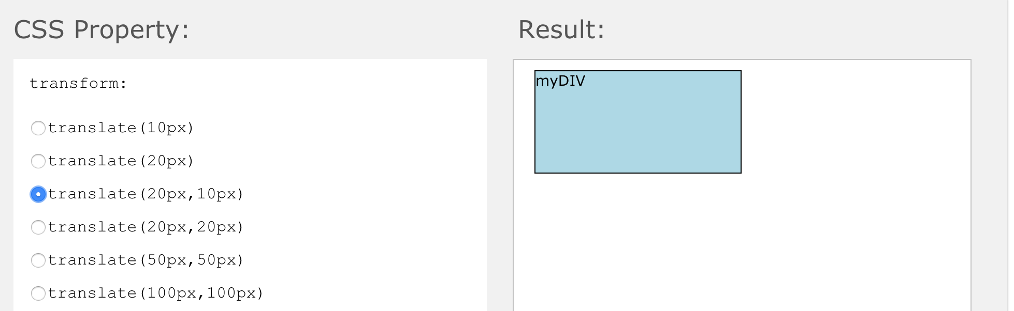

**Note:** this -50% is no longer in relation with the parent element, but of the element itself.

**Top:50% and left:50%:** will move the element’s edge to 50% percent which is not the center of the parent element.

Example:



to make this red box to center of the parent element, we need to move the center of the *red box* to 50% left and top.

To get the center A-XES of the red box above, we can use transform property. As we did below

**Note:** *transform* is related to the element itself, not the parent element.

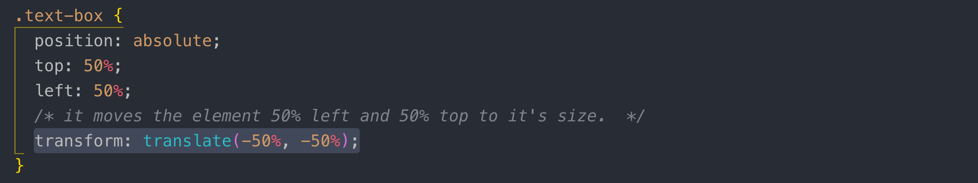



**008 Creating Cool CSS Animations**

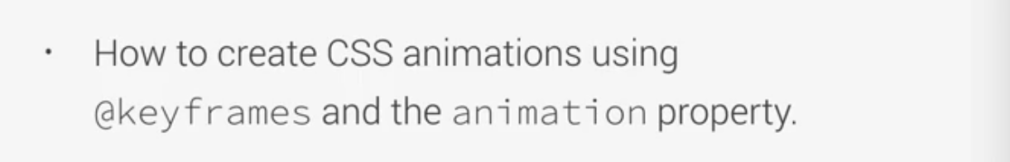

**moveInLeft:** is the name of the animation we add to a specific class.

**0%:** before the animation starts

**30%:** animation at 30% completion state

**100%:** when the animation finishes

For browser performance, it is best to animate only using these 2 properties *opacity and transform.* Browsers are optimized for these 2 properties.

animation-delay:3s => waits before the animation starts

animation-iteration-count: 3 => animate 3 times

animation-timing-function:easeIn

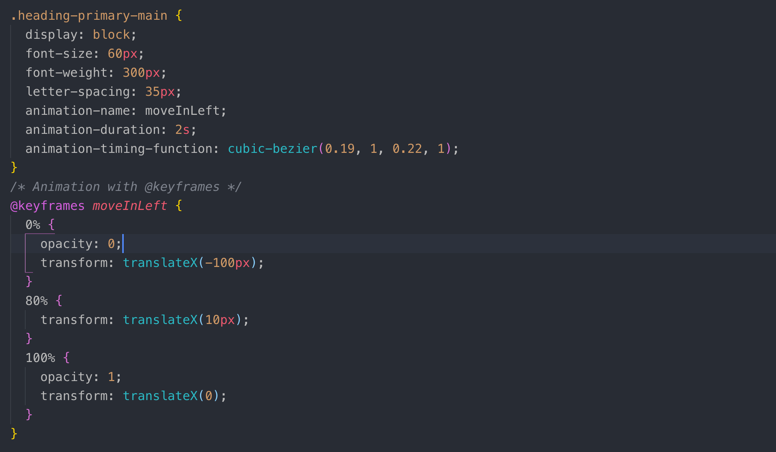

We can set all the 3 animation properties in one line like this

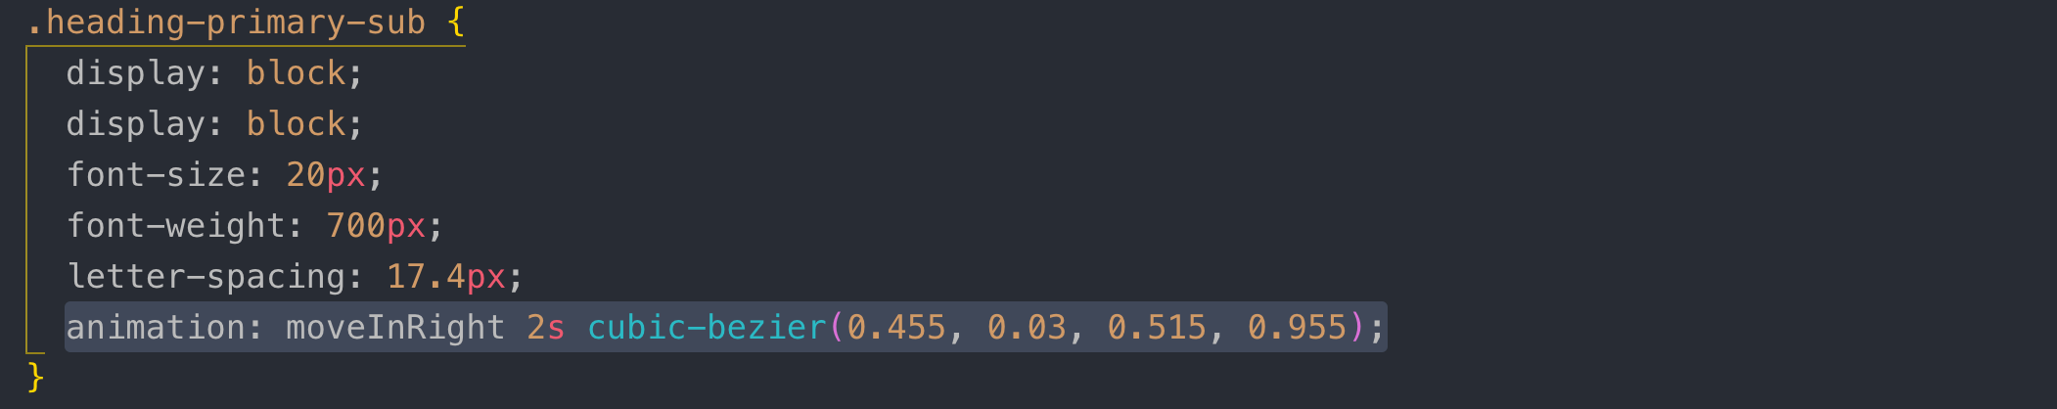

**Note:** little shakiness happens in animation. To fix this problem, we need add ***backface-visibility:hidden*** *to the parent element.*

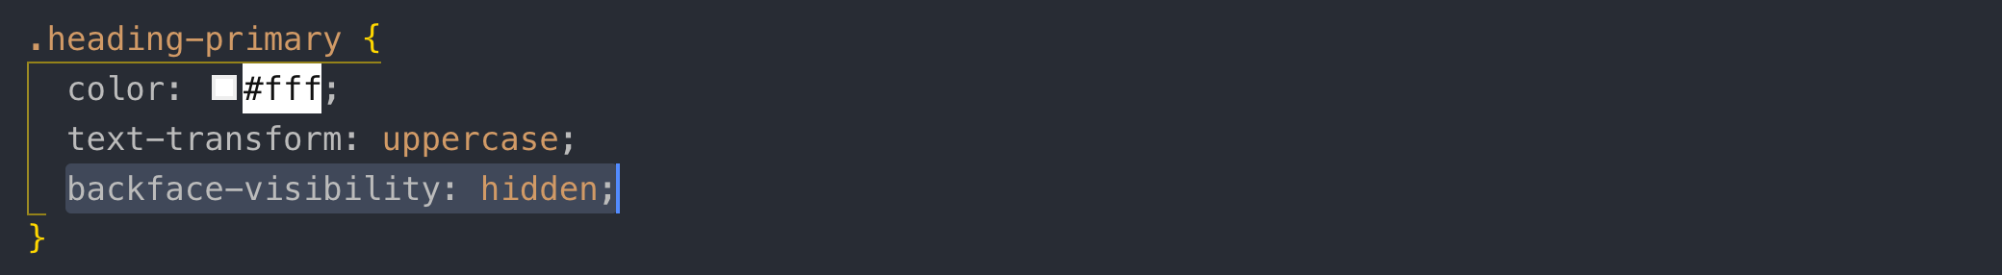

**009 Building a Complex Animated Button - Part 1**

inline-block: it allows height/width and margin/padding to the element, but doesn’t add line break after the element so element can sit next to another element.

**Note:** inline, inline-block, and text can be centered using **text-align:** center

: pseudo classes are the state of the element.

: active when the user click on an element

**Note:** transition property has to be on the initial state in-case of pseudo selector. We add it to visited, and link pseudo classes, not on hover or active.

Box-shadow and transition y-axes effects on :hover

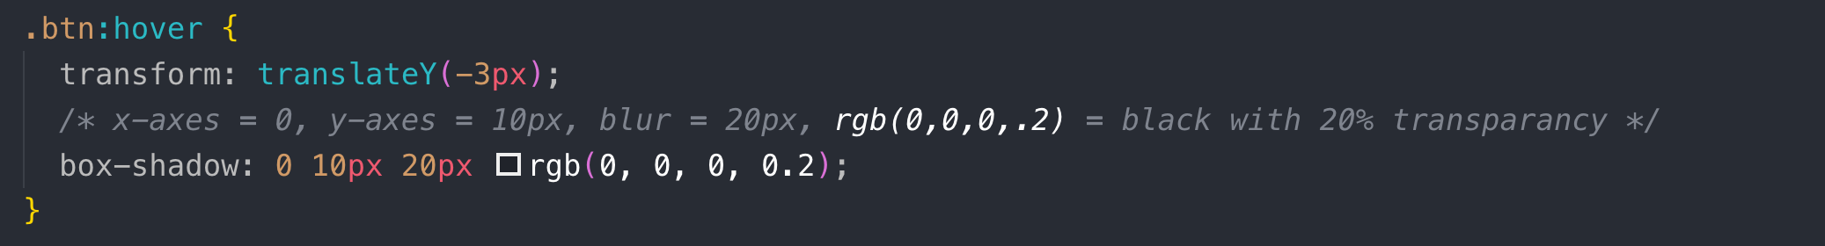

**010 Building a Complex Animated Button - Part 2**

**pseudo-elements: ::before =>** This element content adds before the content of the selected element.

**pseudo-elements: ::after =>** This element content adds after the content of the selected element.

pseudo element, it is like a virtual element right after/before the element’s content that we are selecting and we can then style that element.

The trick is here to add an element that looks exactly like the button that we already have, but we put it behind the button and when we hover the button then this after element goes blur behind the button.

content: this property is always necessary. It can be an empty string.

**Note:** for *@keyframes animation*, you *need to add a separate class*. If you doing some transition on a class and you need to add *@keyframes animation,* you need to add a separate class for that.

**Pseudo element:: after**

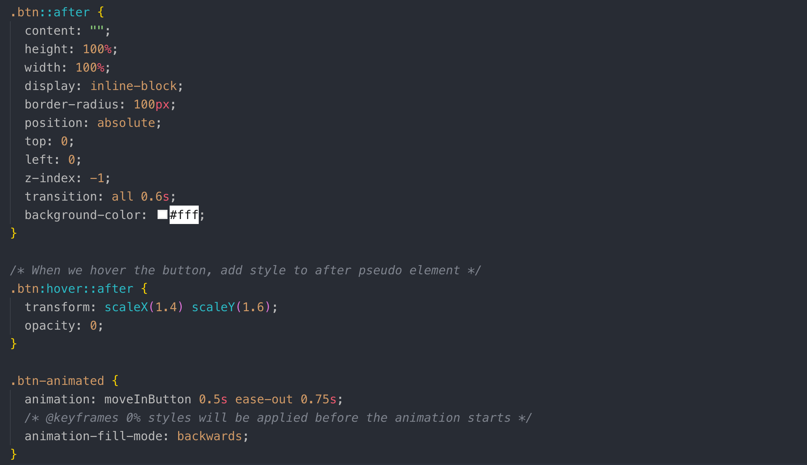

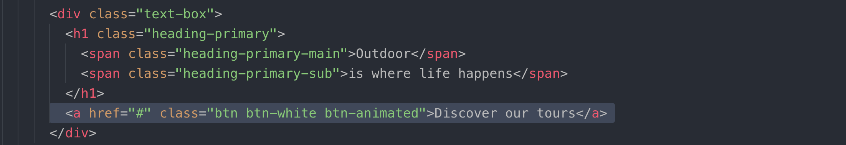

**012 Three Pillars of Writing Good HTML and CSS (Never Forget Them!)**

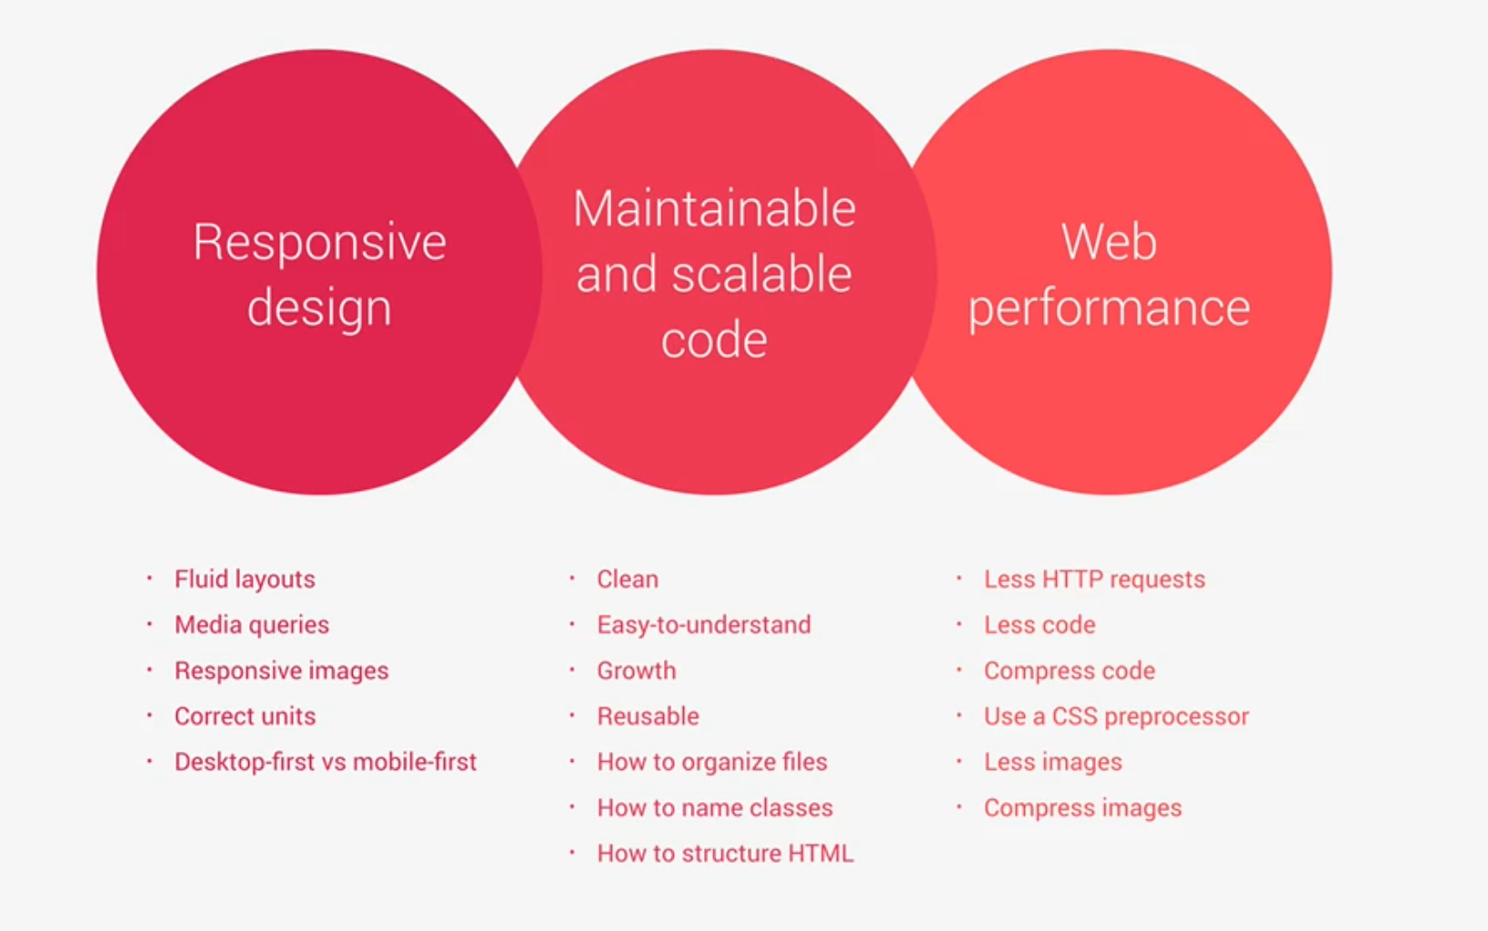

**013 How CSS Works Behind the Scenes_ An Overview**

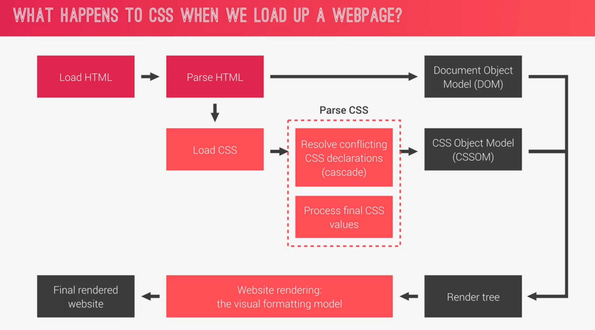

1. In order to render a web page, A browser uses the **CSS visual formatting model,** is an algorithm that processes a document and displays it on **visual** media. It includes, box-model, floats and other bunch of stuffs.
2. Resolve conflicting CSS declaration using the process known as **cascade**
3. Process final CSS values is to convert percentages into pixels. For 50% left on Desktop is different than 50% left on mobile device so this is the reason that these percentages and other relative units can only be calculated on the user’s device in the parsing phase.

**014 How CSS is Parsed_ Part 1_ The Cascade and Specificity**

**Author CSS:** What developer writes.

**User CSS:** CSS coming from the CSS for instance, when the user change the default font sizes in the browser.

**Browser (user agent):** default browser Styles for instance, by default, anchor tag has blue color and underline.

This is the way cascade resolve conflicts when more than one rule applied to certain element.

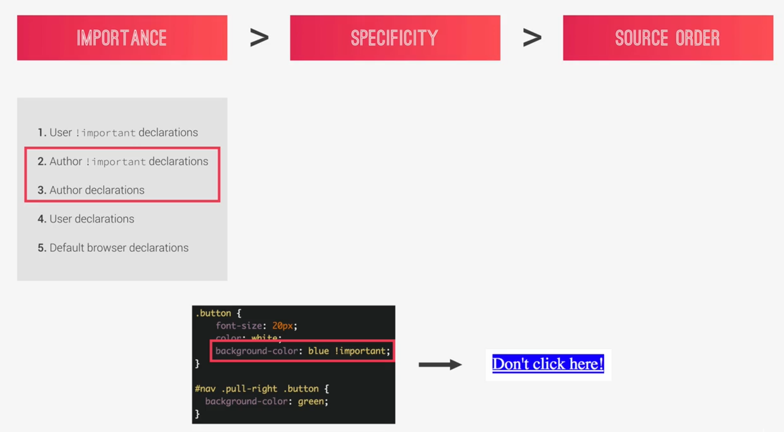

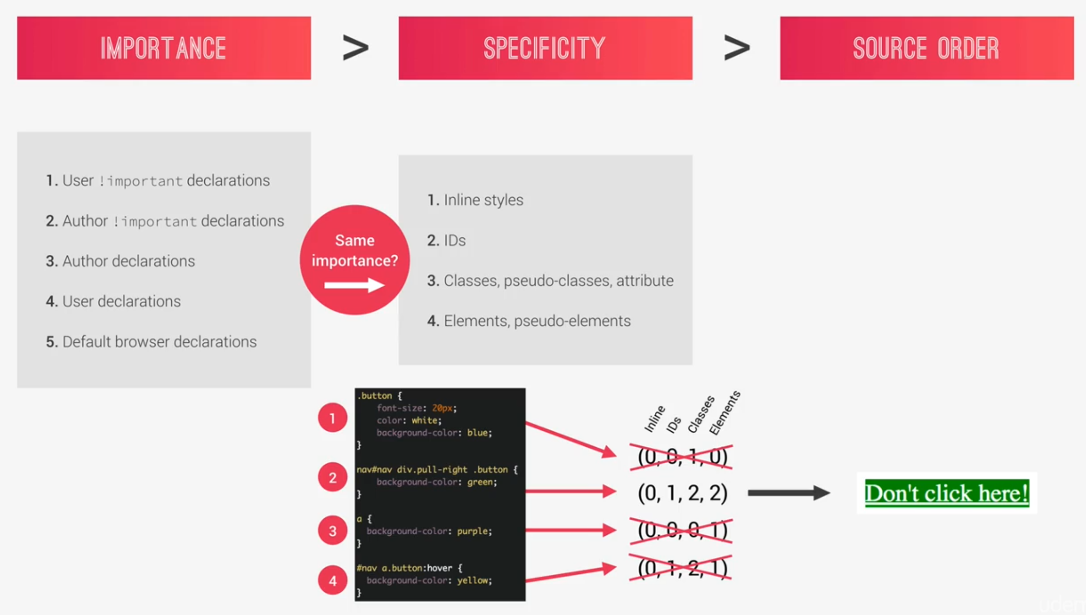

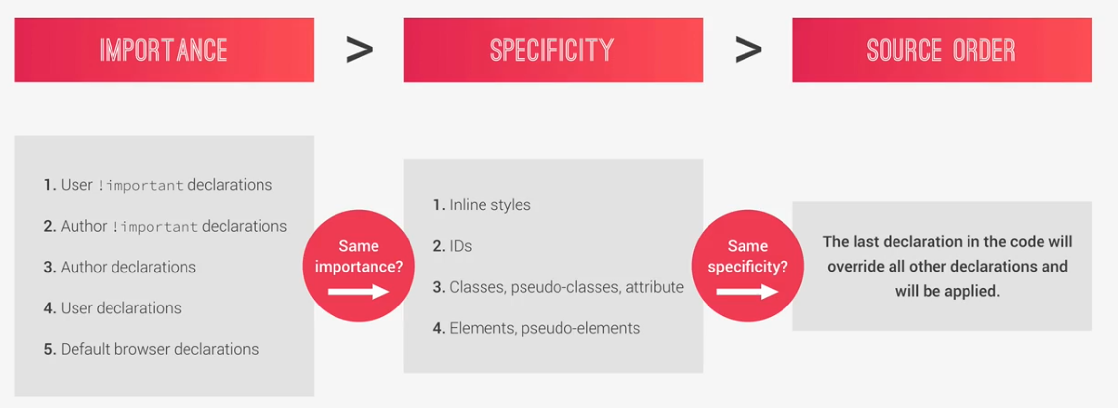

**015 Specificity in Practice**

Note in the below code hover is not working because the specificity is lower.

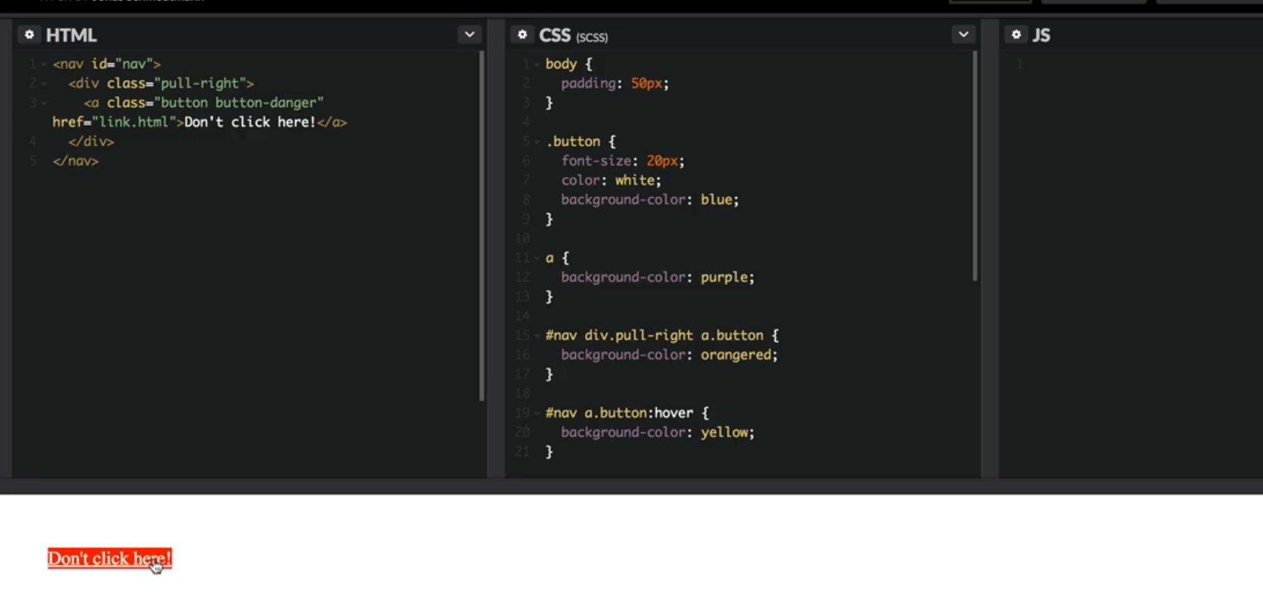

so to make the hover work, we need to add to same specificity like this.

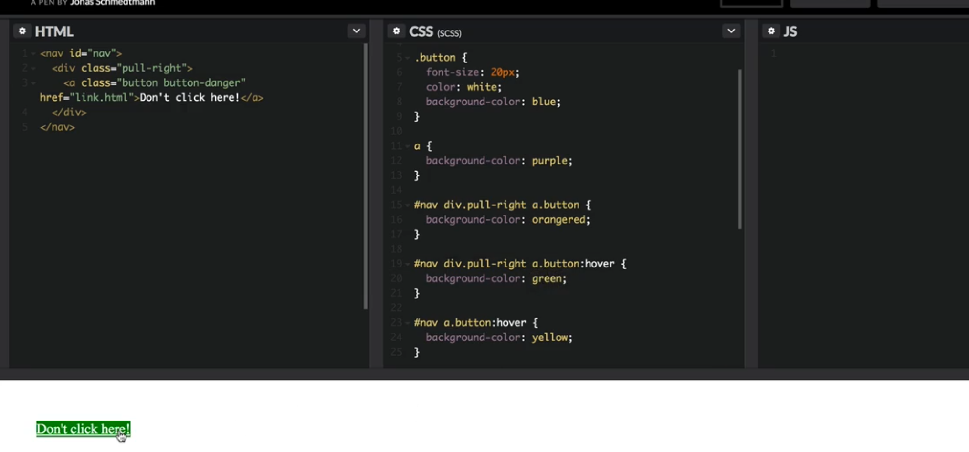

**016 How CSS is Parsed_ Part 2_ Value Processing**

each time you use a **unit** other than pixel like **rem, vh,** or some other relative unit you need to know that will automatically be converted into pixels.

Let see how this conversion happens

Paragraph class and amazing classes are conflicting so let’ see which one cascade will apply and why.

.amazing class is more specific the paragraph so it will .amazing class

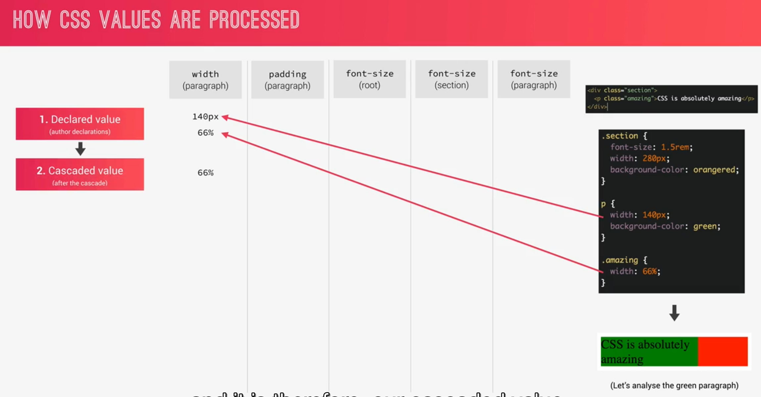

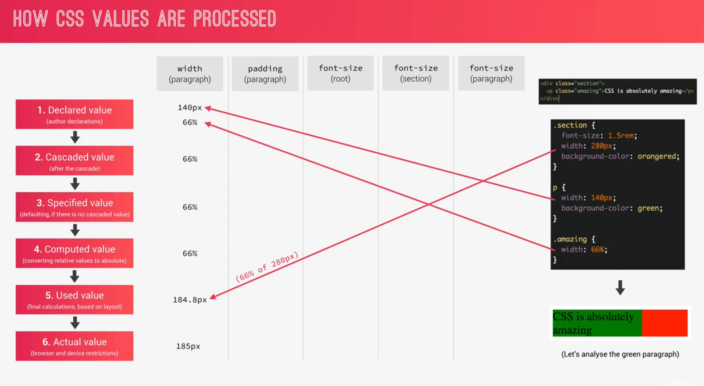

The actual value that the browser will apply is 185px instead of 66%

Browser has a default font-size of 16 pixels.

**Note:** if we define a font-size on a parent element then all the children of the element will inherit this font-size.

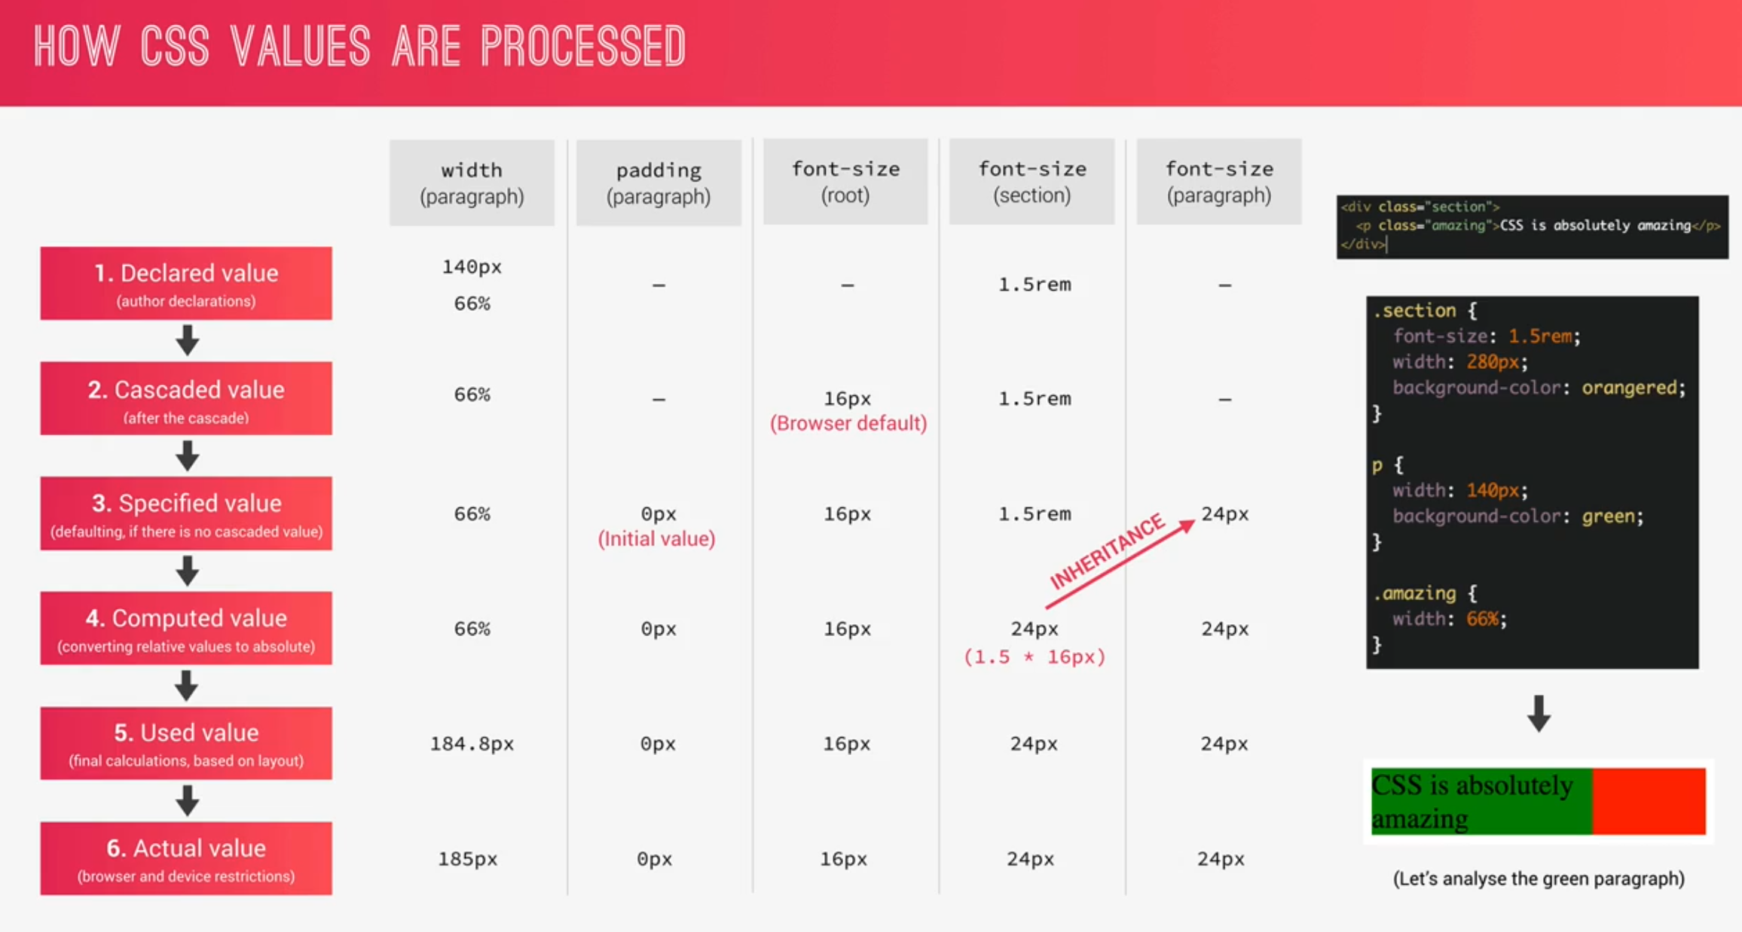

1. parent element is the reference for % based unit calculation.
2. Unit **em** is different for fonts and length

**em** use the parent or current element as a referent while **rem,** uses the root font-size as a reference.

1. **1vh:** 1% of the view port height
2. **1vw:** 1% of the view port width

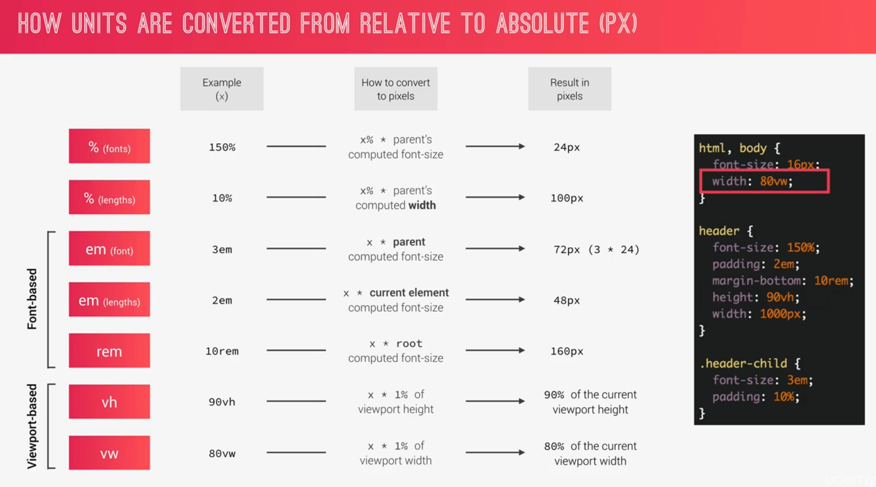

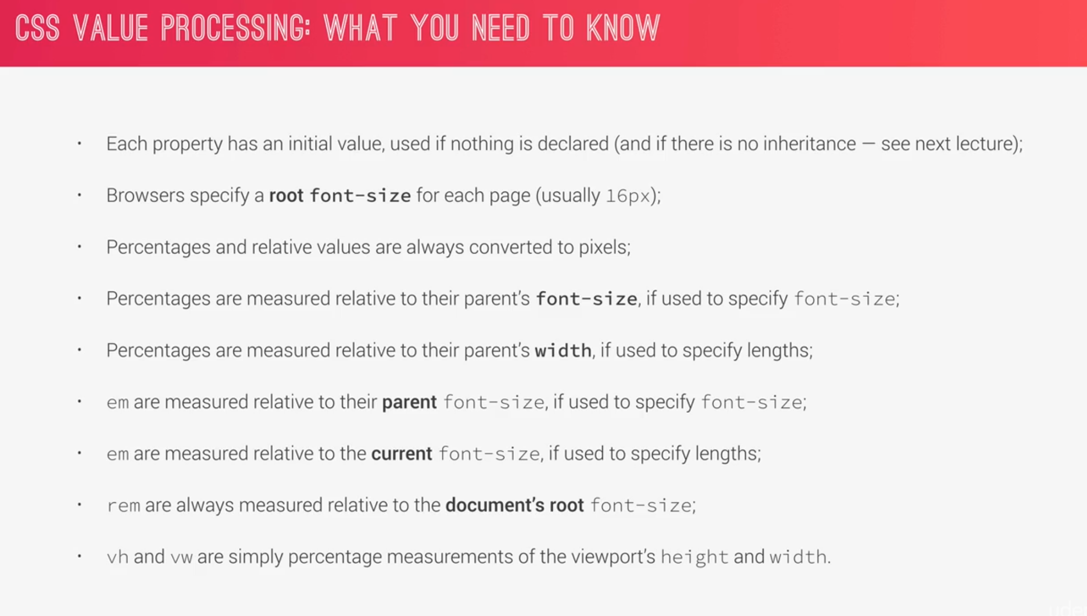

Why should we care about **em and rem** if they are based in font-size well, the reason is that by doing so, we can build more robust responsive layout, because just by changing font-sizes, we can automatically change length since it depends on font-size and it gives lot of flexibility.

**017 How CSS is Parsed_ Part 3_ Inheritance**

Inheritance is way of propagating property values from parent elements to their children.

150% of 20 pixels is 30 pixels

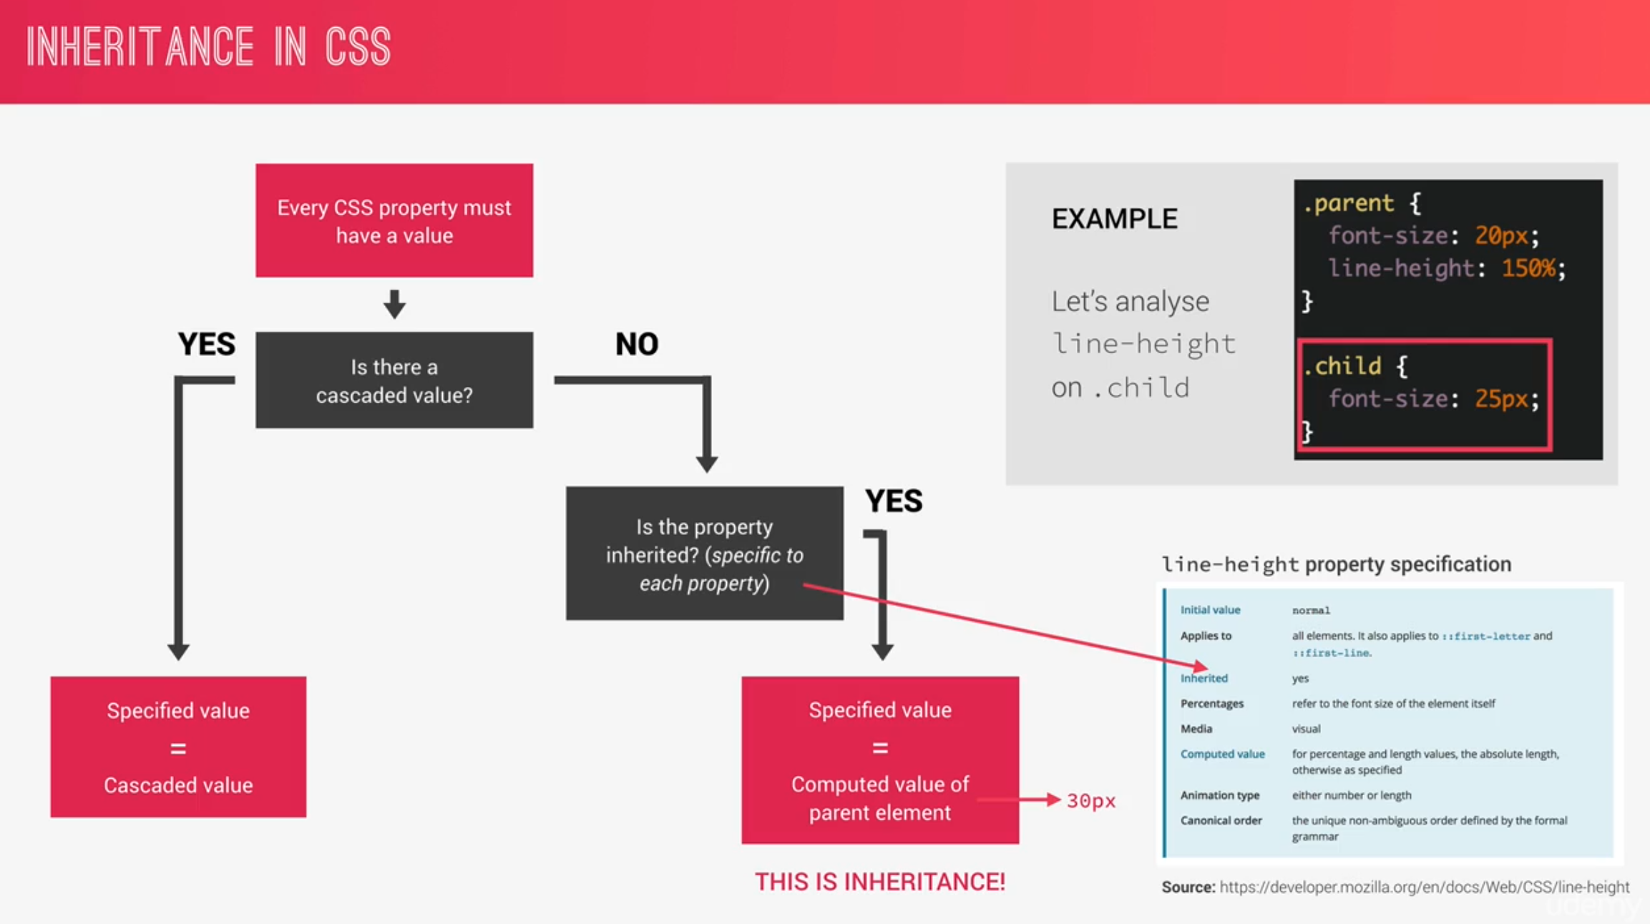

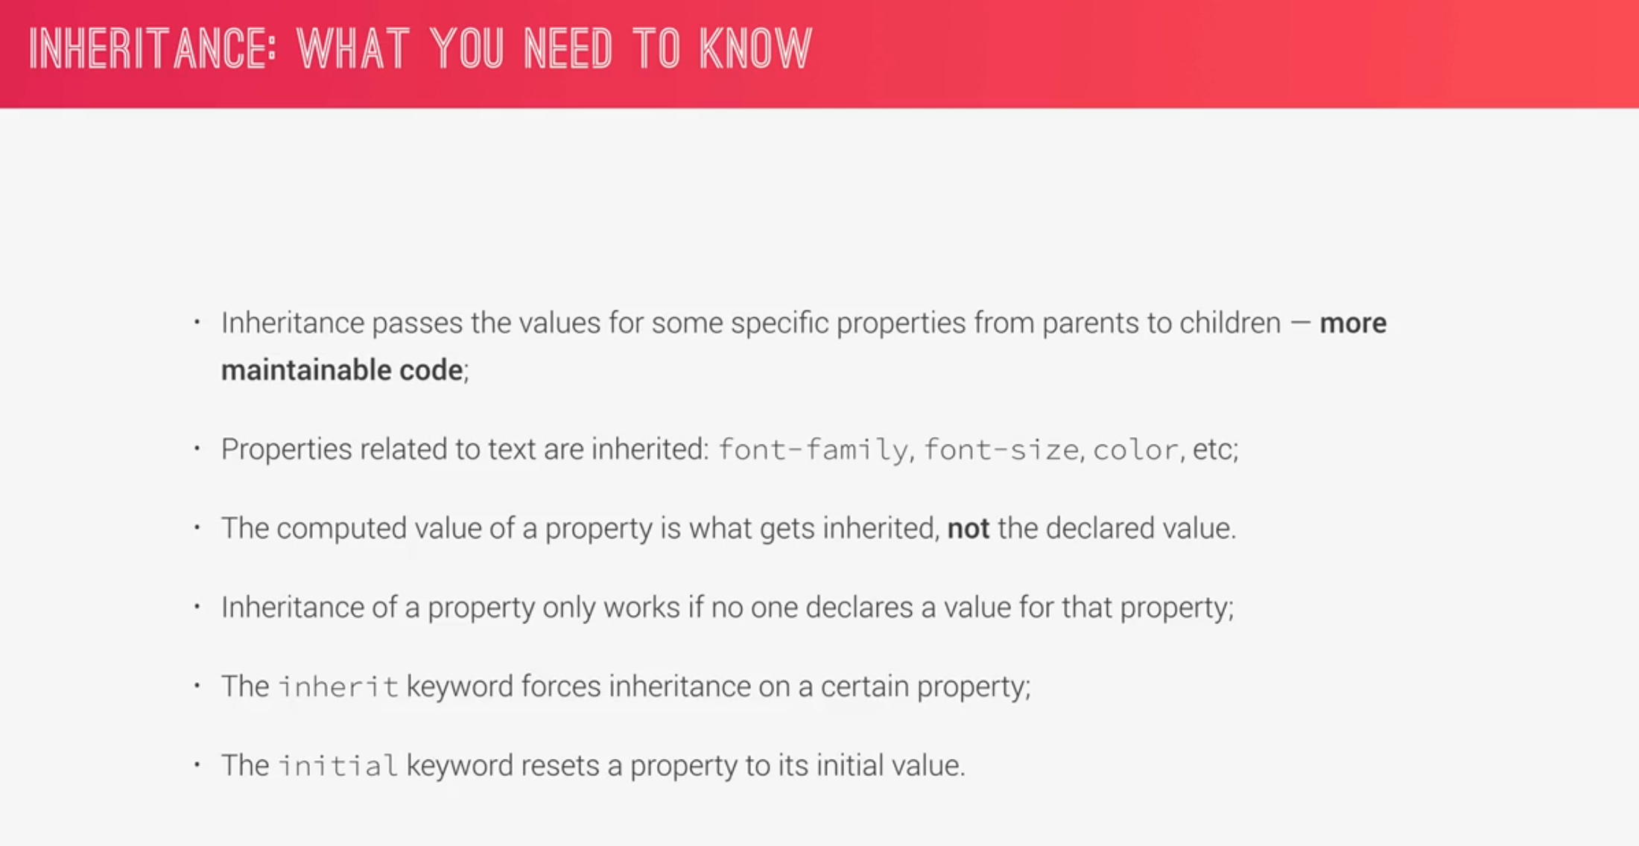

**018 Converting px to rem_ An Effective Workflow**

How and why we use **rem** in our projects?

We use **rem** because we want an easy way to change all the measurements on our page with one simple setting. For example, when we had a break point to display our page on a mobile device. When that happens, we want a way to decrease all the measurements in our site at the same time and instead of writing 100s of lines of code and in media queries, we can just change one global setting and that is the global font-size.

**rem:** this unit is always in relation to the root font-size.

The root font-size is set in the **html.** For easy calculation, keep the root font size to 10px so this way

1rem == 10px

For responsive website, it is best practice to use relative unit like **rem**

Using **em** is not a good idea as it references the current or parent element for which you have to lot of calculation.

Padding will also affect if we change the root font-size.

It is actually a very bad practice to set font-size to pixel so **root font-size should not be in pixels** like this.

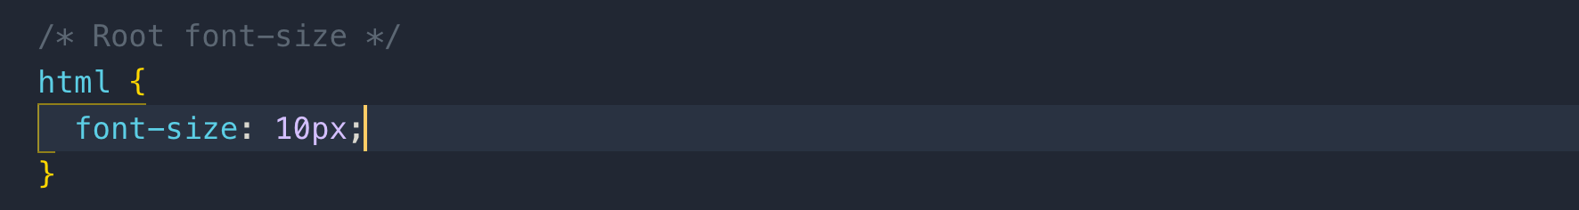

The problem with the above font-size is that we actually overwrite the browser font size setting that the user can manually change in the settings.

Some people change the browser font-size who have bad eye sight. If we set the font-size in pixels like we did above then we remove the ability for these people to see our website properly, because they cannot change the default font-size. well they can, but our root font size will not be affected anymore. It remains 10 pixels no matter what the user has as a default font-size **so this is really a bad practice.**

The solution to this is to set root font-size in percentage which will translate to percentage of the font-size given by the browser.

The default font-size is 16 if the user doesn’t change anything so setting font-size to 100% will convert to 16px.

If the user does change the default font-size let’s say to 18px then the root font-size will be 18px.

These properties don’t need **PX** to add

*Font-weight, line-height*

To set the font-size to 10px in percentage is to divide 10/16 = 62.5%

625*16 = 10px

if the user changes font-size to 20 then the default font-size will be

625*20 = 12.5px

**Note:** rem is not supported below Internet Explorer 9

Whenever we can use inheritance, we should use it instead of universal selector

Let’s enable inheritance to box-sizing and add it to body for using inheritance.

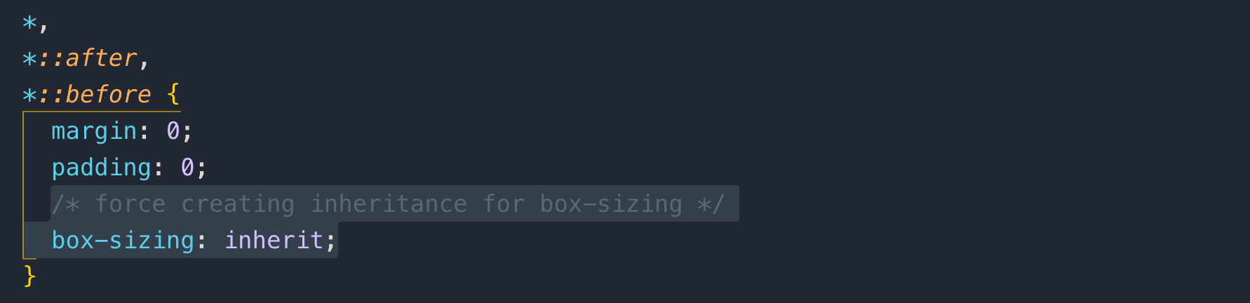

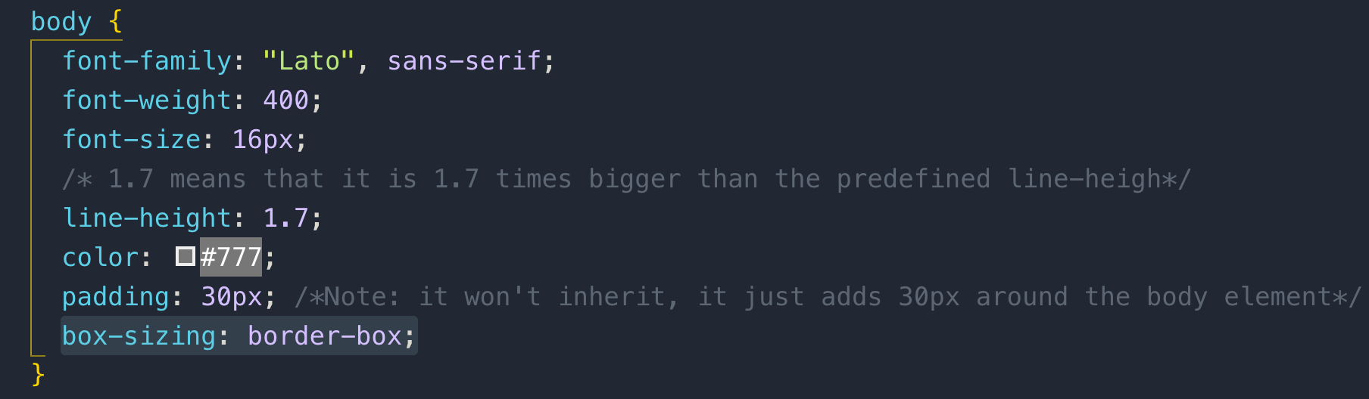

it is best practice by the CSS community

**019 How CSS Renders a Website_ The Visual Formatting Model**

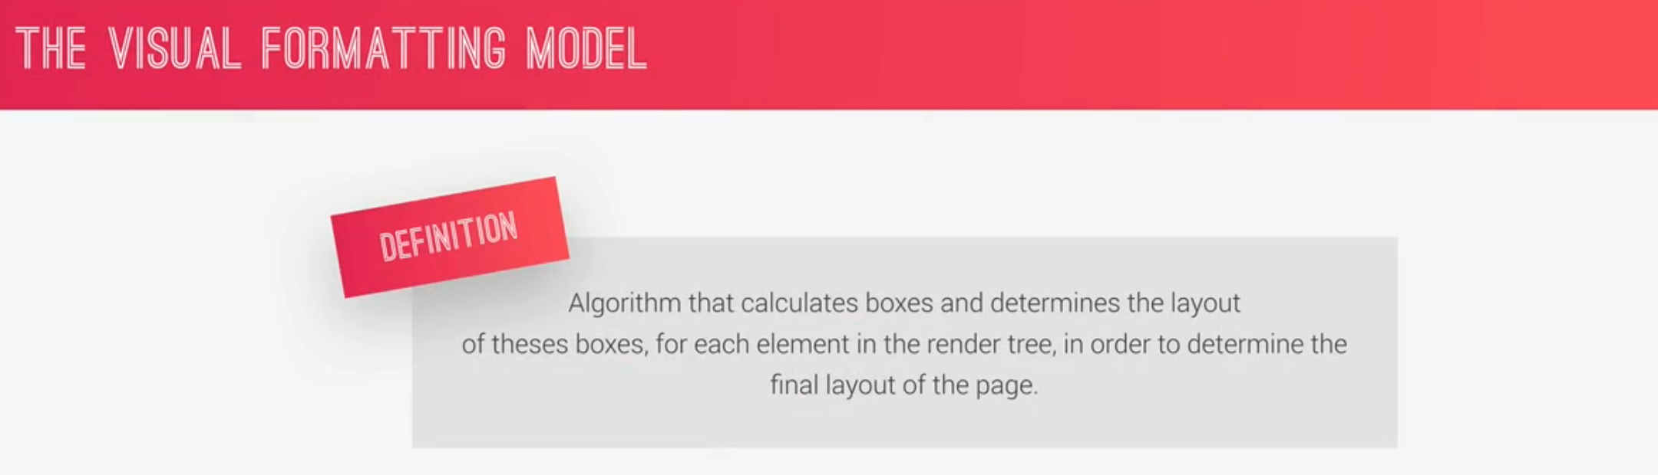

The algorithm takes the following into account factors like

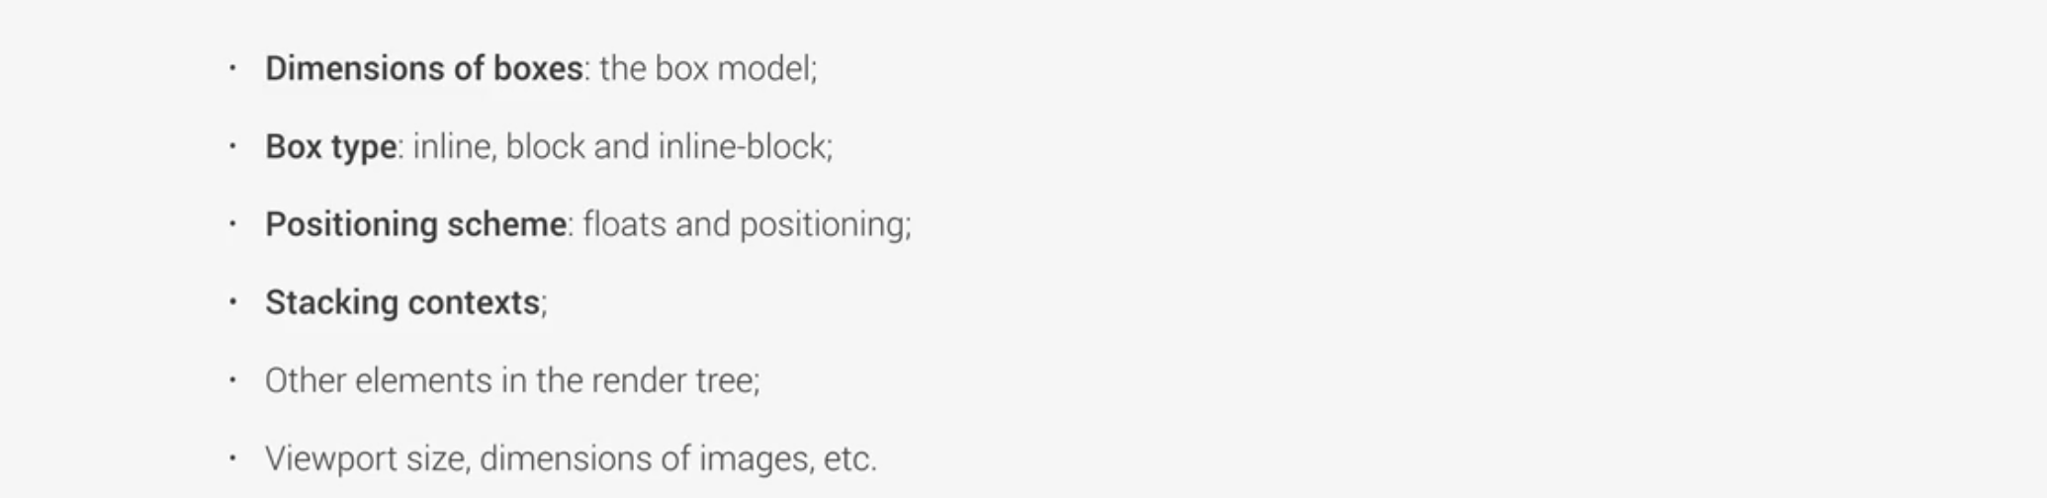

so, by putting all these factors together, the browser figures out how the final website will look for the user.

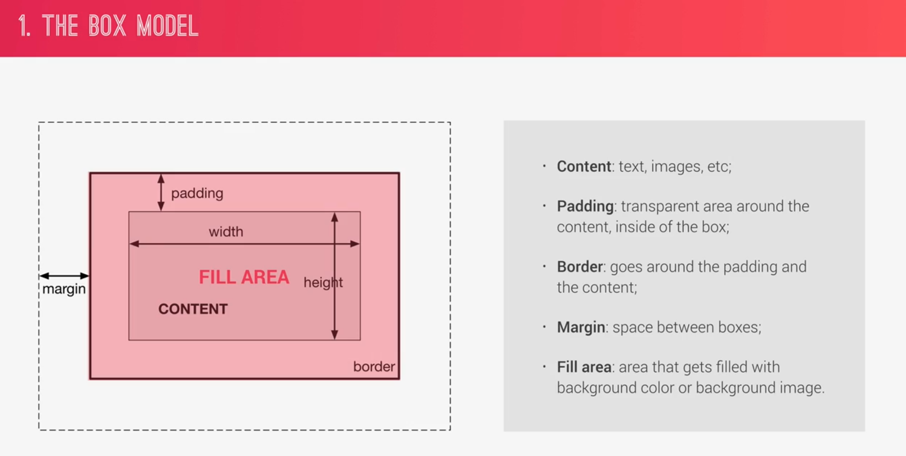

**Note:** the fill area includes the padding and border

**Default box model:** it includes padding, border.

Calculating the above properties is difficult so the solution to this is to use box-sizing: box-model

**box-sizing: box-model:** it automatically adjusts the padding and border to the given width or height.

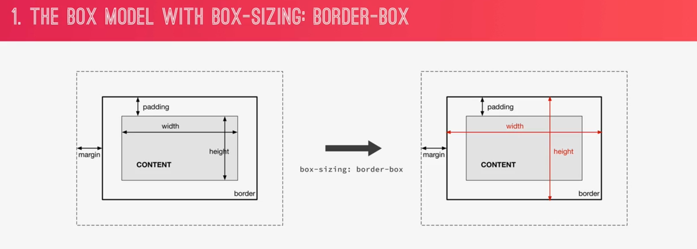

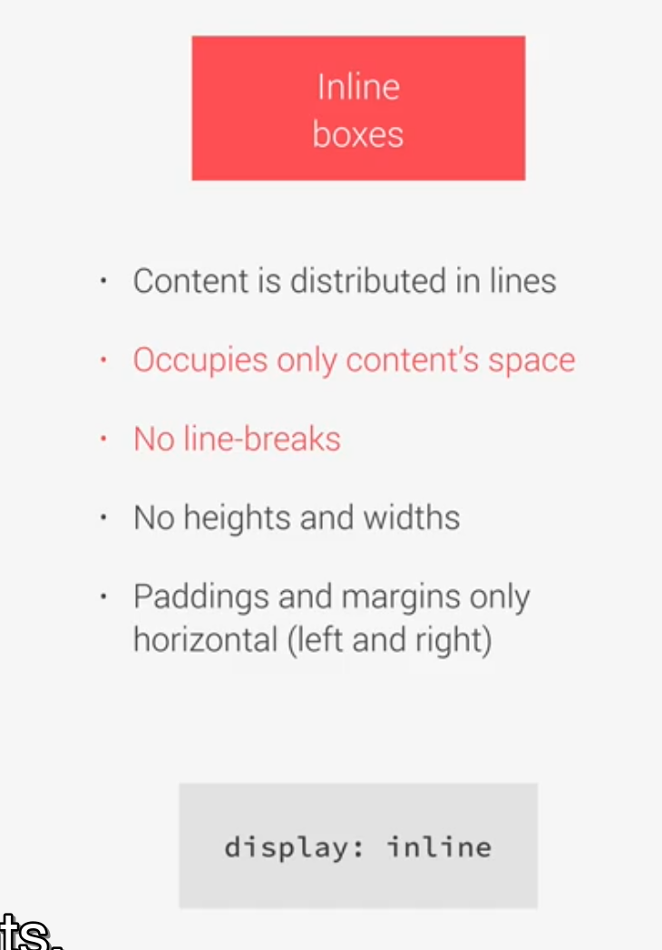

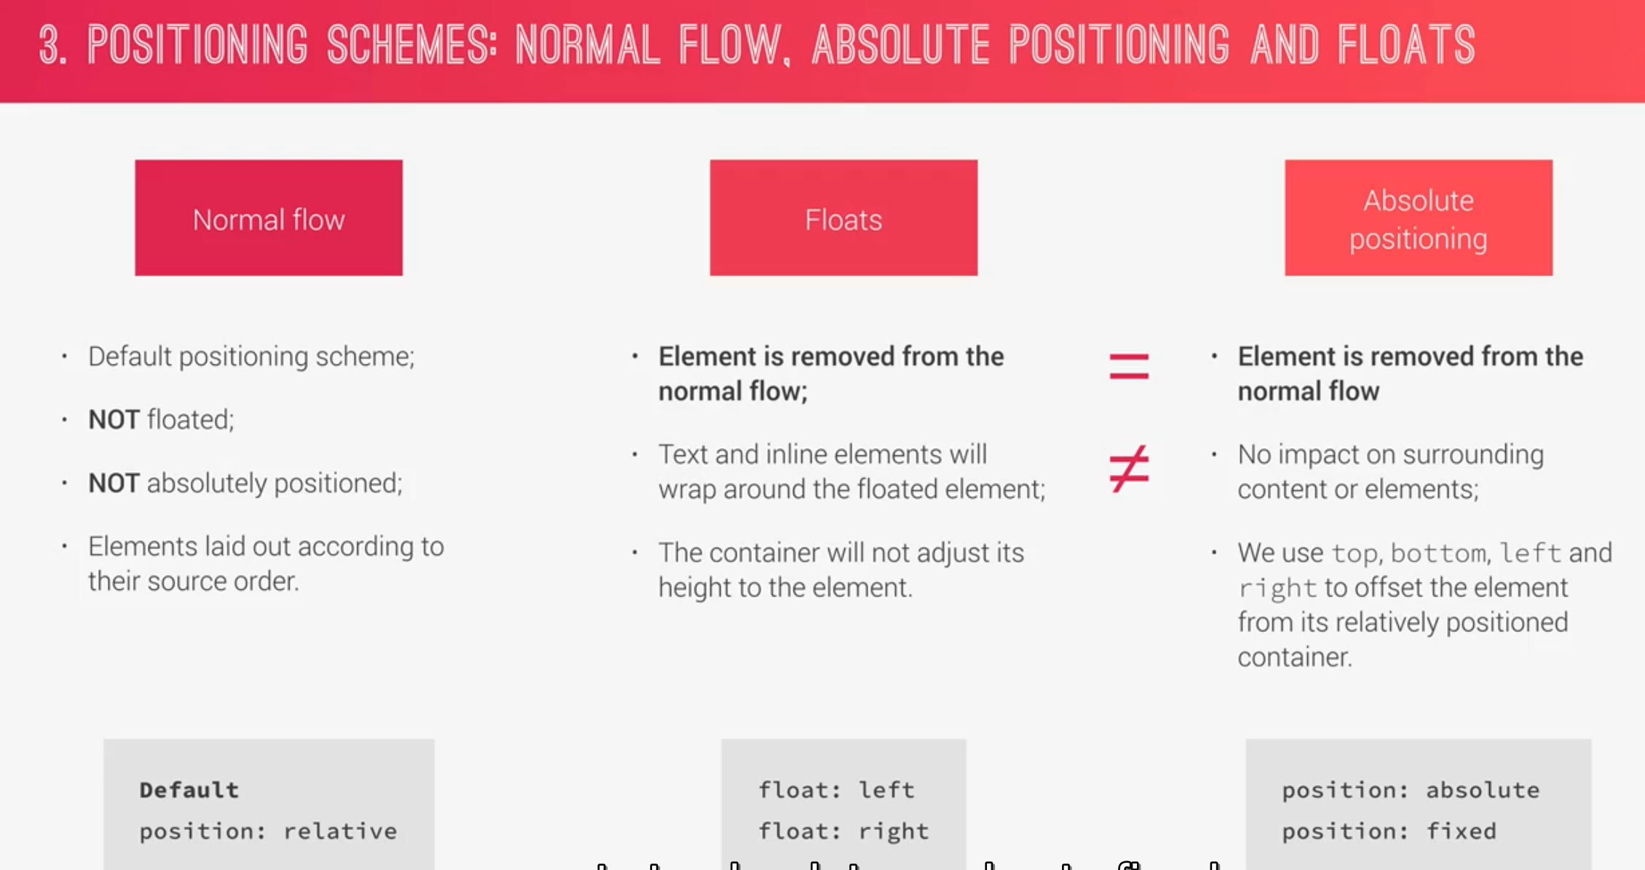

**float:** The container will not adjust its height to the element and to do this we use clear: fixed

**Stacking Contexts:** stacking contexts are what determines in which order elements are rendered on the page.

A new stacking context can be created by different CSS properties called **z-index**

It is a layer that forms a stack.

**Stacking Contexts:** can also be created using different opacity, transform, or filter. That’s why sometime even with the z-index set on a positioned element, the stacking order doesn’t work.

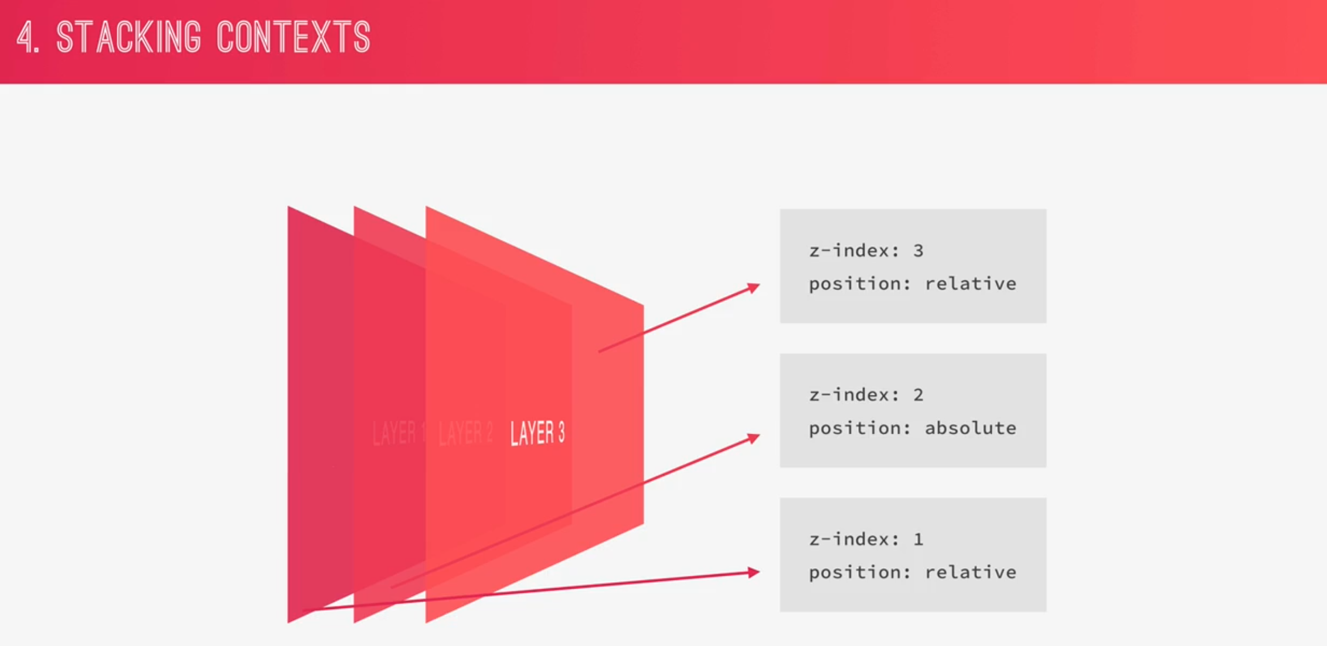

**020 CSS Architecture_ Components and BEM**

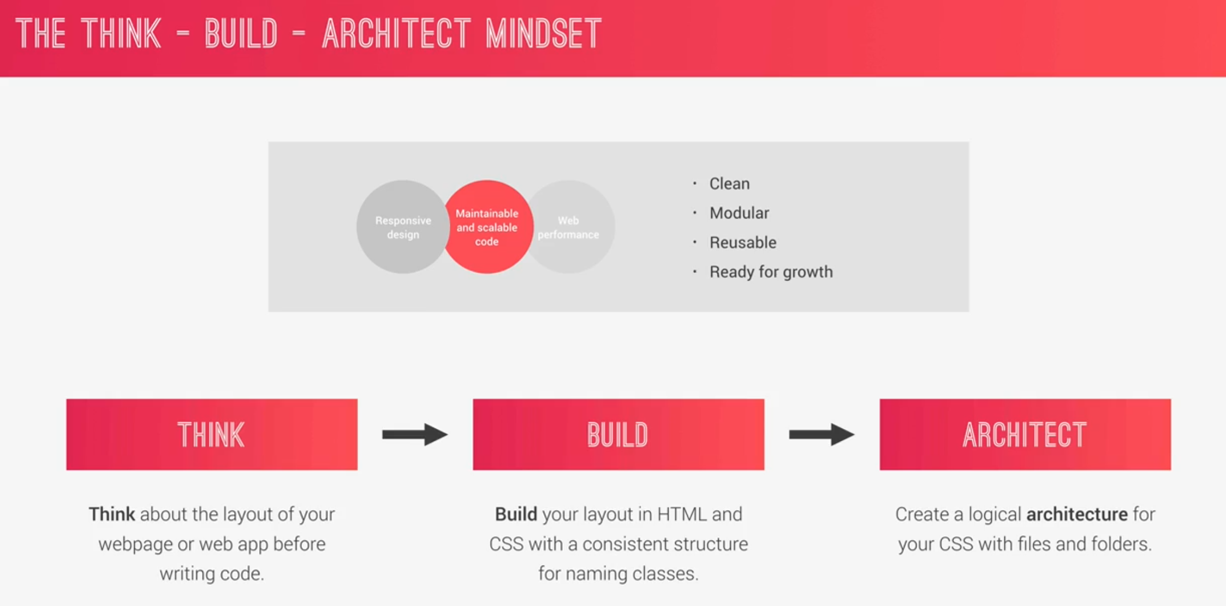

**Component Driven Design** is used across all software development.

Component should not depend on their parent elements.

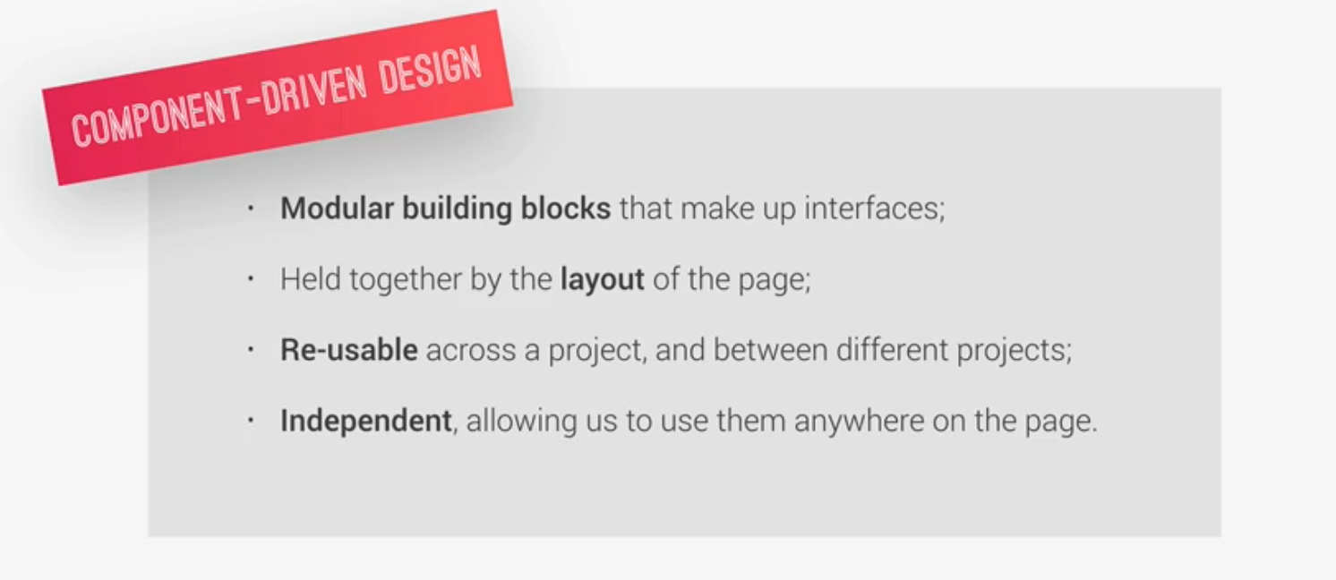

We need to have strategy to naming our classes. There are many approaches like Object-Oriented CSS or S MAX, but the most important is BEM

**BEM:** Block Element Modifier: It is a nice clean system for marking up layouts.

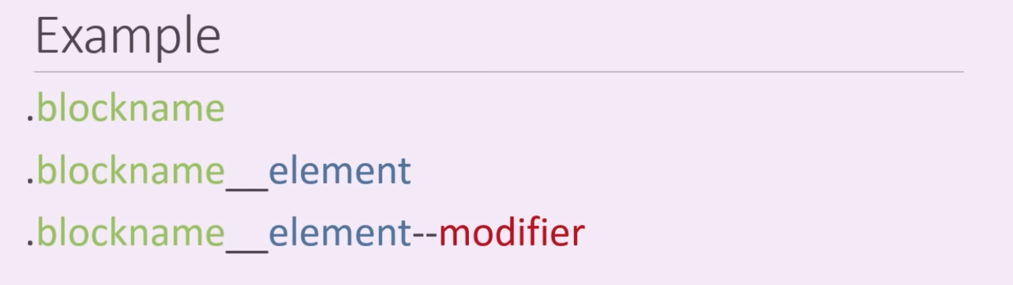

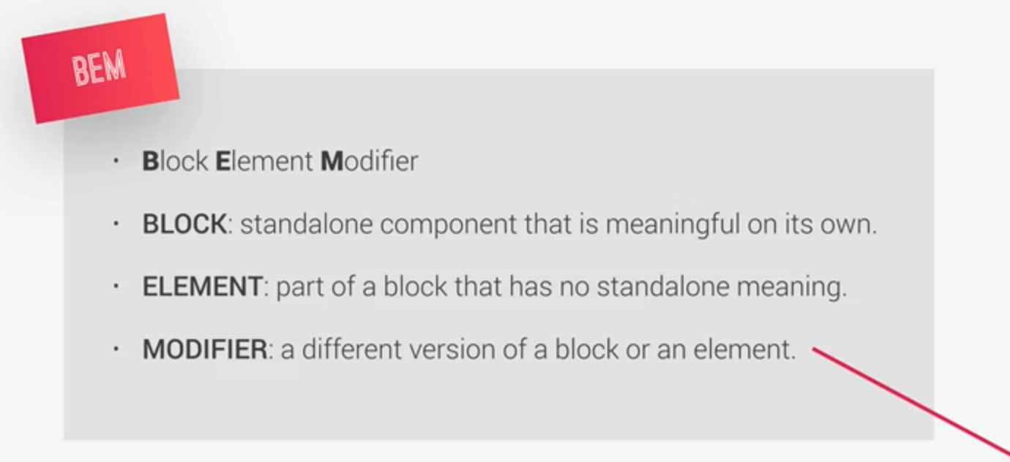

**Architecture CSS:** to create a logical folder and file structure. To do this there are different option like ITCSS method or S MAX, but we will use 7-1 pattern.

1. **Base:** basic product definition
2. **Components:** in this we have 1 file for each component.
3. **Layout:** here we define overall layout of the project
4. **Pages:** where we have styles for specific pages of the project
5. **Themes:** if you want to implement different visual themes
6. **Abstract:** here we put code that doesn’t output any CSS such as variables or mixins
7. **Vendors:** All 3rd party CSS

We can remove some folders according to the projects need.

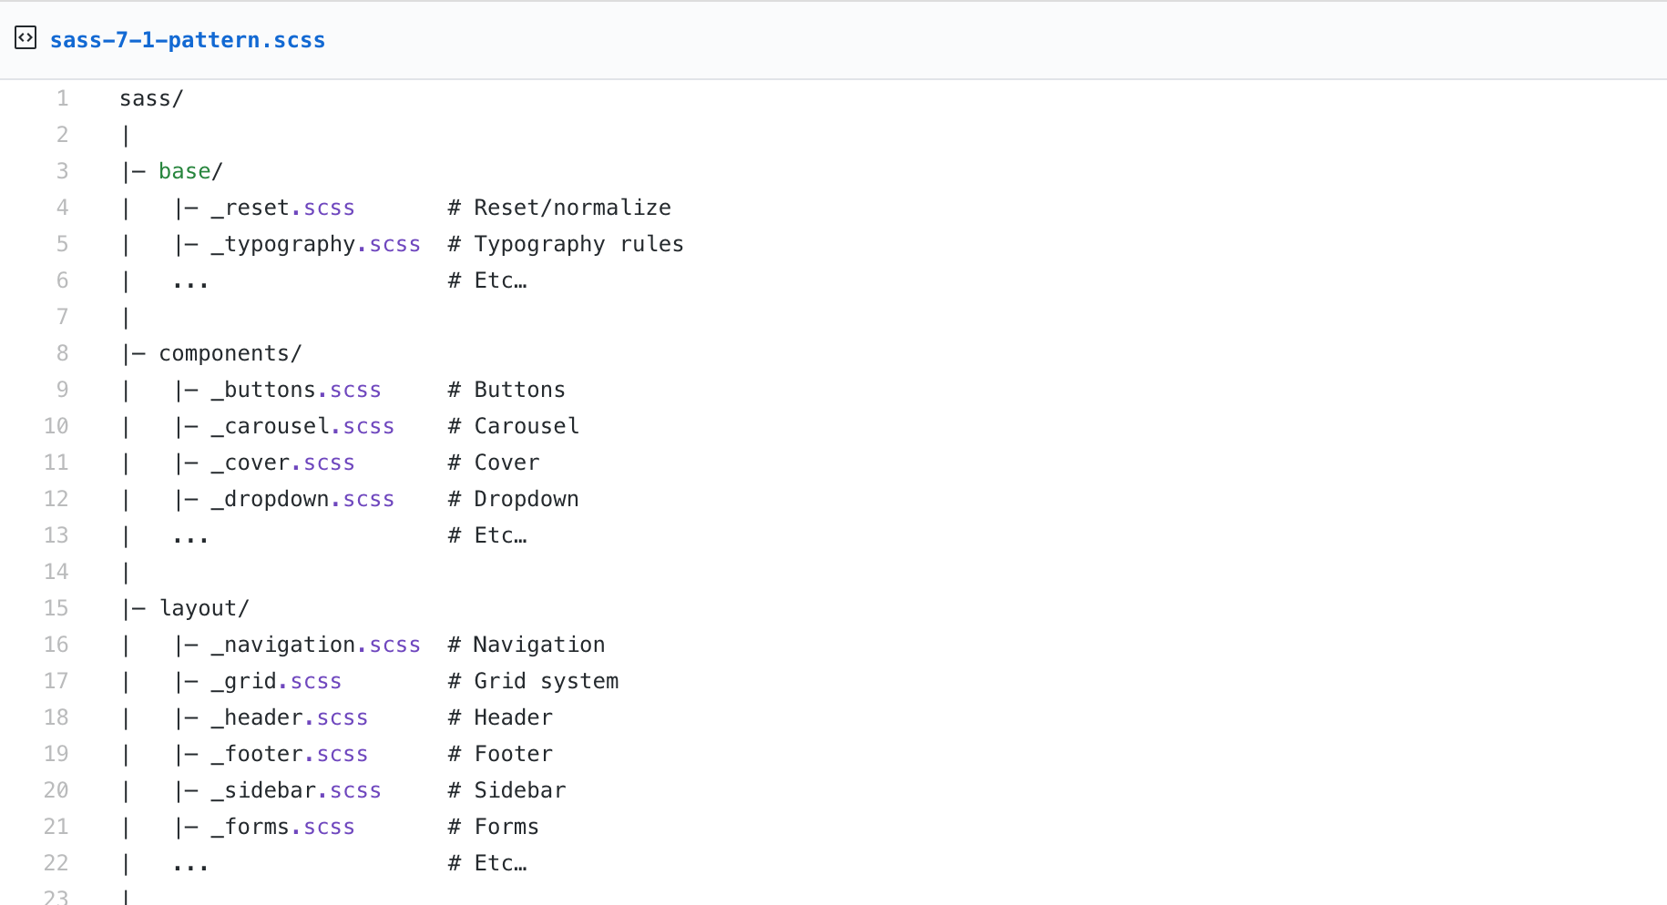

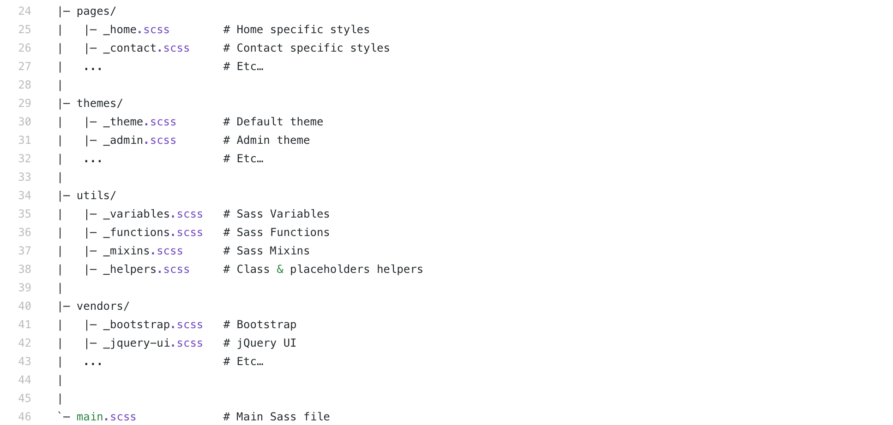

**021 Implementing BEM in the Natours Project**

**Block:** A <header> is a stand-alone component and meaningful on its own so all the elements inside it should also have the header attached to them.

How to use BEM? The example is given below

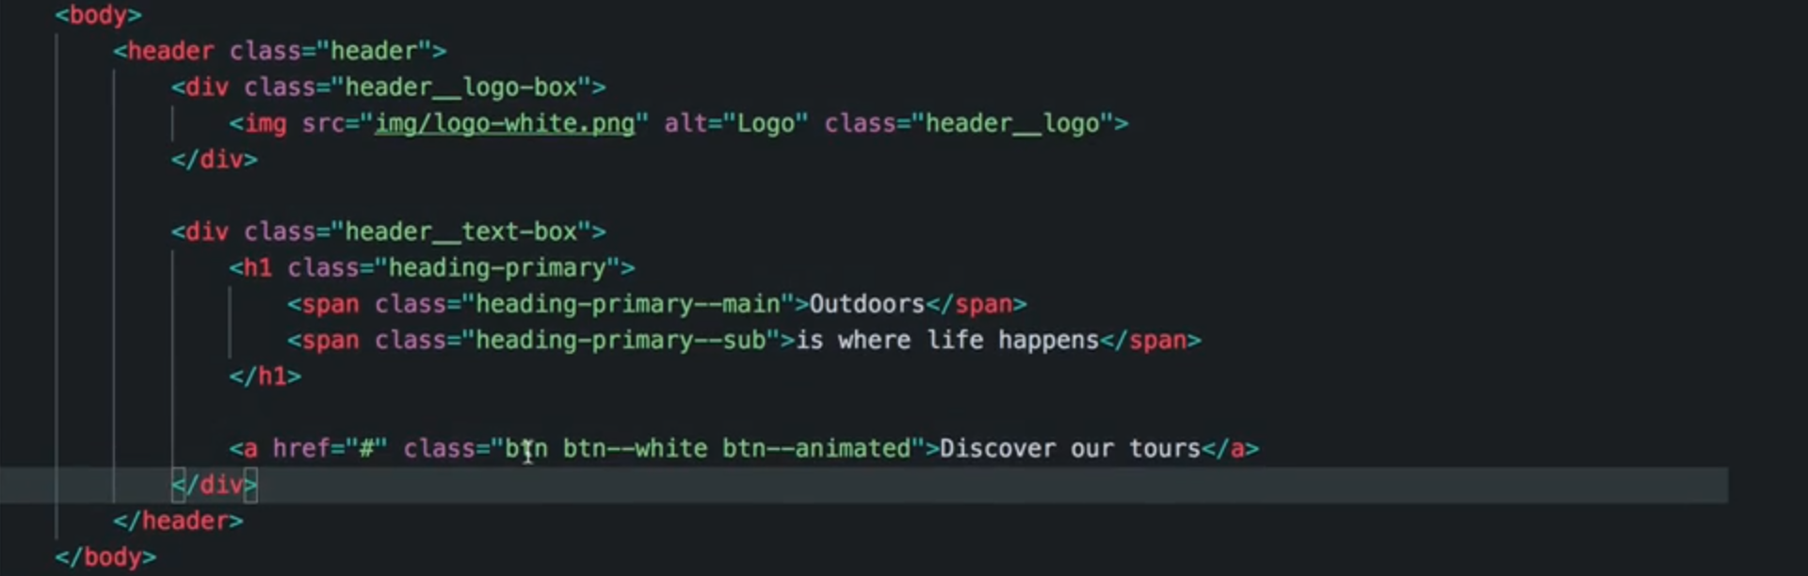

**04 Introduction to Sass and NPM**

**023 What is Sass_**

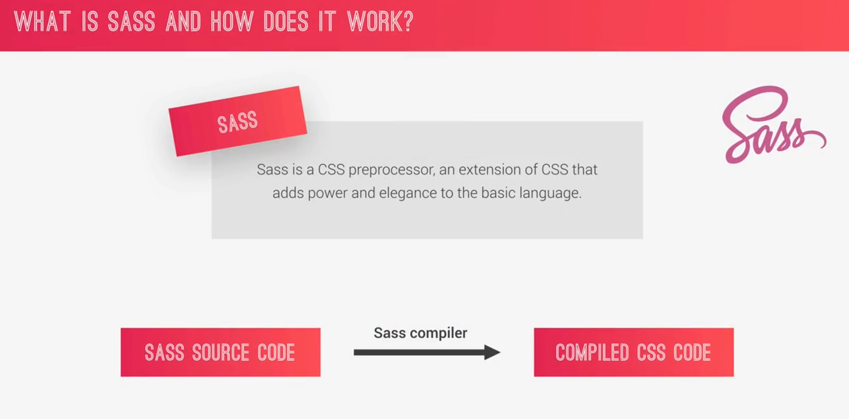

We use sass to fix the problem that we have with CSS. CSS gets very messy very quickly. Using a large single CSS file is completely unmanageable after sometime.

The features of **SASS**

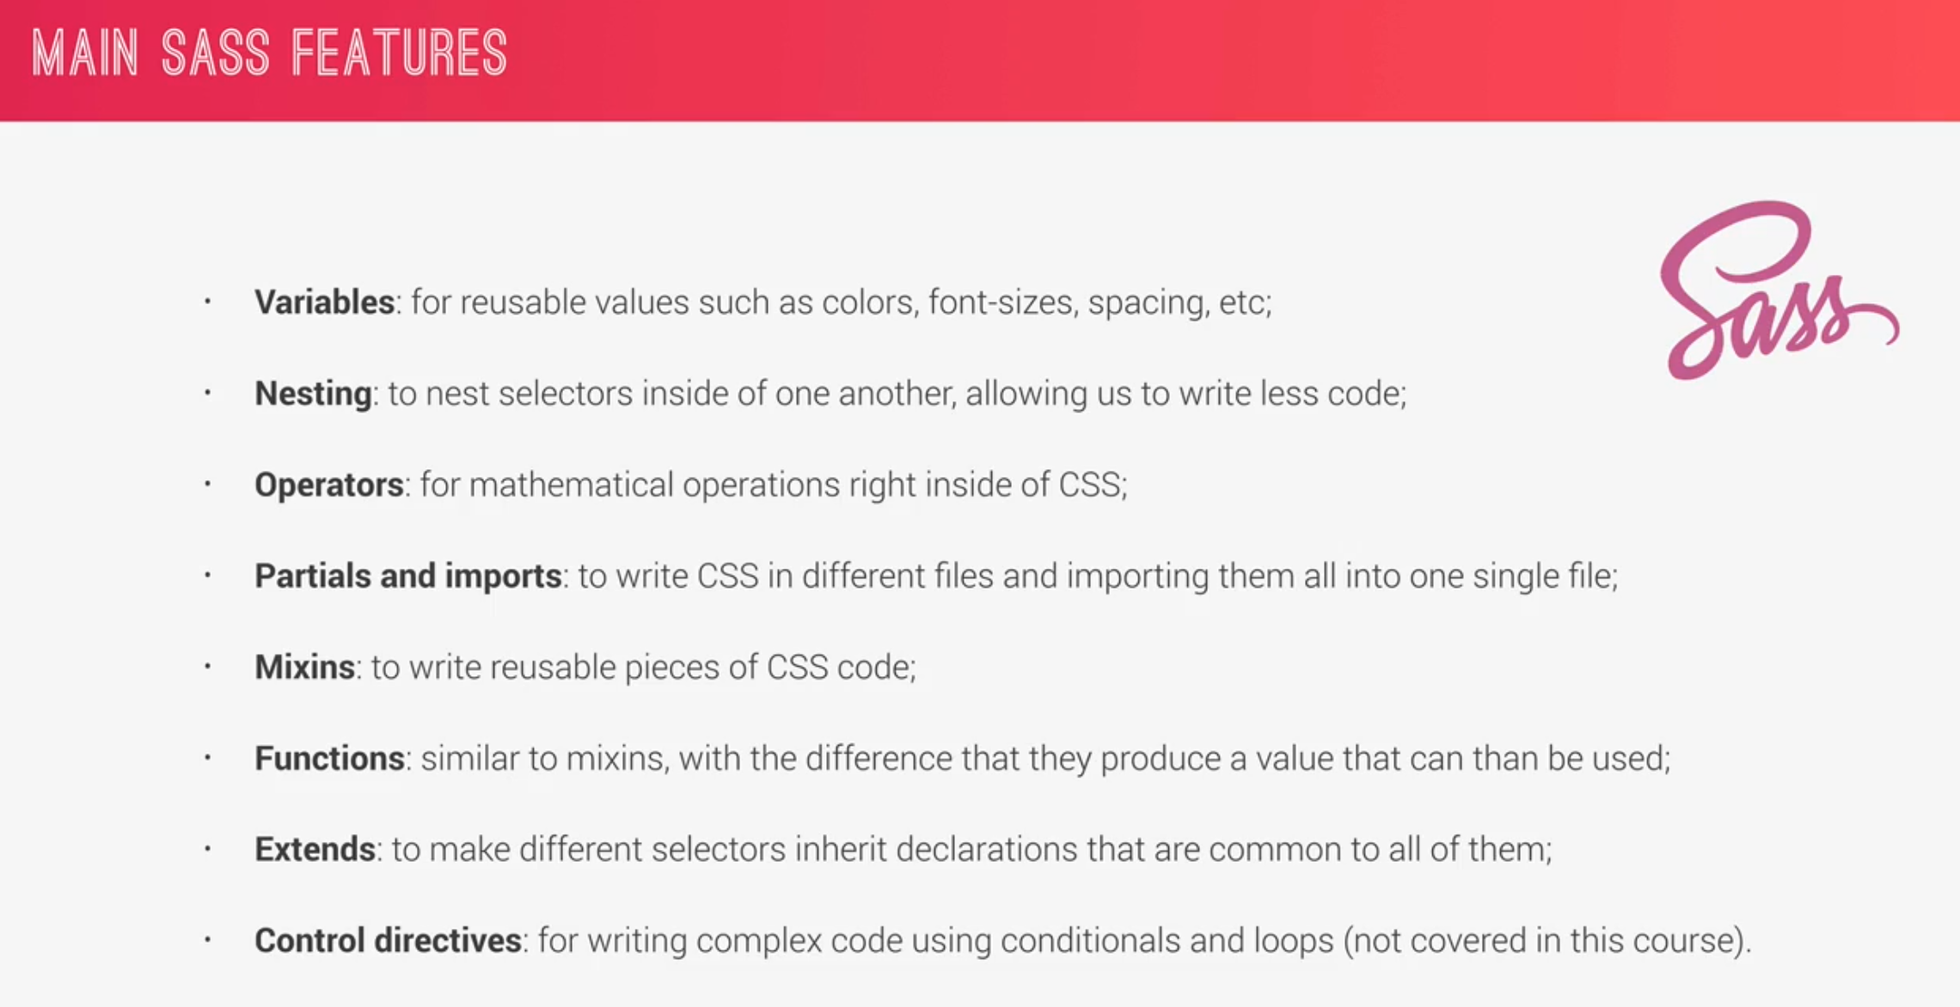

There are 2 sass syntaxes given below

1. Sass Syntax
2. SCSS syntax

SCSS syntax is easy to understand.

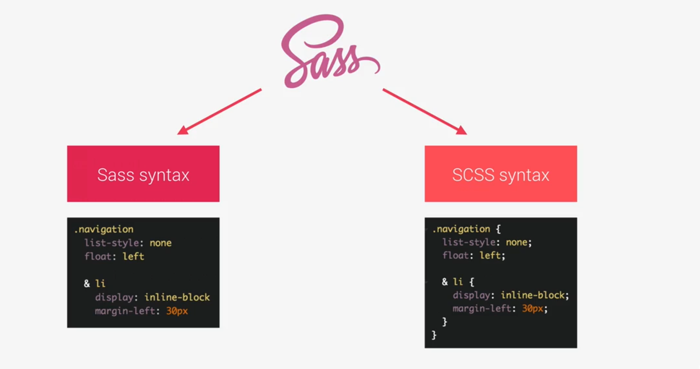

**024 First Steps with Sass_ Variables and Nesting**

**Using Variables:**

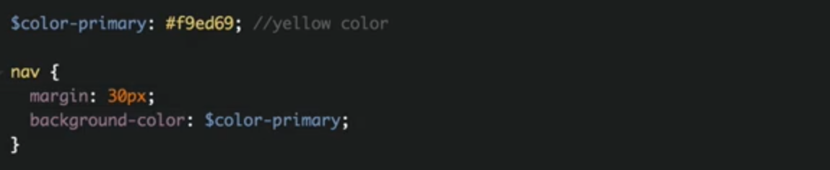

**Nested Structure**

**SCSS style**

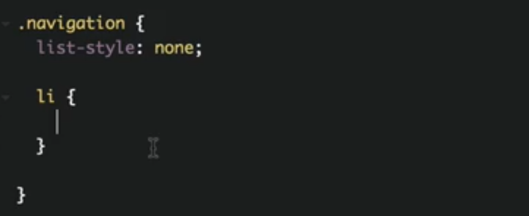

below 2 codes are exactly same, but the above **SCSS** is more readable and we need to write less code with this approach.

**Normal CSS**

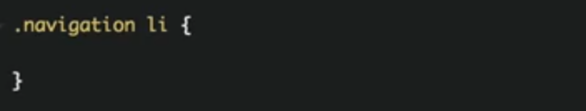

**SCSS** => **&** represents here is .*navigation li:first-child.* We use **&** to represent pseudo class.

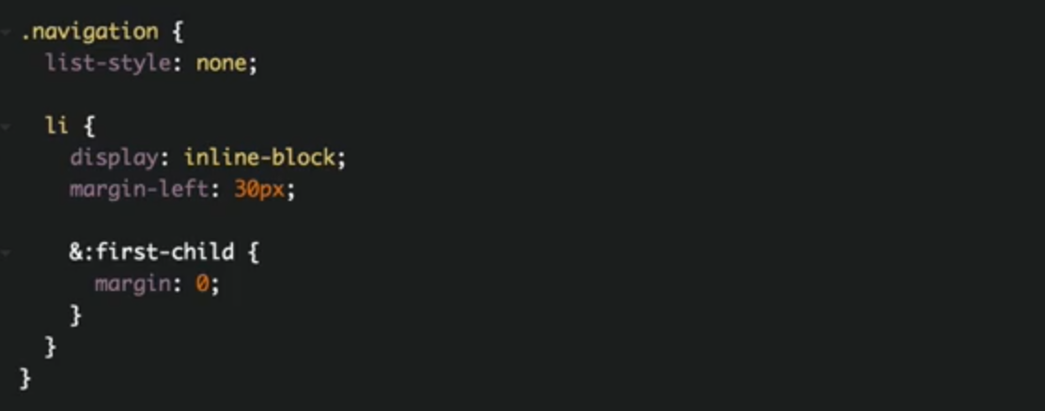

**Normal CSS** of the above SCSS code

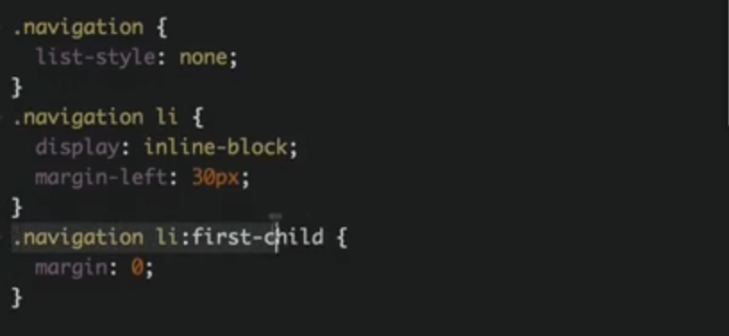

Adding a: link to navigation

*navigation li a:link*

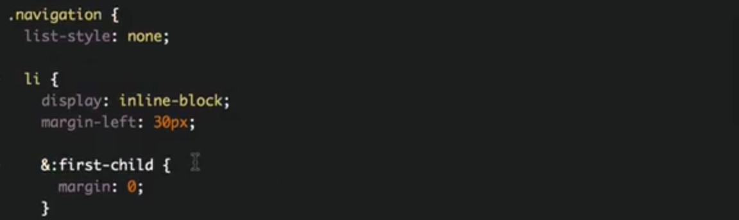

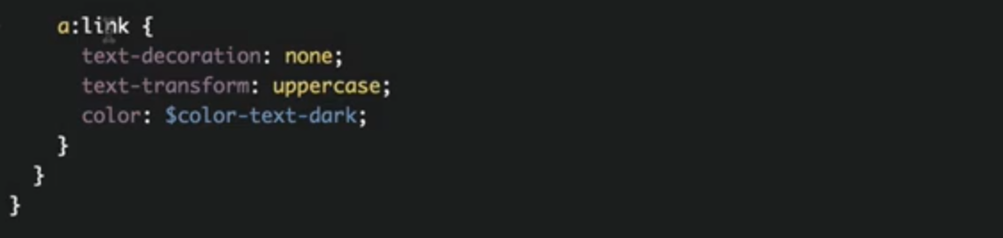

another example of **&.** It will convert to *nav::after*

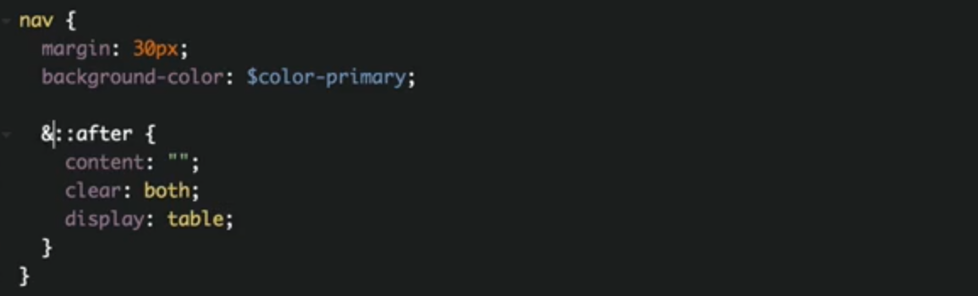

There are color functions that we can use to make the color lighter and darker

15% darker with **darken() function**

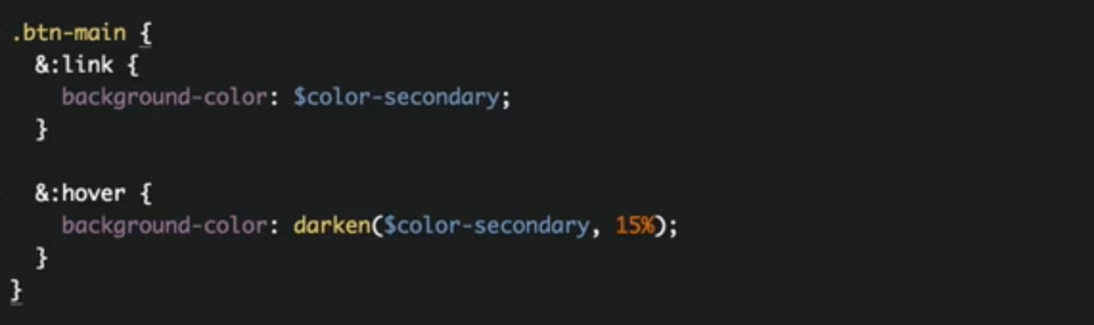

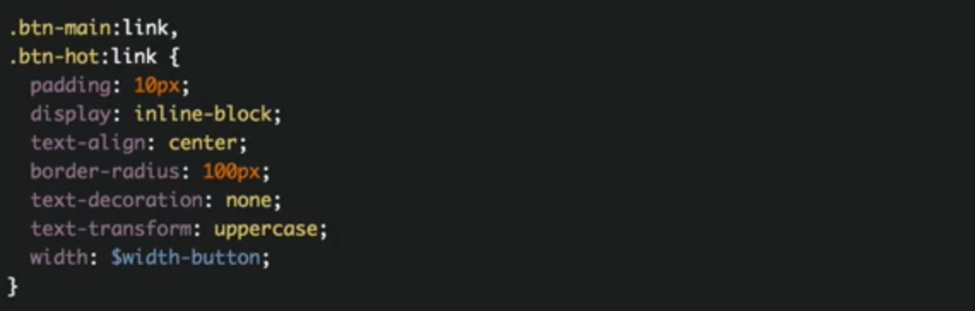

**025 First Steps with Sass_ Mixins_ Extends and Functions**

**Mixins:** A mixin is just a reusable piece of code that we write into a mixin. We use it with **include**

We use to remove redundancy. DRY principle

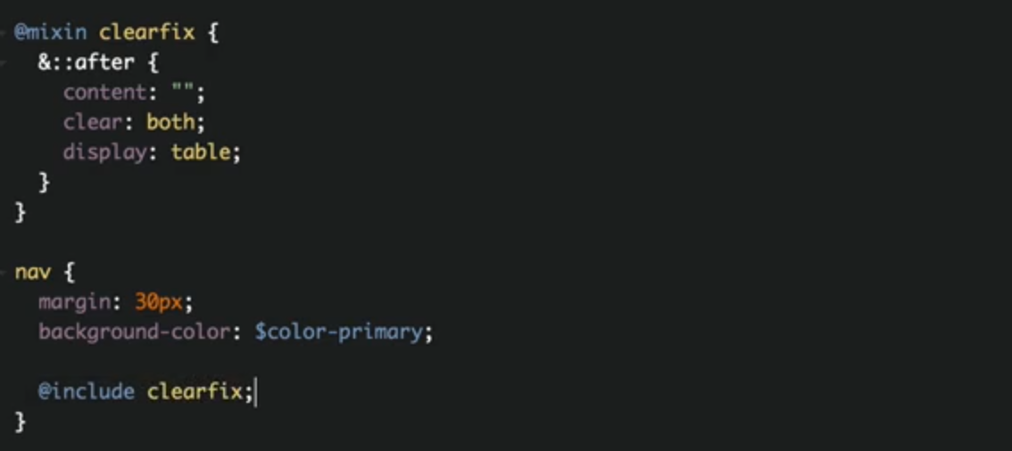

We can even **pass arguments** in minix. Here is another example of mixin

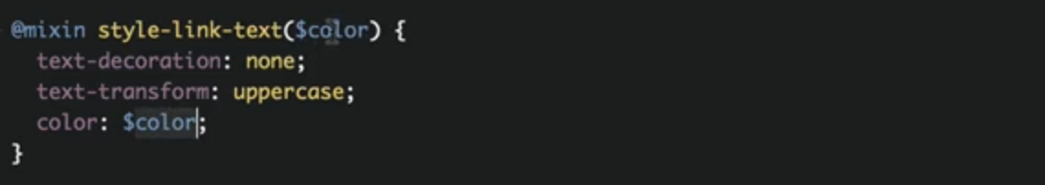

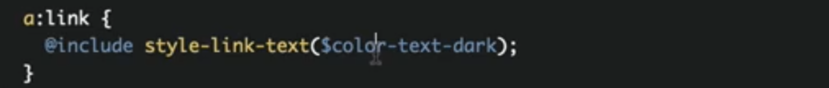

**Custom Sass Functions**

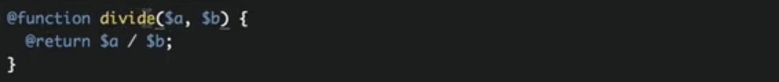

To add the pixel unit to function result, we multiple it with 1

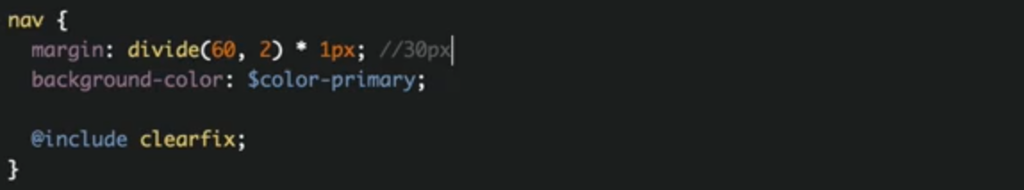

**Extend with Sass**

**Extend:** we can write a placeholder and put a bunch of styles in there and then have other selectors extend that placeholder. We write it with **% sign.**

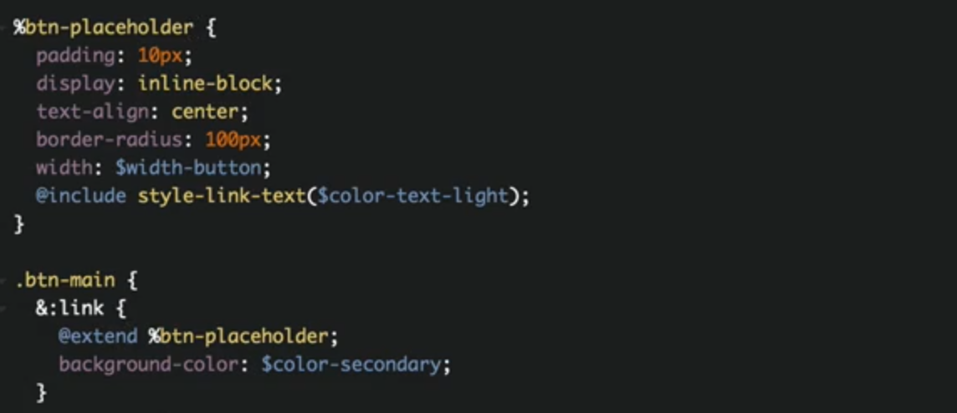

instead of copying the same code in the compiled file, it adds the selector to the placeholder like this.

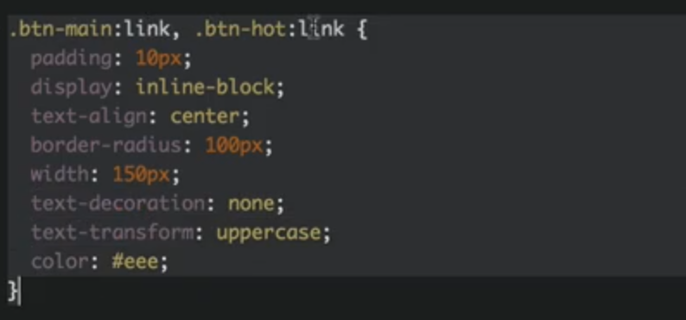

**026 A Brief Introduction to the Command Line**

**027 NPM Packages_ Let's Install Sass Locally**



**028 NPM Scripts_ Let's Write and Compile Sass Locally**

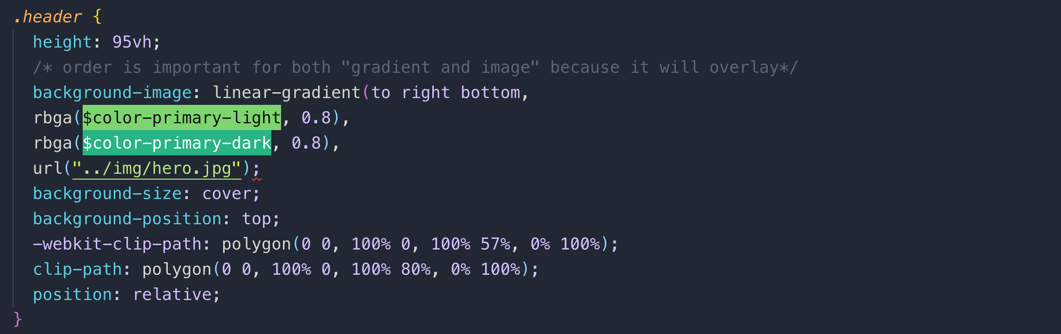

instead writing rbga() like we used above, we can write hex code with alpha like this.

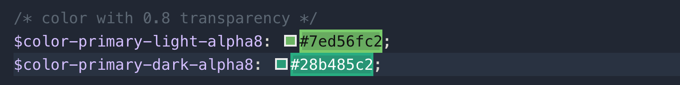

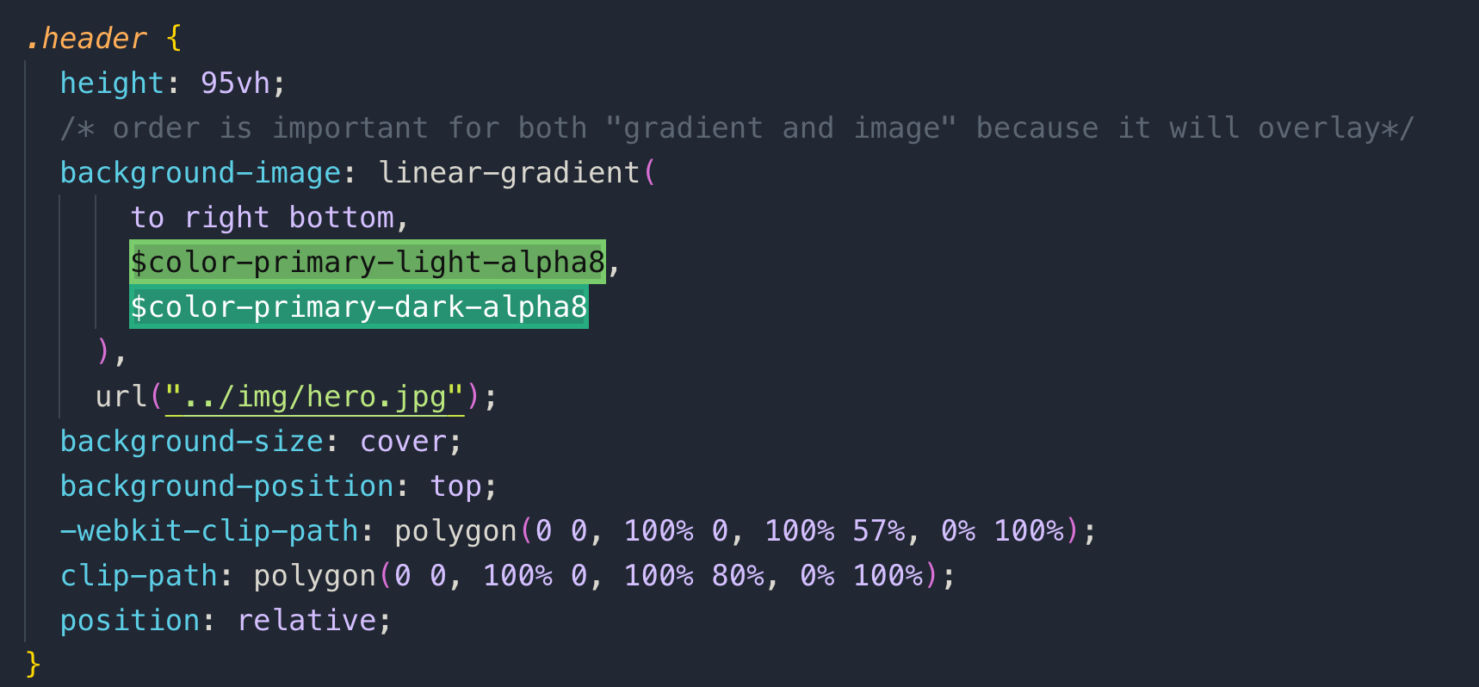

let’s compile the SCSS file

creating command in package.json

**input file:** sass/main.scss

**output file:** css/style.scss

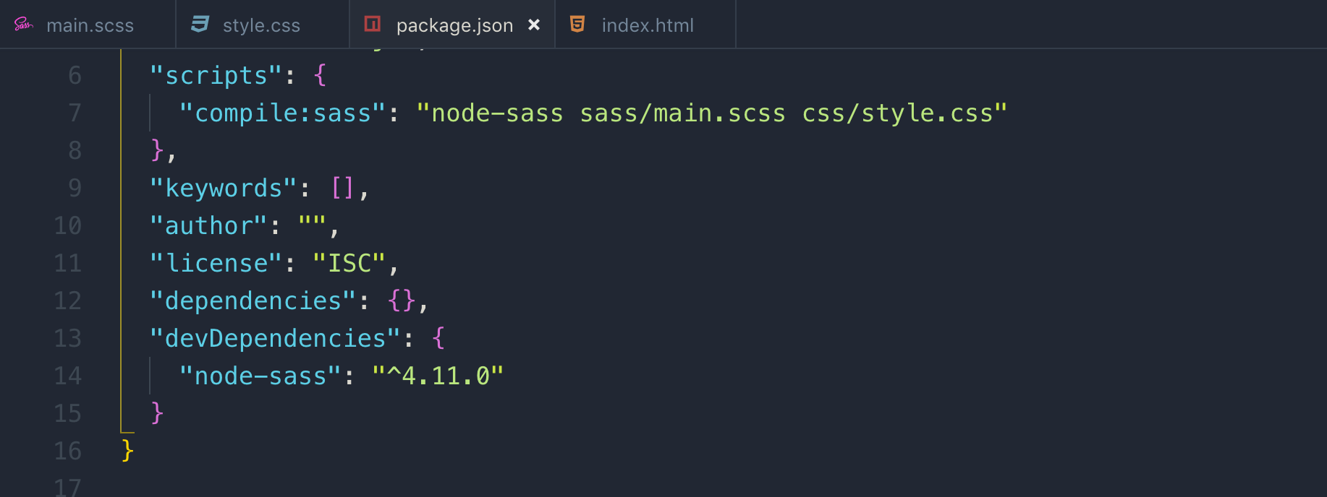

everytime we change something to sass file, we have to run the command, so to avoid that we can add a flag –w which will watch if there is any change and run the script automatically.

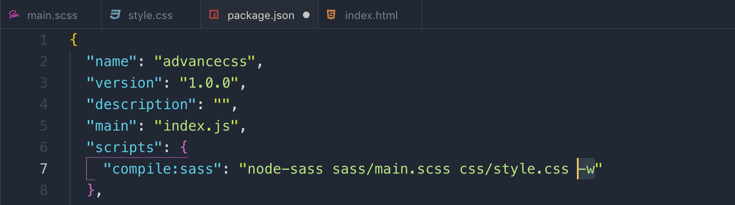

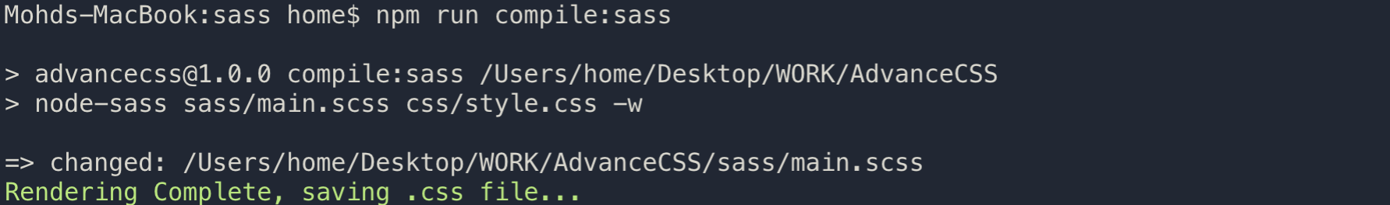

**029 The Easiest Way of Automatically Reloading a Page on File Changes**

**05 Natours Project Using Advanced CSS and Sass (Part 2)**

**031 Converting Our CSS Code to Sass_ Variables and Nesting**

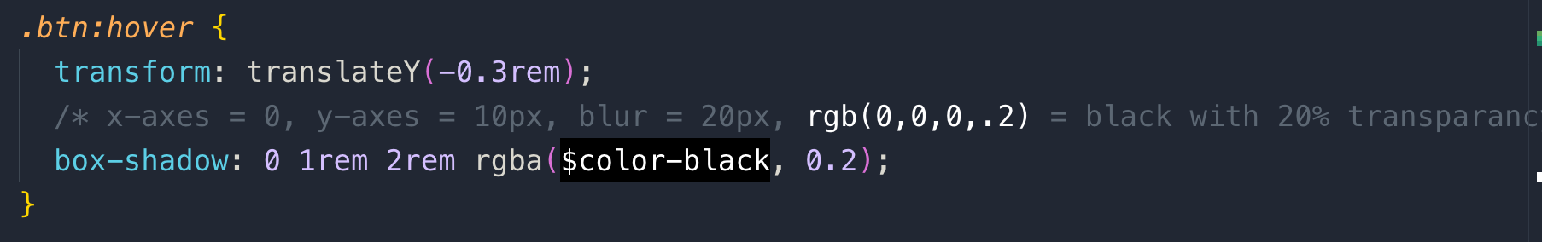

**logo-box** inside header

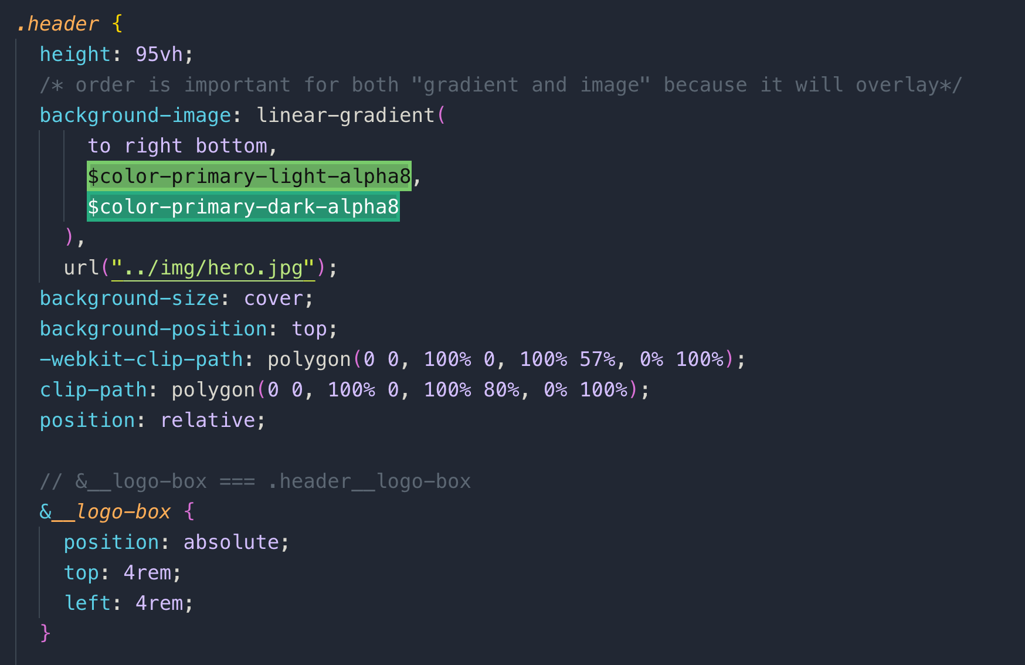

just replace the parent name with & in case of nested classes like we did for

.header__logo-box **==** &__logo-box

you can do the same thing for button and pseudo classes

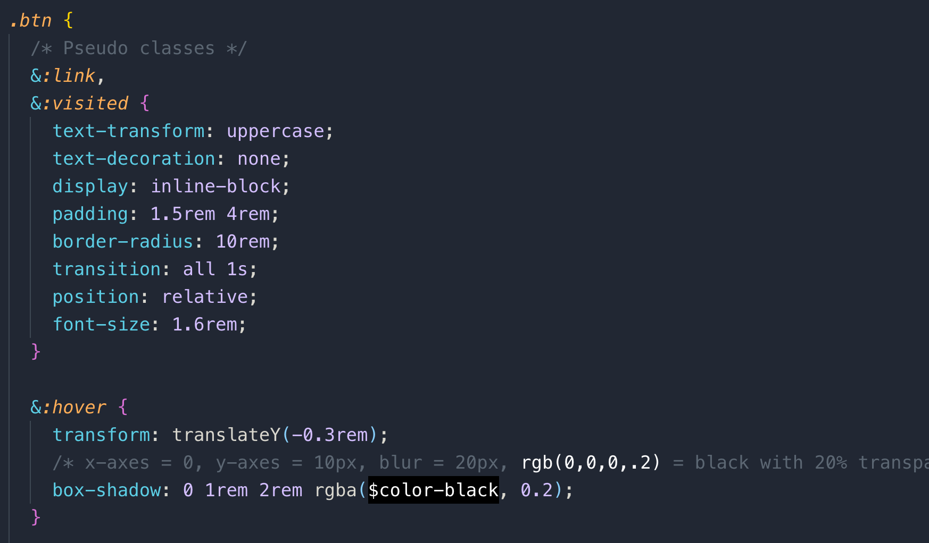

**032 Implementing the 7-1 CSS Architecture with Sass**

Let’s create 7 folder structure for organizing SASS codes

**BASE FOLDER**

**sass/base/_base.scss:** it is a basic low-level basics such as resets and style for HTML. This is a partial files which import into main.scss file. Partial file starts with _ underscore.

**Note:** while importing this partial file, we **don’t** have to add _ underscore and .scss extension, just the name of the file like this.

You can add **body, html, and universal selector** here in this _base.scss file. If the body text has some global typography then move that to typography also so this way **body** selector will be in 2 files

1. _typography.scss, and _base.scss



sass/base/_animations.scss: All the @keyframes animation go here

sass/base/_typography.scss: any special text like title or landing page header font

sass/base/_utilities.scss:

**ABSTRACTS FOLDER**

sass/abstracts/_mixins.scss

sass/abstracts/_variables.scss

sass/abstracts/_functions.scss

**COMPONENTS FOLDER:** each file for each app’s component. They together build the website layout.

sass/components/_button.scss

**button** is a component, because we can reuse it anywhere in our app. Anything that is independent and can be reused is considered a component.

**PAGES FOLDER :** style for specific page like home, contact, about etc.

sass/pages/_home.scss

**LAYOUT FOLDER :** <header> is consider a layout element

sass/layout/_header.scss

**main.scss:** this file only contains all the input, not the actual code like this.

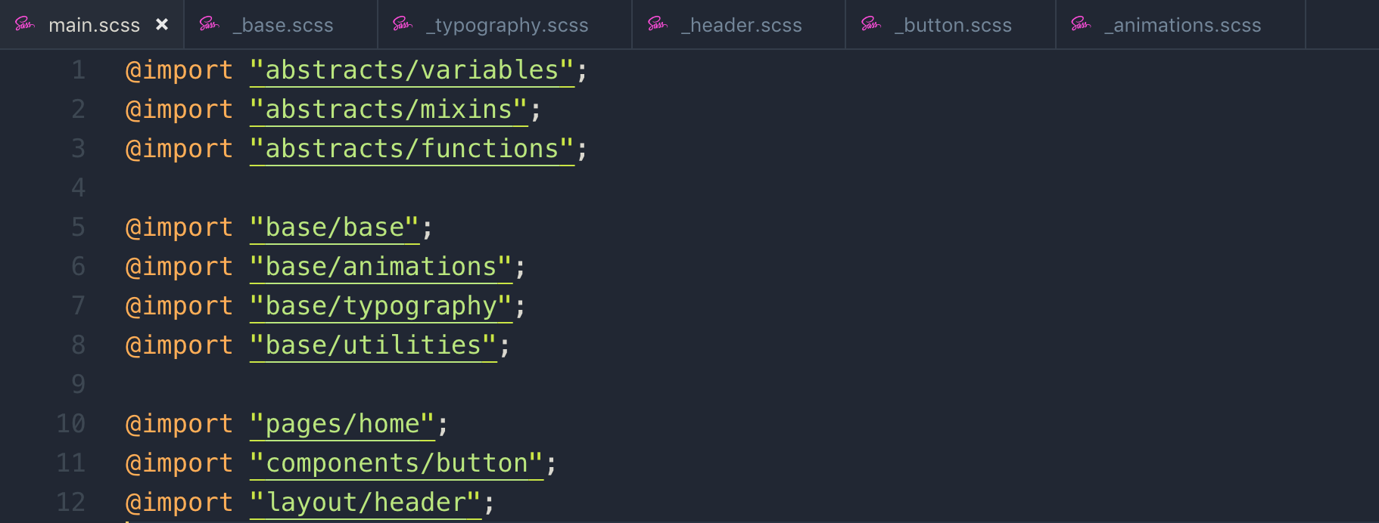

7 folder sass structure with respective files.

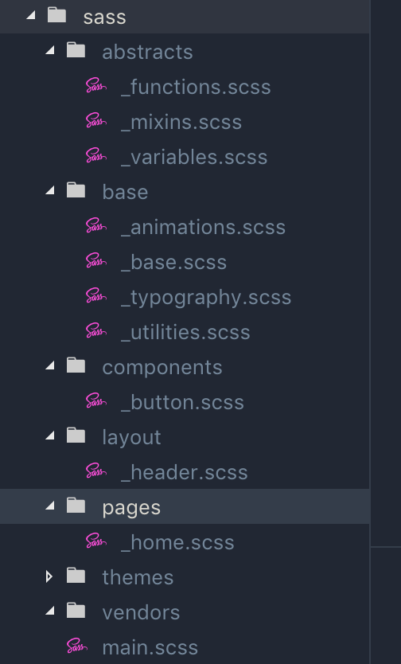

**033 Review_ Basic Principles of Responsive Design and Layout Types**

We make images responsive by giving their dimensions in percentages.

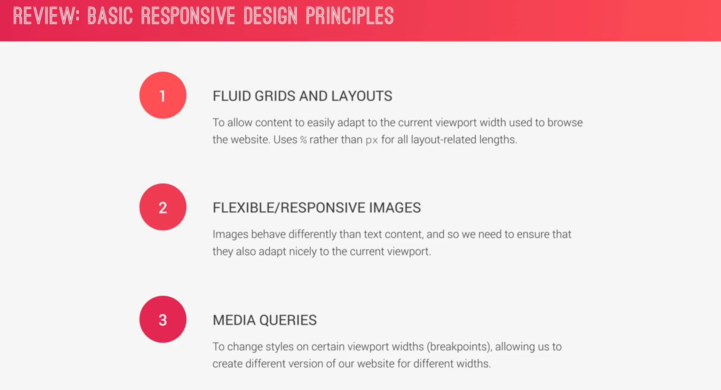

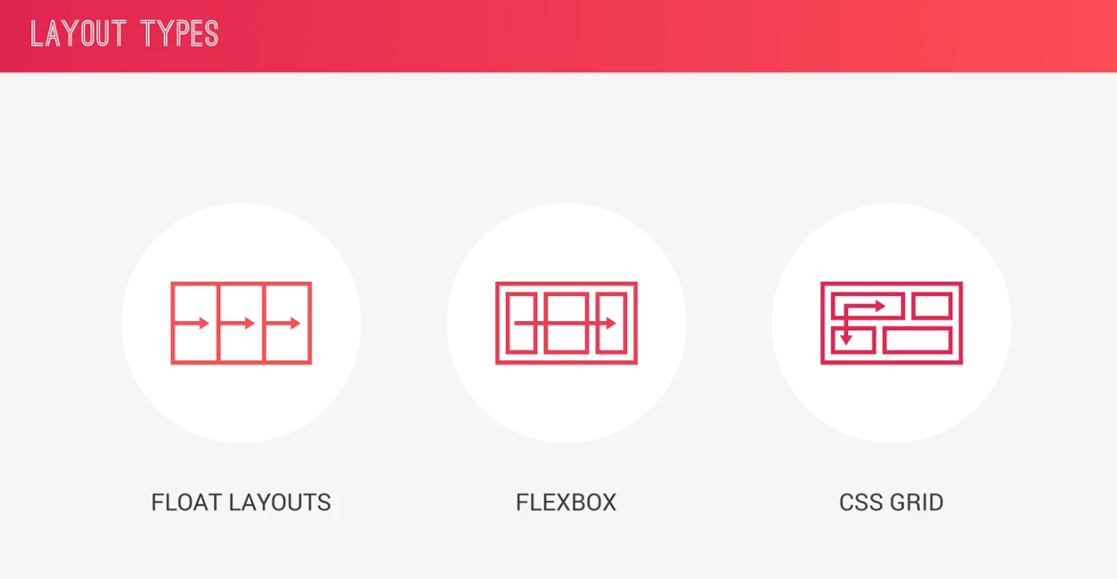

**034 Building a Custom Grid with Floats**

**Grid:** this is just a design system which allows us to build consistent interfaces. Grid divides the space between number of columns and rows as shows below.

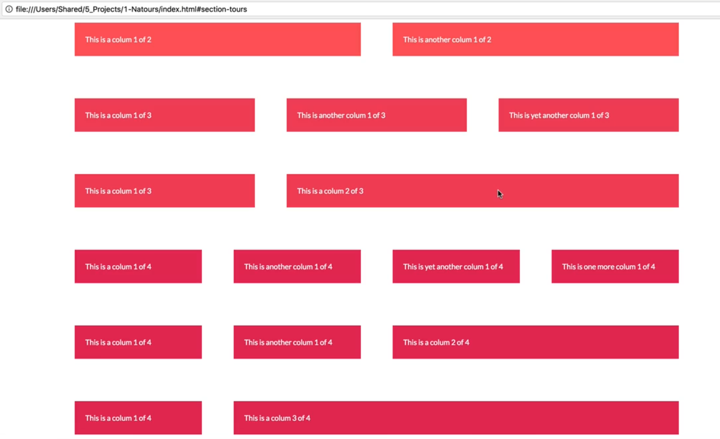

**gutter:** the consistence space between all of the above columns.

The standard of row in pixel is 1140px == 114rem

We created a *layout/_grid.scss* file below

**calc():** you can do mathematical operations and you can actually mix units here, and this is the main different between calc() and native SASS calculation, using function or mixin.

Float problem:

All of the child element of the row is floated so the height collapses and become zero. To fix it, we use **clearfix.** Let’s add this clearfix to _mixinx.scss file. Mixin always starts with **@minix mixinName { }**

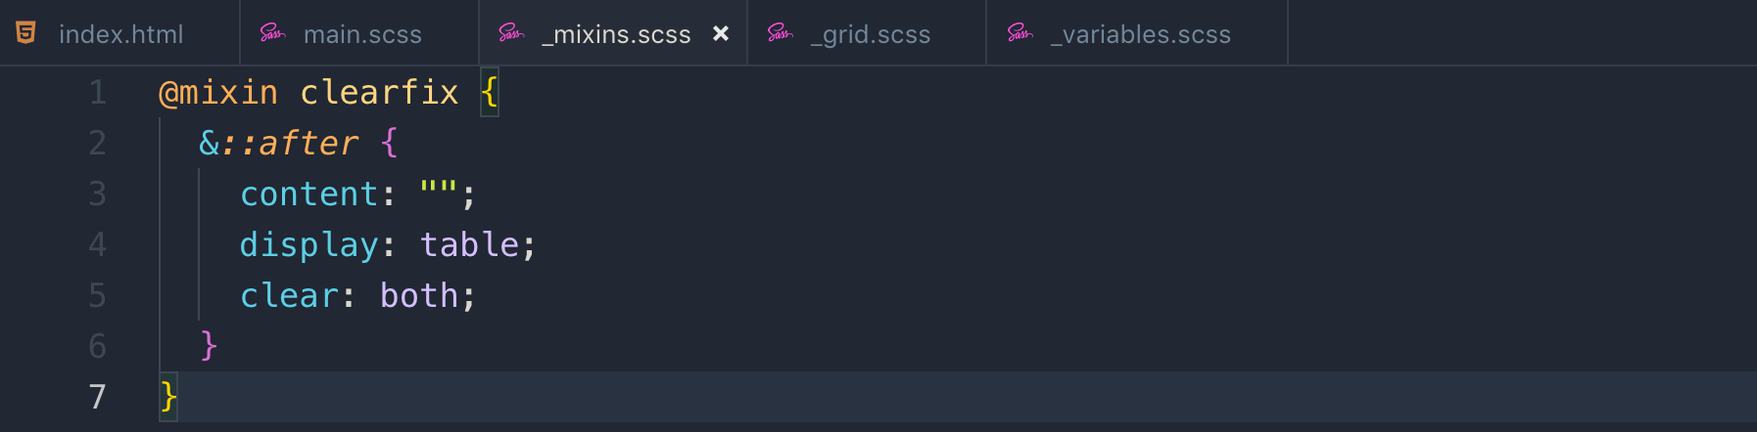

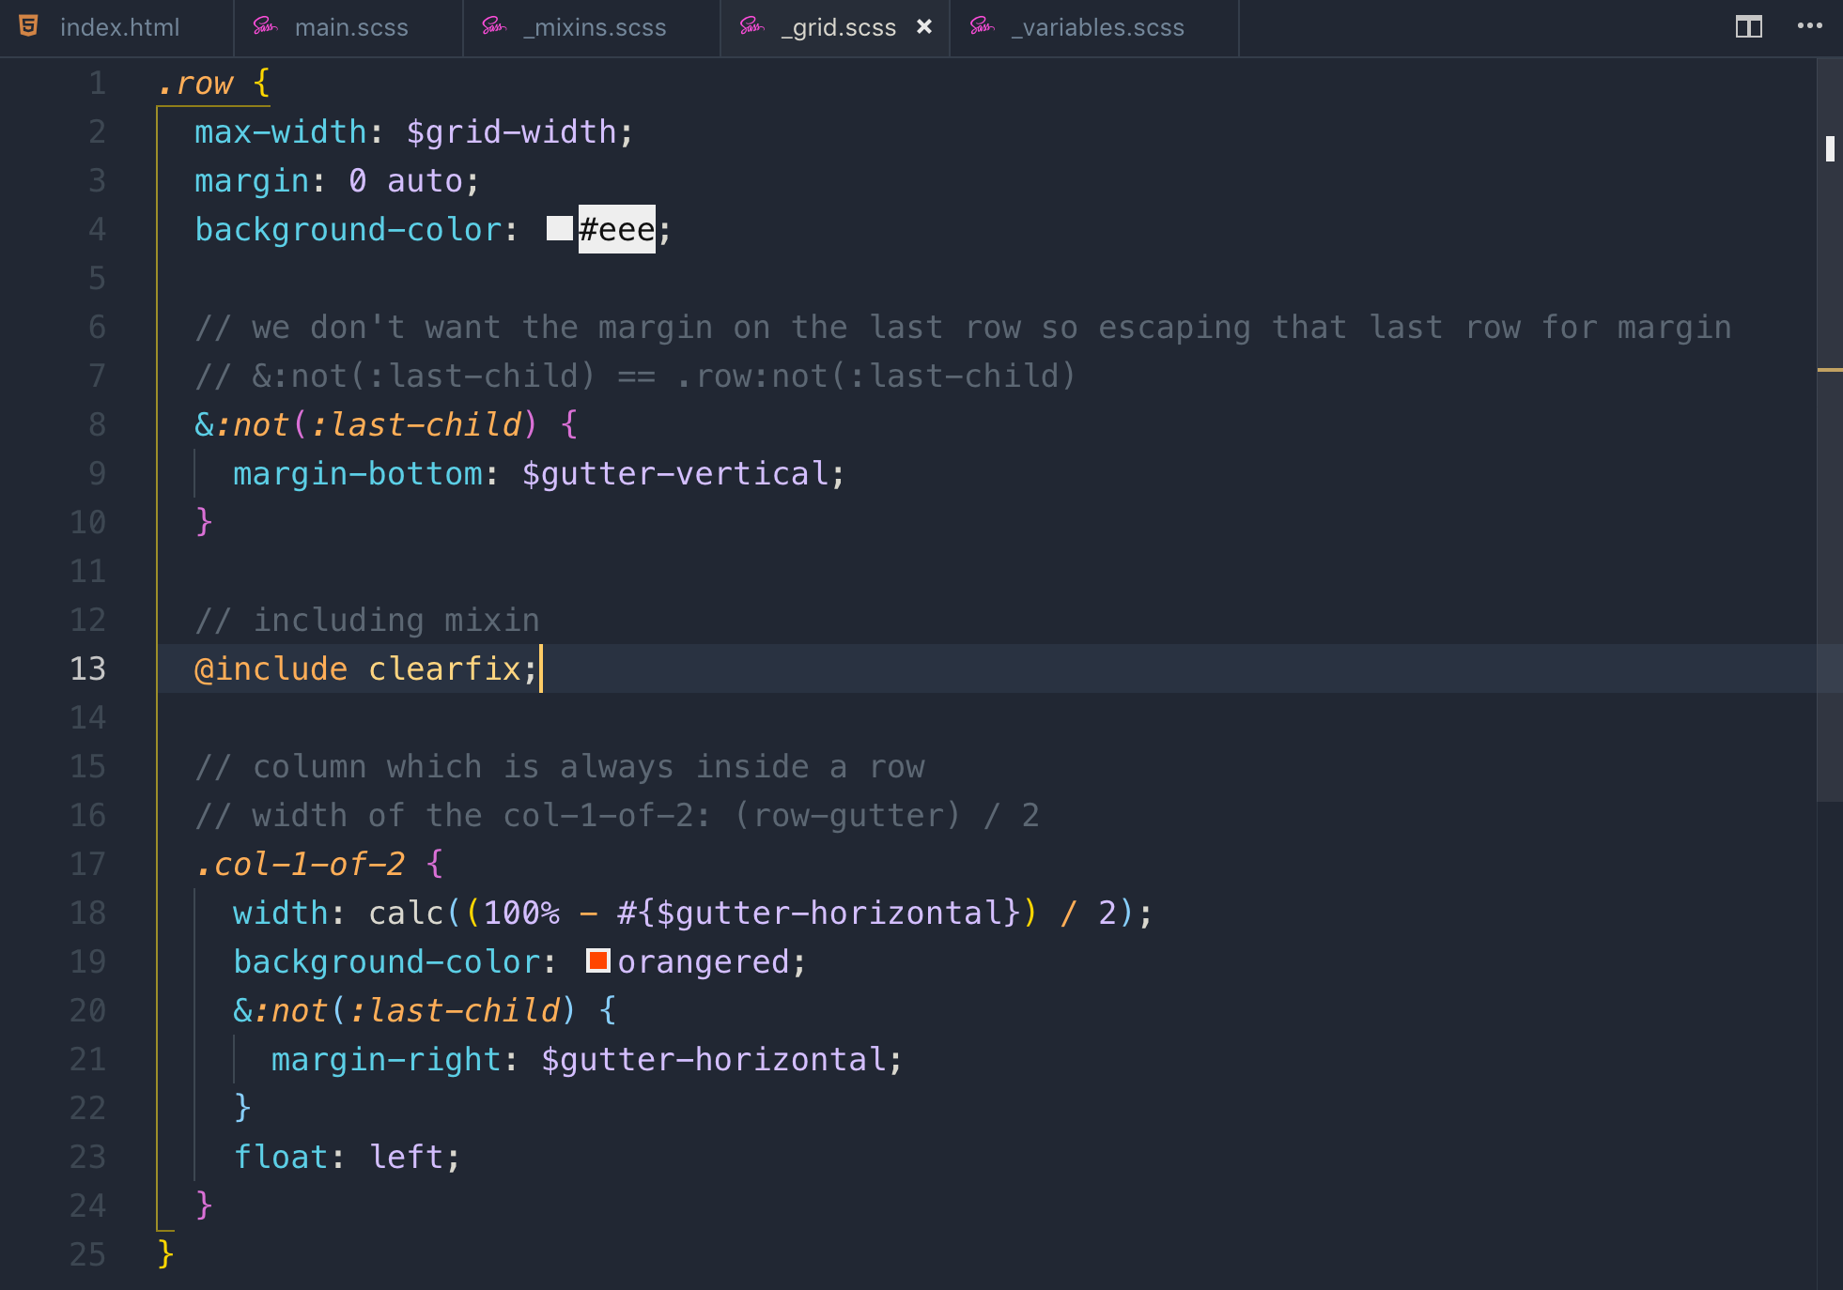

attribute selector: [src]

Example: [alt=”logo”] : it will select all of the elements which have this alt attribute with value “logo”

Example 2: [class^=col-] : it will select all the element which has class attribute and starts with “col-”

Example 2: [class*=col-] : it will select all the element which has class attribute and contains “col-”

**035 Building the About Section - Part 1**

We can overlap div by using margin in minus.

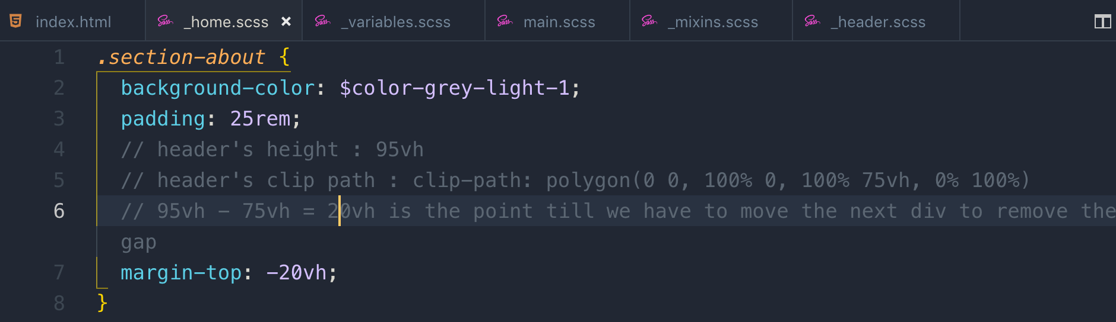



To remove the above while gap between grey div and above header is to move the div up to -20vh

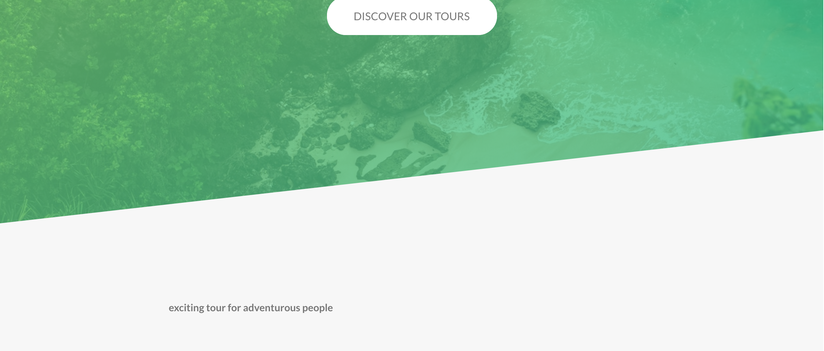

Let’s show the above text <h2> with gradient effect. Let’s add this font style to base/typography.scss

This is the effect of background-image gradient in text



to fill the background gradient into text we have new CSS property called **background-clip**

we need to prefix it with **webkit-background-clip:text**

This is the effect of hover



This is the CSS for above text effect

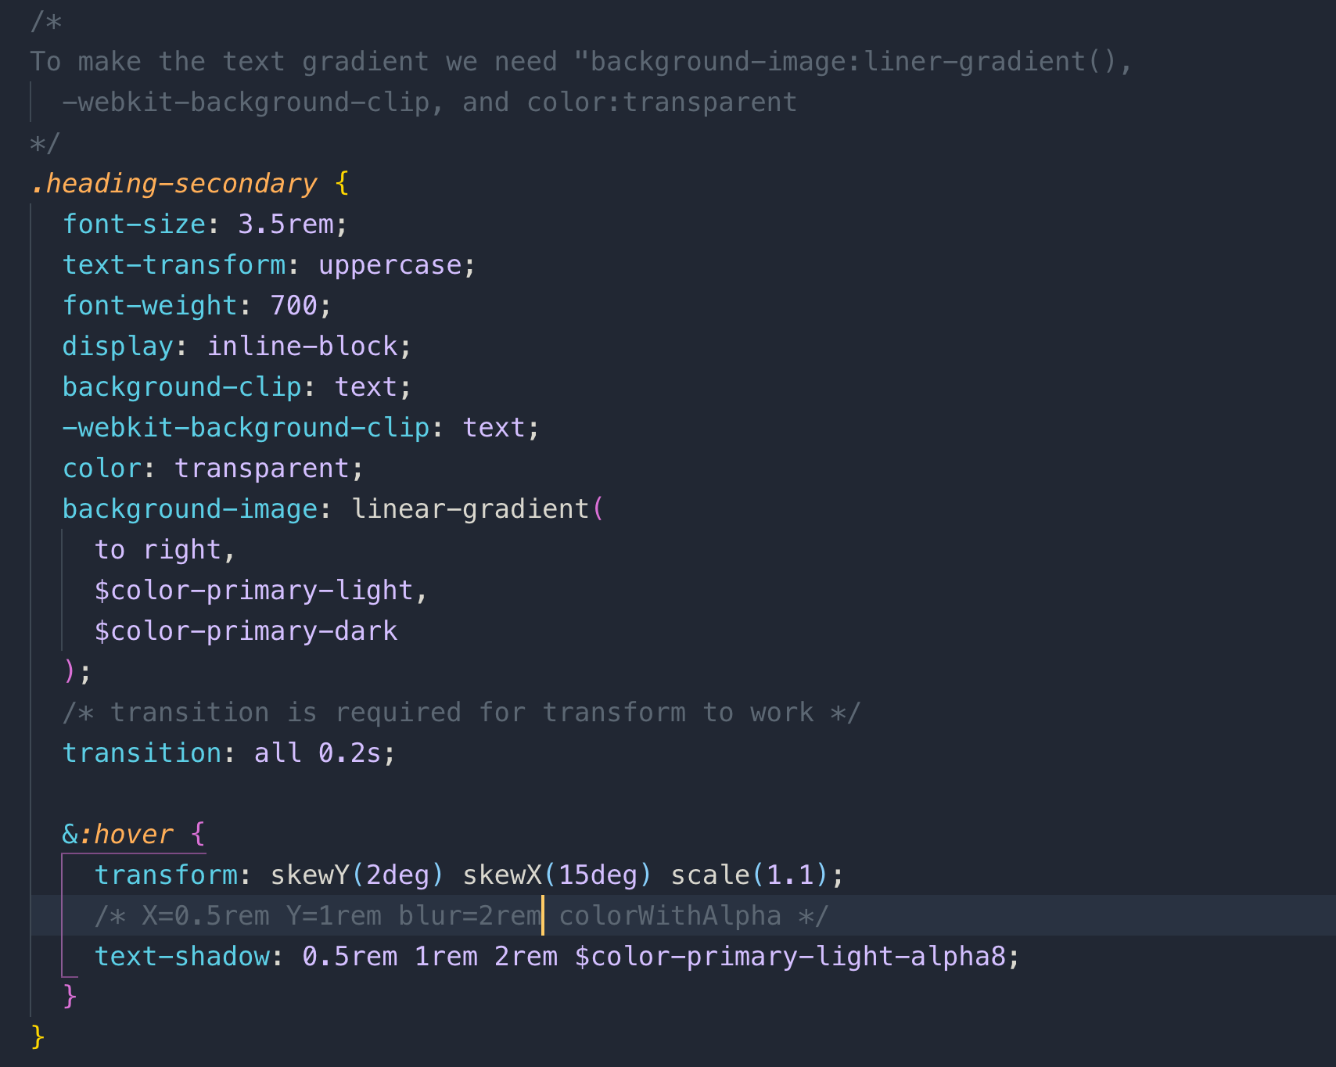

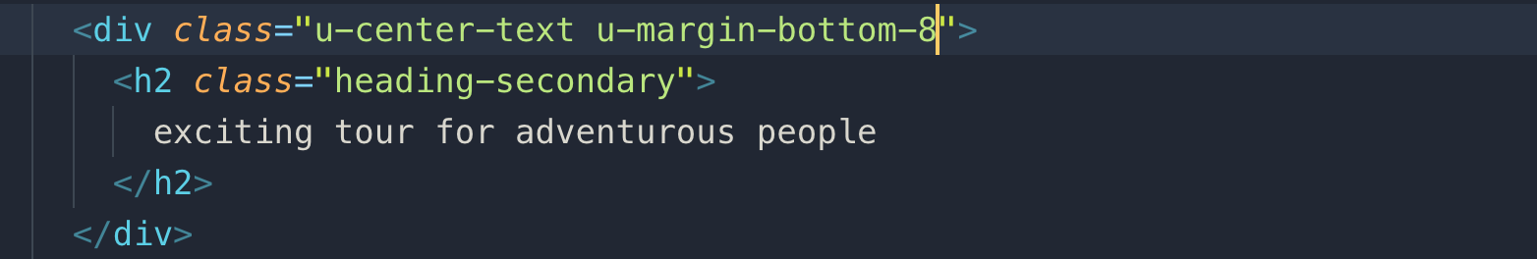

**.u-center-text:** these are the utilities classes defined in the sass/base/utilities.scss

use these classes if you want add specific style to an element

**036 Building the About Section - Part 2**

Lear more button



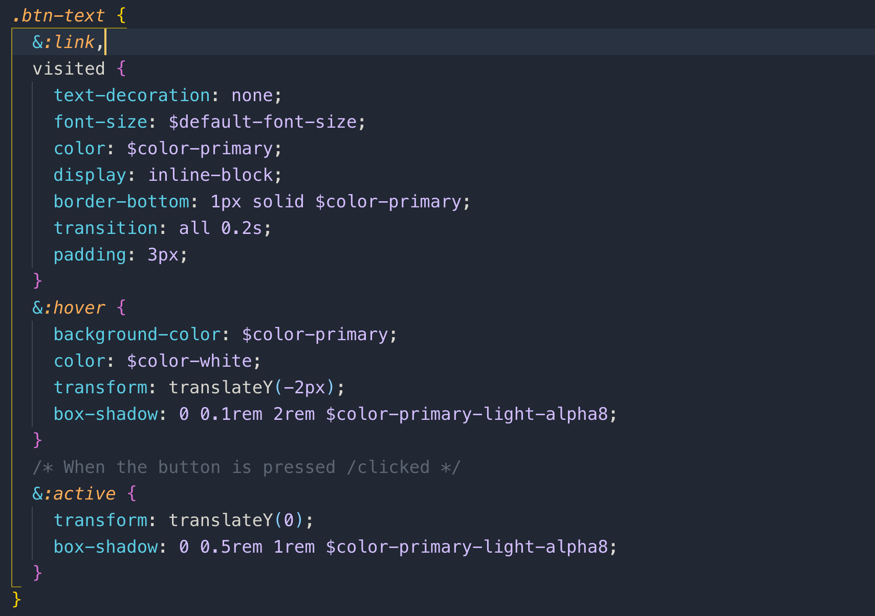

**037 Building the About Section - Part 3**

let’s build the right image section

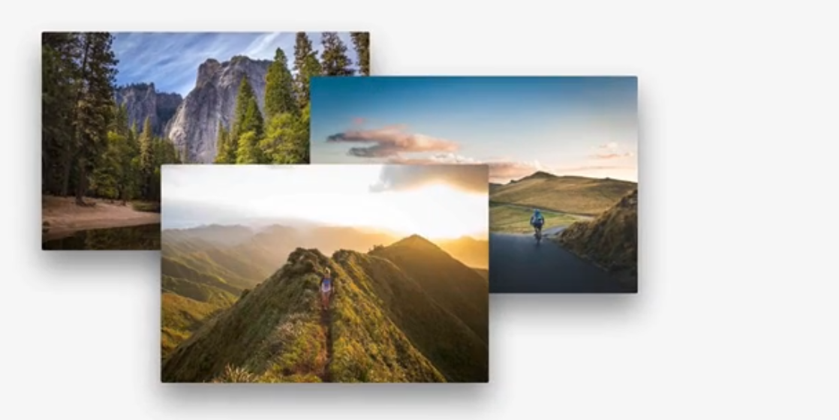

Emmet shortcut

.composition>(img.composition__photo.composition__photo--p1)*3

hit tab and it will convert into

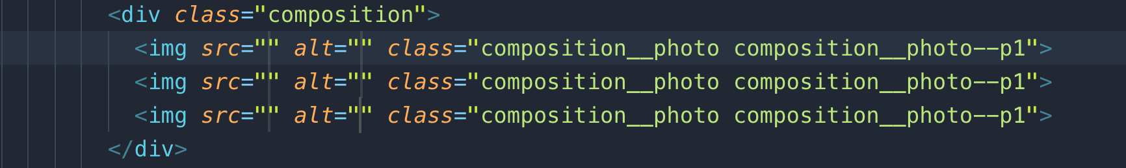

**Note:** we should always define images size in percentage, because with percentage, it will nicely fit with the view port.

Important: Instead of border, we will use outline as we can set offset with it which we require to create space between photo and outline which looks like a border

sass/components/composition.scss

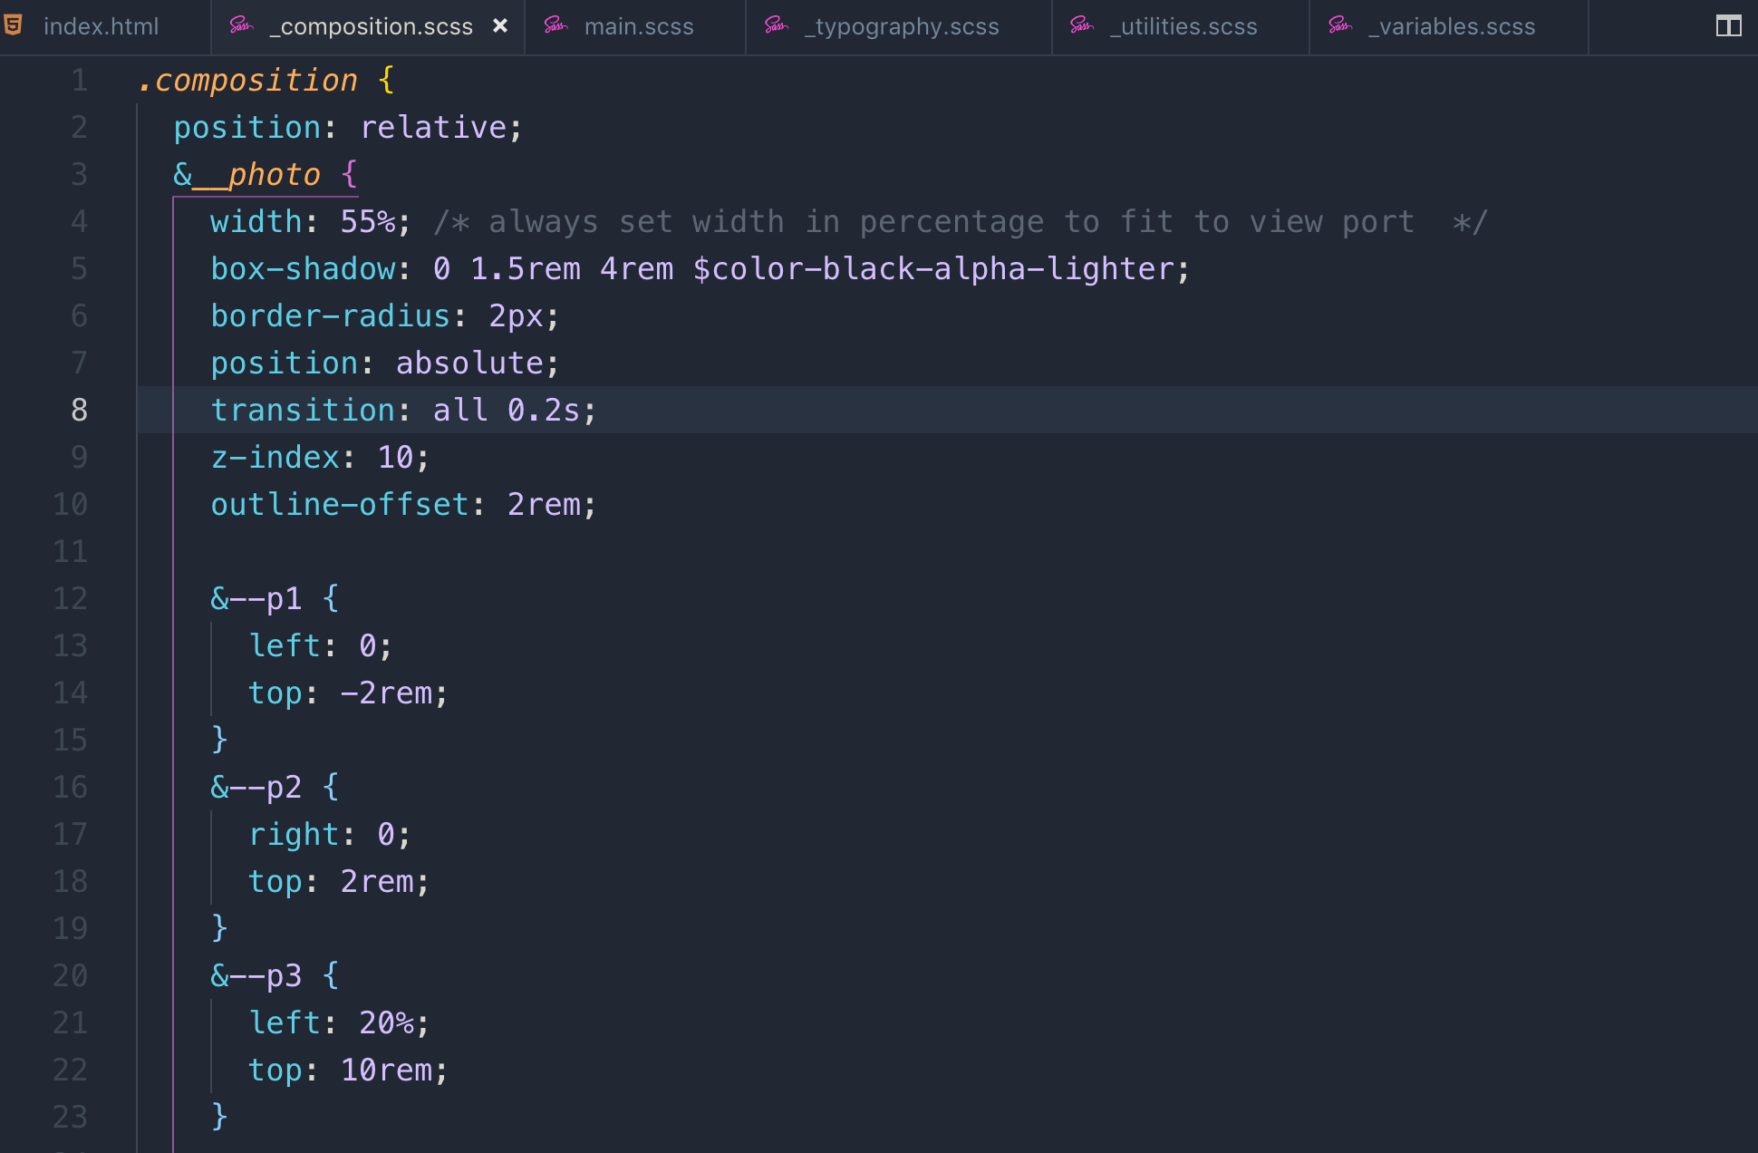

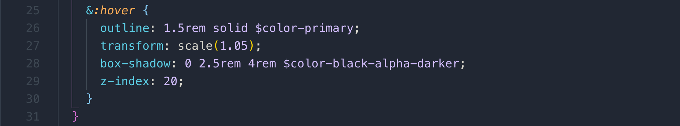

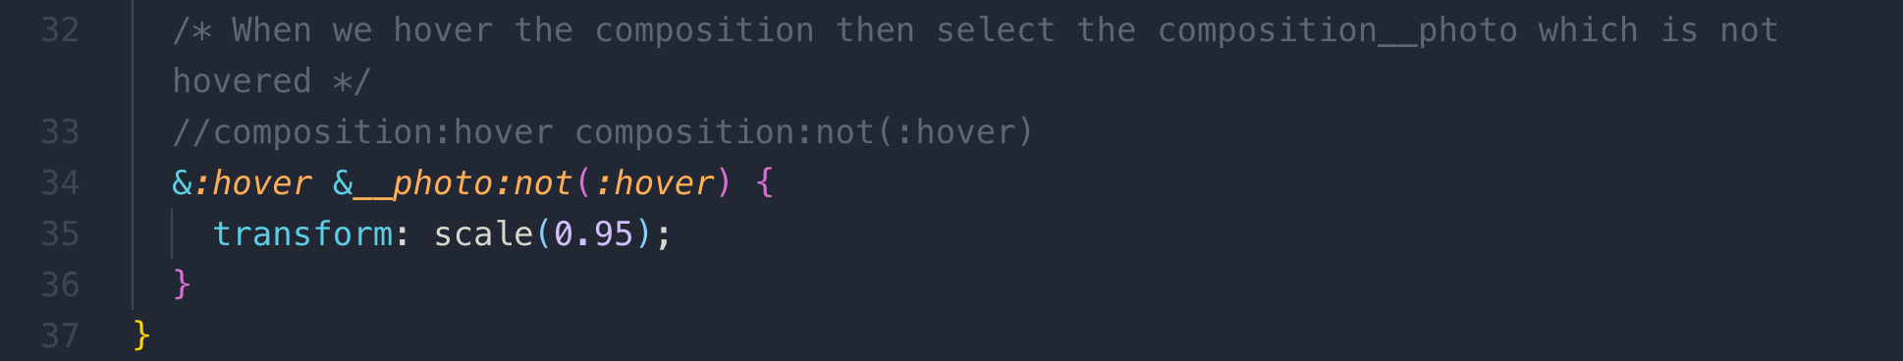

**038 Building the Features Section**

We are going to build this feature section in upcoming lessons.

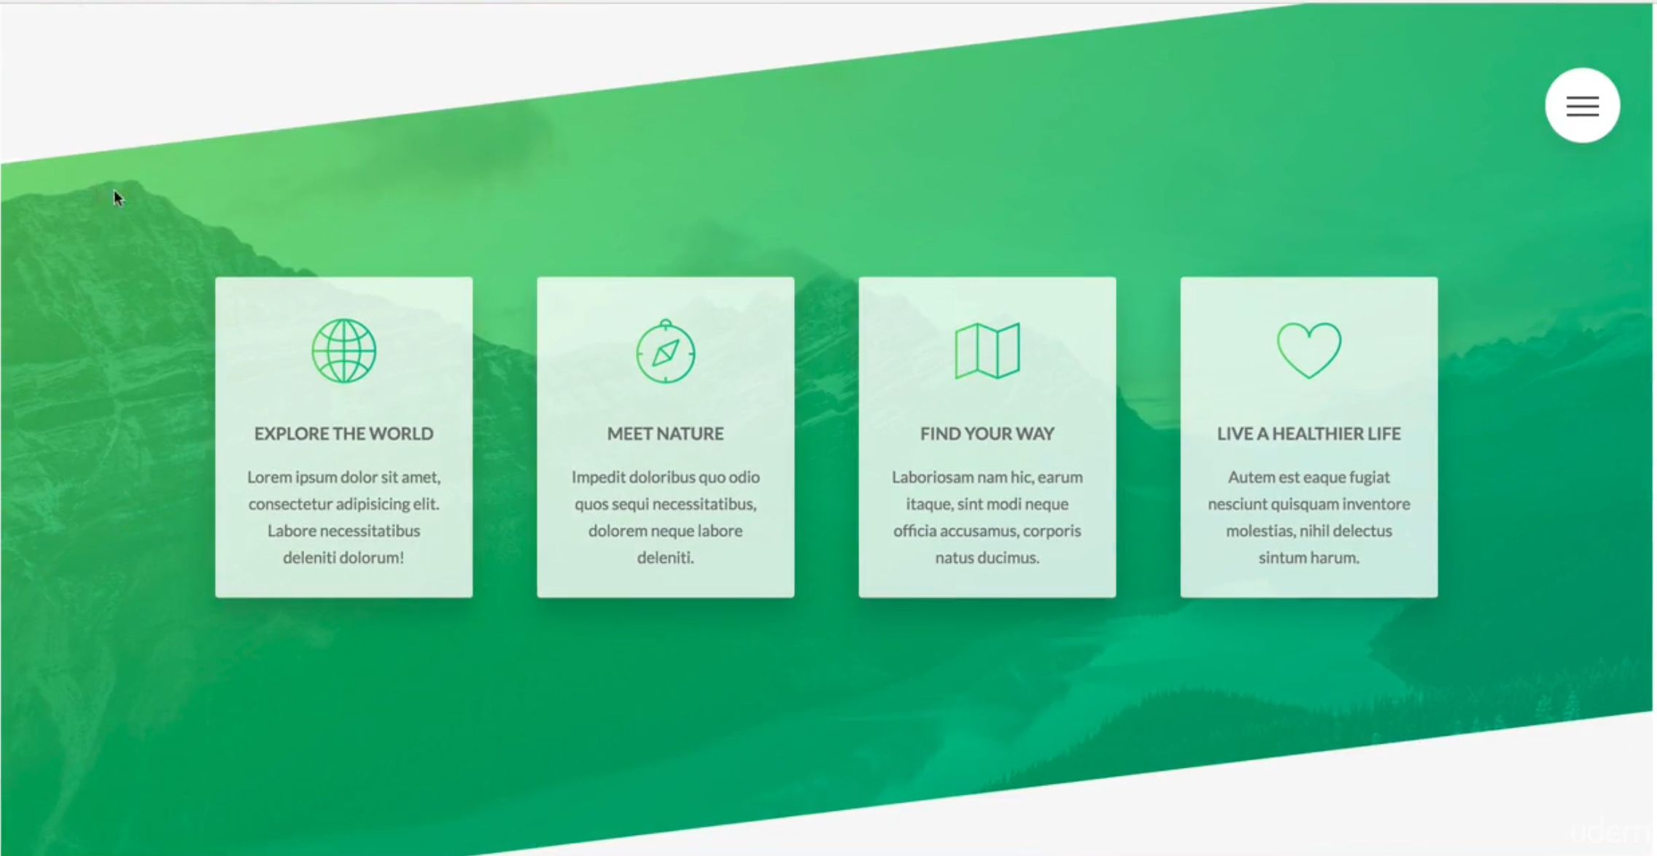

Let’s download some icons as shown in the above design

**Linea.io**

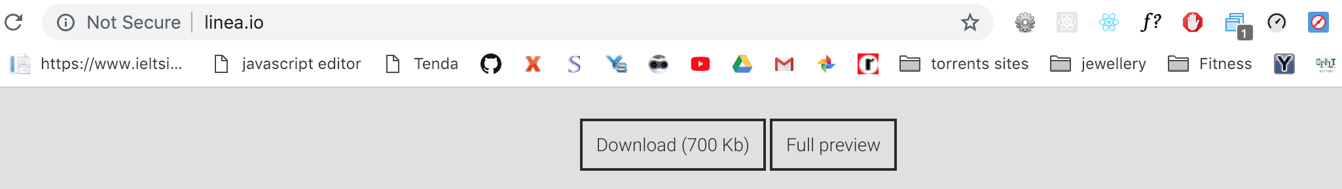

We only need to copy fonts and style.css from the download package. Copy and paste it into our project’s CSS folder

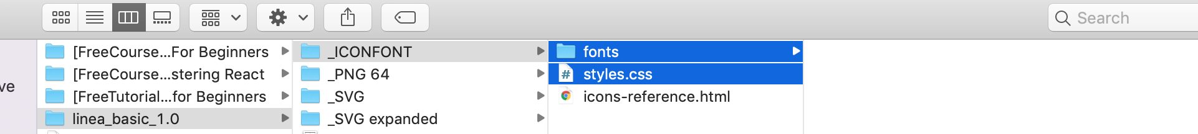

Using **png images** as icons is not a good practice as it does not scale on zooming. If we use font-icons which are vectors so it doesn’t matter how much we zoom-in it will remain as sharp and clear.

Changes the name of styles.css to icon-fonts and added it index.html

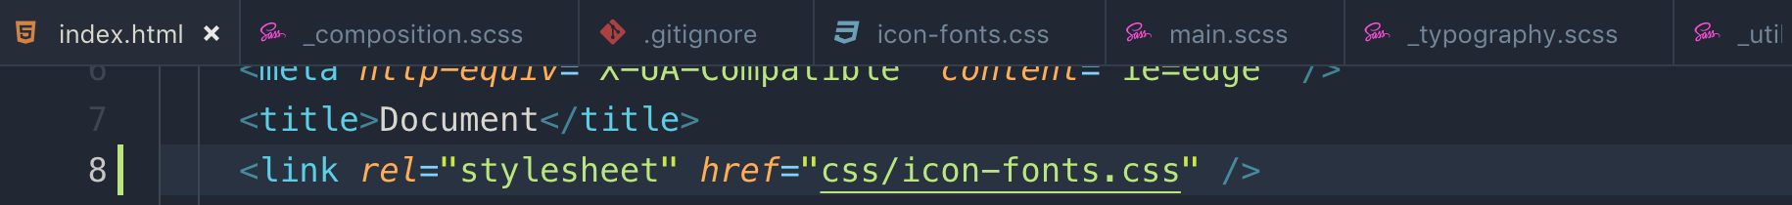

These different font formats because different browser reads different font format

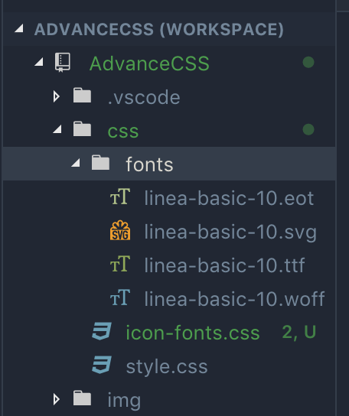

This is section feature. Background-image, skew/tilt of the section. The skew is not applying to the children as we have used direct-children selector which is **> \*** and it select all the direct children.

Main feature section skew the entire section including all the children so we reverted back all the children by direct-selector **> \***

**Sass/pages/_home.scss**

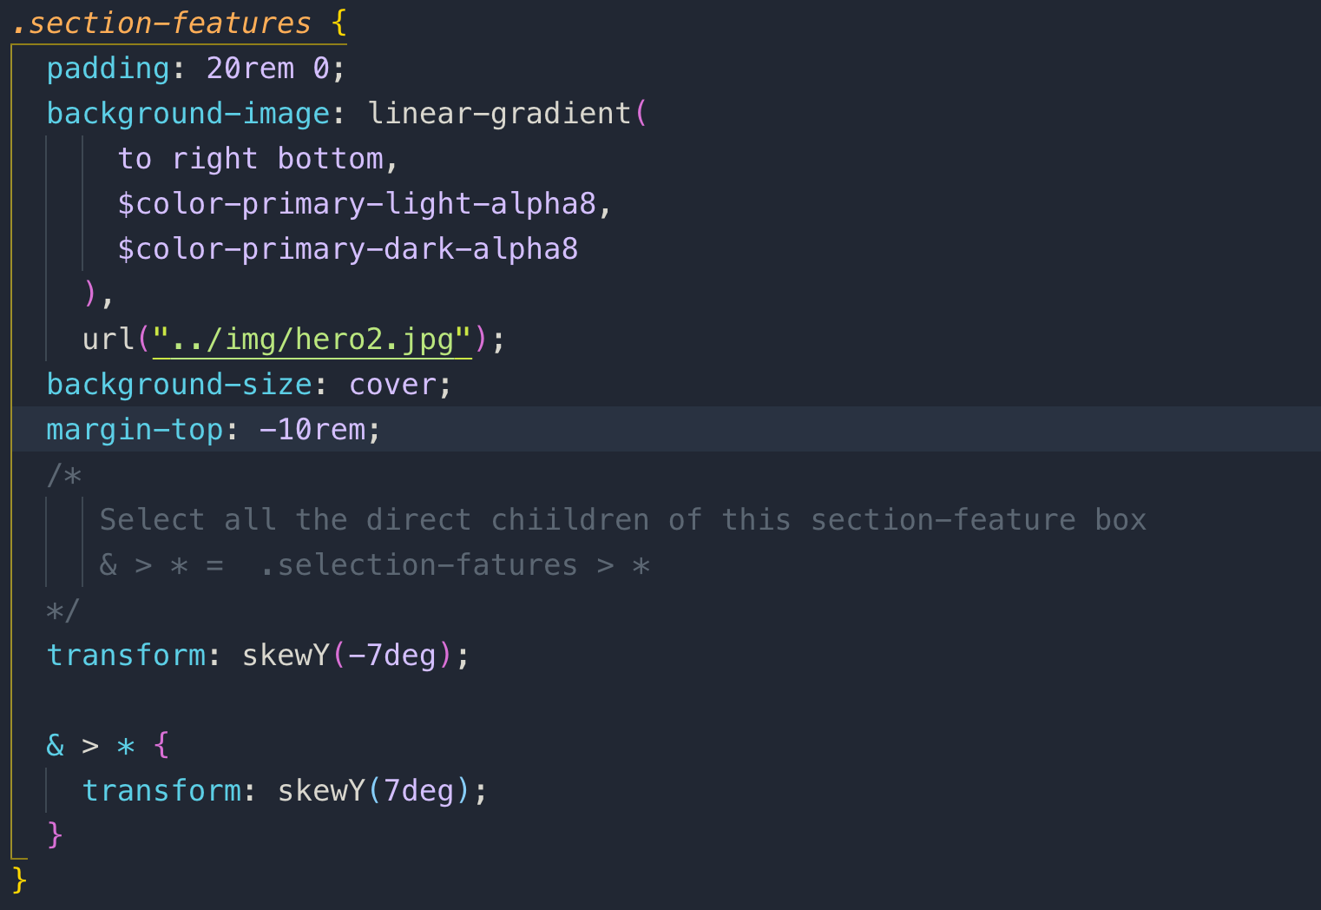

sass/components/_feature-box.scss

Now let’s see the styles for card which is called feature-box

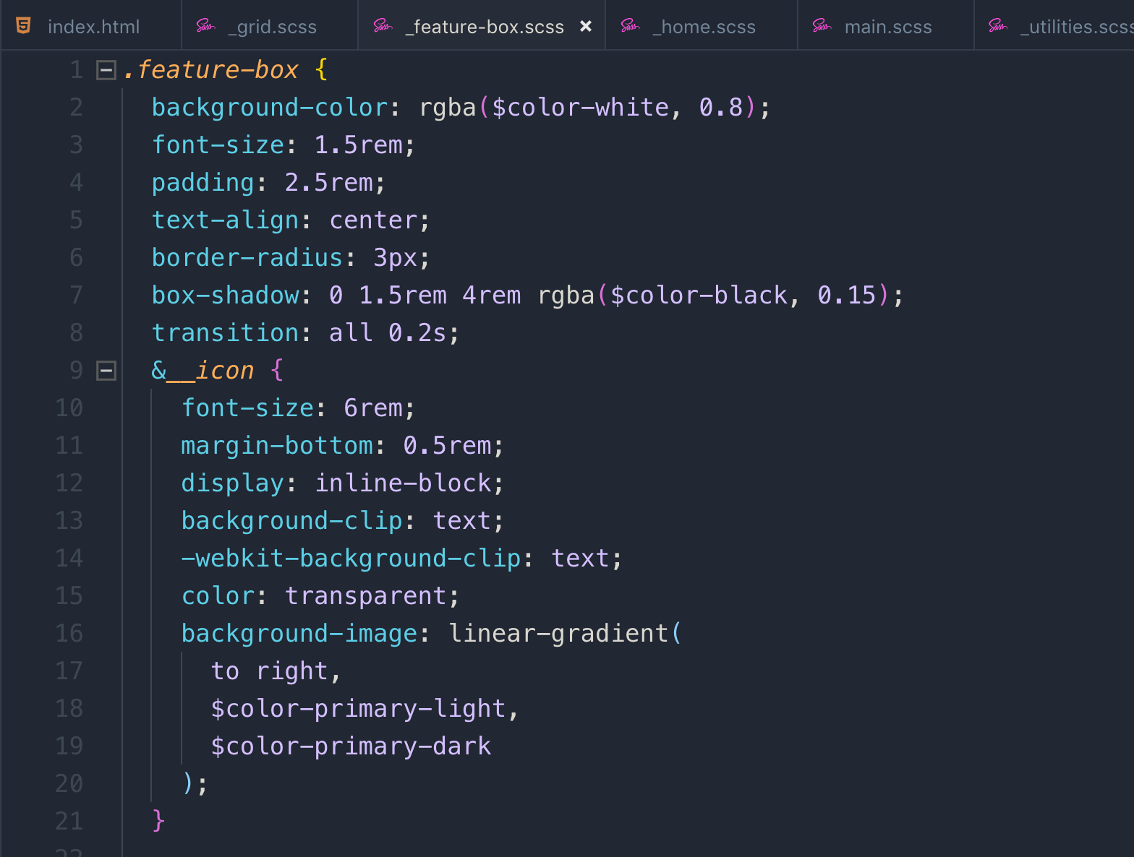

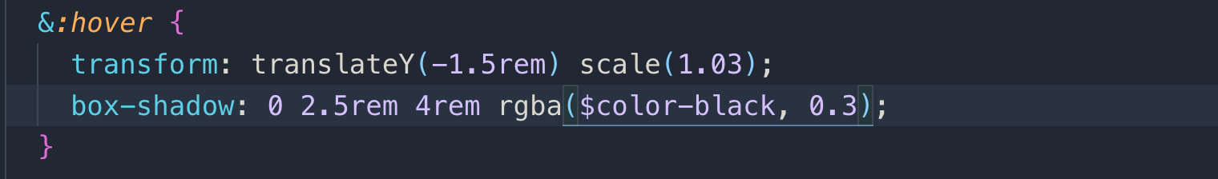

on hover, it scales and moves up

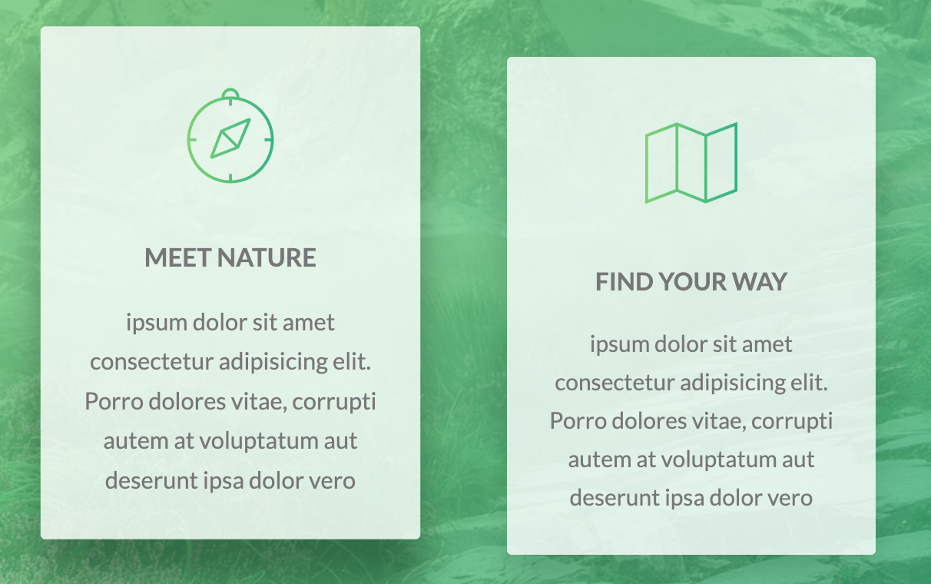

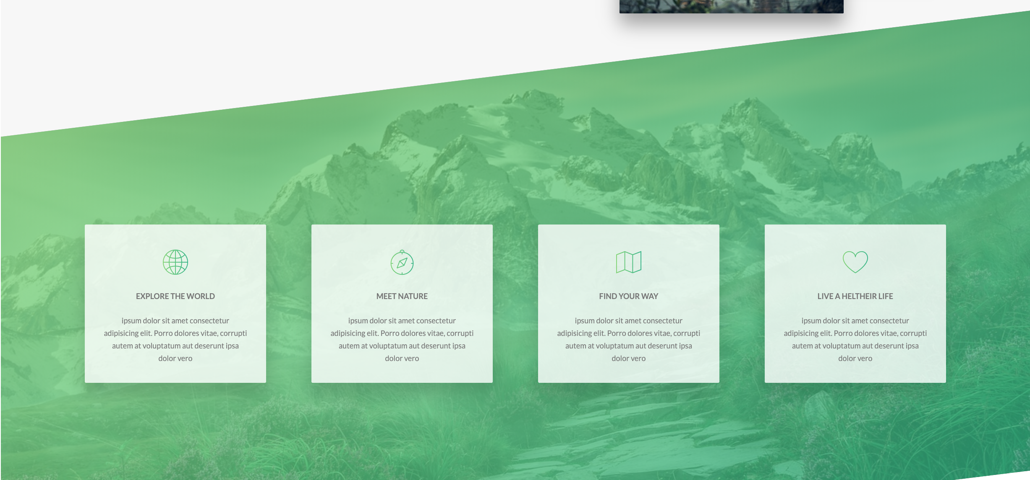

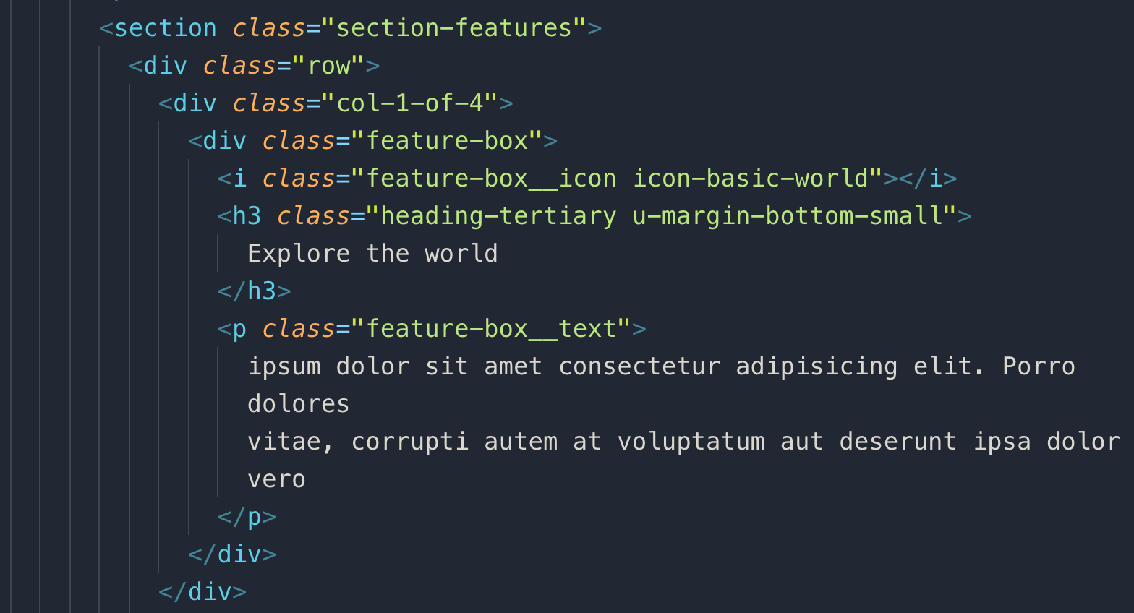

**039 Building the Tours Section - Part 1**

We are going to build this card section in the upcoming lesson

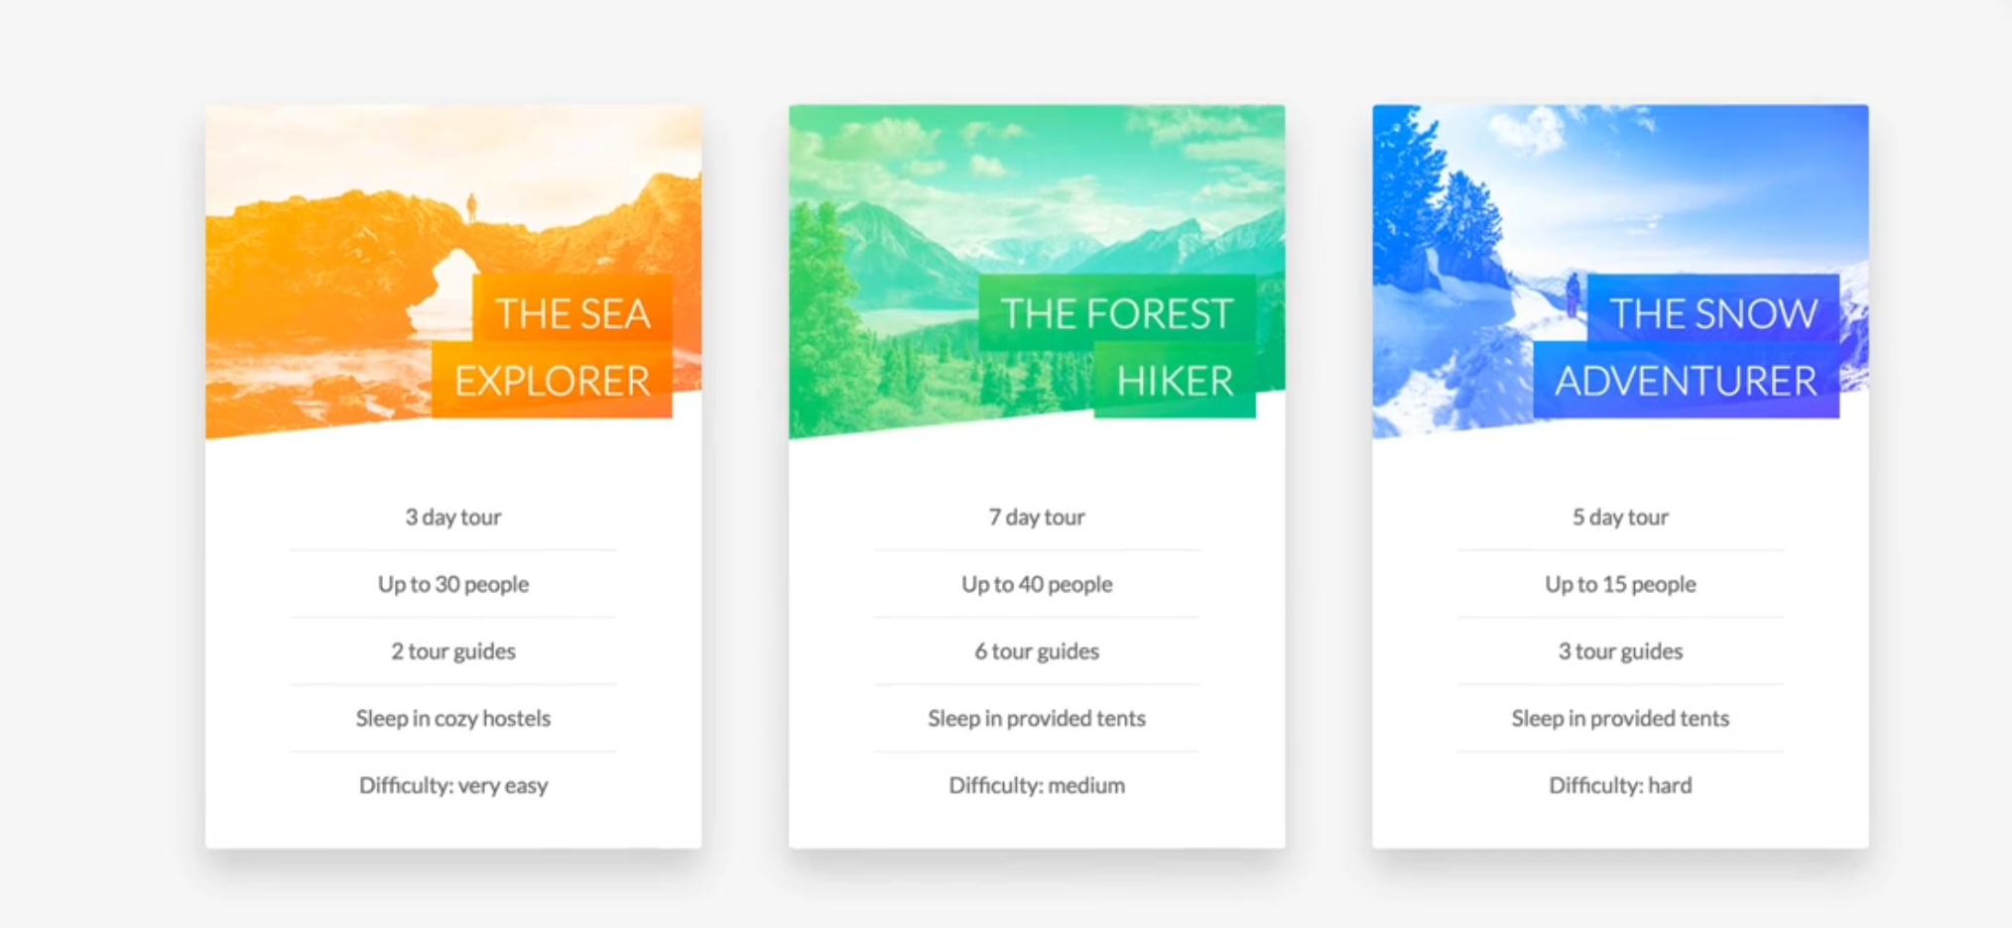

**Note:** X-axes direction in rotate is actually Y-axes direction that is why we will we rotate in Y direction.

So the idea is to create the above card rotation is to create 2 cards, front and back and overlap them each other and change their rotation on hover.

You need to used 2 more things beyond rotation and that is

Perspective and backface-visibility

The **backface***-***visibility**property defines whether or not the **back face** of an element should be visible

The **perspective CSS** property gives an element a 3D-space by affecting the distance between the Z plane and the user. To get the effect, we need to add perpective property to parent element.

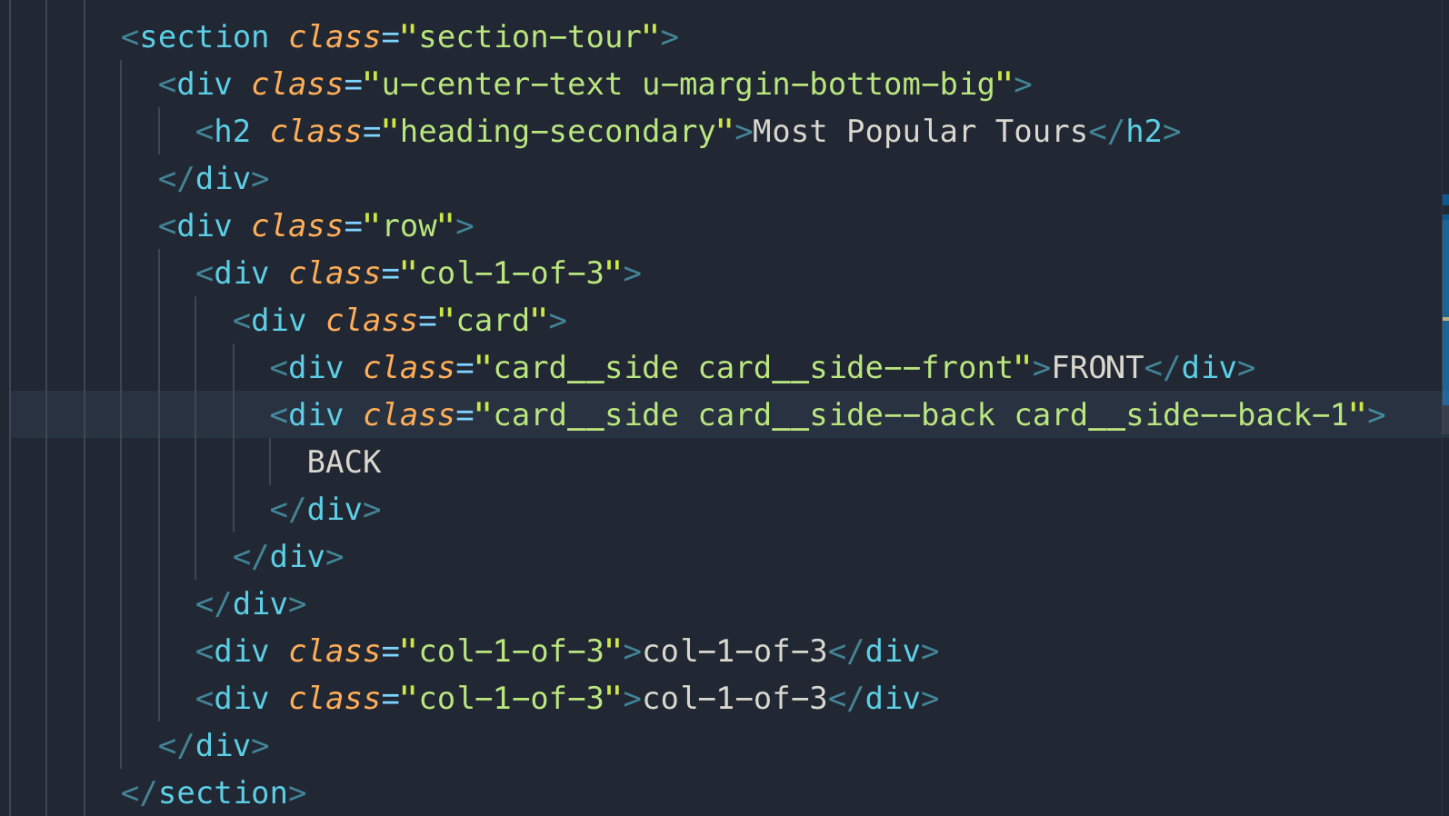

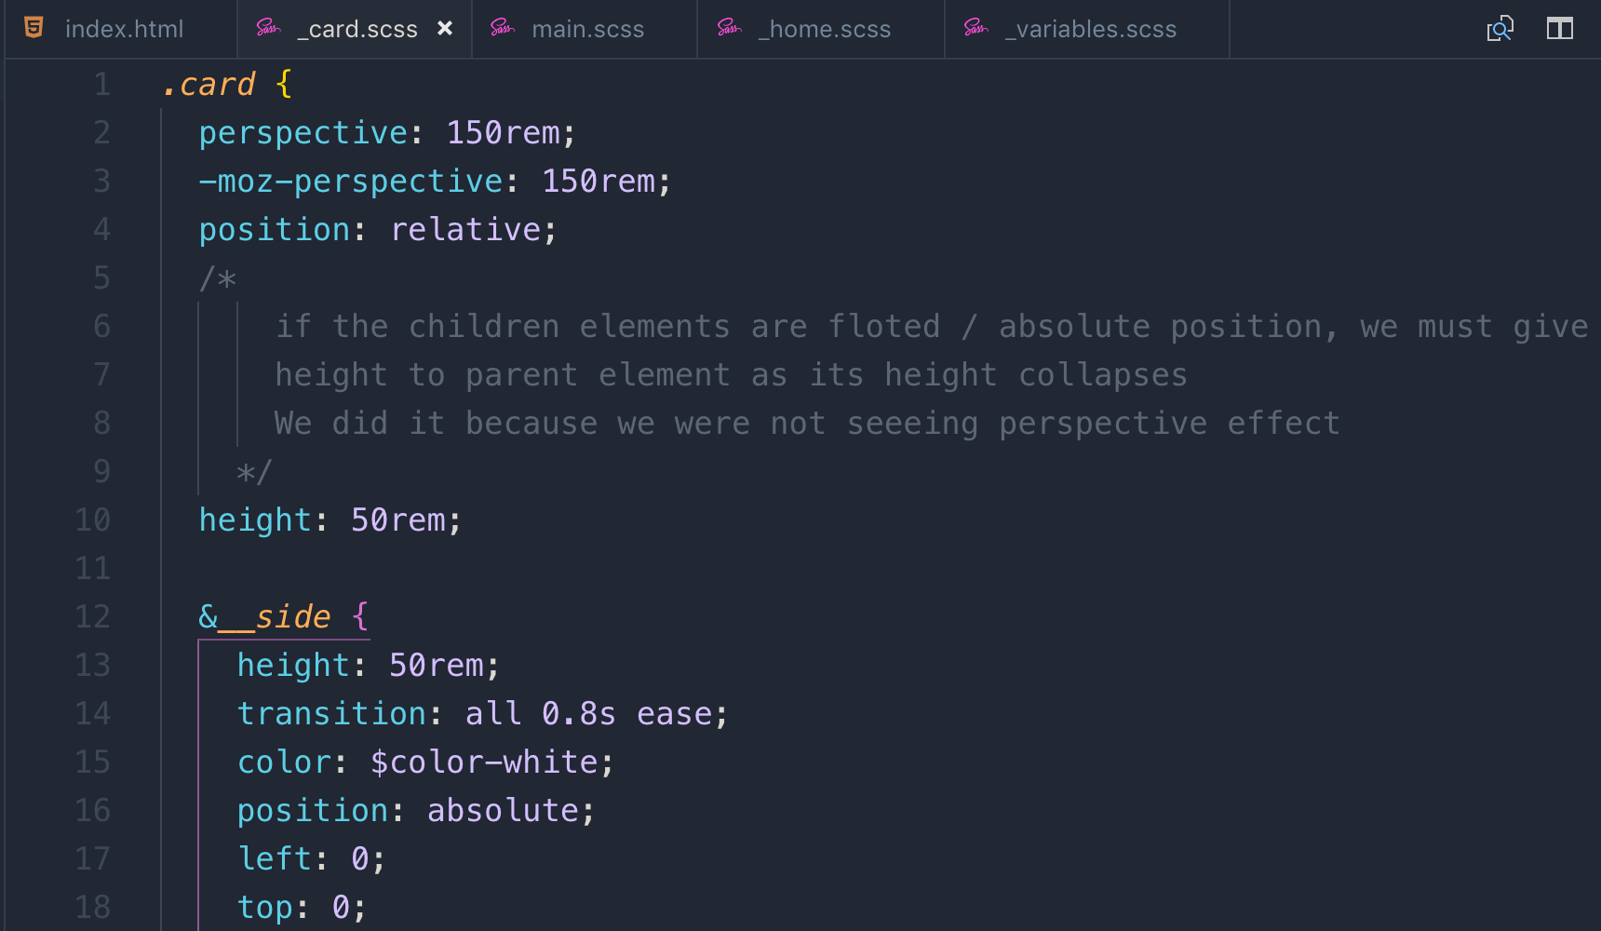

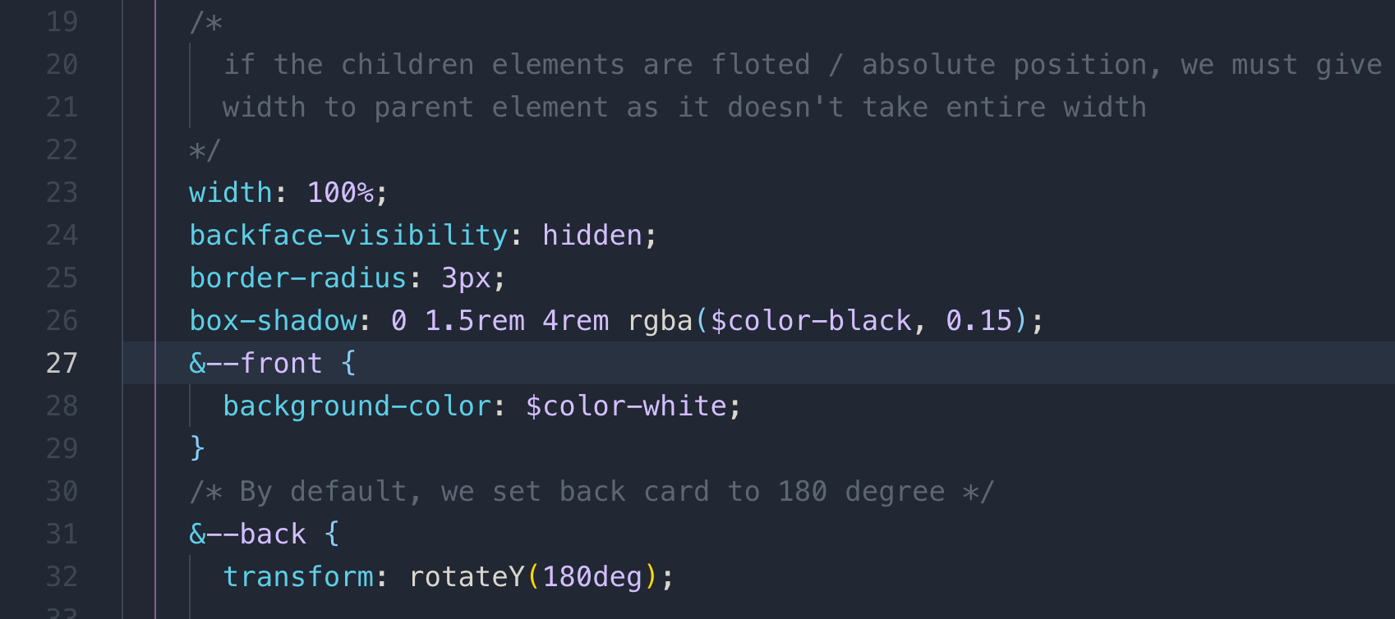

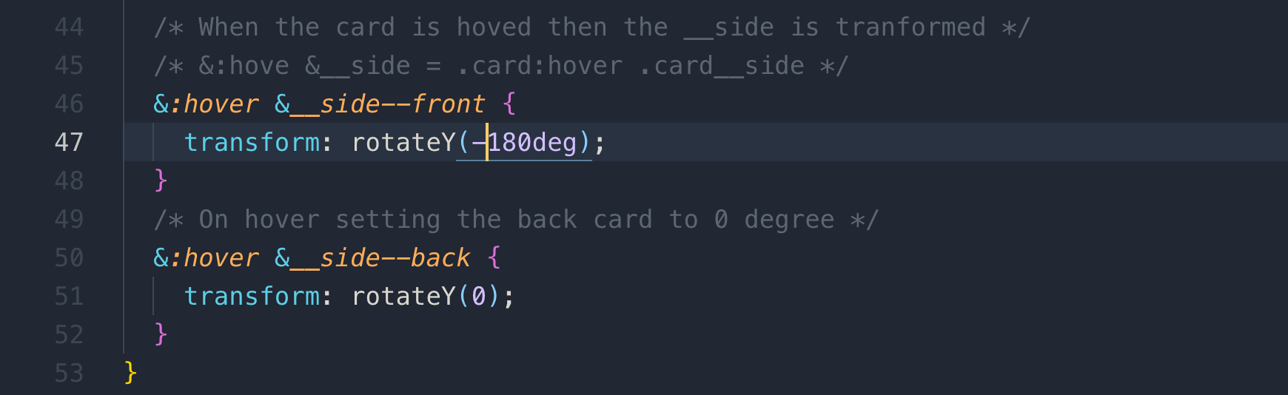

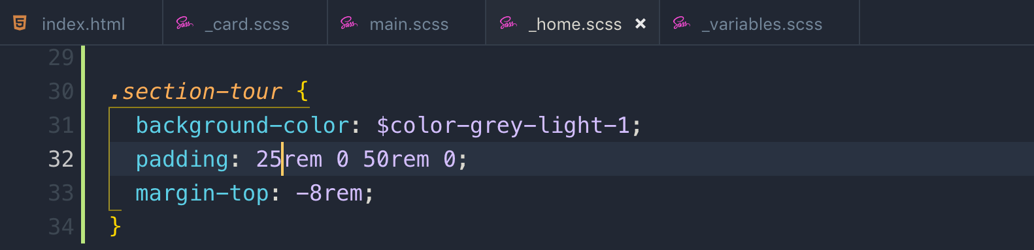

Note: in BEM methodology, we do not nest elements names. In the below example .card__picture is not dependent on the .card__side although it is inside it, but .card__picture is a stand-alone element.

.card__picture is a direct a element of .card__side **so** card__side__picture **is wrong!**

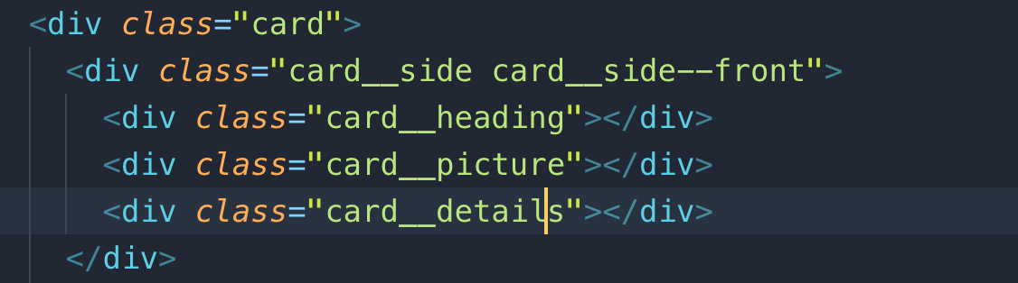

This time for picture we will use <img> with background image, just to show you background blend mode

background blend mode property: it is a brand-new CSS property which describes how the background images should blend. If we have multiple background images and we want to blend so for this e blend the image with linear gradient.

**Note:** it doesn’t work on IE.

**Note:** wherever you find heading, always use <h1> or <h2> and so on, but never use div as we used above for HTML semantics

In the blend background image if you want the text to be on top, you need to use “absolute positioning” for the text.

To break the text and adjust their paddings we have a new CSS property called

Box-decoration-break: in order for it to work, we need to create an element inside text element or in our case inside <h4>

The simplest way to center a block element inside a block element is to use

margin: 0 auto;

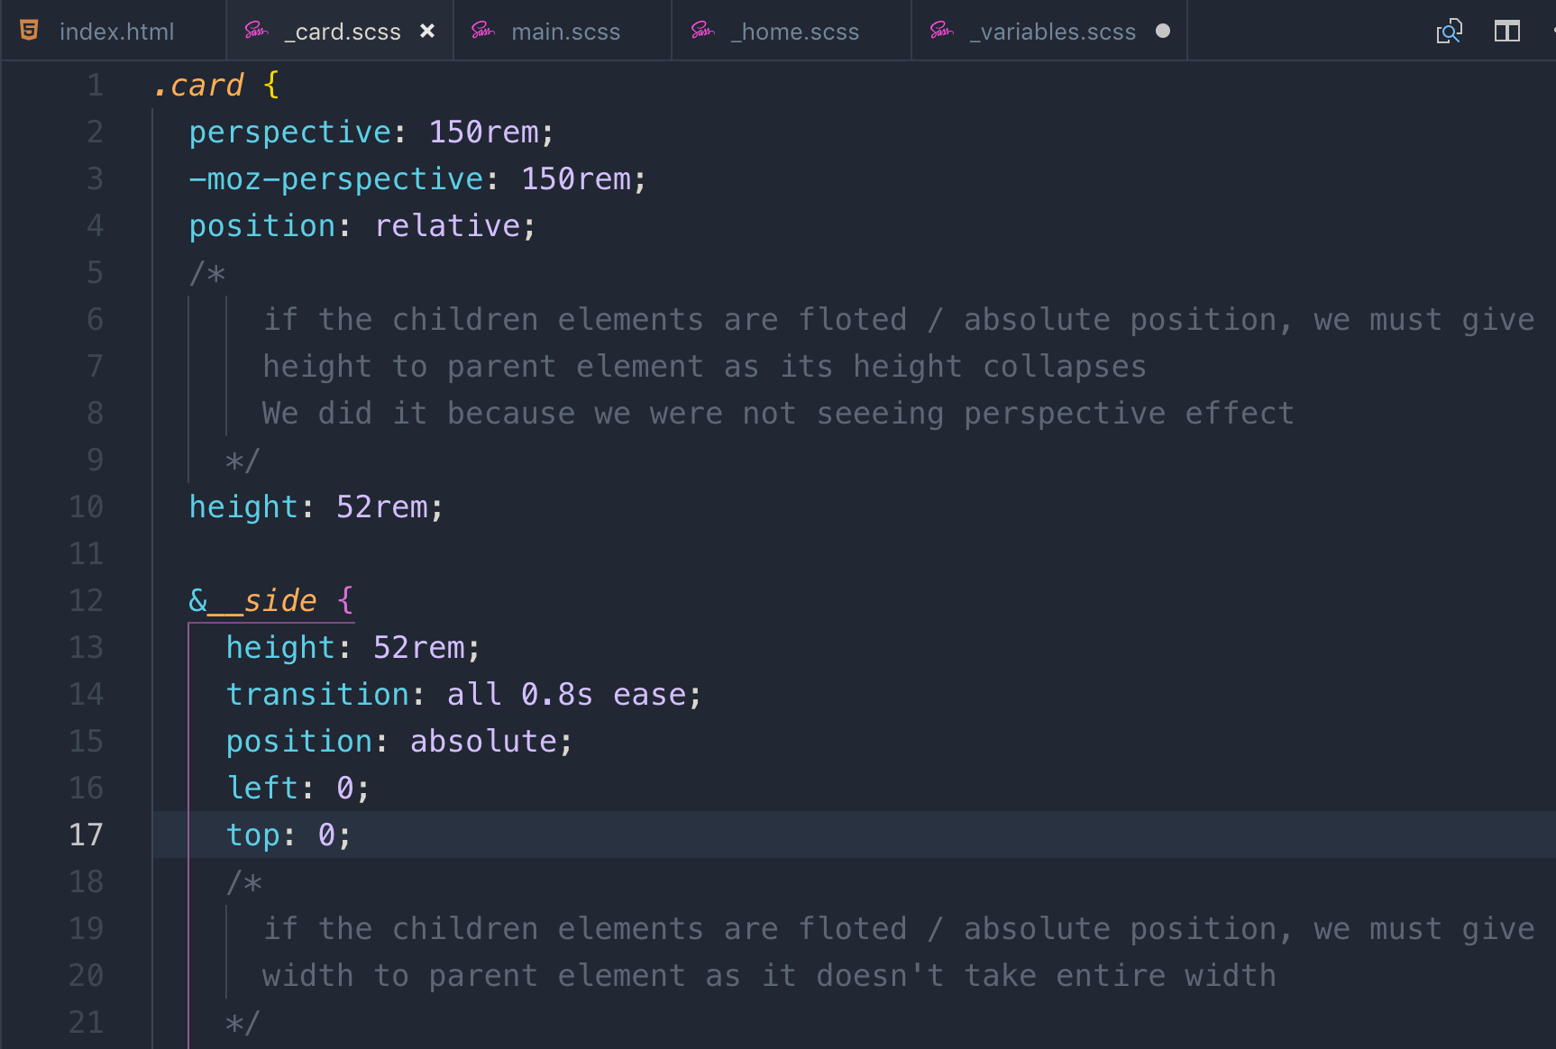

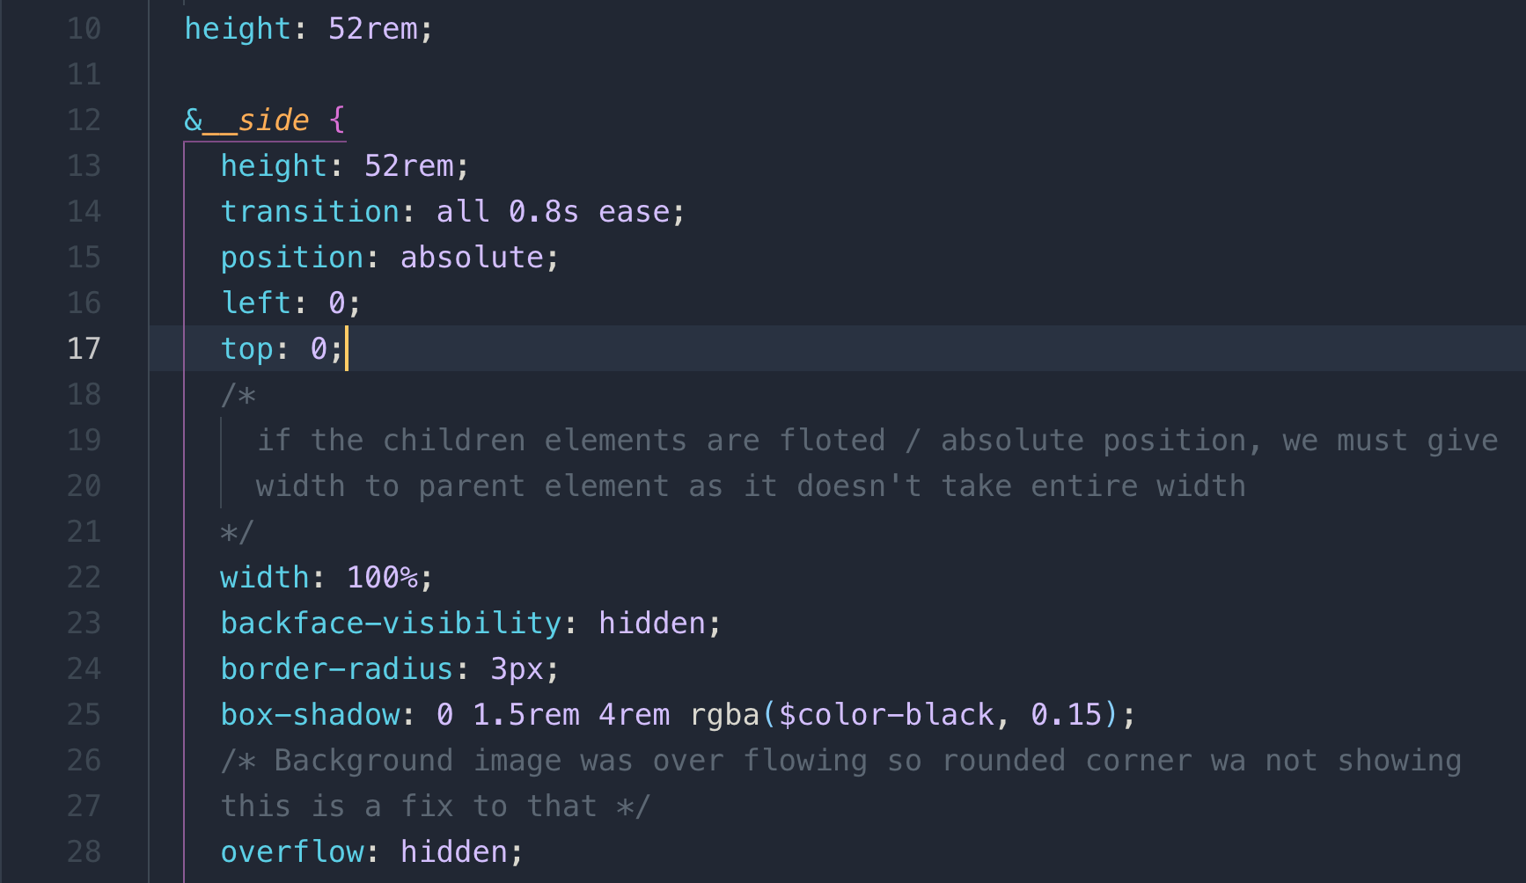

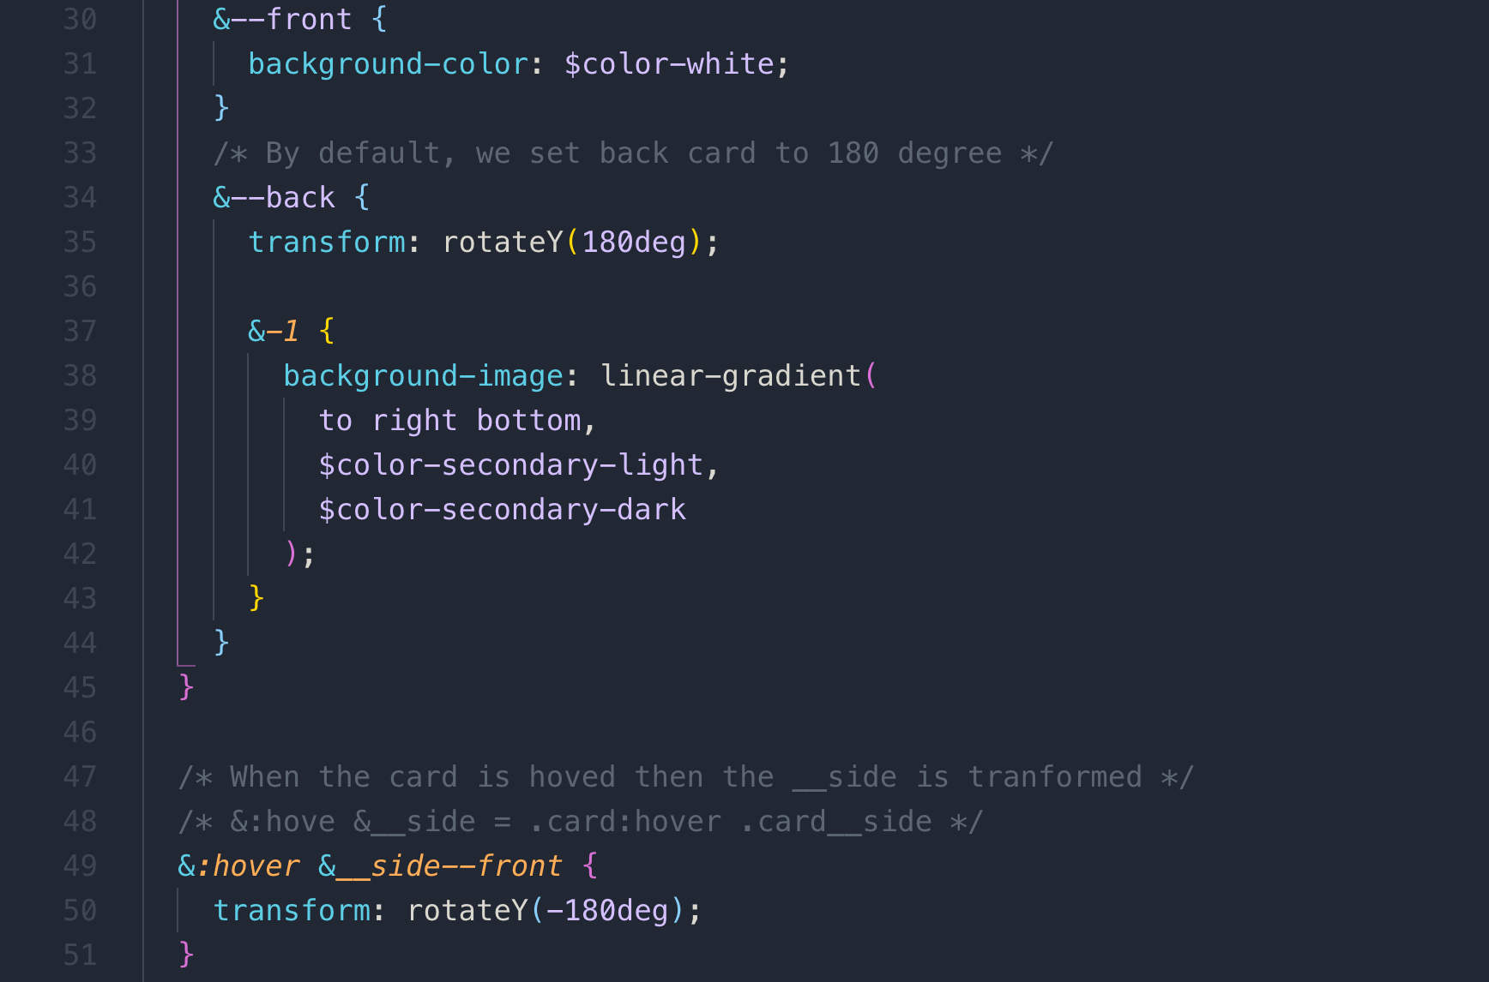

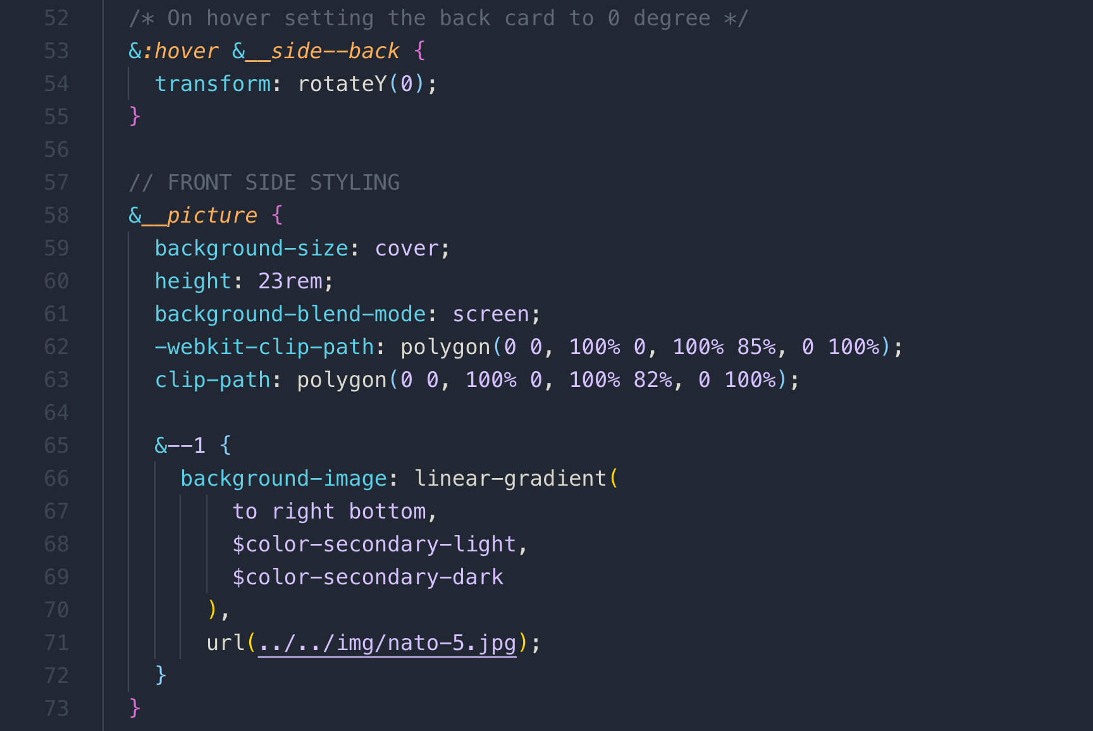

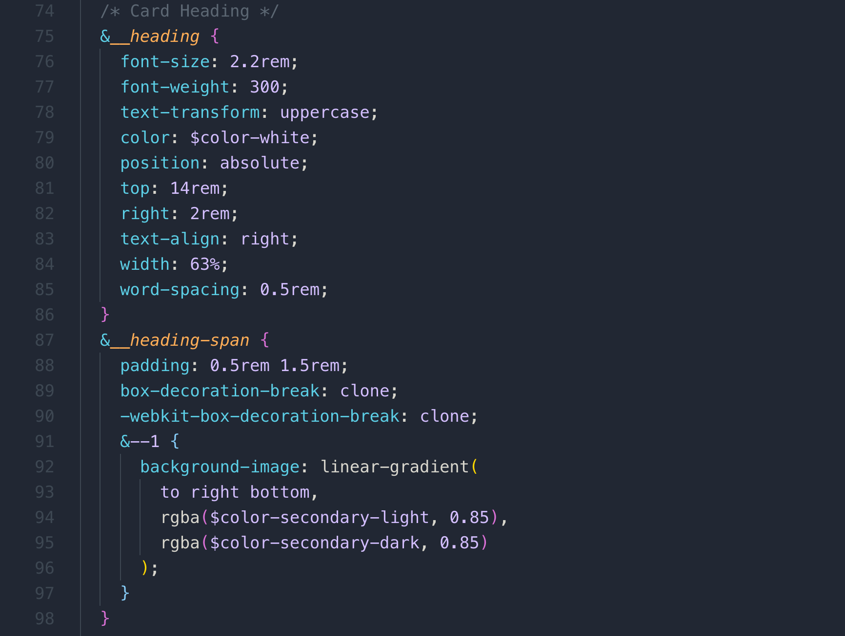

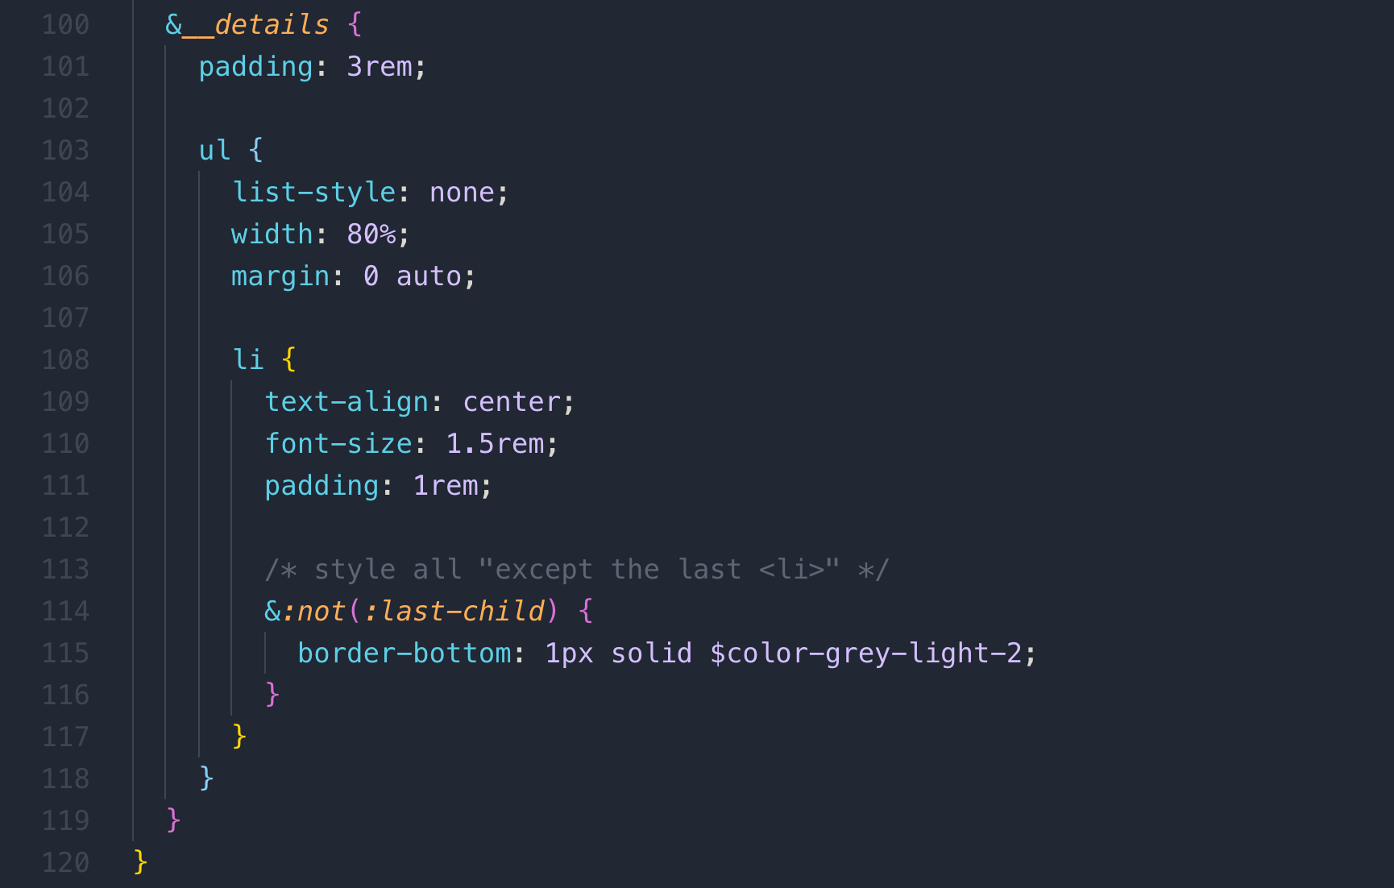

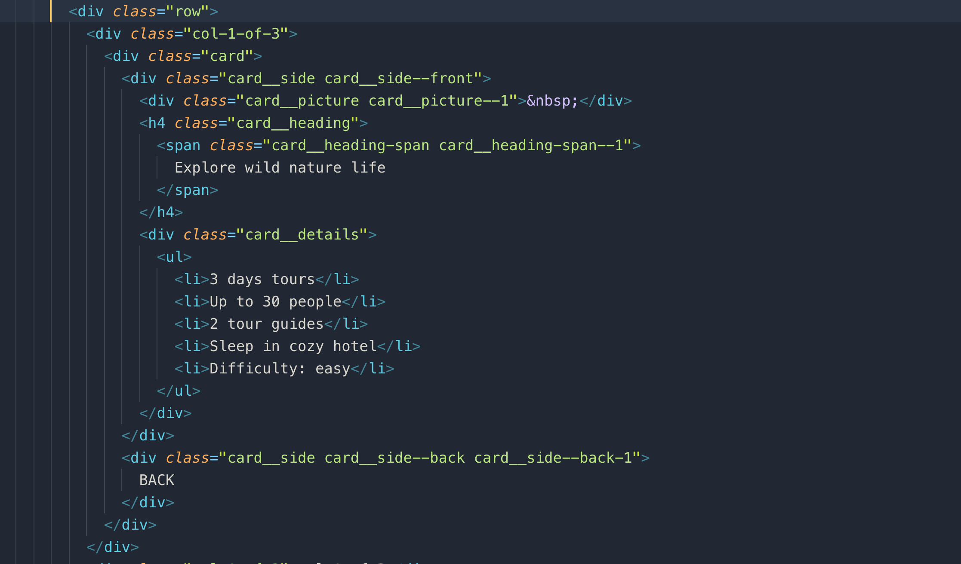

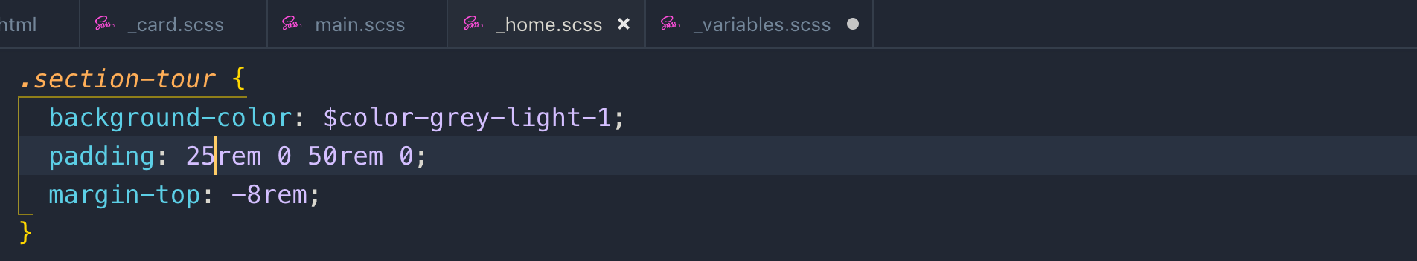

sometime overflow doesn’t work with clip-path property so border-radius doesn’t show so just add border-radius to the element where you are using clip-path property

**041 Building the Tours Section - Part 3**

**042 Building the Stories Section - Part 1**

This is what we are going to build in this section

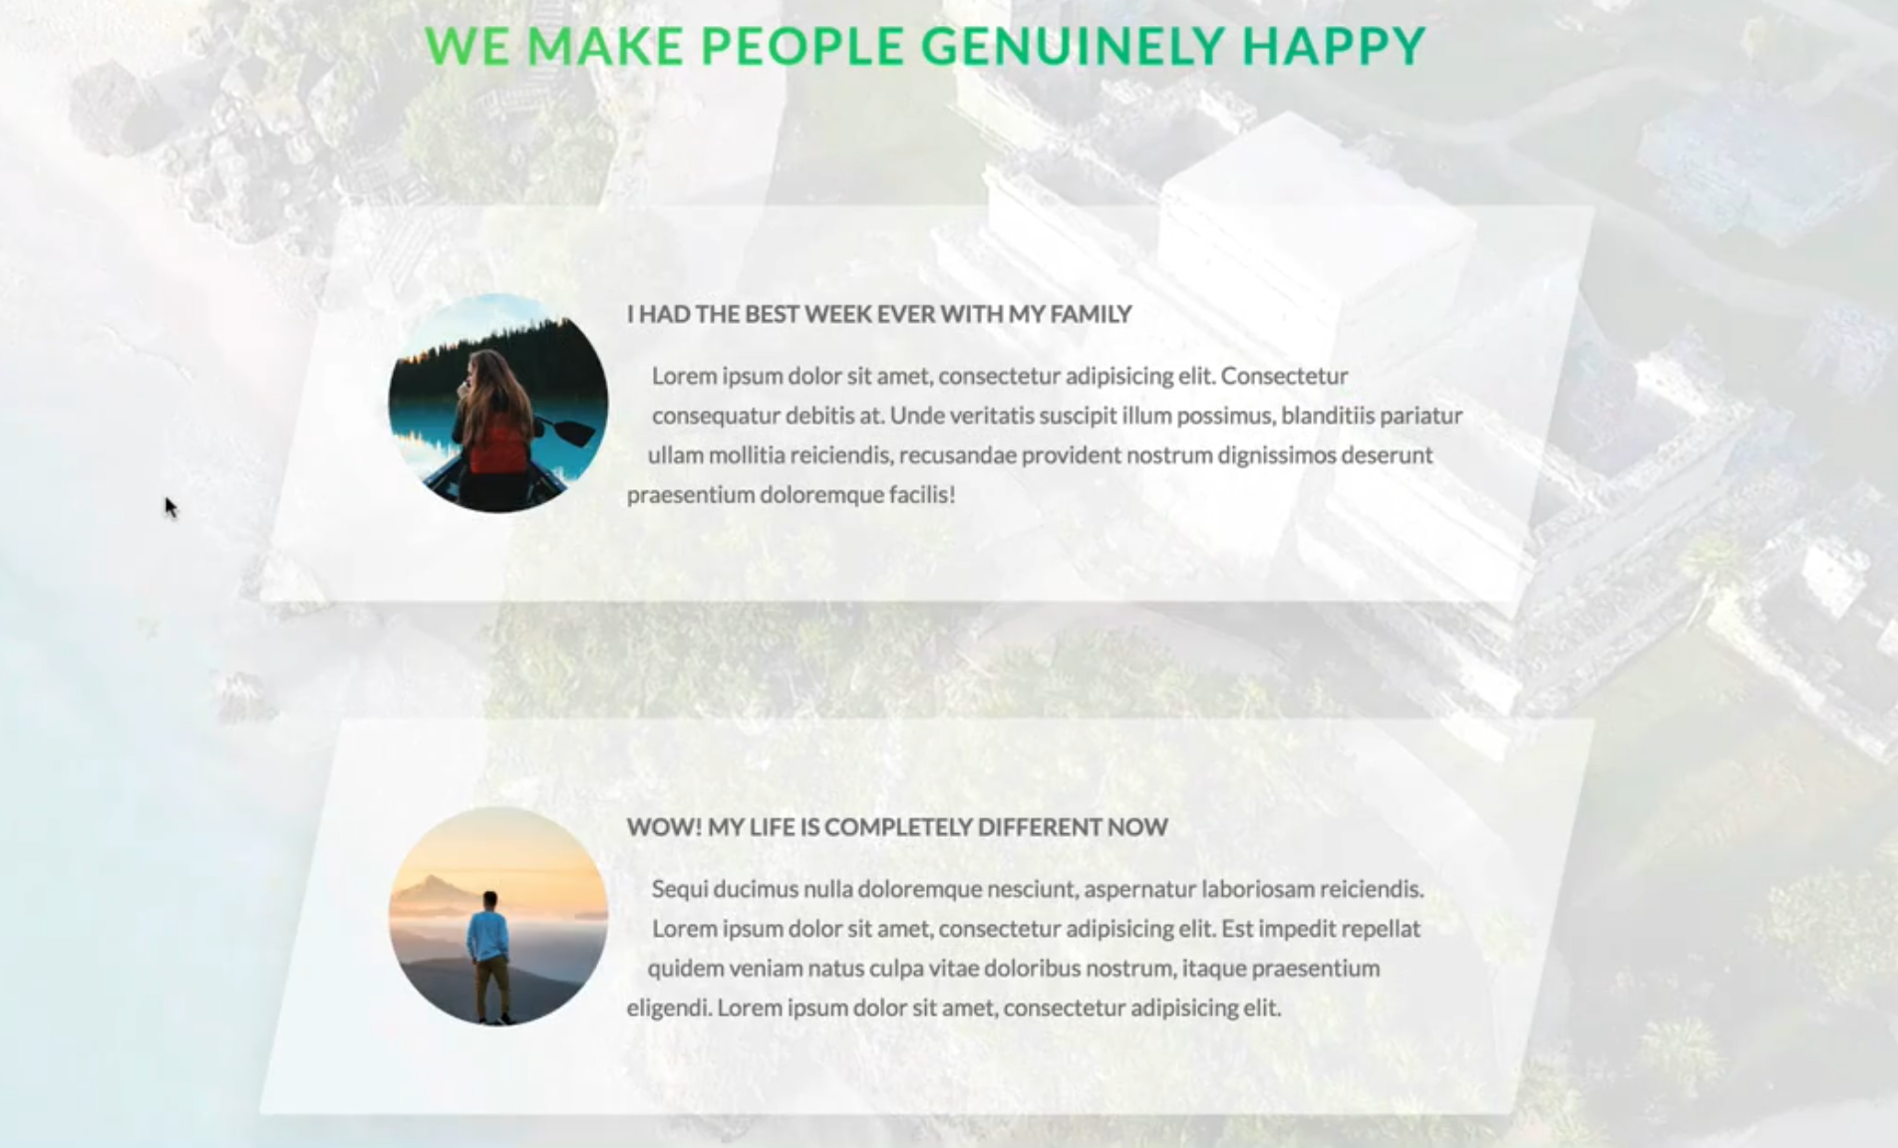

We us <figure> element for the design like above where we put text/caption right next to image.

<figure>: We use this tag where we use image with caption

## shape-outside: if we use circle(50%) this will be 50% of the height and width. For example width:15rem then radius will be 7.5 rem radius. In order this property to work, it has to be floated.

**Note:** Shape-outside works with clip-path

<https://www.youtube.com/watch?v=hIw7AmAPIQk>

**Note:** if you set 2 transforms properties on both parent and child then the child will take transform precedence.

# **043 Building the Stories Section - Part 2**

if something doesn’t work using transform or animation, or there is a glitch, you can use

backface-visibility: hidden to fix that issue. Most of the time it works.

A new CSS property

## Filter: it uses for decorating images like, blur, saturation, brightness, and making image darker and so on

# 044 Building the Stories Section - Part 3 – **Background video**

To find free background videos for website

<http://www.coverr.co/>

There are 2 video format which we have add

1. mp4
2. webm

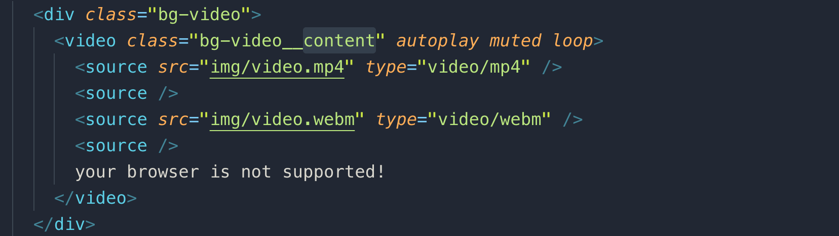

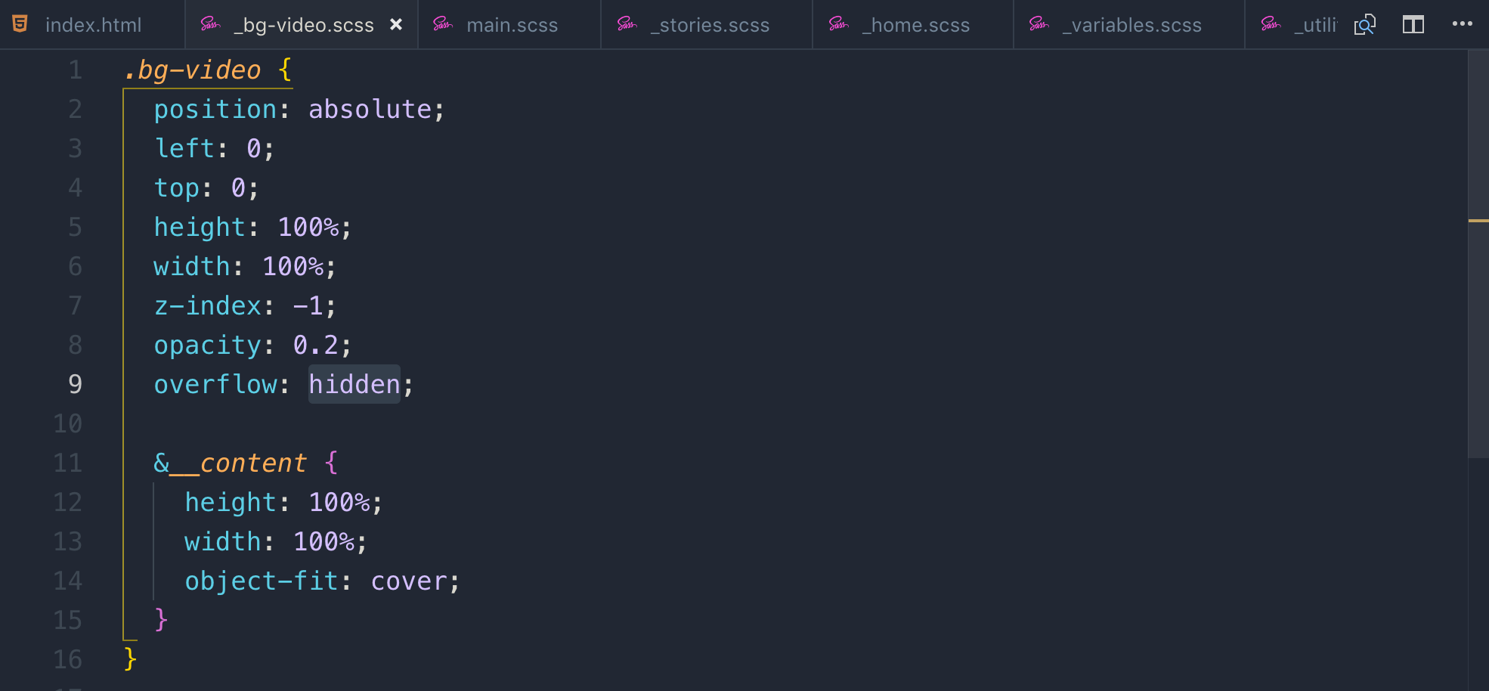

We used new CSS property called object-fit: cover

**045 Building the Booking Section - Part 1**

## These the things, that we are going to learn in this lesson

1. solid-color gradient
2. adjacent sibling selector
3. input-placeholder
4. how and when to use focus,
5. :invalid, placeholder-shown, and :checked pseudo classes.
6. Custom radio button



form label is connected to the id on the input box and when we click on the label the connected input box focus

Here us the code for base design

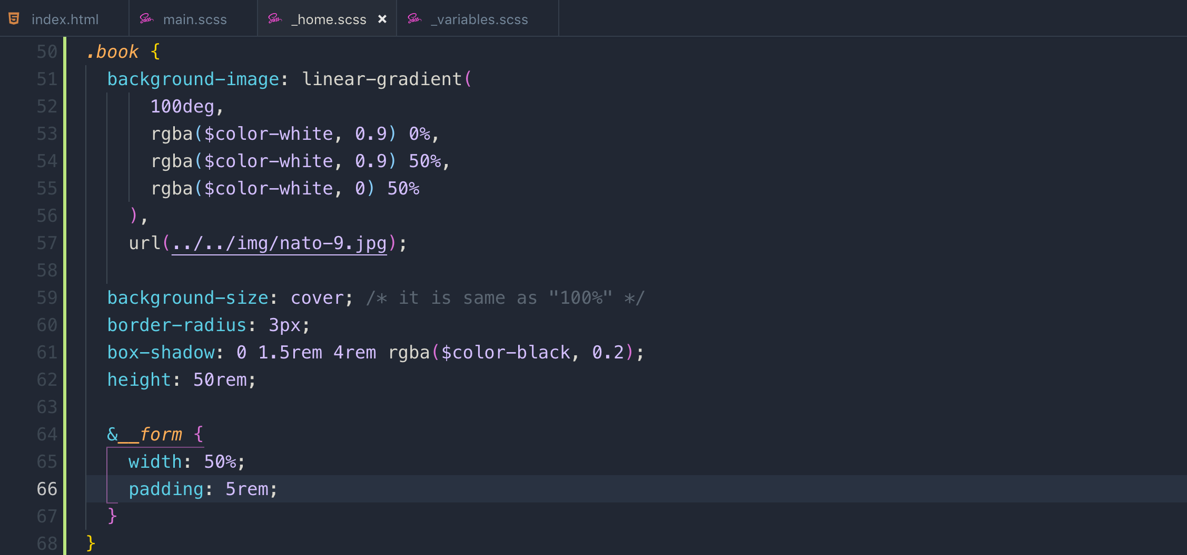

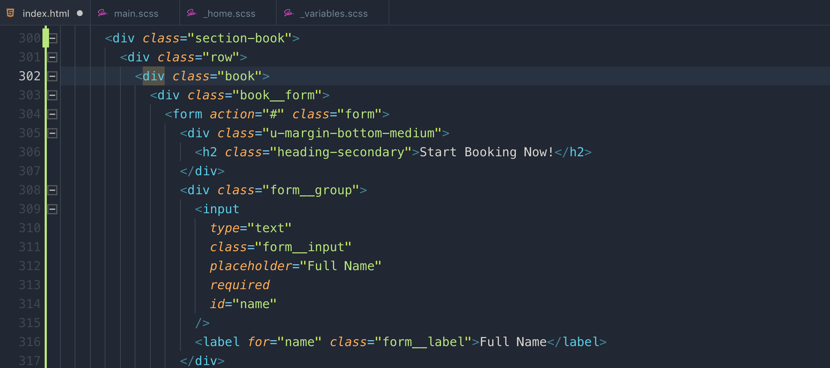

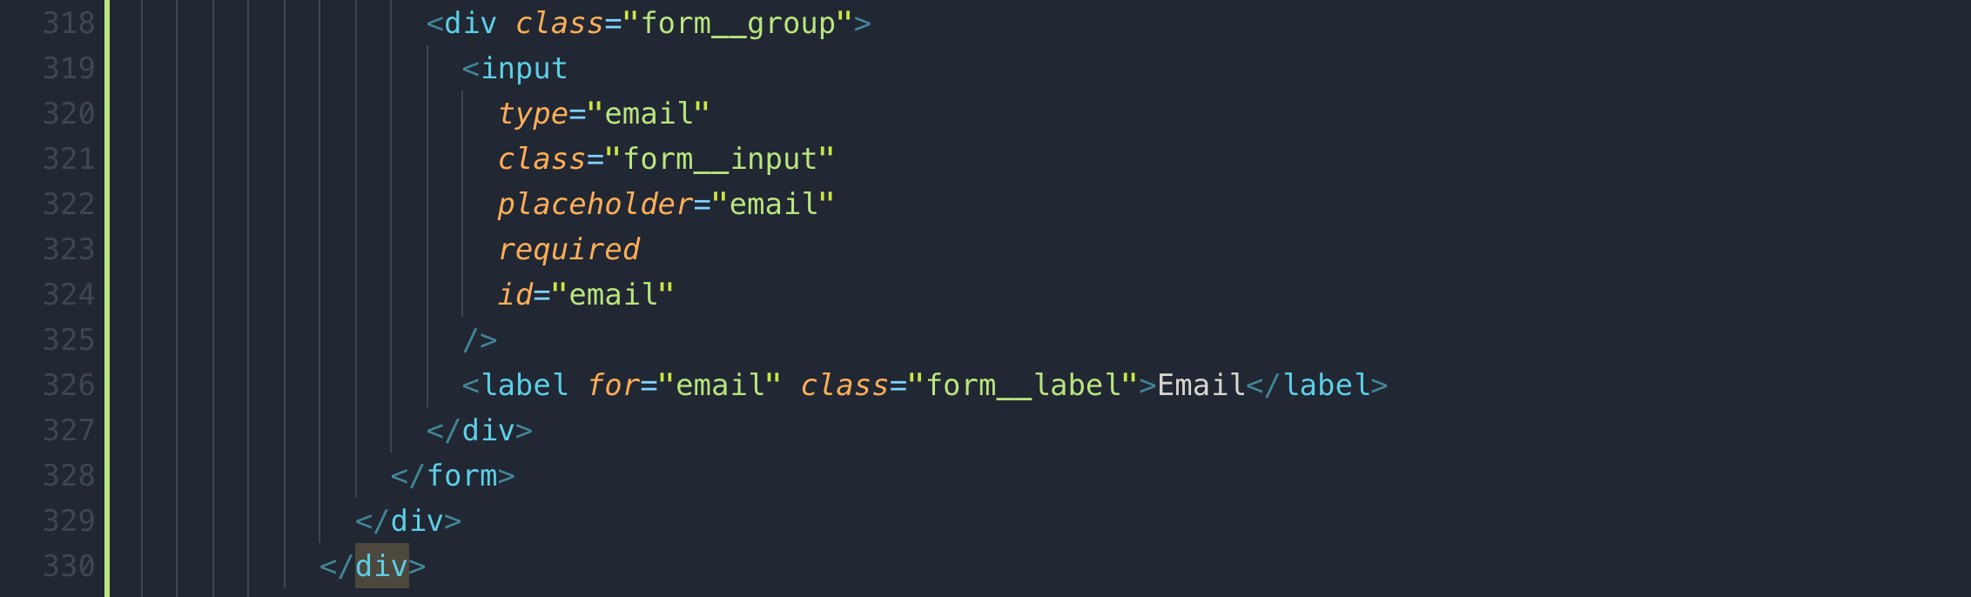

**046 Building the Booking Section - Part 2**

by default, font properties like font-family, color, size do not inherit for form input elements. You have to inherit it manually.

By default, browser adds a class to input element if it is valid or not

The **::placeholder** [CSS](https://developer.mozilla.org/en-US/docs/Web/CSS) [pseudo-element](https://developer.mozilla.org/en-US/docs/Web/CSS/Pseudo-elements) represents the [placeholder text](https://developer.mozilla.org/en-US/docs/Web/HTML/Forms_in_HTML#The_placeholder_attribute) of a [form](https://developer.mozilla.org/en-US/docs/Learn/HTML/Forms) element.

The **:invalid** [CSS](https://developer.mozilla.org/en-US/docs/Web/CSS) [pseudo-class](https://developer.mozilla.org/en-US/docs/Web/CSS/Pseudo-classes) represents any [<input>](https://developer.mozilla.org/en-US/docs/Web/HTML/Element/input) or other [<form>](https://developer.mozilla.org/en-US/docs/Web/HTML/Element/form) element whose contents fail to [validate](https://developer.mozilla.org/en-US/docs/Web/Guide/HTML/HTML5/Constraint_validation).

**+** sign is the sibling / adjacent selector in CSS. The very next sibling

**~** sign is the sibling / adjacent selector in CSS. It will select the next sibling whether there are other elements before the sibling

This is the styling for form input text elements.

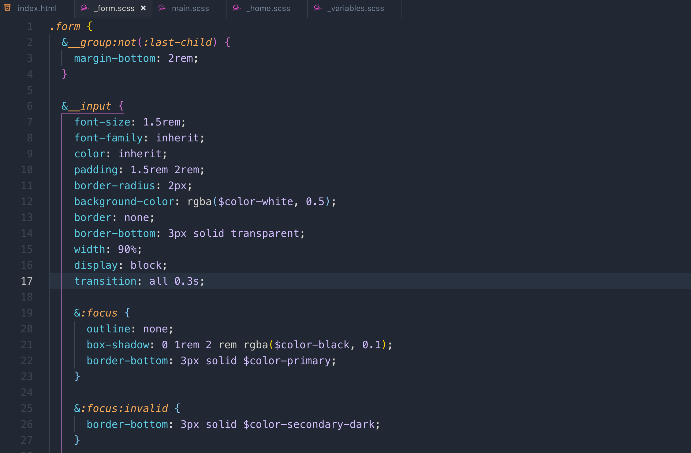

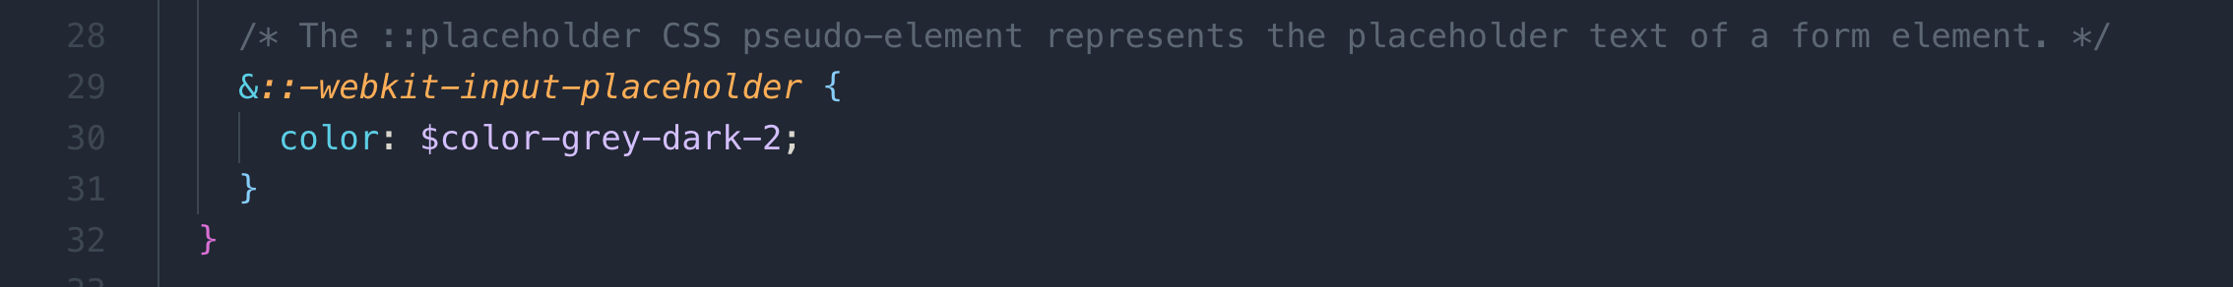

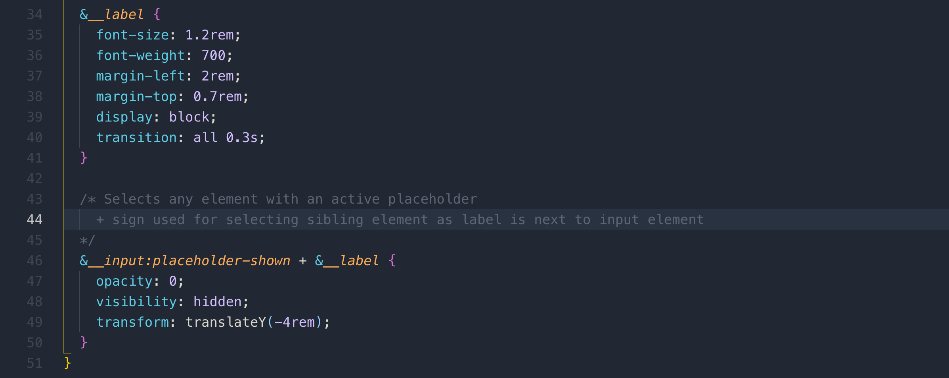

**047 Building the Booking Section - Part 3**

**Note:** in CSS, we have no way of styling radio-buttons.

The trick to make custom radio button is to add a <sapn> tag inside the <label> and display it as radio button in your own style. Off course we need to hide the original radio-button, but as we have connected the original radio button with label, as soon as we click on the label, it will select the original button and this is the trick.

In form, don’t use anchor tag, use button as form understand it that it is a submit button.

Sometime transition issue comes with the sizing and top and left position so if backface-visibility is not working alone, try this with that.

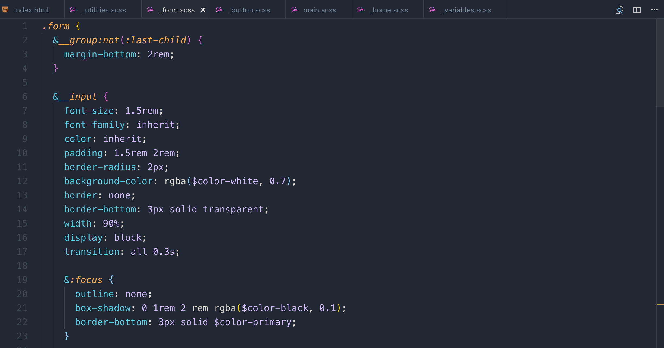

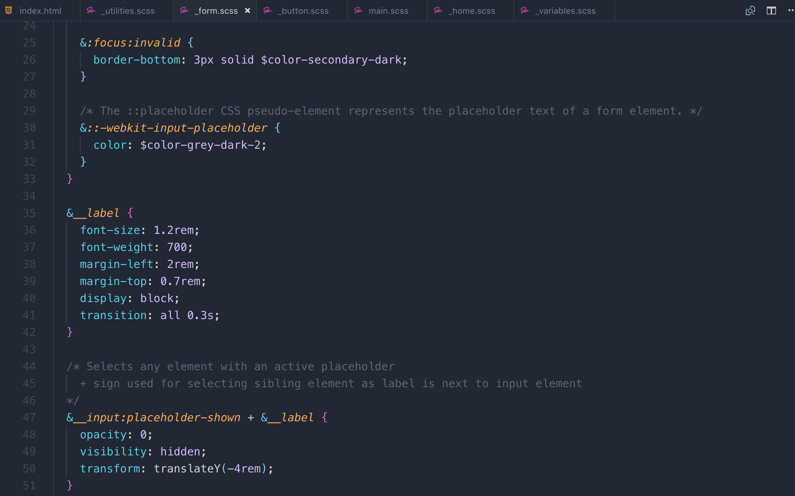

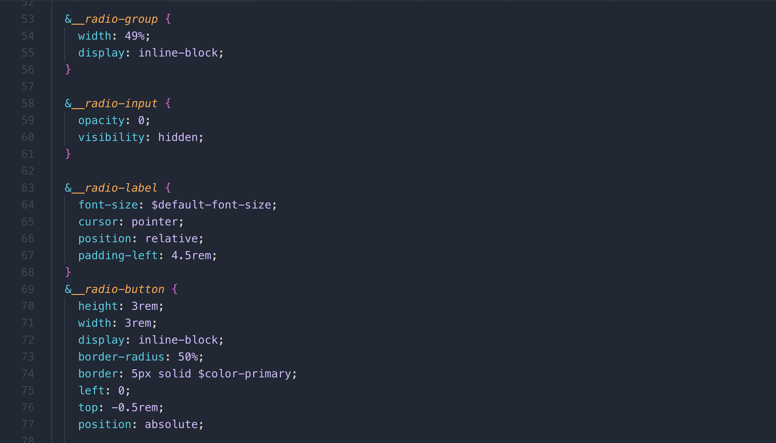

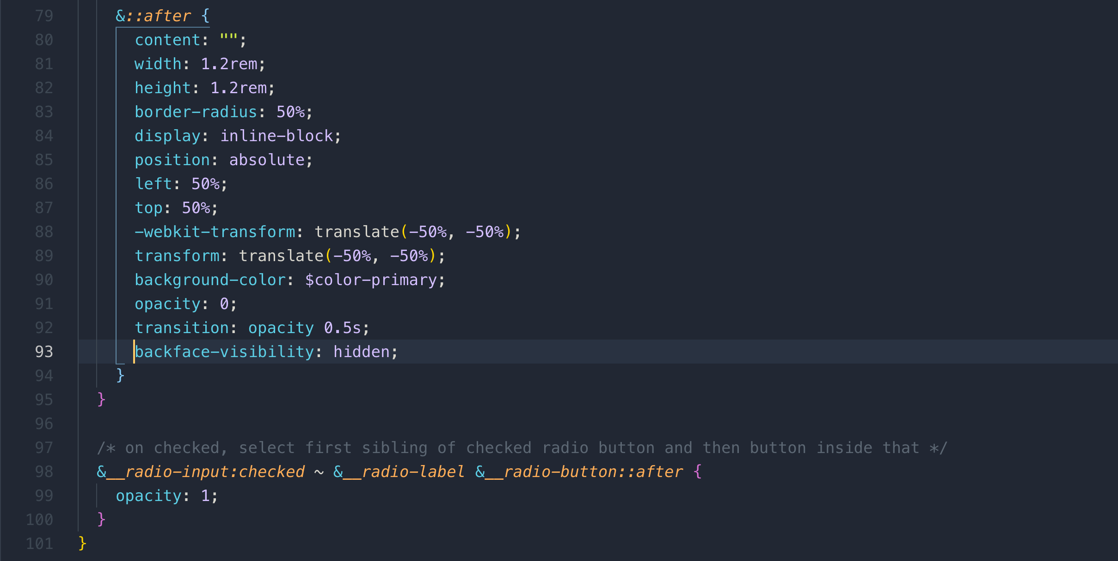

**049 Building the Navigation - Part 1**

This is what we are going to learn in this lecture

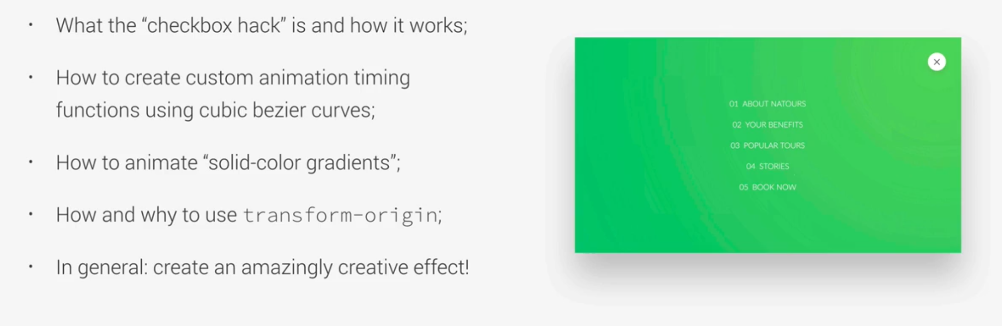

position: fix => it also takes the element out of the flow and allows us to specify it in relation to a positioned element.

Linear-gradient: it goes from one side to the other one.

Radial-gradient: it goes from center of the element in all directions.

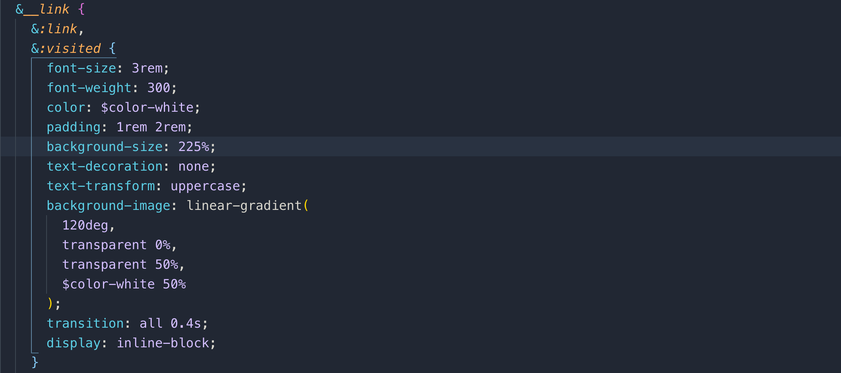

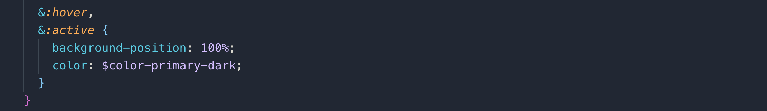

**050 Building the Navigation - Part 2**

<https://easings.net/>

<http://cubic-bezier.com/#.17,.67,.83,.67>

We used checkbox trick to open and close the navigation. If checkbox is checked, scale the background to 80 times and nav to opacity 1

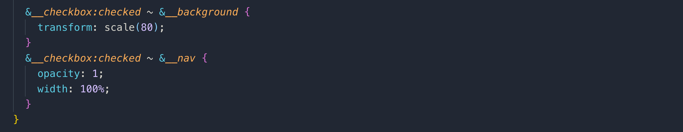

**051 Building the Navigation - Part 3**

We used one <span> element and used pseudo ::before and :: after elements to design the three lines navigation icons.



transform-origin: it describes where the transformation happens.

Left, right or center

/* + is an adjacent sibling */

&*__checkbox:checked* + &*__button* &*__icon* {

background-color: transparent;

}

&*__checkbox:checked* + &*__button* &*__icon::before* {

transform: rotate(135deg);

top: 0;

}

&*__checkbox:checked* + &*__button* &*__icon::after* {

transform: rotate(-135deg);

top: 0;

}

**052 Building a Pure CSS Popup - Part 1**

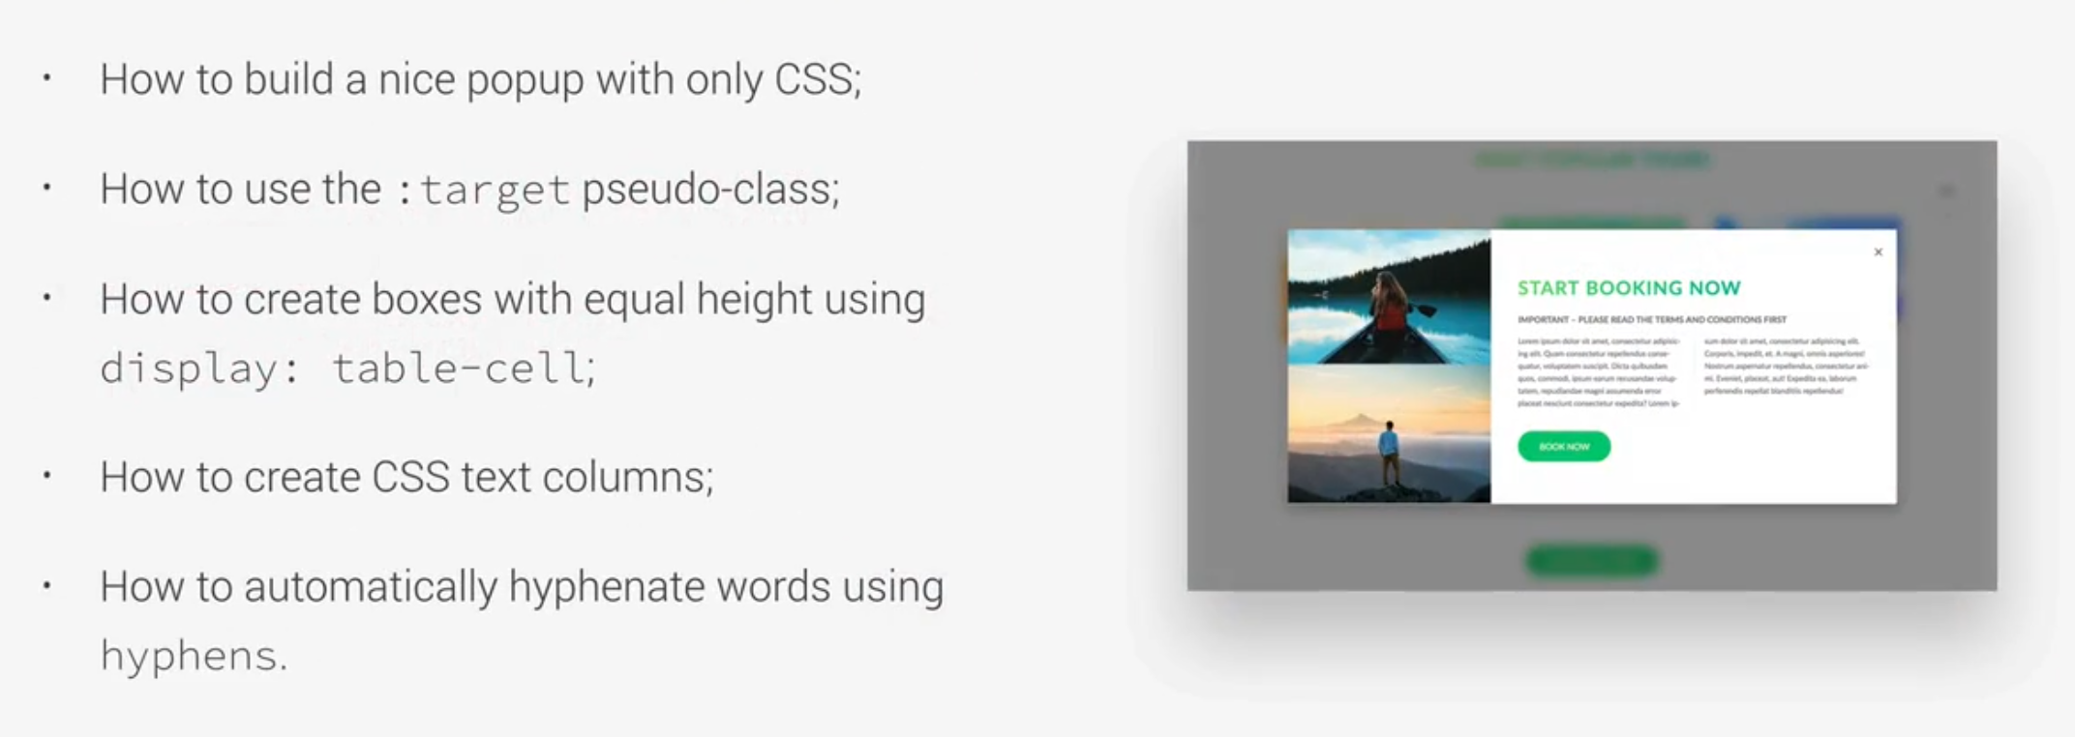

Instead of using float, we used table and table-cell. We also used column-count and column-gap.

We also used hyphen:auto which adds hyphen to text automatically.

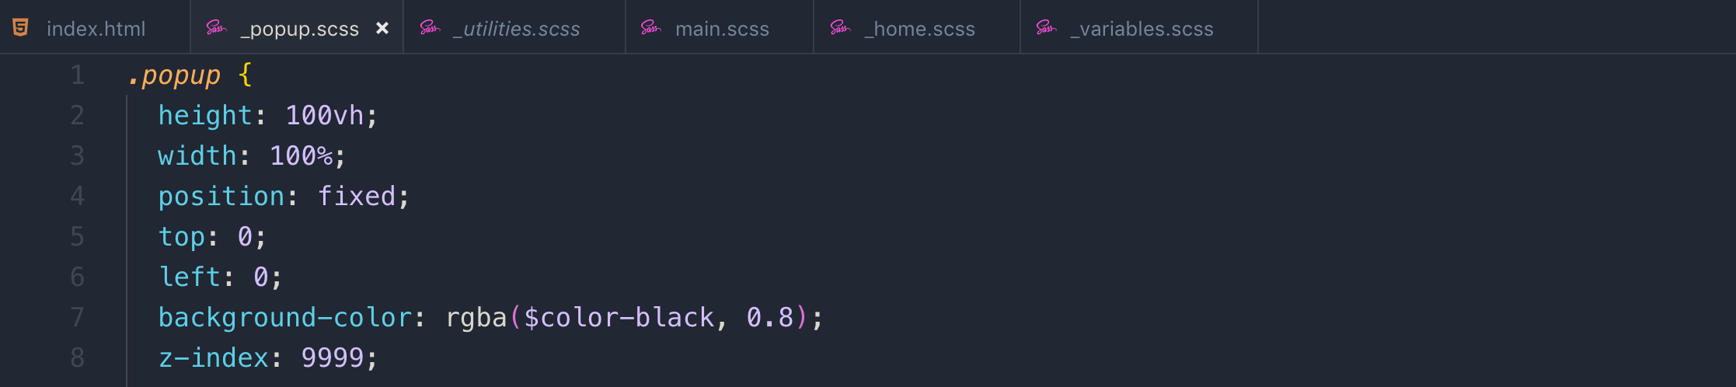

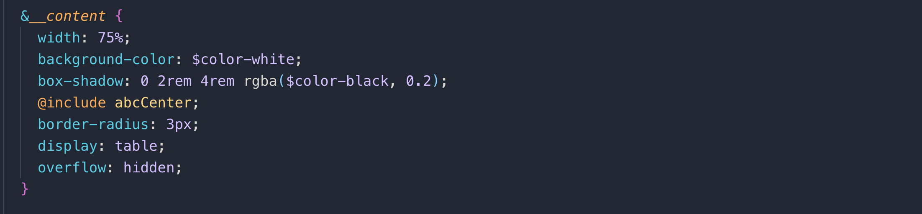

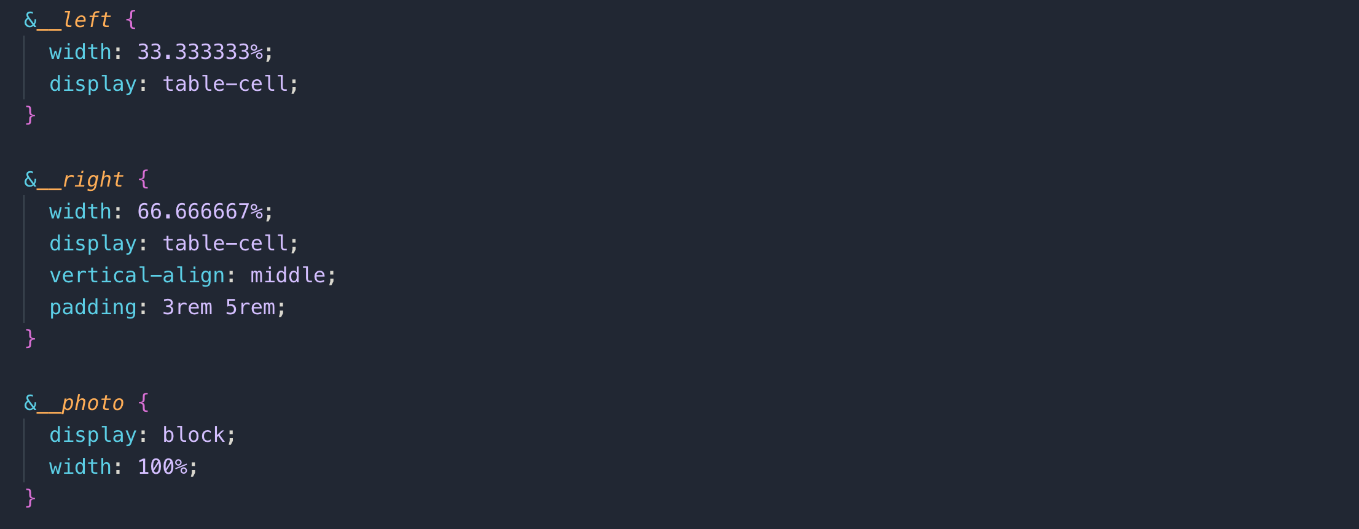

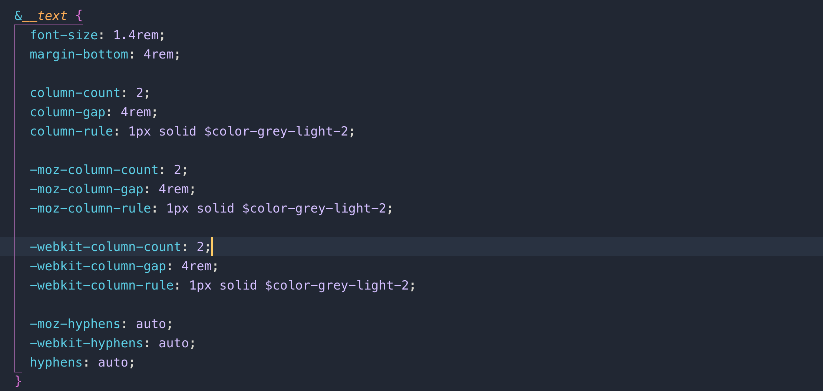

This is the pop-up code

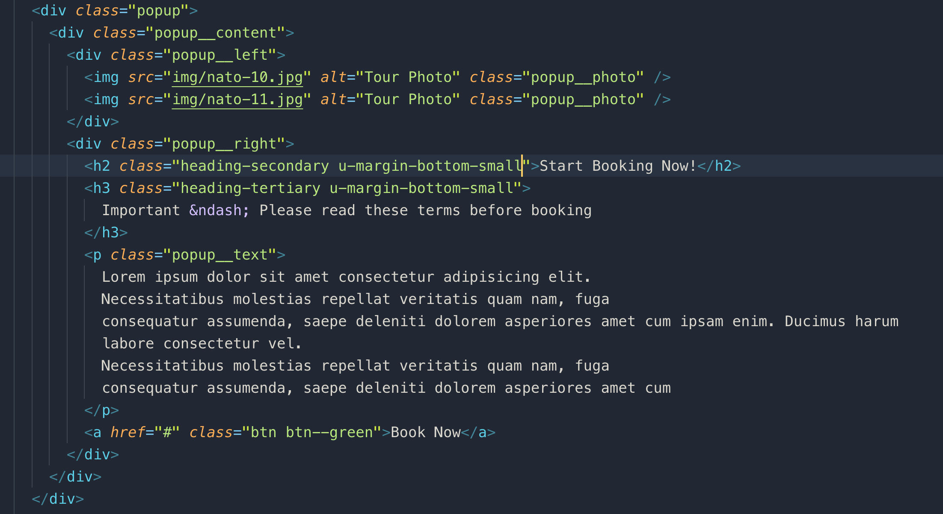

**053 Building a Pure CSS Popup - Part 2**

We will use #anchors in this section. To go to a section on a page, we use it and it works with id



When we click on the above anchor tag, it will take us to this section.



We can also use it to open or close popup. Here it works with target

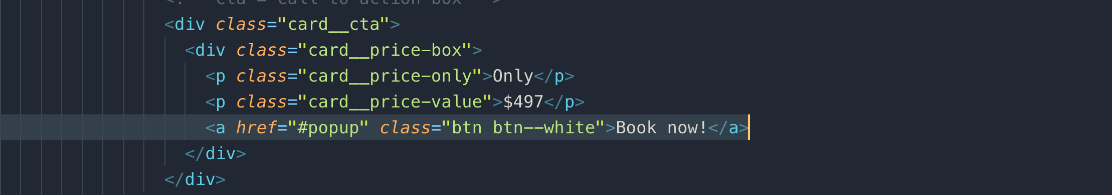

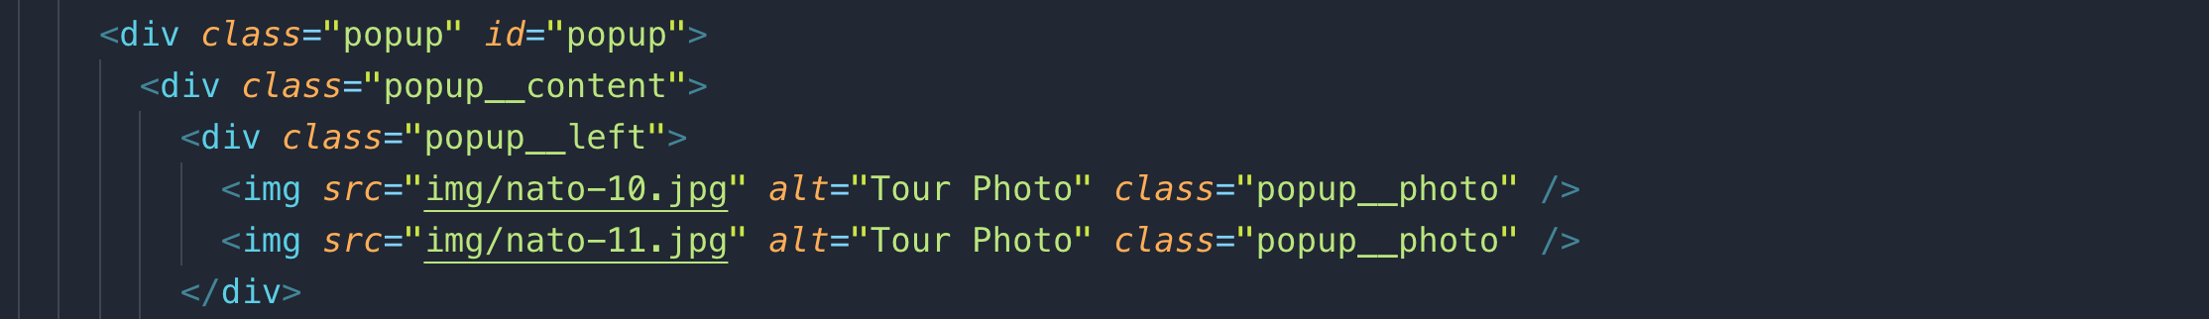

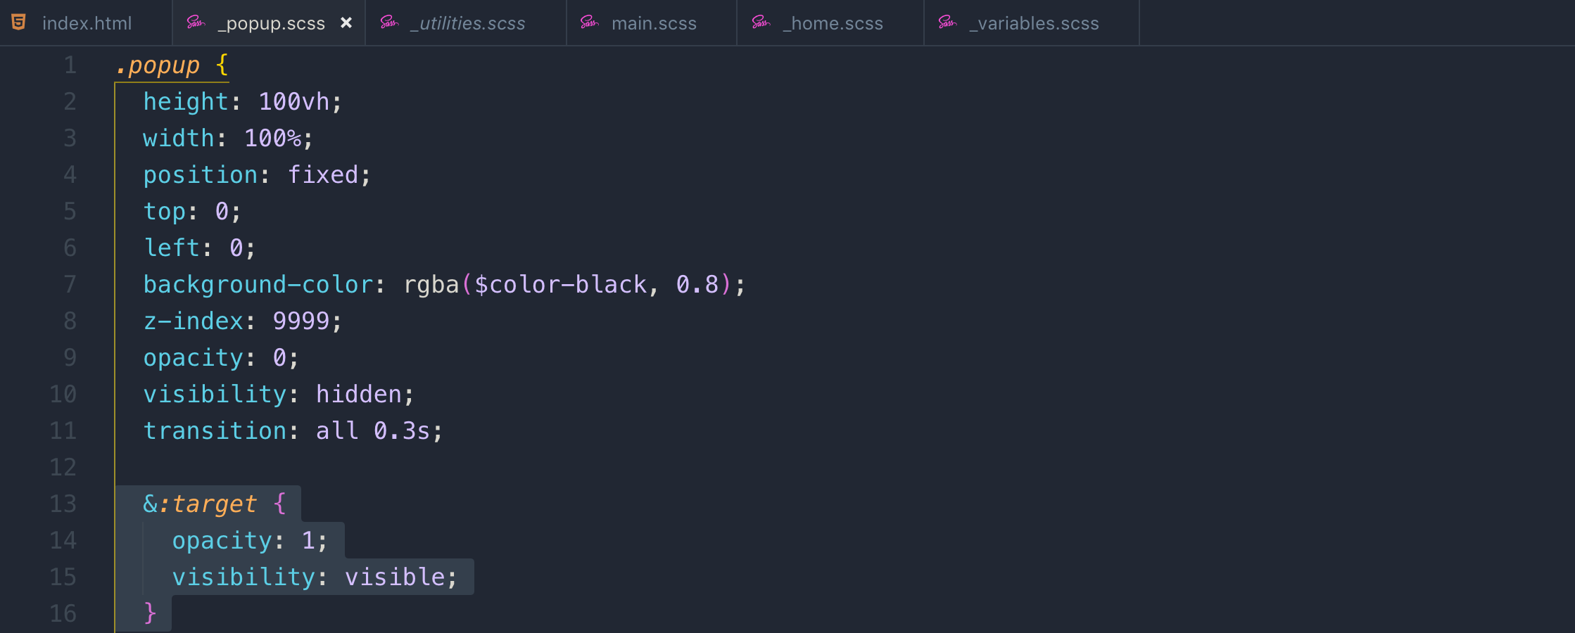

To make the content zoom-in while showing up the popup. We used this technique

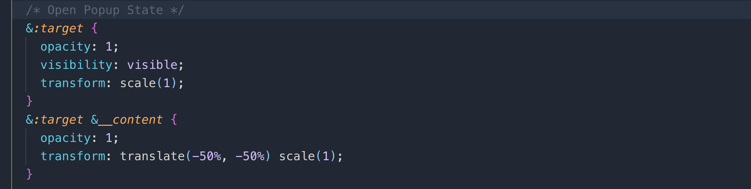

**06 Natours Project Advanced Responsive Design (Part 3)**

**056 Let's Use the Power of Sass Mixins to Write Media Queries**

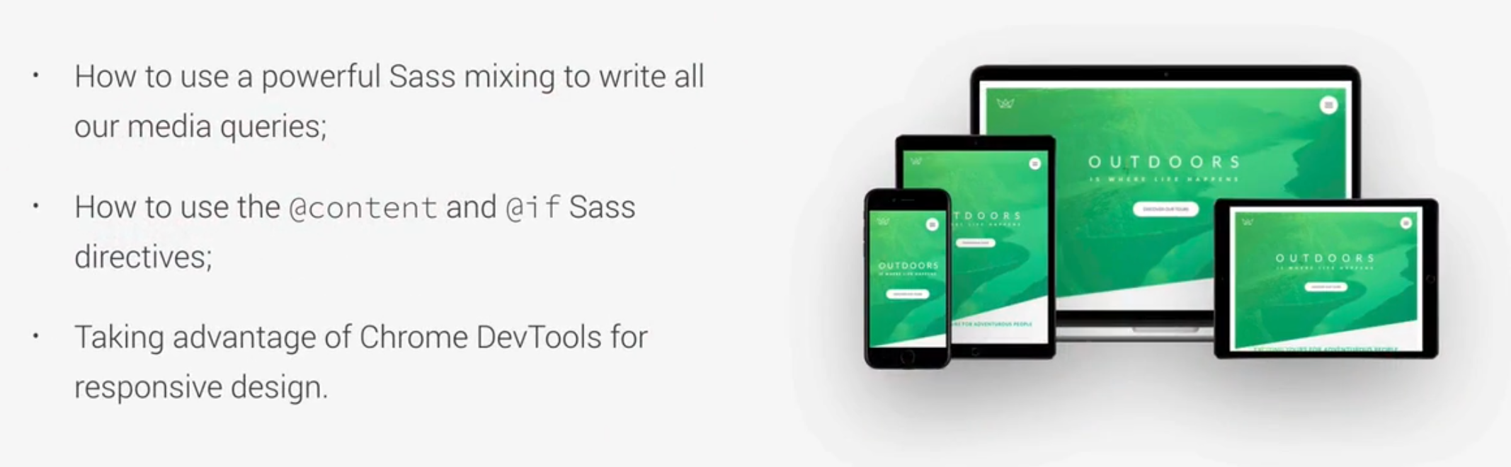

**@content:** allows us to call a block of code into a mixin.

**Note:** font-size will be replaced by @content.

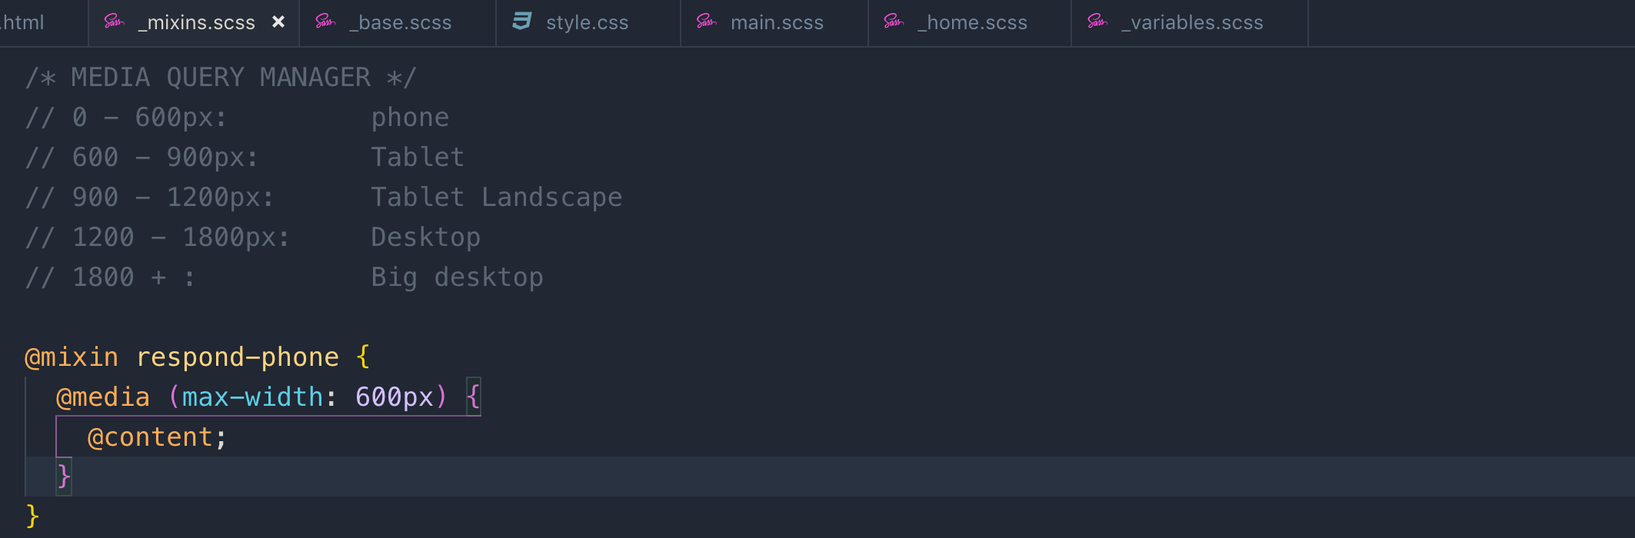

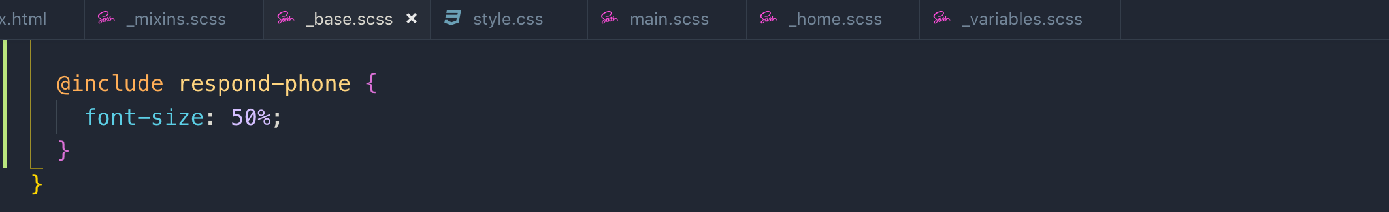

**@if:** this is “if directive” in mixin

if the user changes the default font-size in browser than the media query will not work so we have to use relative unit in media query.

**Em** and **REM** in media queries, they are not affected by a **root font-size**. **1rem** in media query is always just equal font-size which is coming from the browser and that is by default is 16 **pixels.** If the user changes the font-size to 20 pixels then it will be 20 pixels no matter what we have in base font definition.

But we will use **Em** in media query as **REM** failed to work as intended in some of the browser. Ems are the best options in the media query.

Keep in mind that

So **1em == 16px**

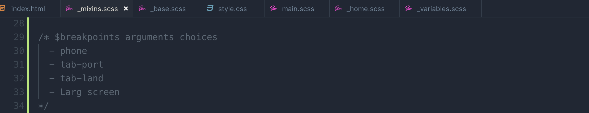

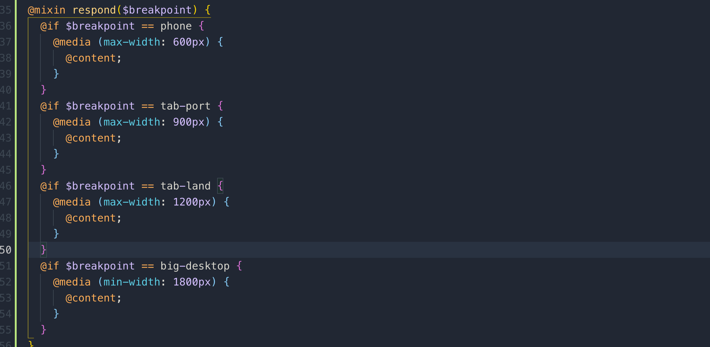

So, for media query for 600px will **35.5em** in relative units



By using **rem unit,** we will make the entire layout of the webpage dependent on the font-size. This is a good thing because now in responsive design, we can simply change the font-size and all the rems will scale down or up according to font-size.

As default browser font-size is 16px;

62% of 16 is = 10px and according to this way 1rem == 10px

50% of 16 is = 8px and according to this way 1rem == 8px

56.25% of 16 is = 9px and according to this way 1rem == 9px

75% of 16 is = 12px and according to this way 1rem == 12px

As tab-port will work for the phone also so we removed that. **_base.css**

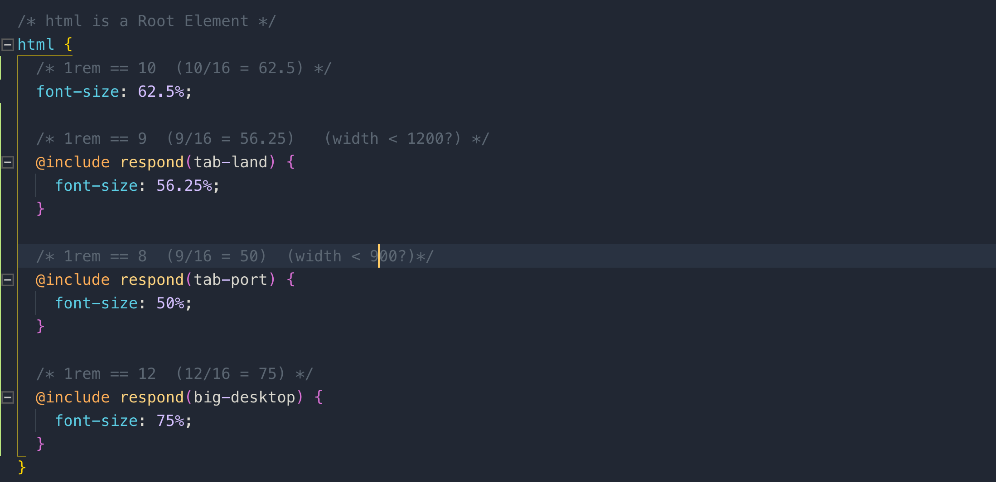

**Note:** Please note the order of the media queries. This is important!

**057 Writing Media Queries - Base_ Typography and Layout**

This is the order in which we start changing code for media queries



**Typography:**

Removing the padding for tab-port mode

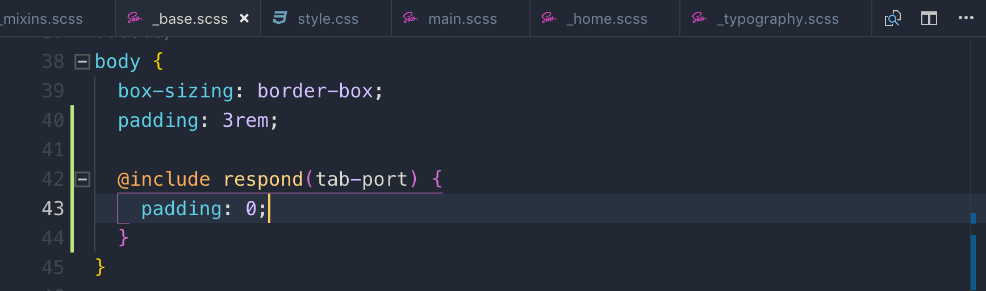

Applying phone media query to decrease the font-size for the screen below 600px

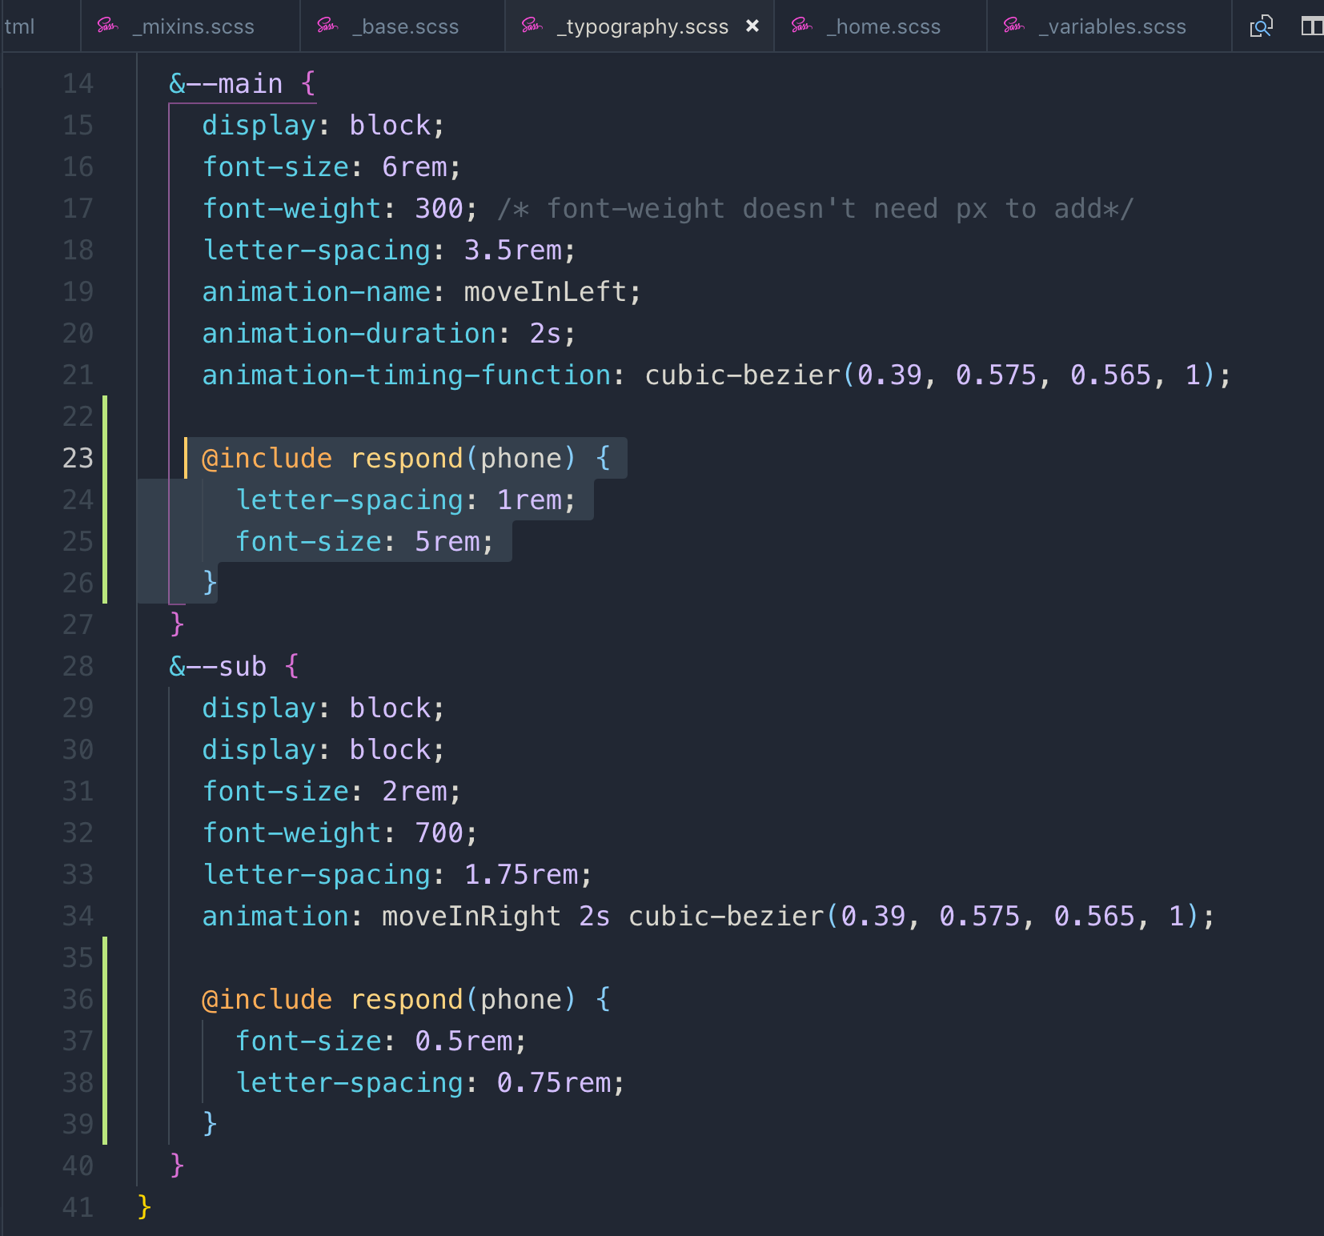

Adding media query for secondary heading

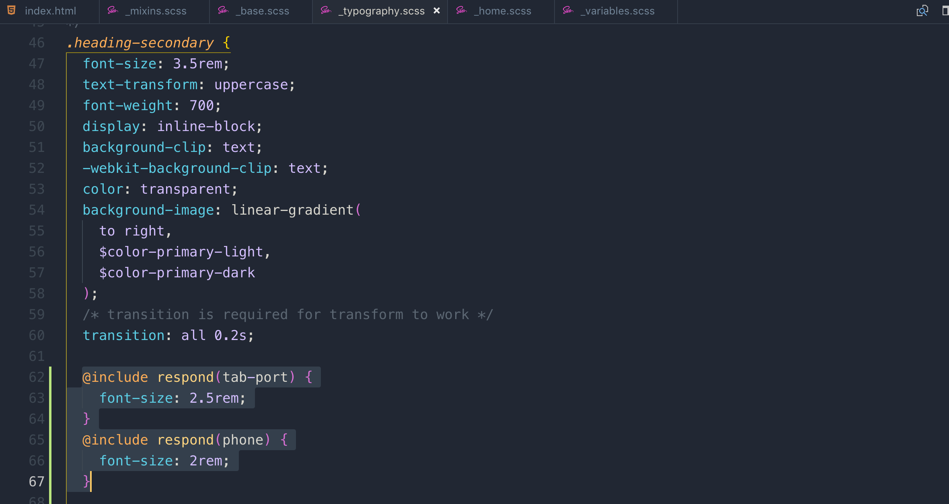

**Media query for Grid:**

For gird we also need to change the max-height

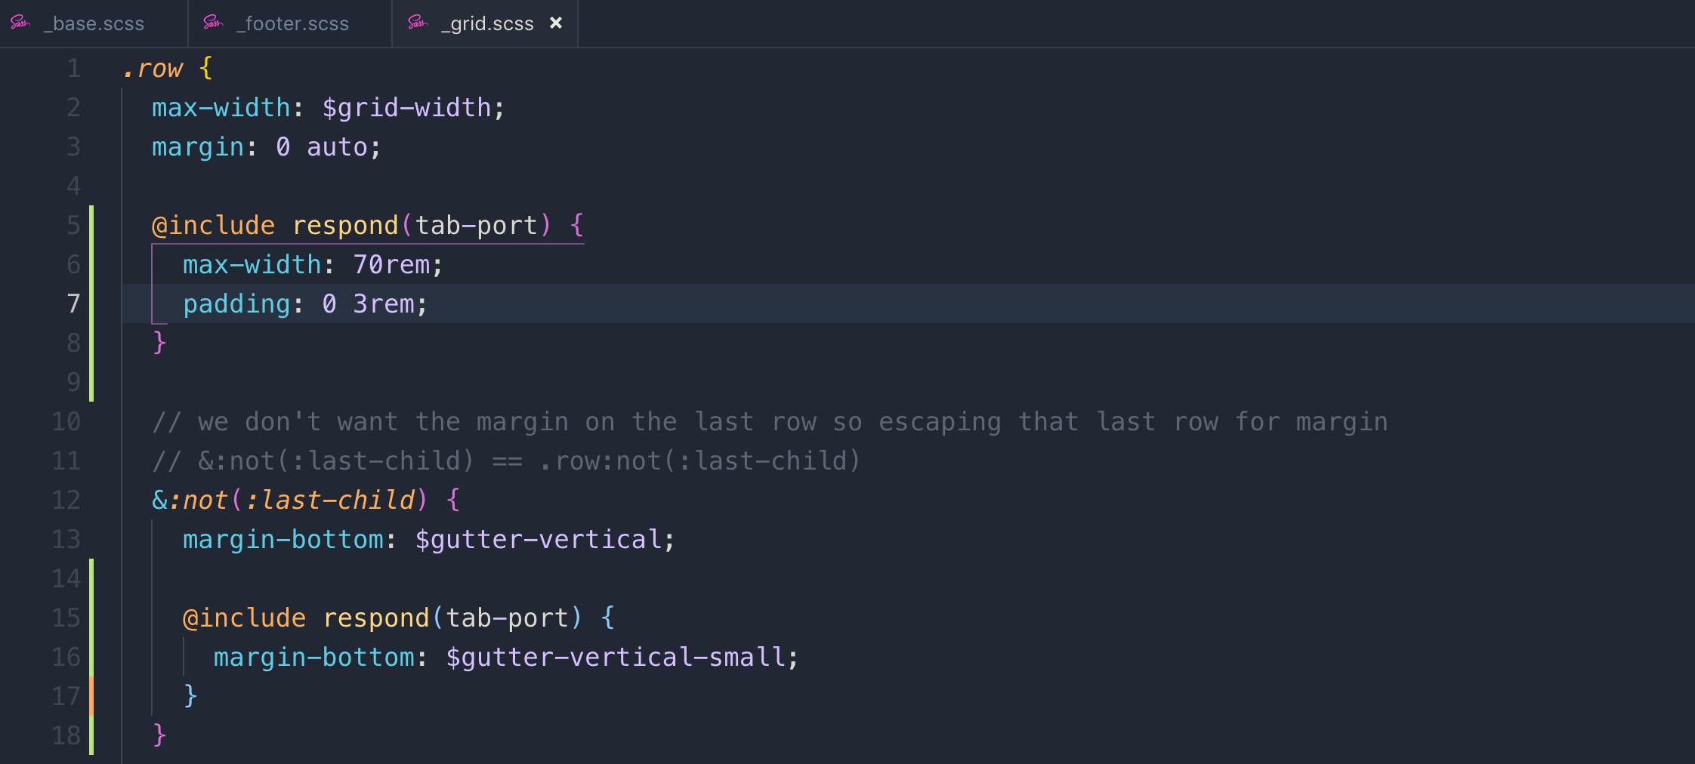

To make the row column to show 1 each row, we have to make the width of every column to 100%

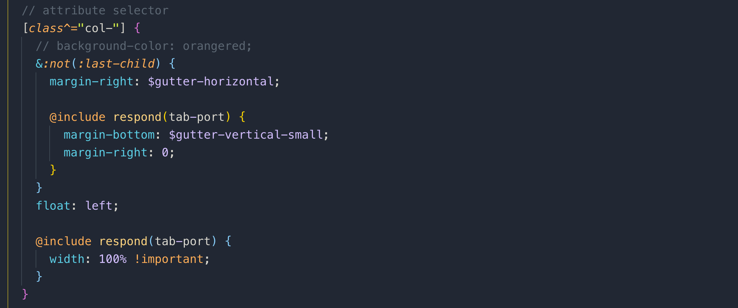

We also need to adjust the margins

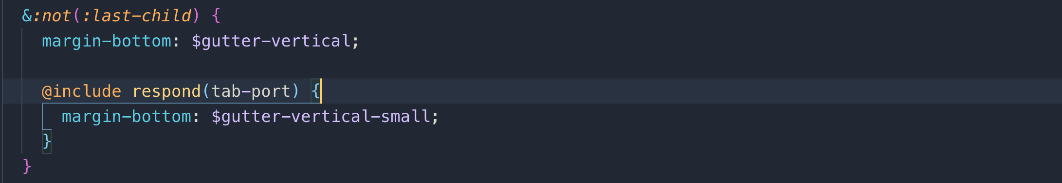

**Media query for Header:**

Here we only need to change it for tab-port

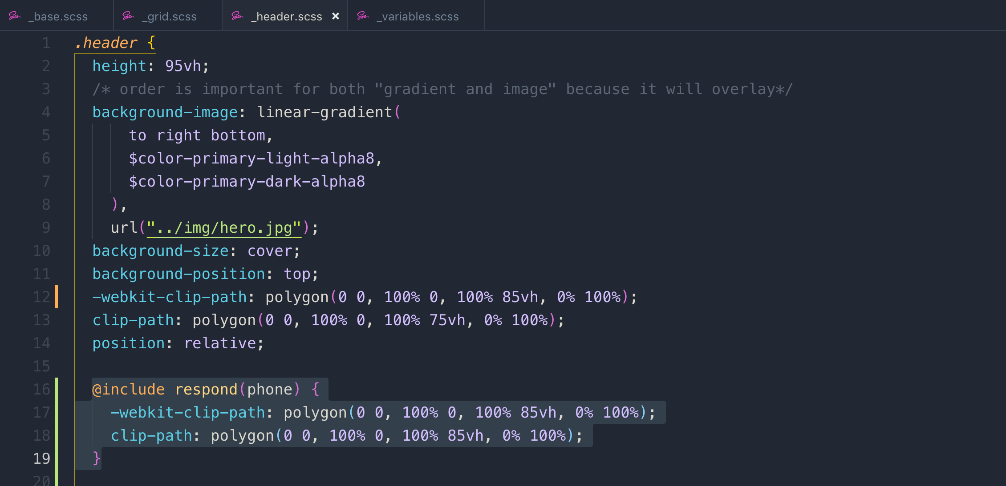

**Media query for navigation:**

Let’s change the position of the navigation icon

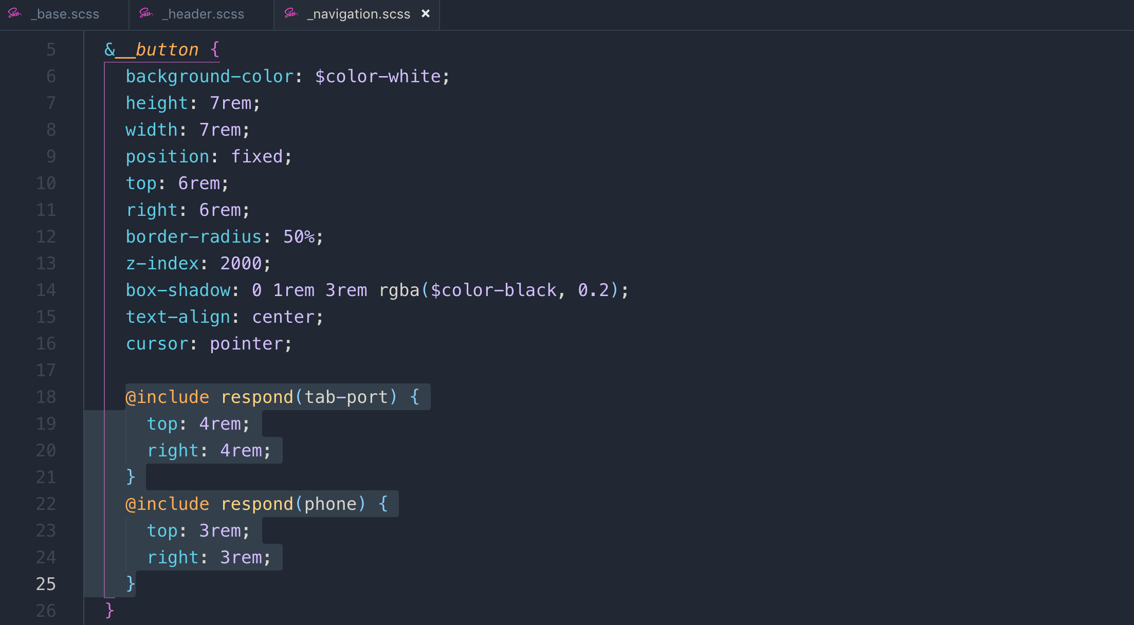

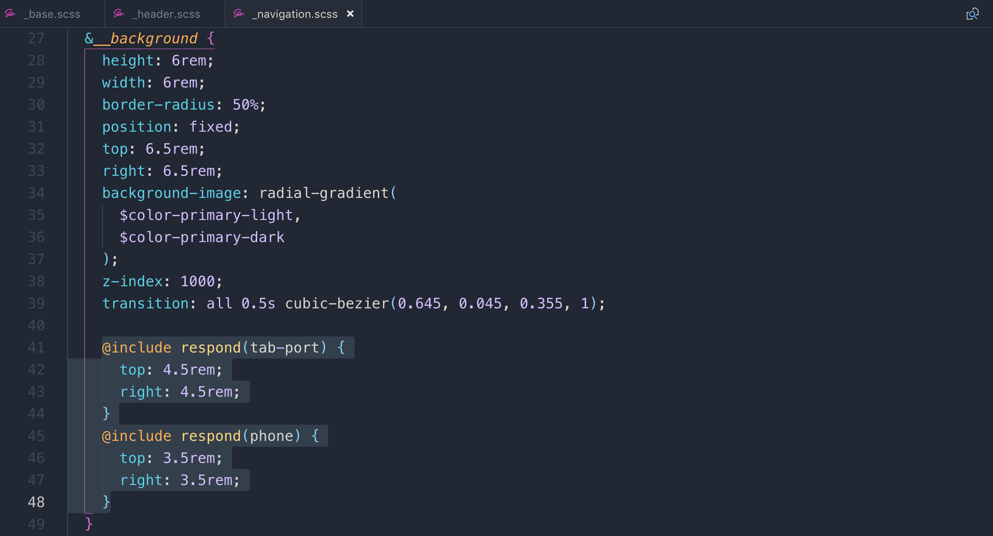

**Media query for footer:**

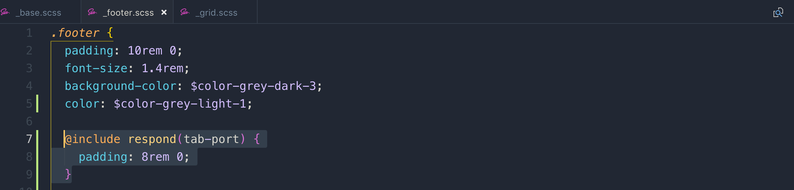

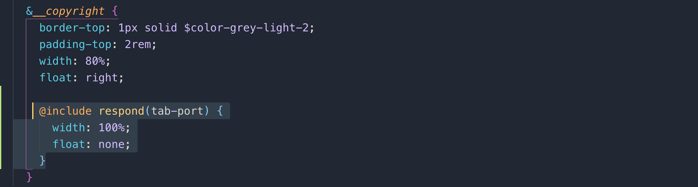

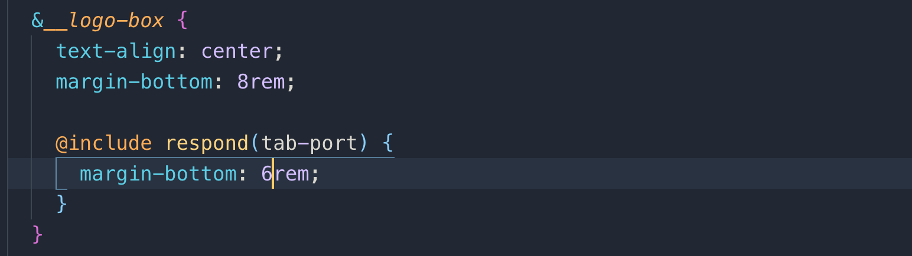

**058 Writing Media Queries - Layout_ About and Features Sections**

let’s apply media query on **_home.scss**

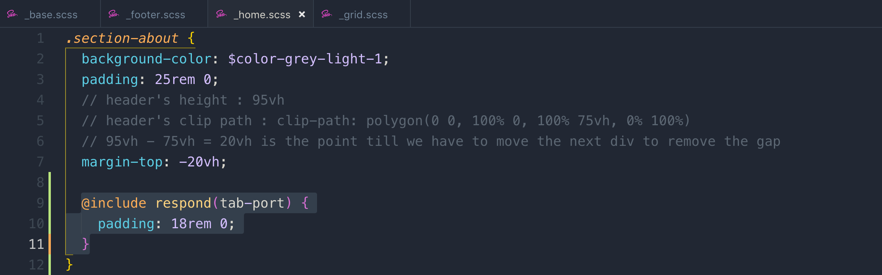

decreasing padding and margins. Note: keep the margins and padding consistent as I have decrease 7 in the above section-tour so keep the difference of 7 in the following sections.

**_utilities.scss**

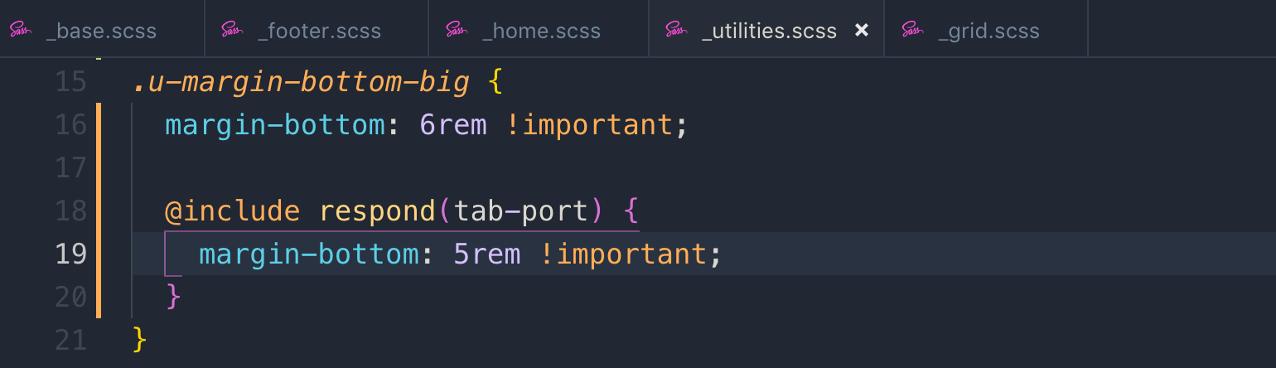

**components> _composition.scss**

Reverting the absolute position to relative

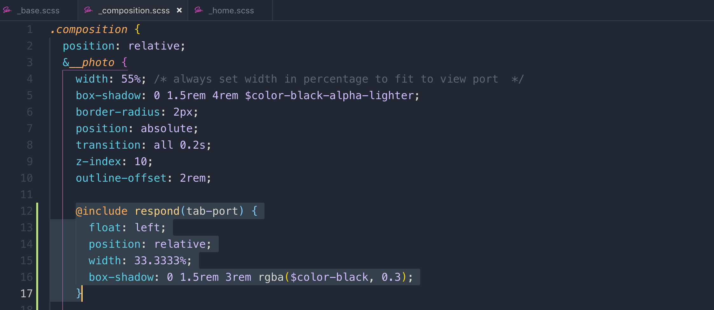



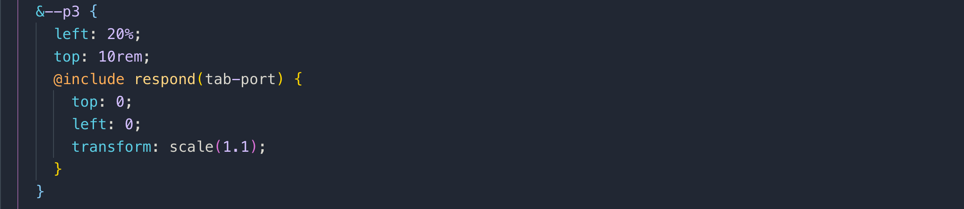

**components> _feature-box.scss**

Decreasing padding

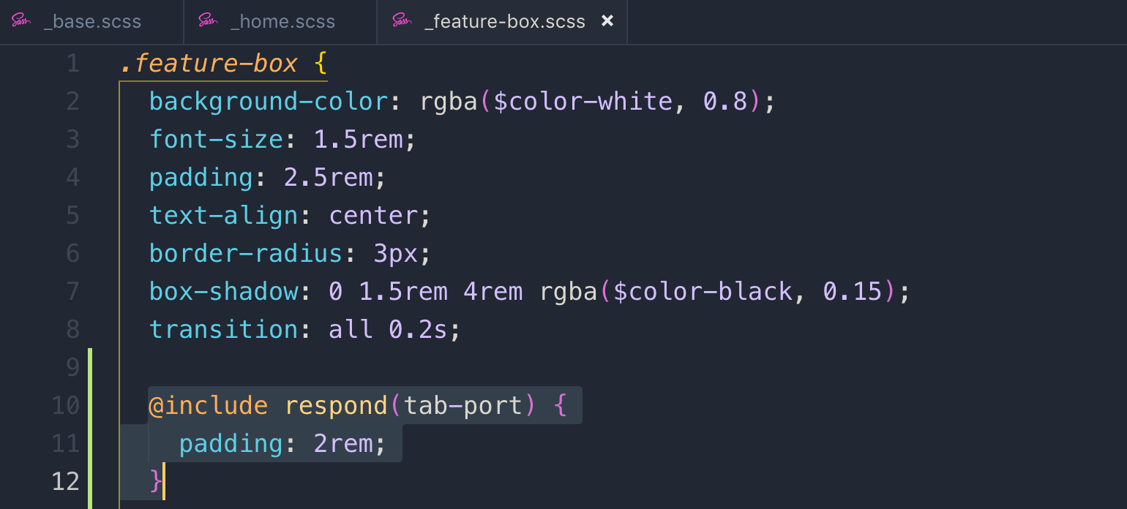

**059 Writing Media Queries - Tours_ Stories and Booking Sections**

**component > _card.scss**

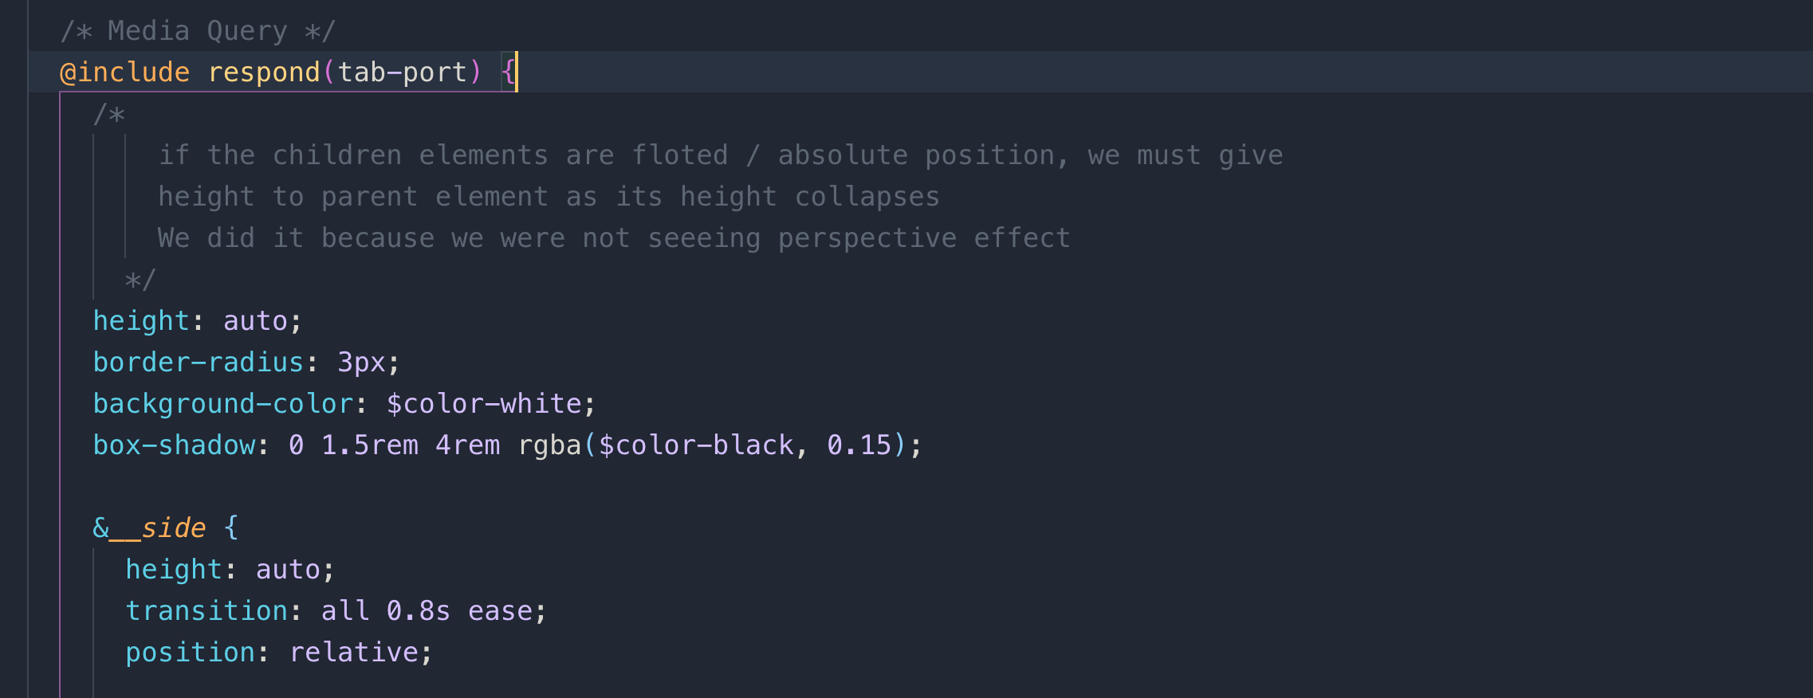

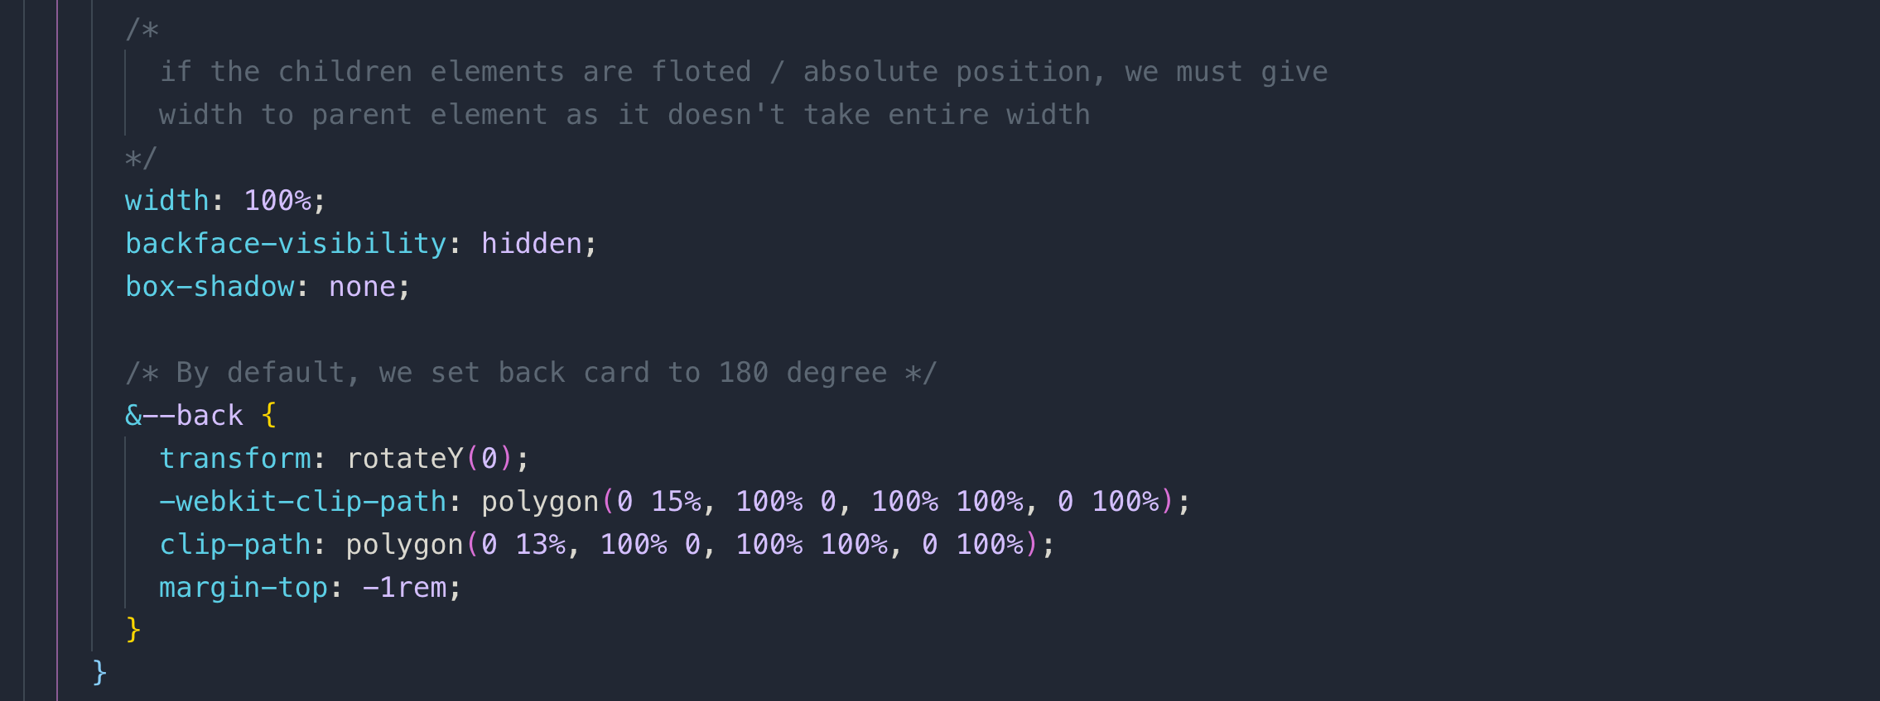

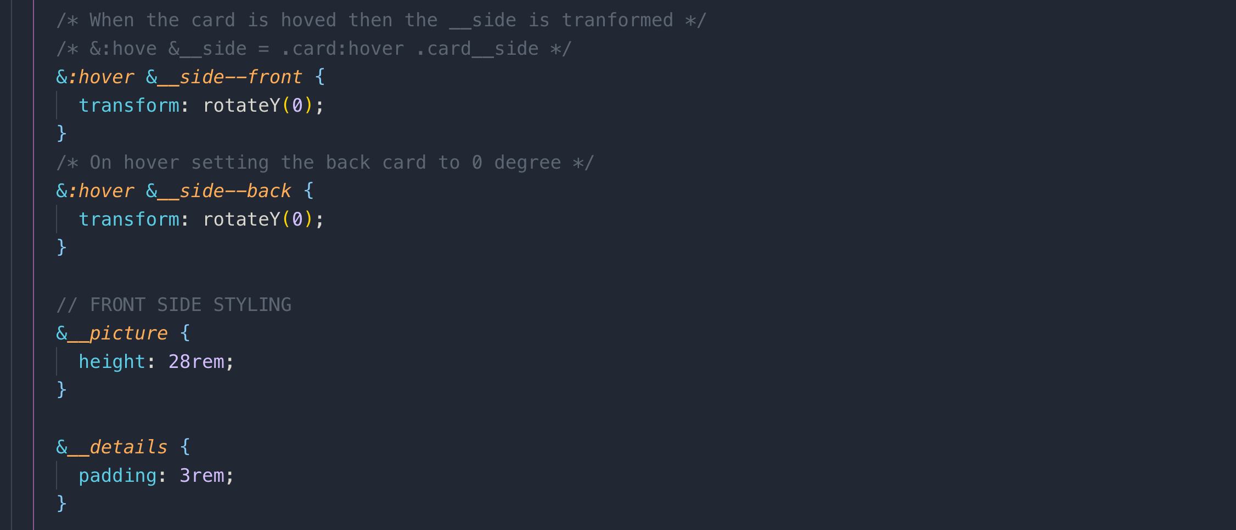

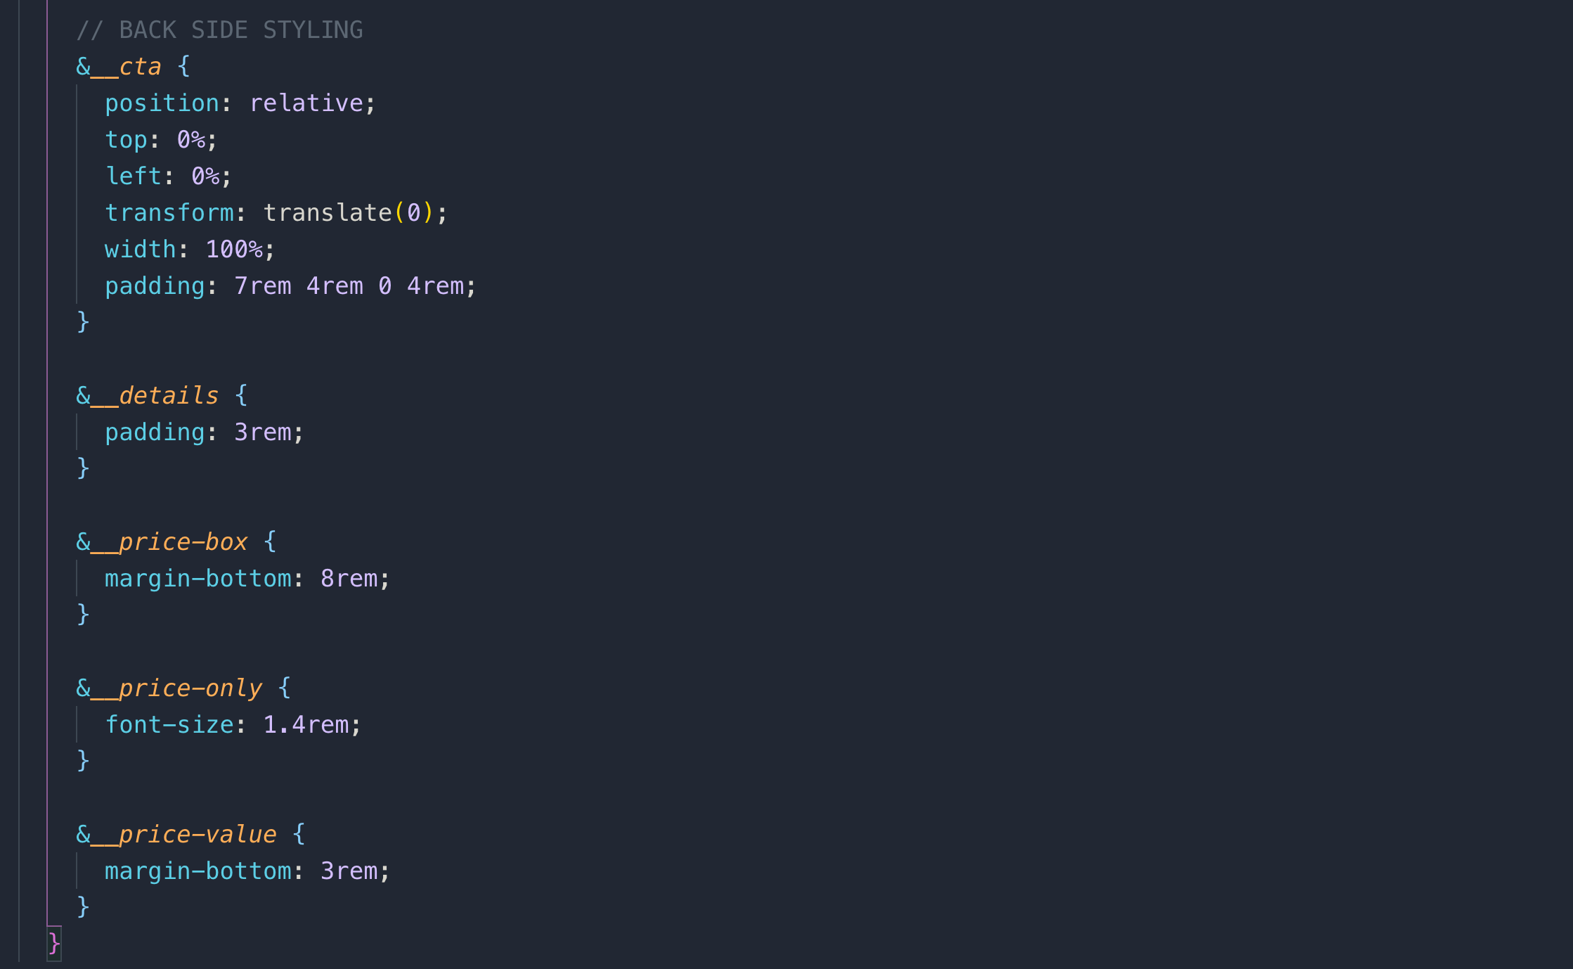

**_stories.scss**

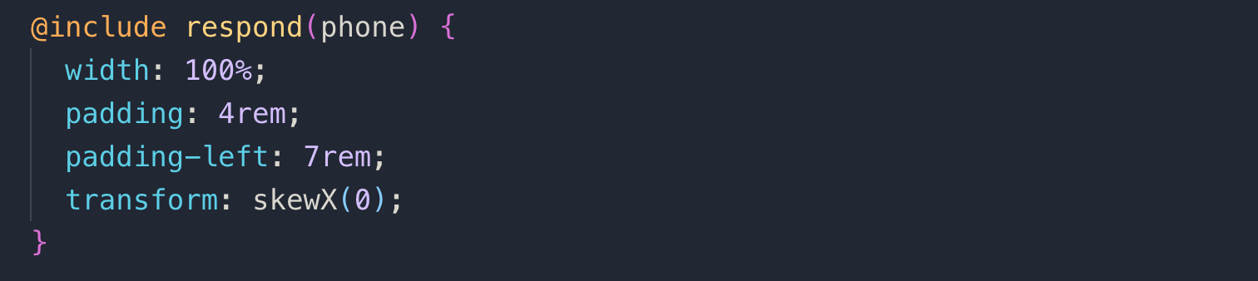

**_home.scss**

only in this file we used **port-land** mode for media query.

**you can check all your sizes on this website**

[**https://sizzy.co/**](https://sizzy.co/)

**060 An Overview of Responsive Images**

They not only help in responsive design, but also plays an important role in web performance and are images are crucial for web performance.

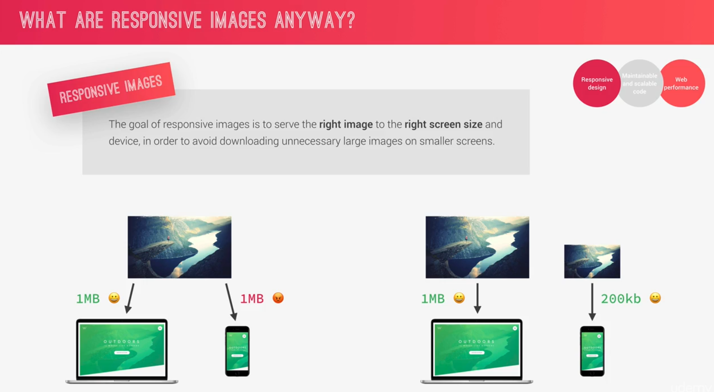

**Pixel density:** pixels found in an inch or a centimeter.

As compare to normal display, retina display requires double the resolution(pixels) to display images sharp and clean as it uses 2 pixels internally.

**Example:**

if an image is 100px then we will need 200px images for retina display to look sharp and clean.

**Art Direction:** when you want to serve a different image

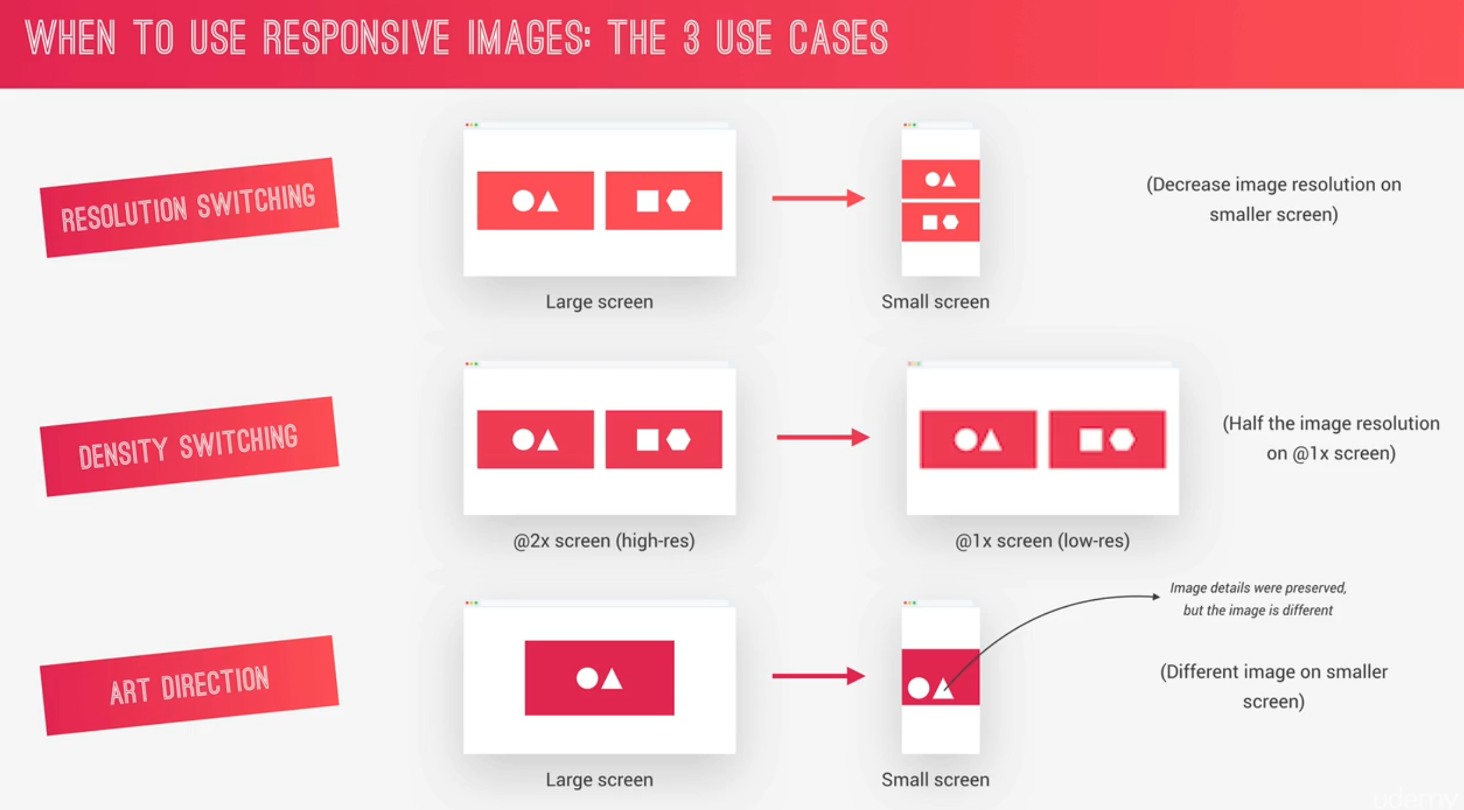

**061 Responsive Images in HTML - Art Direction and Density Switching**

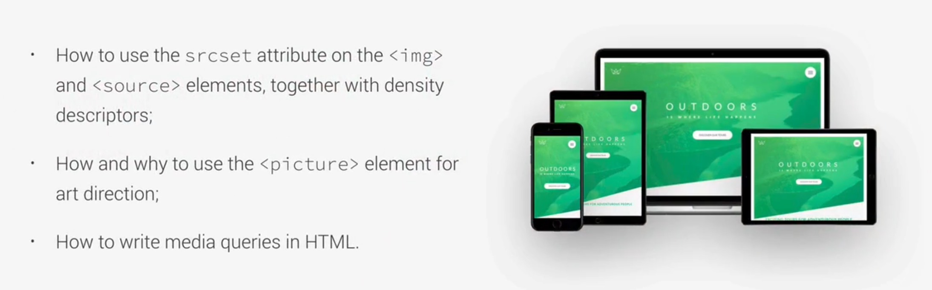

**Note:**

There are 2 types of responsive images, in HTML with <img> and in CSS with background and gradient.

**Density switching:** on the basis of device, browser chooses what image to use

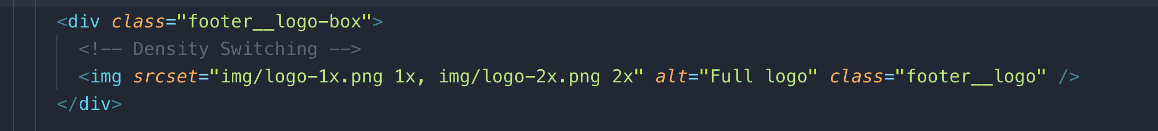

**Art Direction:** to tell the browser to use one image on screen width and another image with another screen width.

We have to use at least one image here, 0 or more <source>. The <img> down below is for fallback.

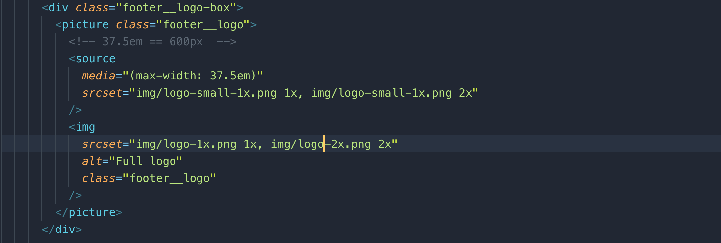

**062 Responsive Images in HTML - Density and Resolution Switching**

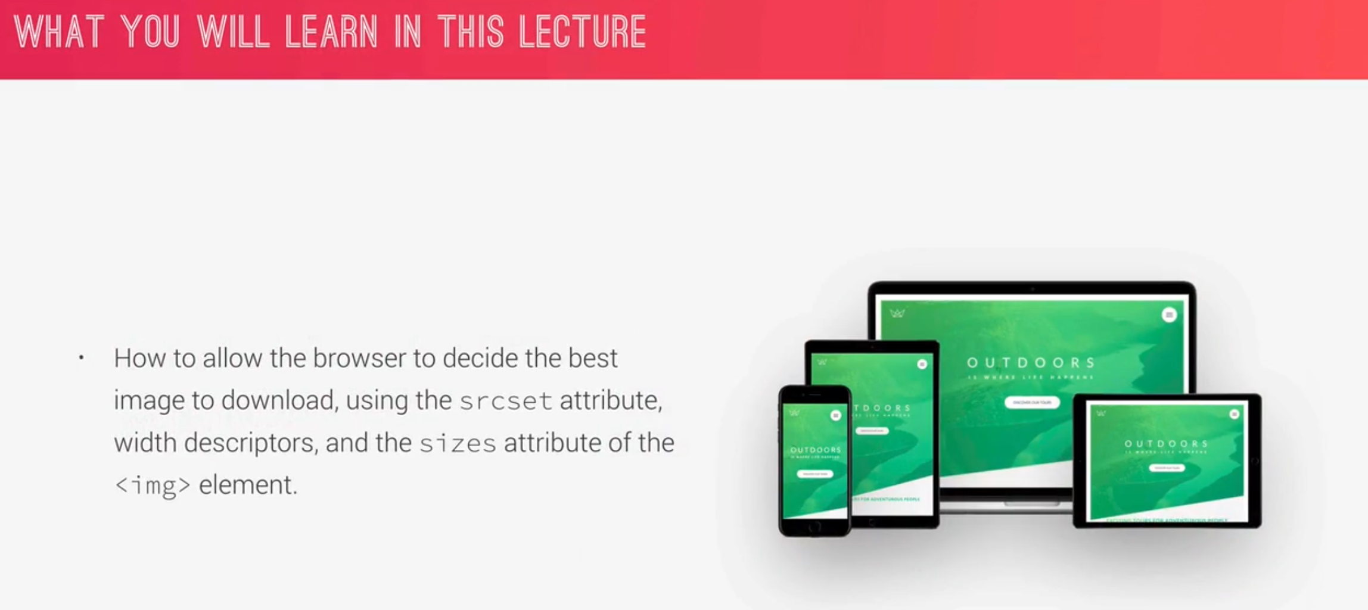

**DPR:** Device Pixel Ratio

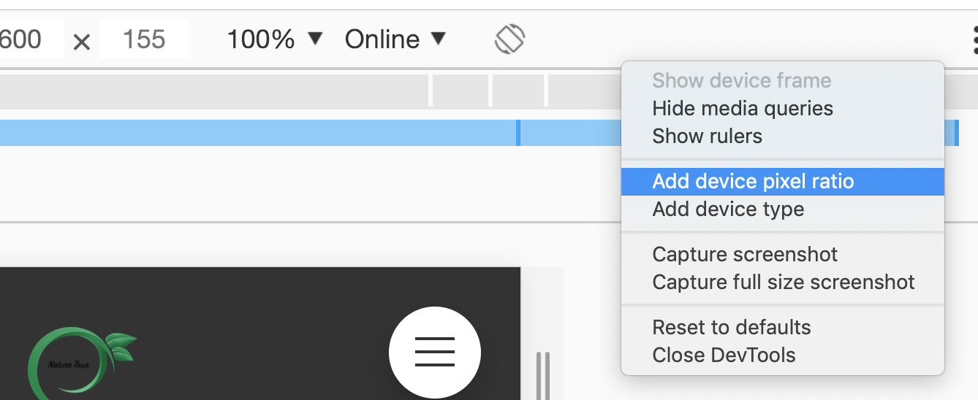



We can change the pixel ratio from 1 to 2 as shown in the above picture.

To be sure what is the actual loaded image

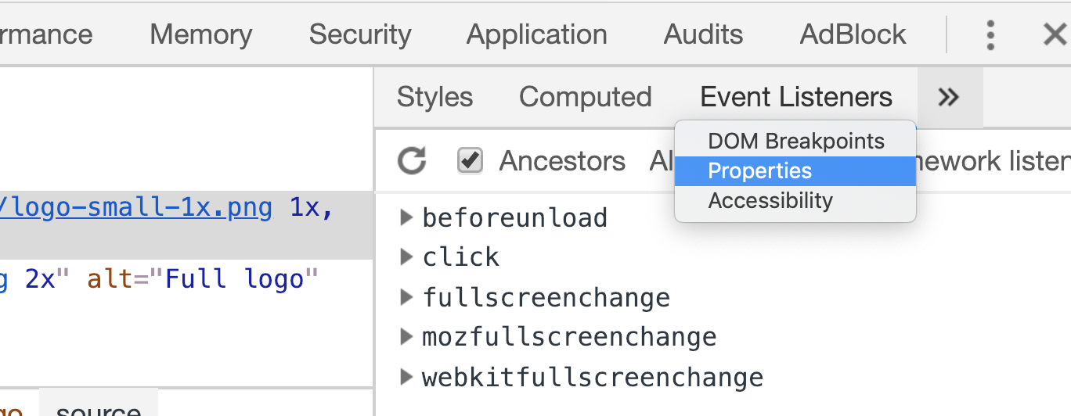

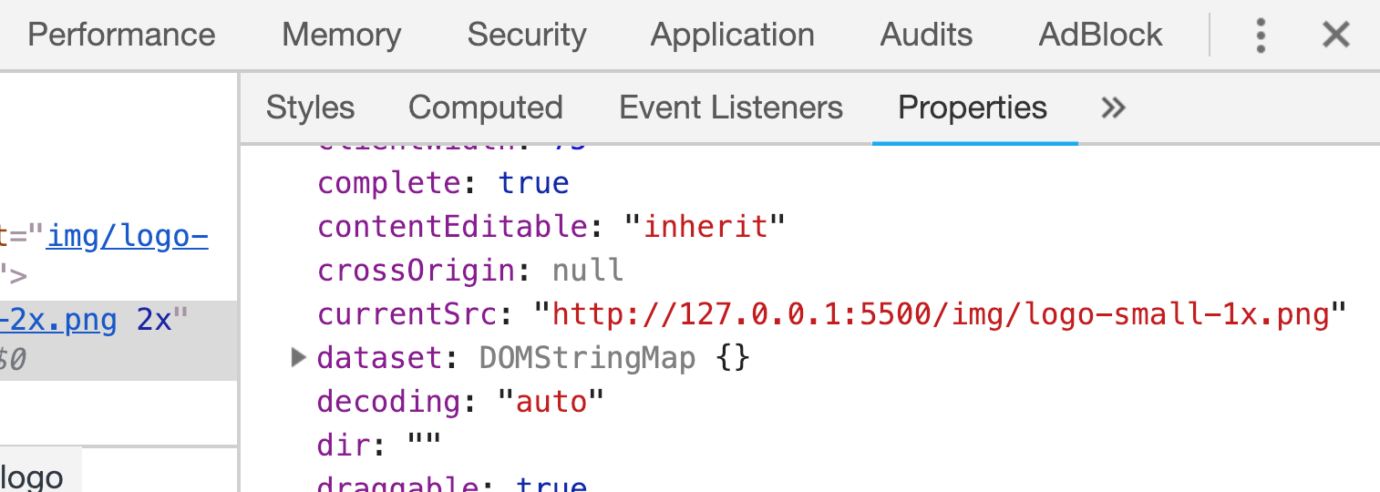

This time we will use **width density descriptor**

**064 Testing for Browser Support with @supports**

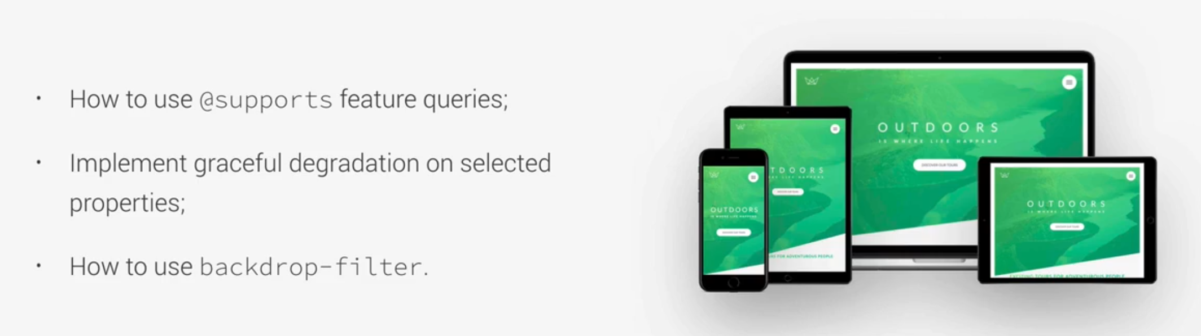

what backdrop-filter does is to apply a filter to what’s behind the selected element.

@support() : checks whether a property supports in safari or not.

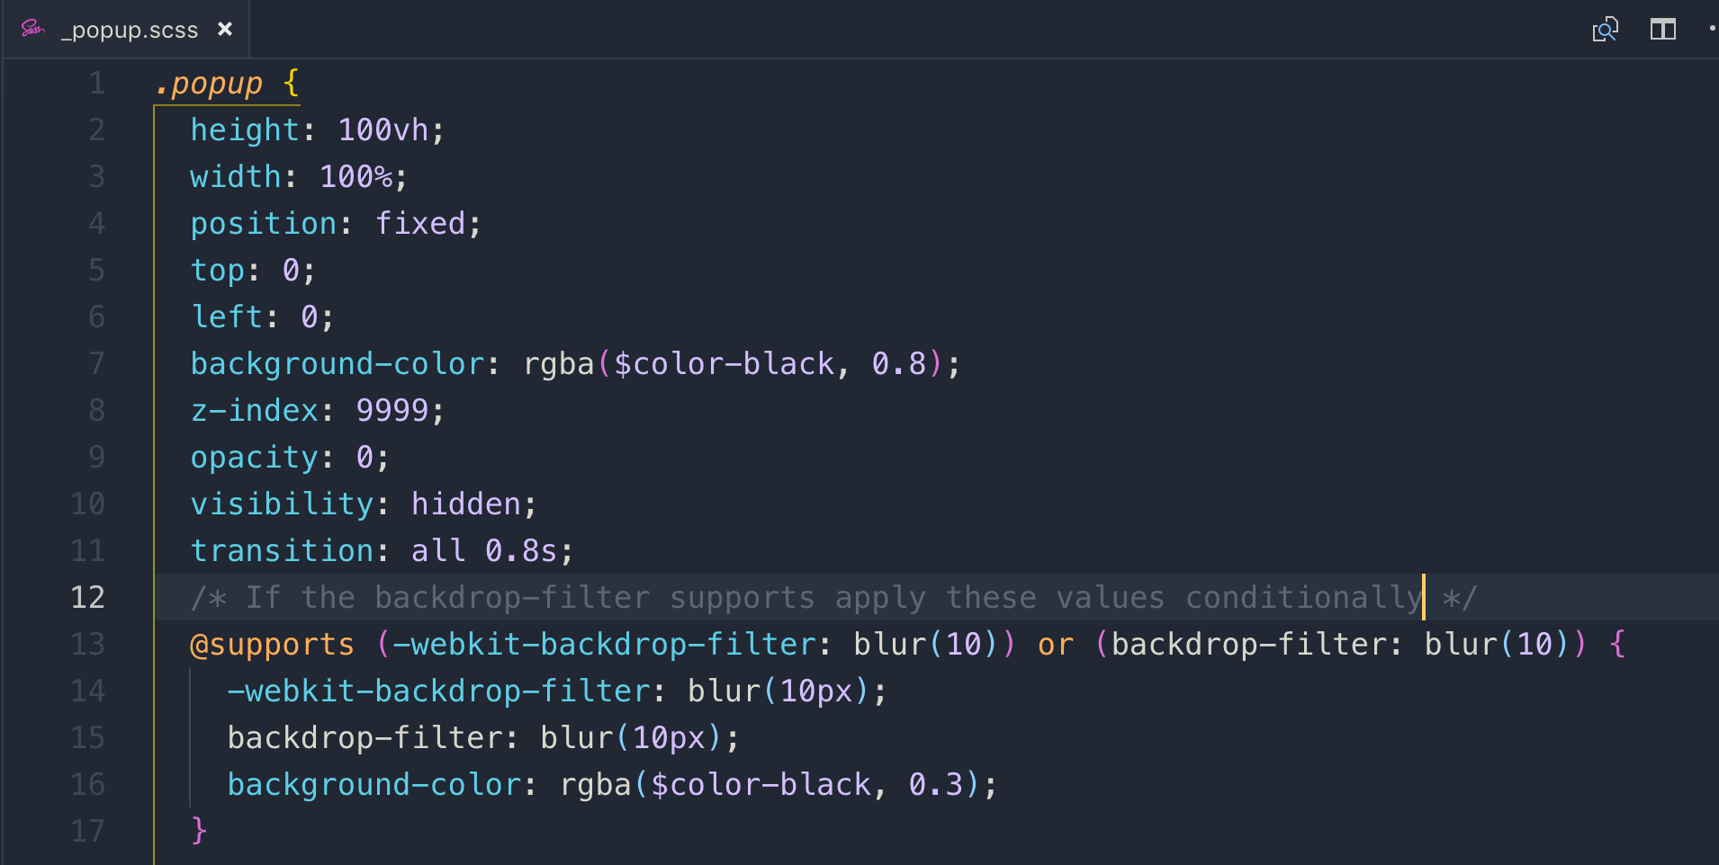

We can even change backdrop-filter from blur to invert, brightness, sepia and etc.

**065 Setting up a Simple Build Process with NPM Scripts**

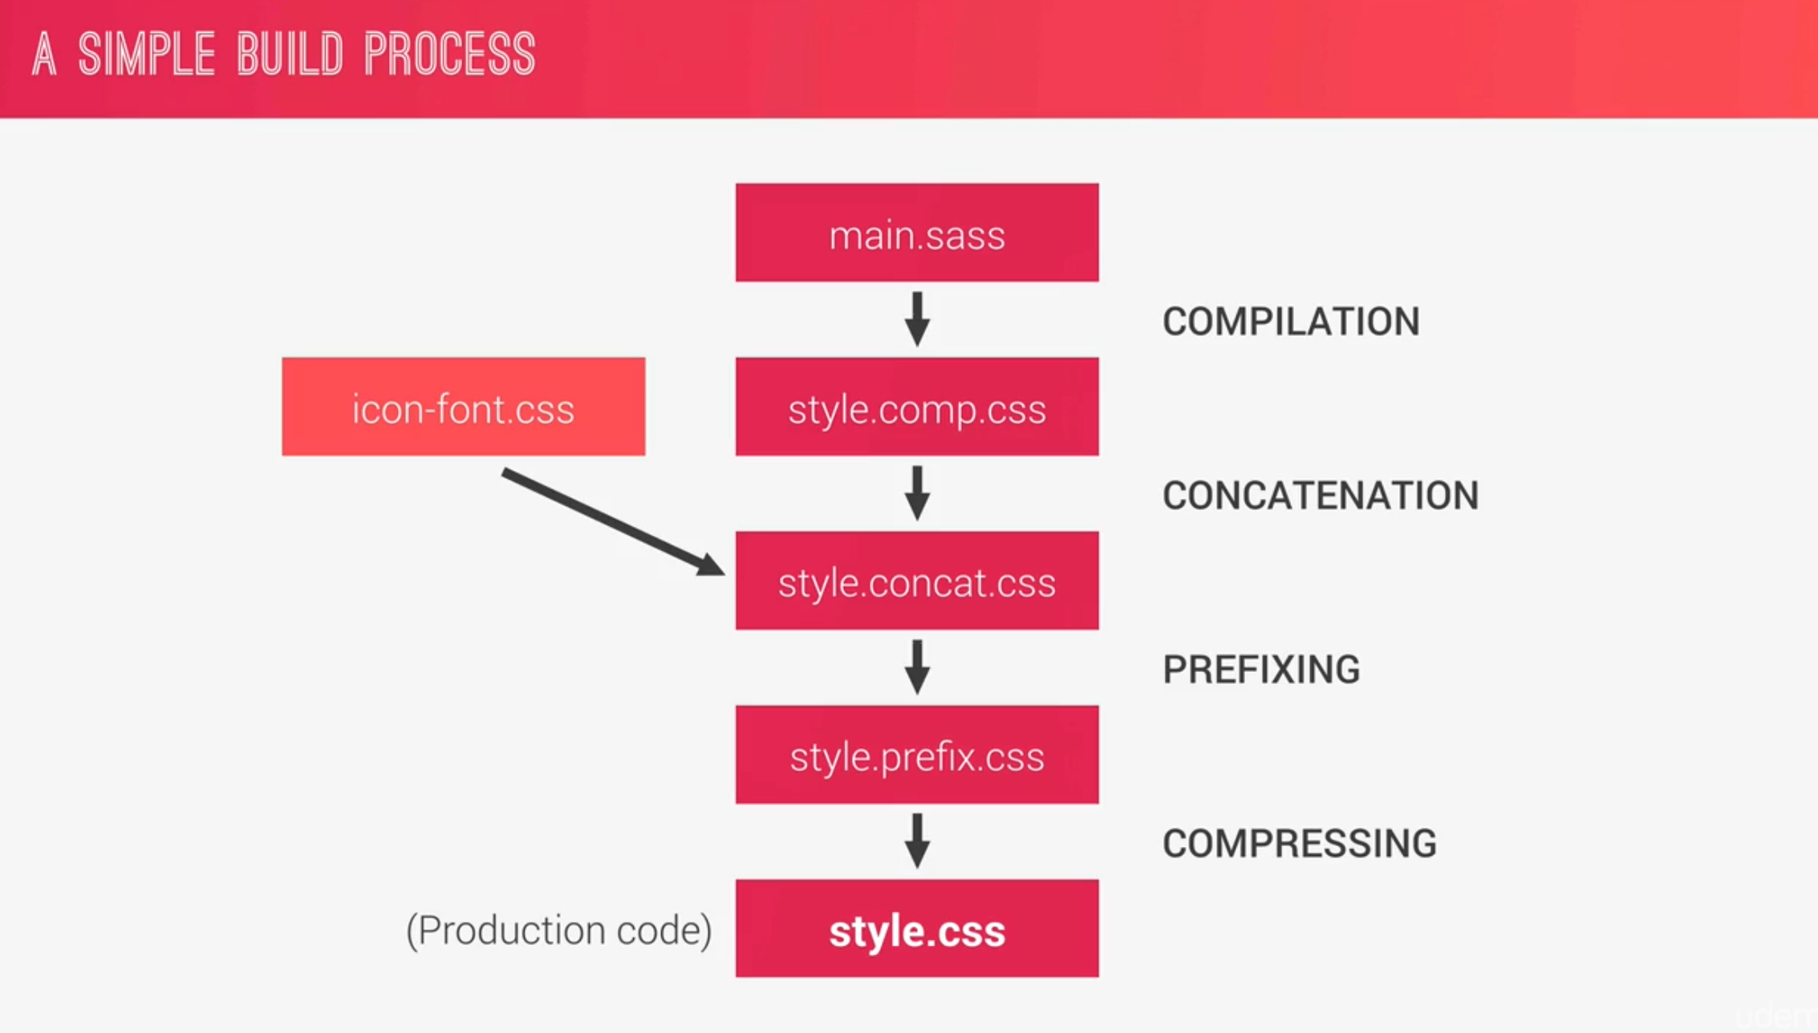

We will automatically add prefixes to our CSS file.

To concatenate multiple CSS files, there is a NPM package, and it is called **concat**

**npm install concat**

**npm install autoprefixer.** It is a part of postcss-cli

**npm install live-server.** It is a part of postcss-cli

in order for **autoprefixer** to work, we need to install another package which is called **postcss-cli**

in order to run all the commands at once, we install an npm package called **npm-run-all –save-dev**

**package.json**

This is the build workflow

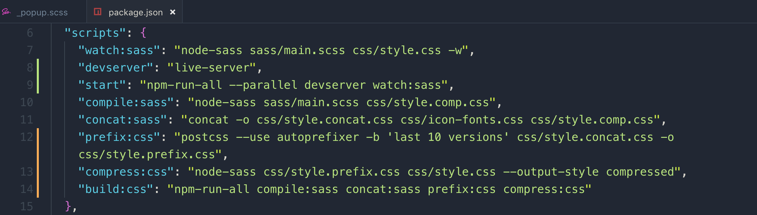

**066 Wrapping up the Natours Project_ Final Considerations**

We are going to change few tweaks in this last chapter.

First let’s change the selection background effect with **::selection pseudo selector**

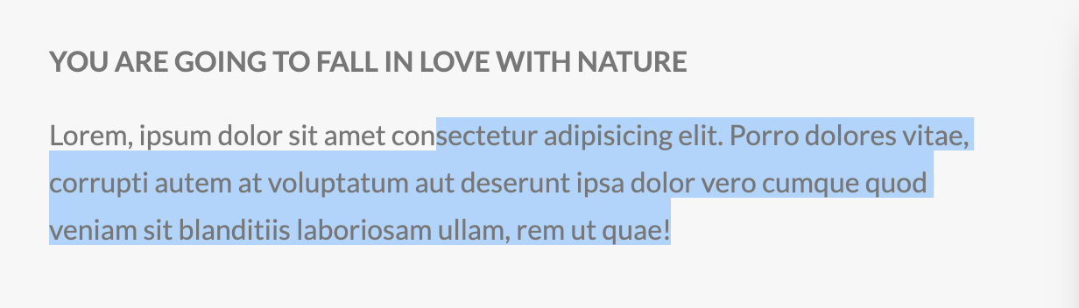

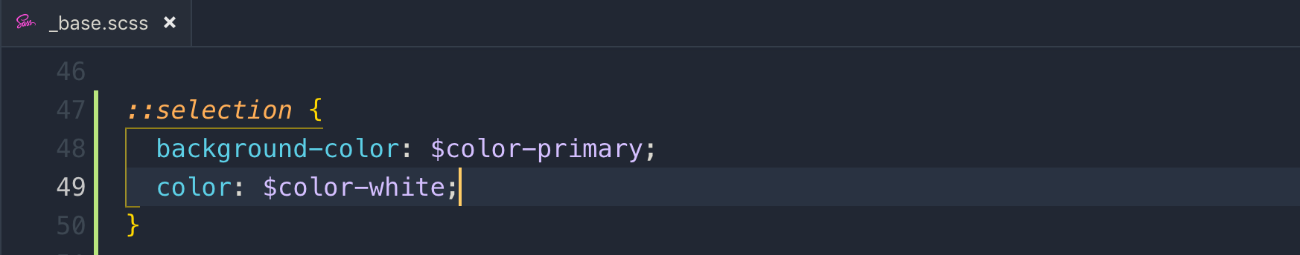

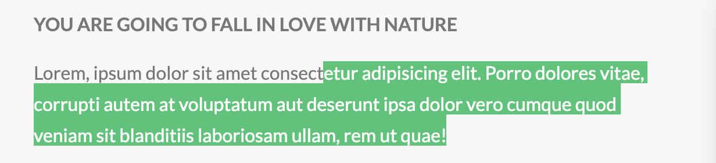

**only screen and:** what this means is that it only gets apply to screens. If somebody tries to print our page, media query will not apply.

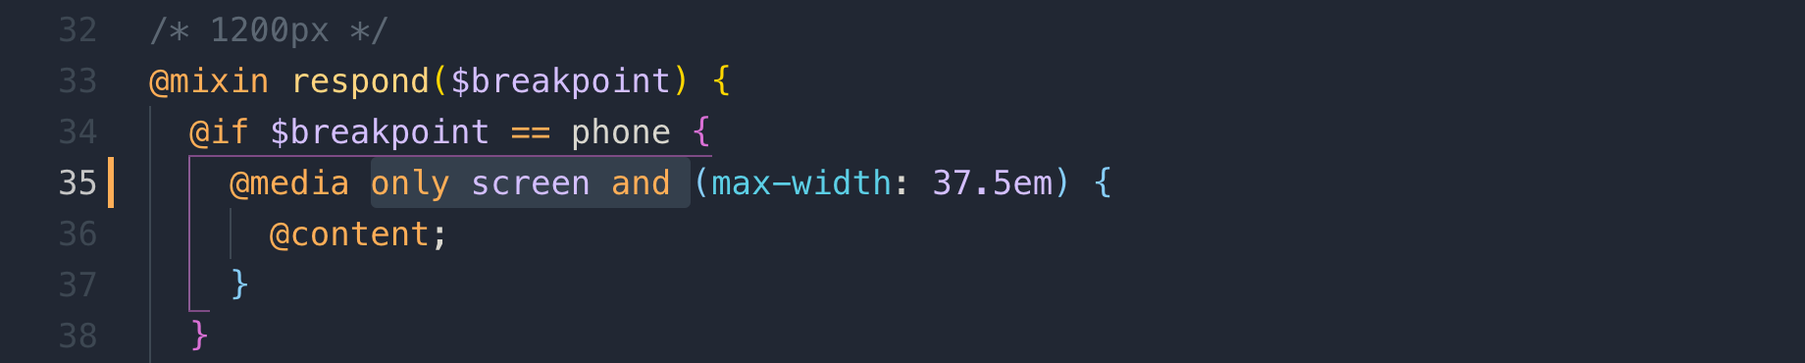

Responsive design does not work without this <meta> tag in HTML

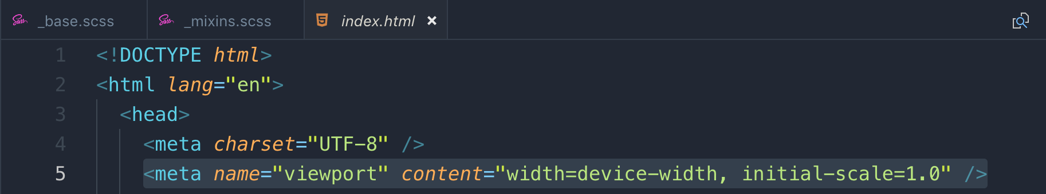

**width-device-width:** width of the content should the device width

on touch devices, we don’t have hover effect, and to enable that on bigger touch devices, we can do it with @media query

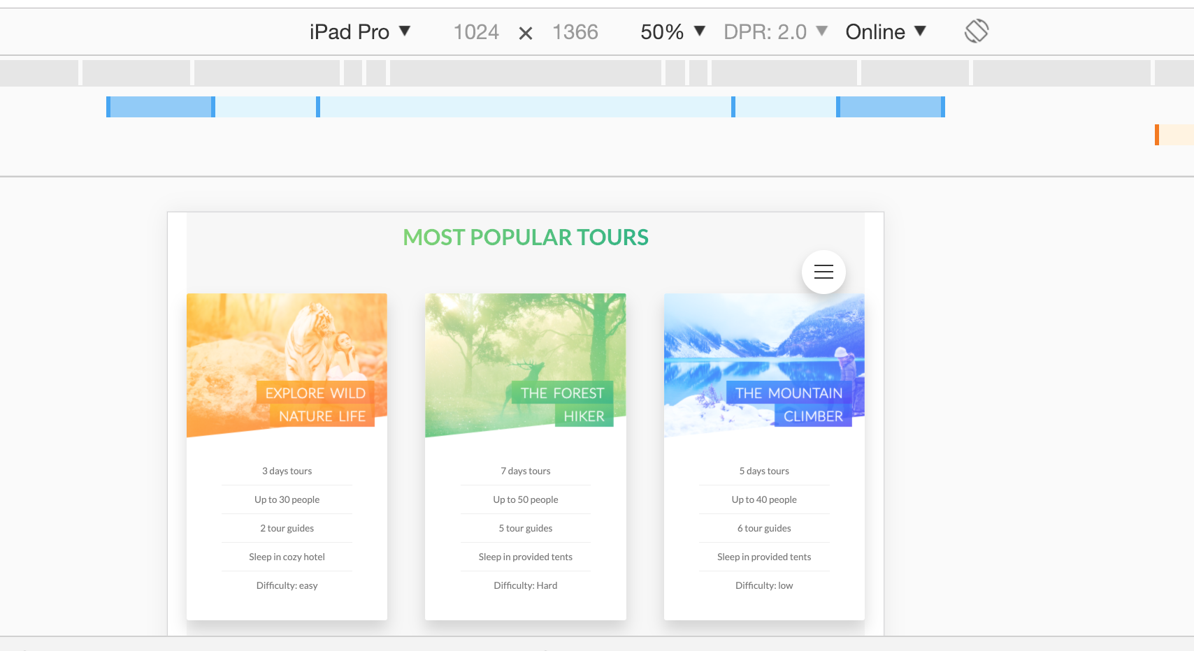

landscape on smaller devices and **Ipad** pro will not show back park of the card so they will not be able to click on the book now button.

In CSS, we can actually write media query which can identify if the user can hover over elements, or not. We can identify touch devices and not touch devices.

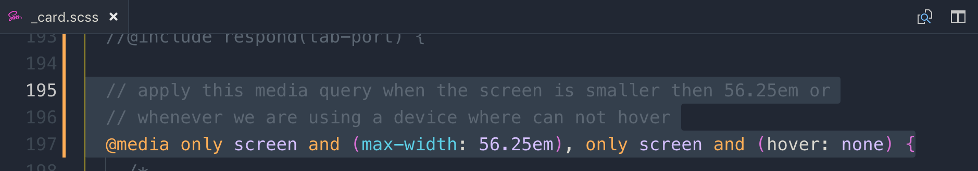

**07 Trillo Project Master Flexbox!**

**068 Why Flexbox_ An Overview of the Philosophy Behind Flexbox**

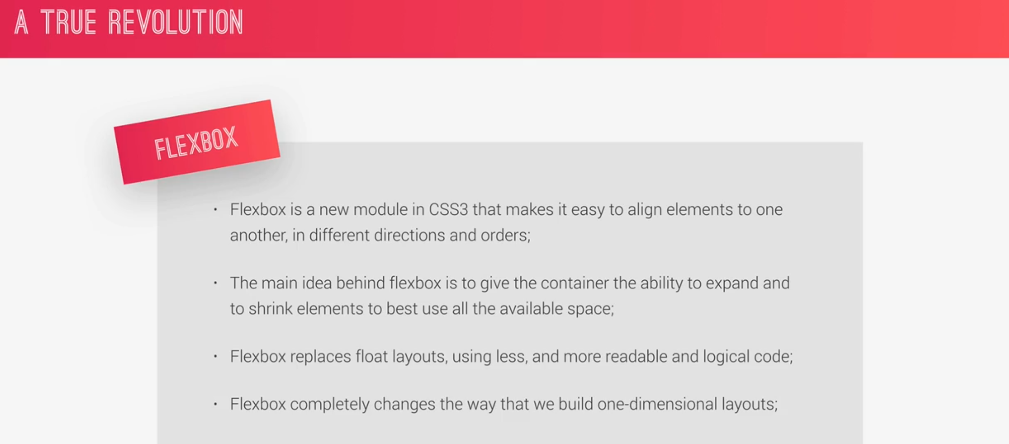

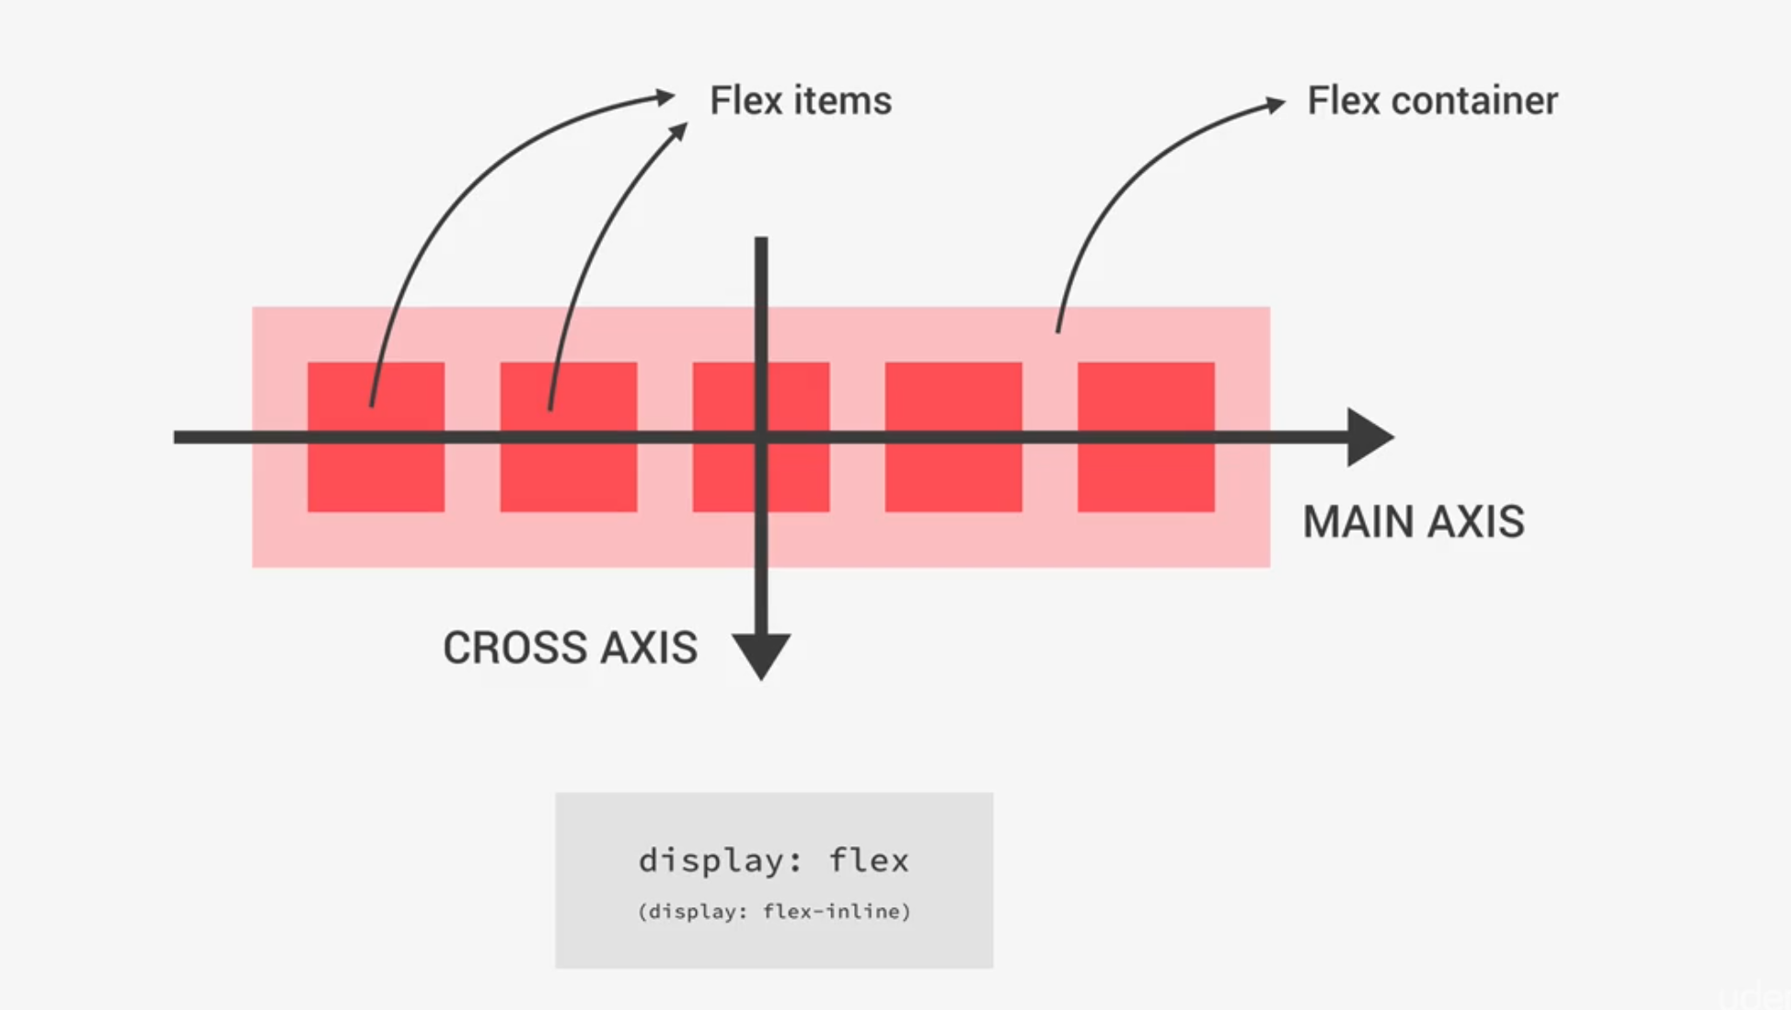

**align-items:** align items CROSS AXIS

**justify-content:** align items MAIN AXIS. It is to control how the items should be positioned along the main axis.

**align-content:** only applies when more than one row of flex items. It aligned CROSS AXIS

**align-self** is similar to align-items, but for one individual flex item

These 3 properties decide the width of the flex items

1. **Flex-grow:** how much an item can grow
2. **Flex-shrink:** how much it can shrink
3. **Flex-basis:** it’s base width

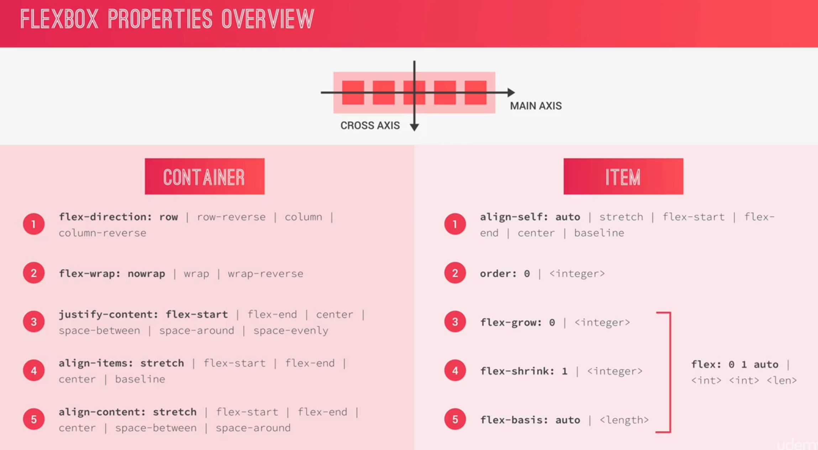

**069 A Basic Intro to Flexbox_ The Flex Container**

**justify-content: space-around**

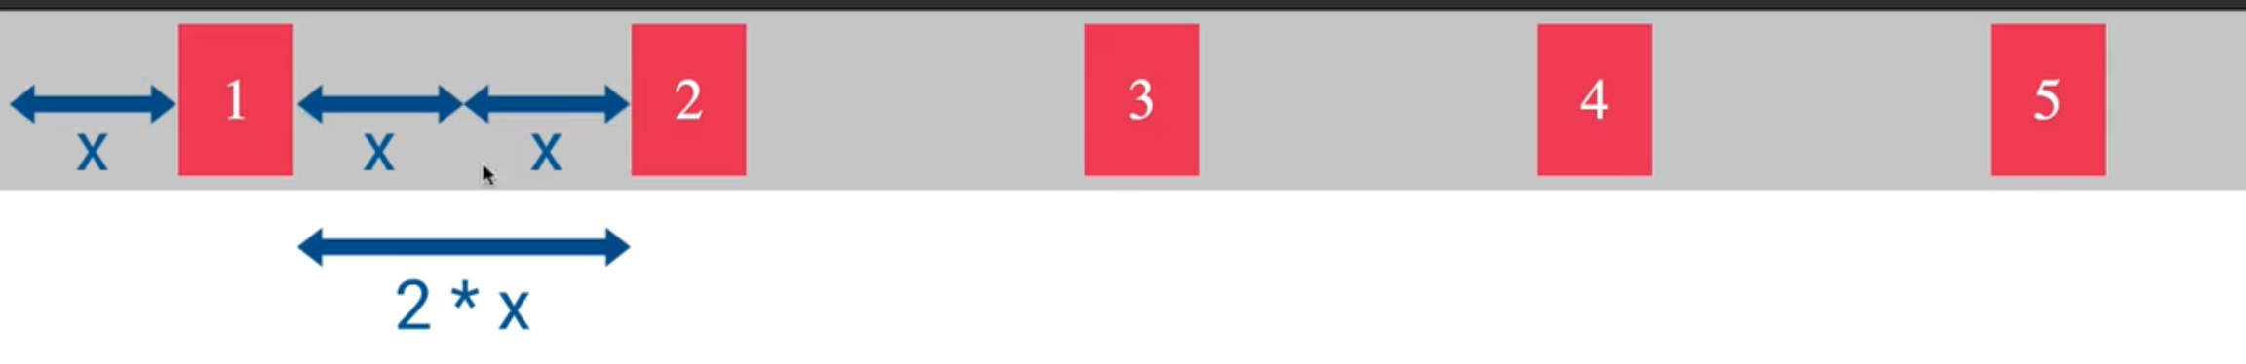

**justify-content: space-evenly**

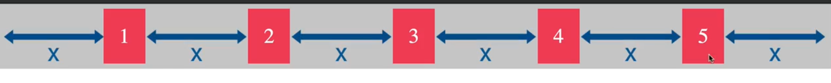

**justify-content: flex-end**

it moves the items on the right side

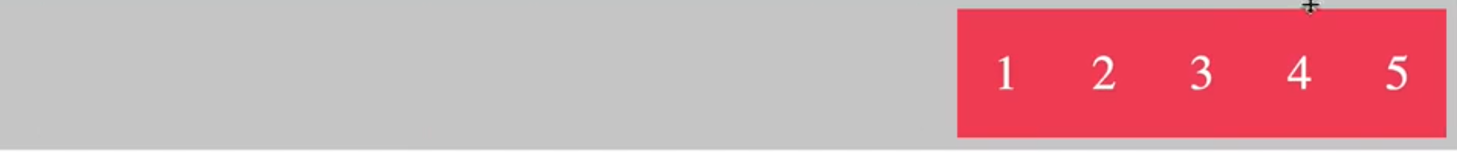

**justify-content: flex-start (default)**

it moves the items on the left side

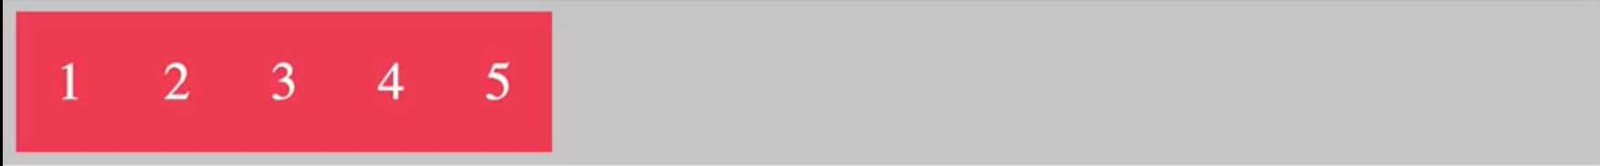

**justify-content: center**

it moves the items on the center



**align-items: center**

if **align-item** is not mentioned, then the size of all the items will be of the bigger one

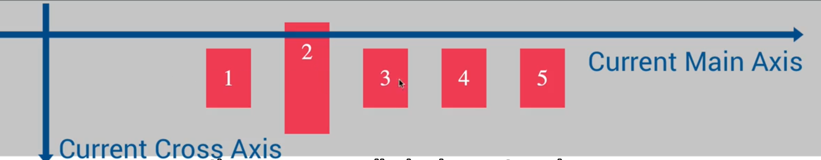

**align-items: flex-start**

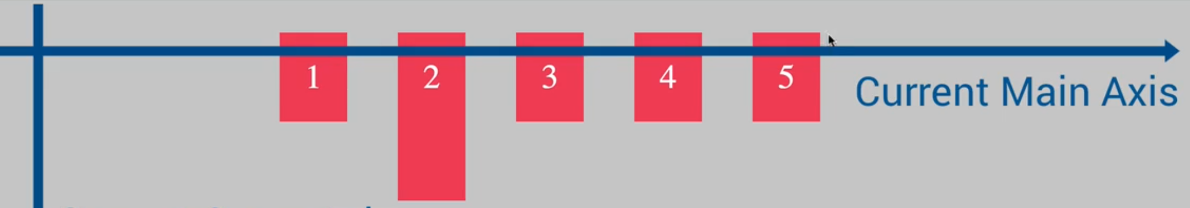

**align-items: flex-end**

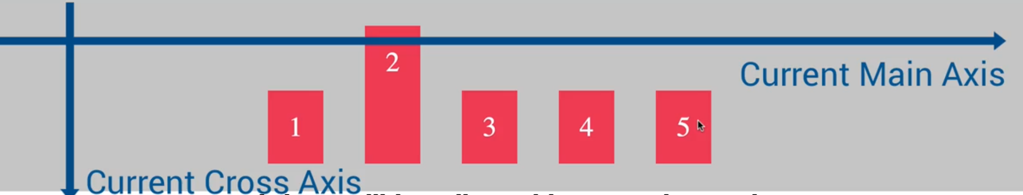

**align-items: stretch (default)**

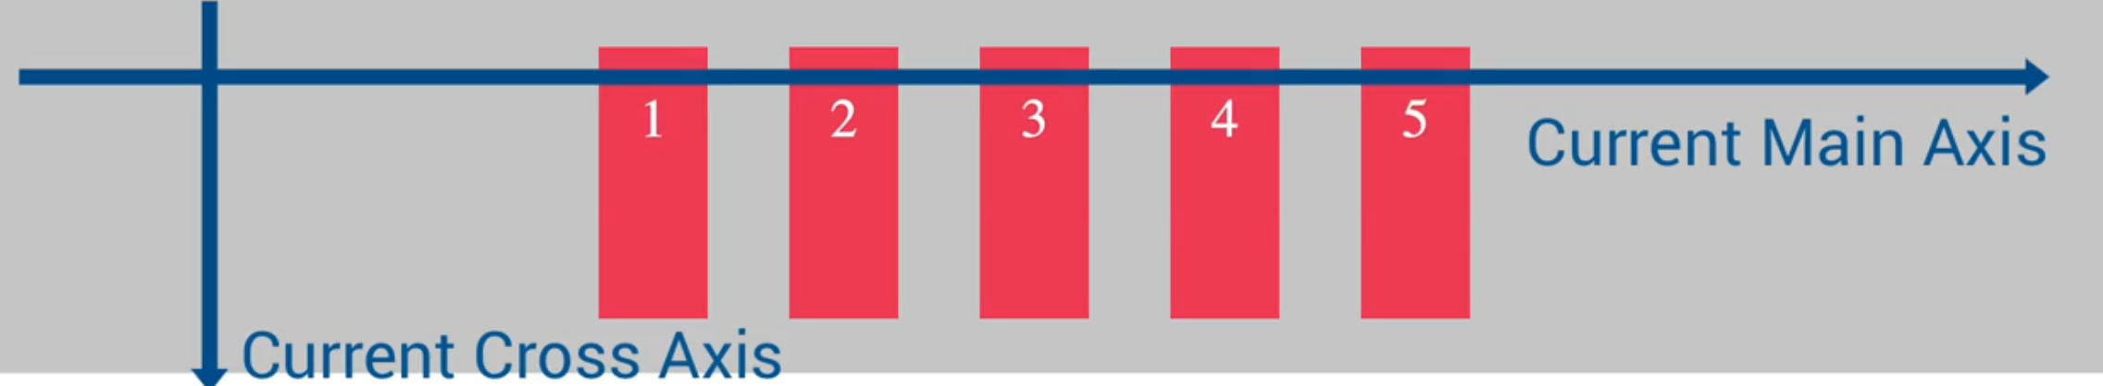

**align-items: baseline**

It keeps the **fonts** on baseline. If you check it by increasing the font size of one of the item.

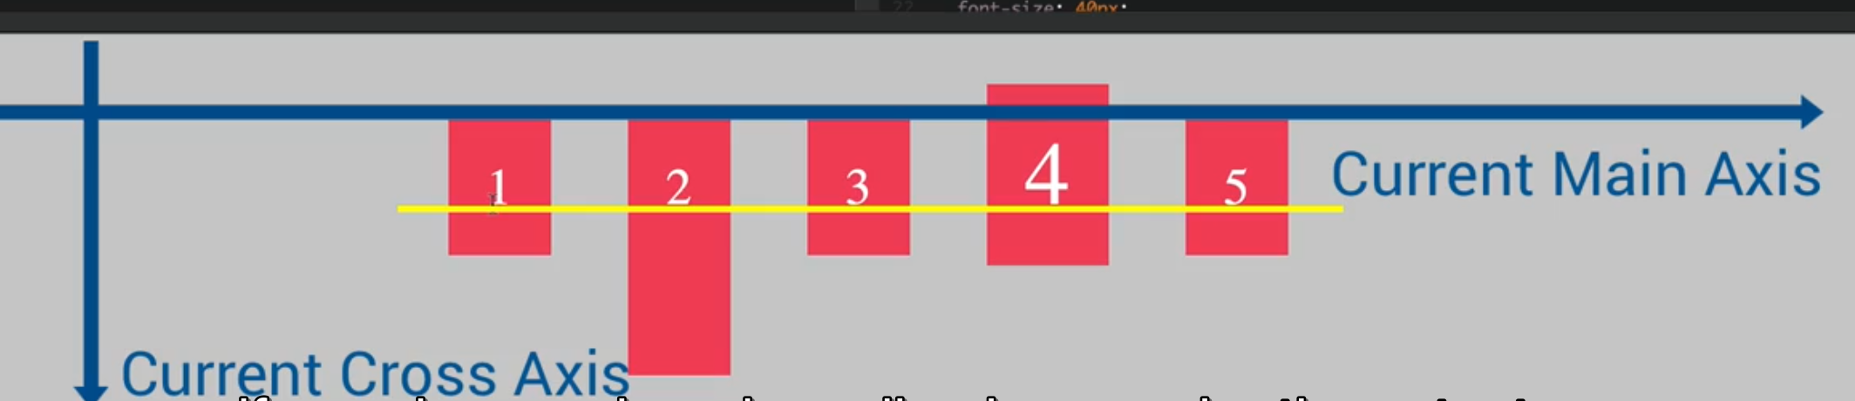

If you change the **flex-direction:column** then **align-items** will work on MAIN AXIS

**flex-direction: column**

**flex-items: flex-start**

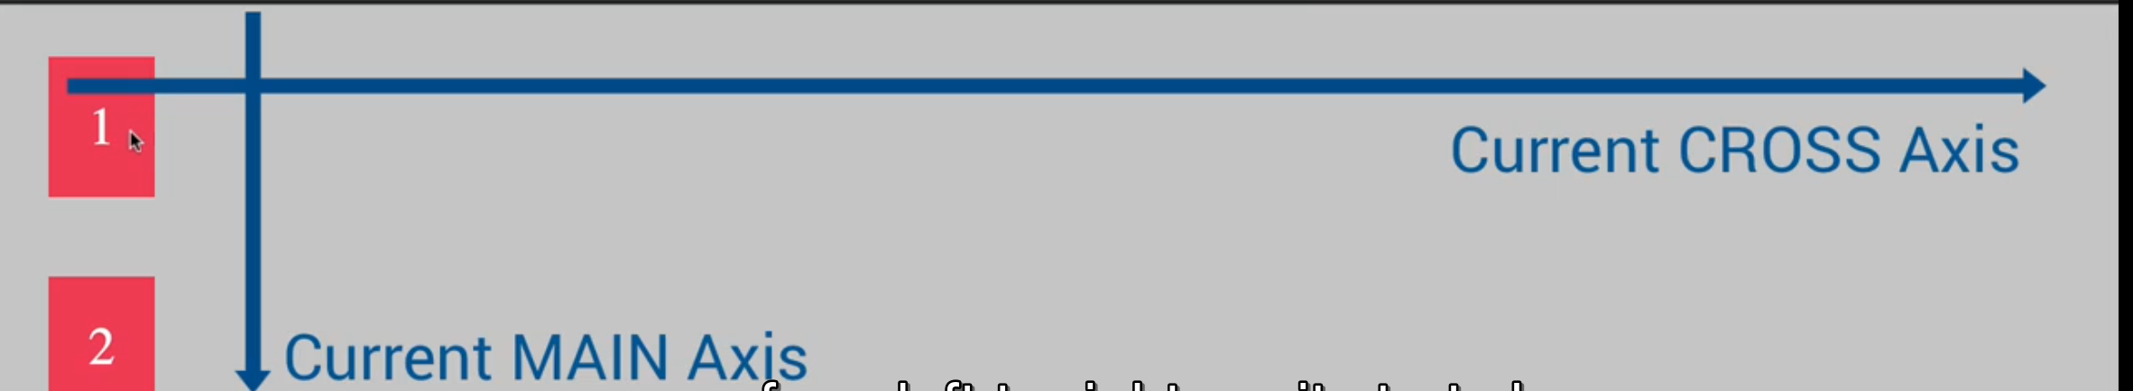

**flex-direction: column**

**flex-items: flex-end**

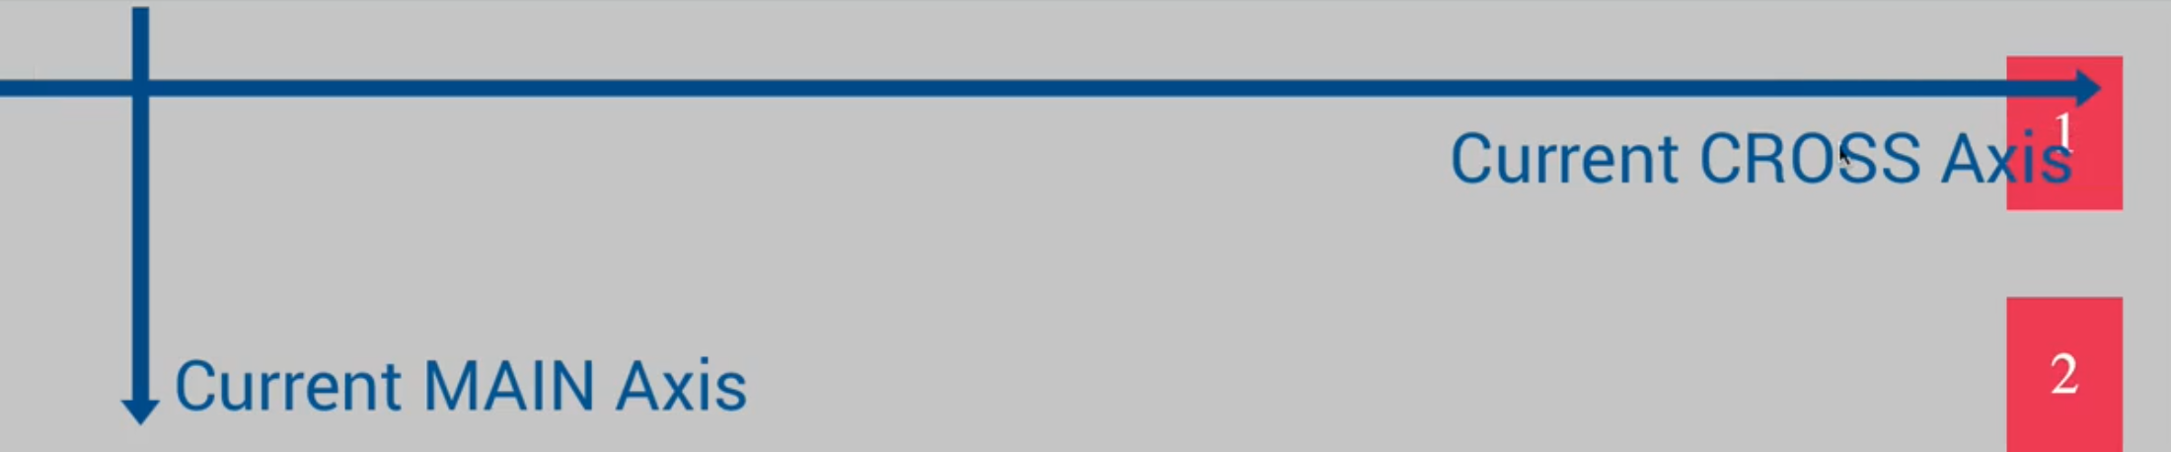

**070 A Basic Intro to Flexbox_ Flex Items**

**align: self:** it overrides the default alignment of parent flex container on the **Cross-Axis**

**align-self: flex-end**

add it on item 4

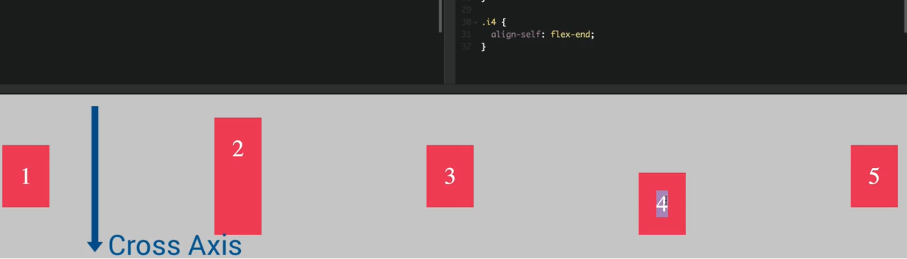

**align-self: flex-start**

add it on item 4

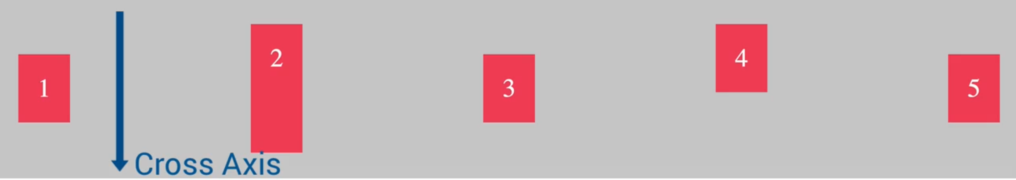

**align-self: stretch**

adds it on item 4. It increases the height of the maximum height item in the flex container

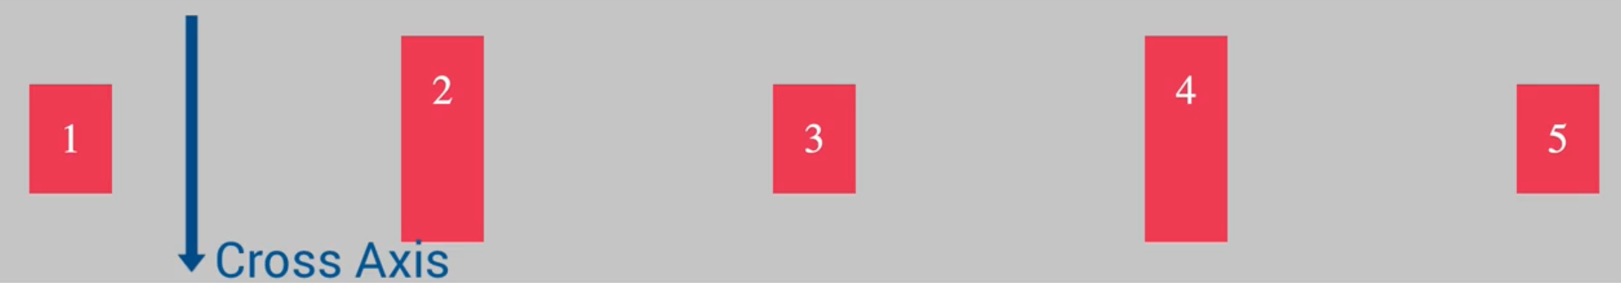

**align-self: stretch**

**order: -1**

order: -1 is to move to first position. Here we have moved the item 4 to first position.

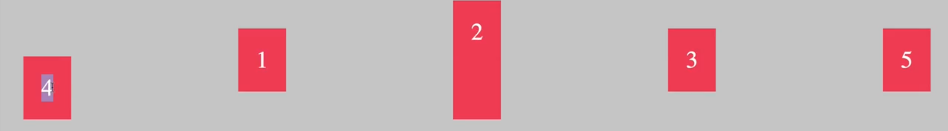

**Note:**

1. Item 4 is -1
2. Item 3 is 1

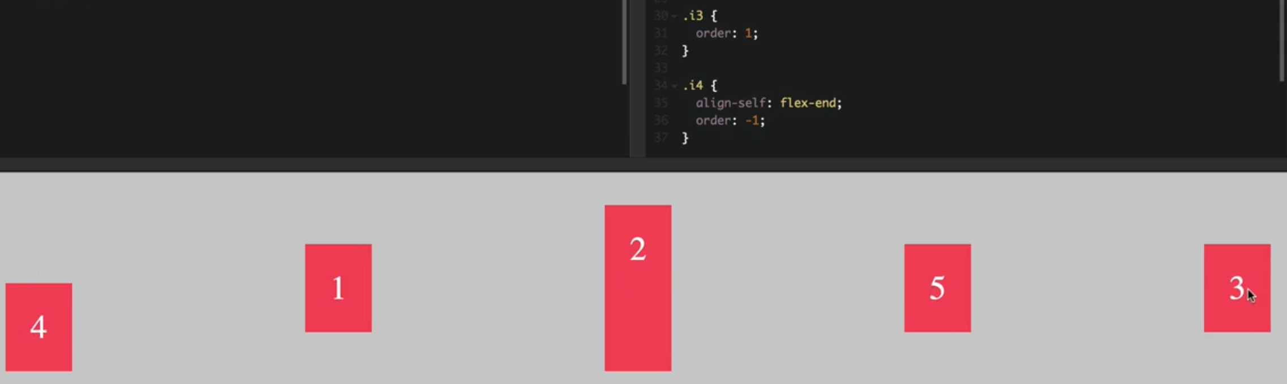

The reason why item 3 is at the end is due to this order lowest to highest

**Order**

4 === -1

1 === 0

2 === 0

5 === 0

3 === 1

**flex-grow:** is the ability of an element to grow and we specify an integer for it. It works in relation with other elements. *It is specific to flex items.*

*Flex-grow === flex. We can use it without grow. It is a shorthand property*

You can see in the example that it is 3 times bigger than the other items

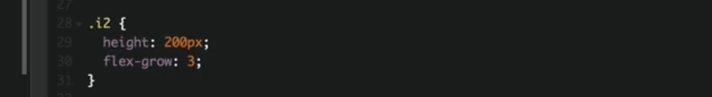

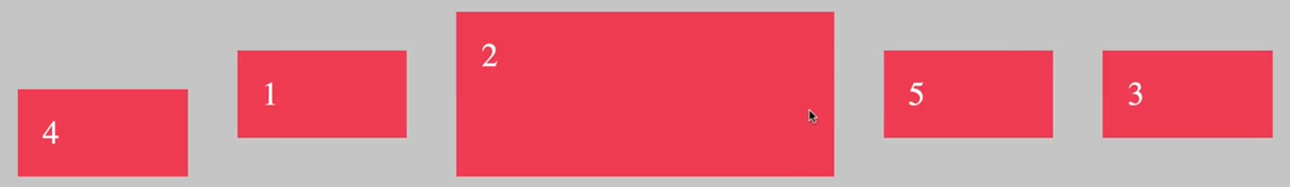

if flex is only set on one of the items then it will take the rest of the width

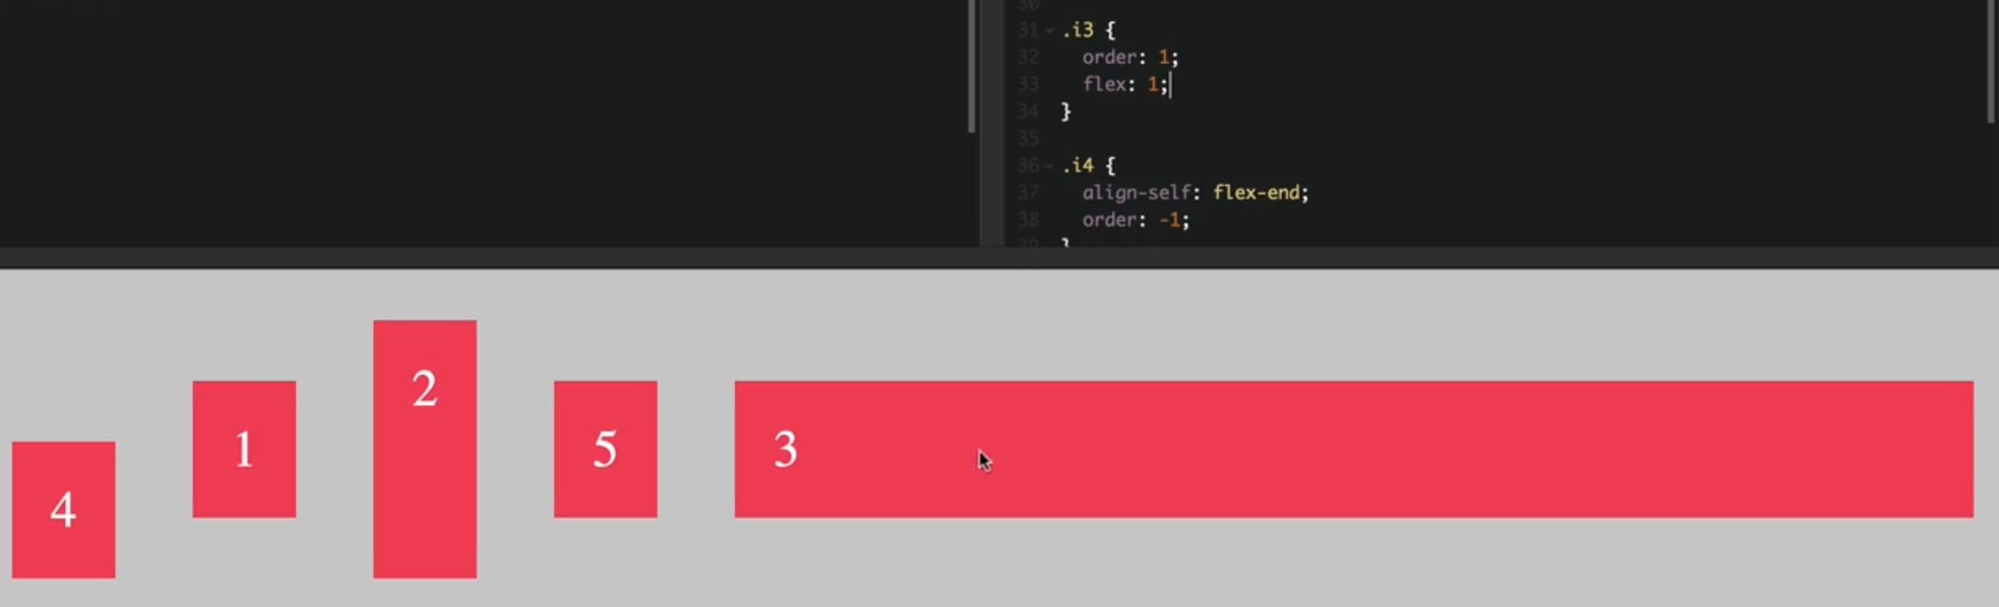

**flex-basis:** with flex basis, we can set width of a flex item

on item 2 we set width to 20%

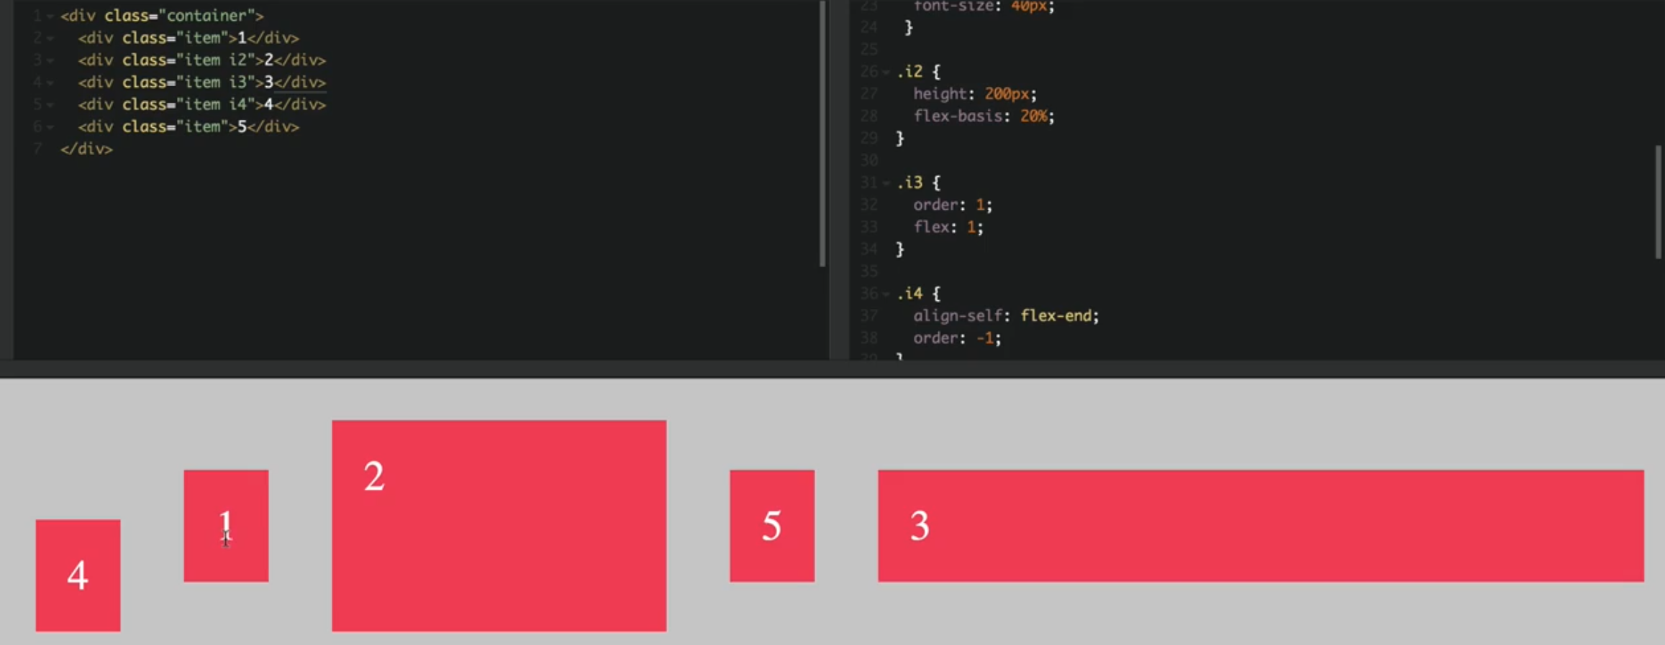

**flex-shrink: 1 =>** 1 means, it allows the element to shrink while changing window size

0 means, it does not allow the element to shrink while changing window size

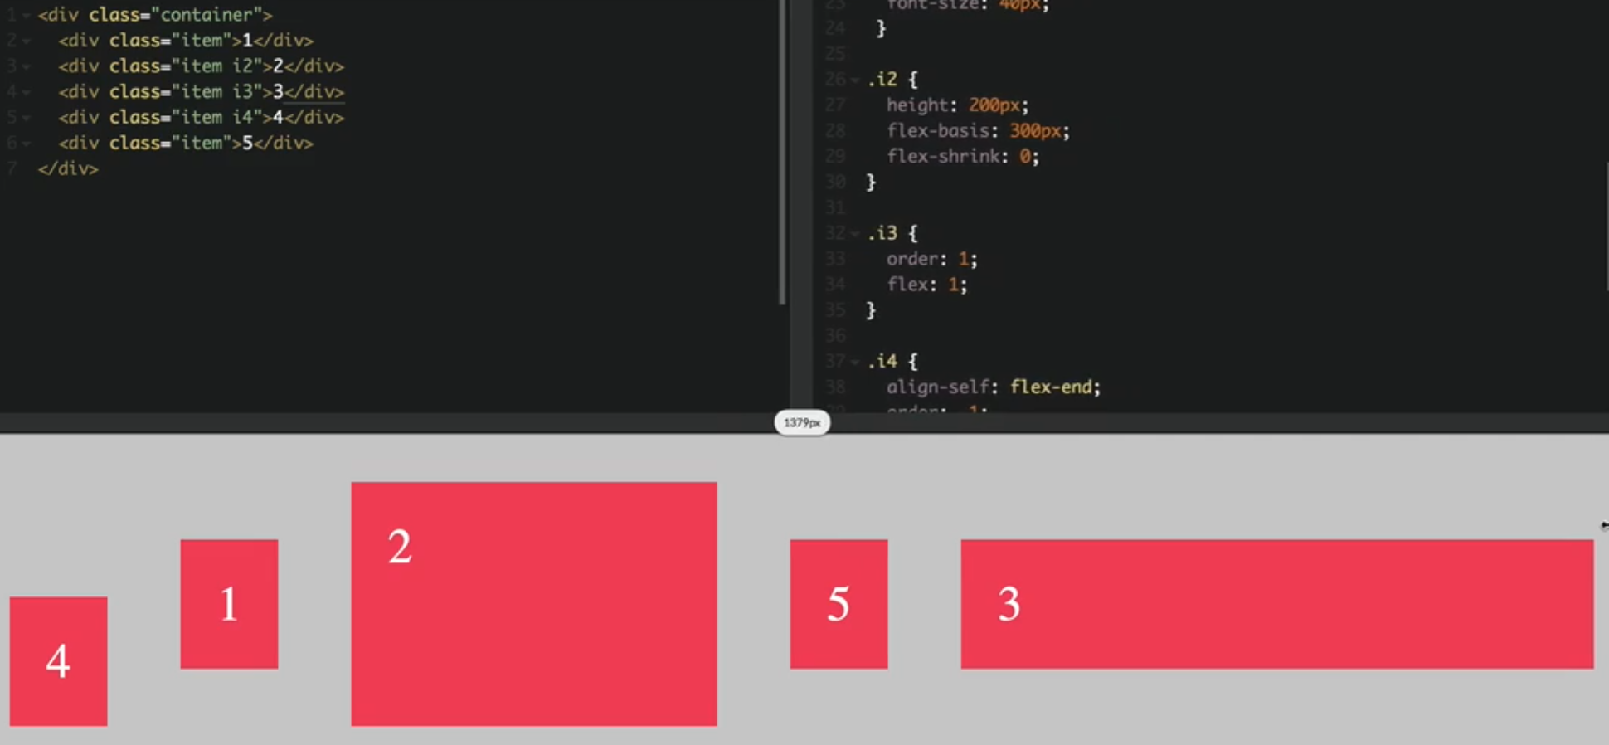

The shorthand property

Flex-grow, flex-shrink, width

**Flex: 0 0 300px**

**071 A Basic Intro to Flexbox_ Adding More Flex Items**

**flex-wrap:** sets to flex container and it moves down the elements which are not fit in the container width.

**align-content: flex-start =>** it aligns the entire rows along the cross axes.

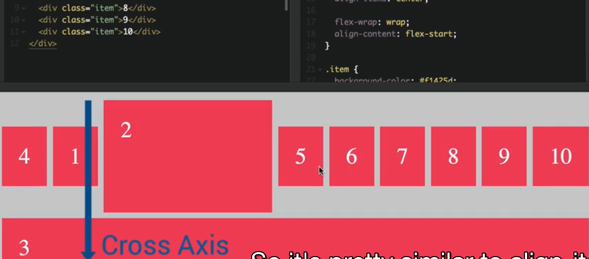

All these actions will apply on the entire row

**align-content: center**

**align-content: space-around**

**align-content: space-between**

**072 Project Overview**

create scss folder and with these three files

1. _base.scss
2. _components.scss
3. _layout.scss
4. main.scss

**073 Defining Project Settings and Custom Properties**

Basic project settings

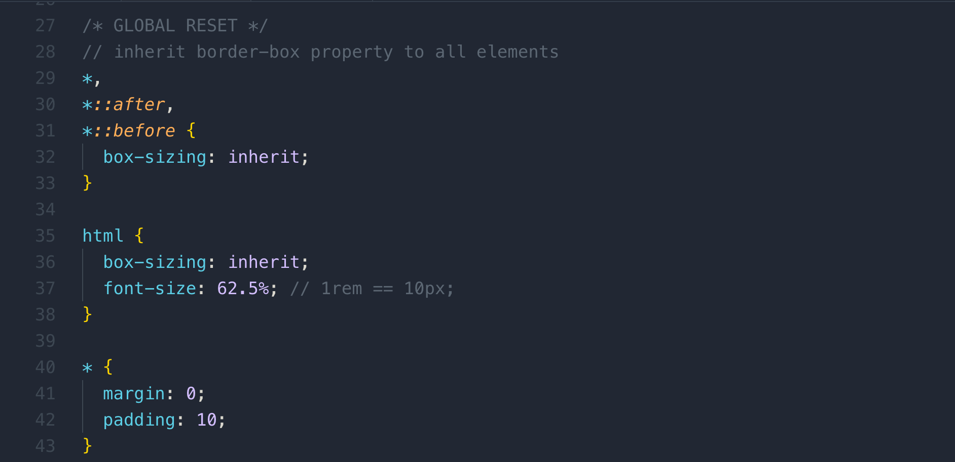

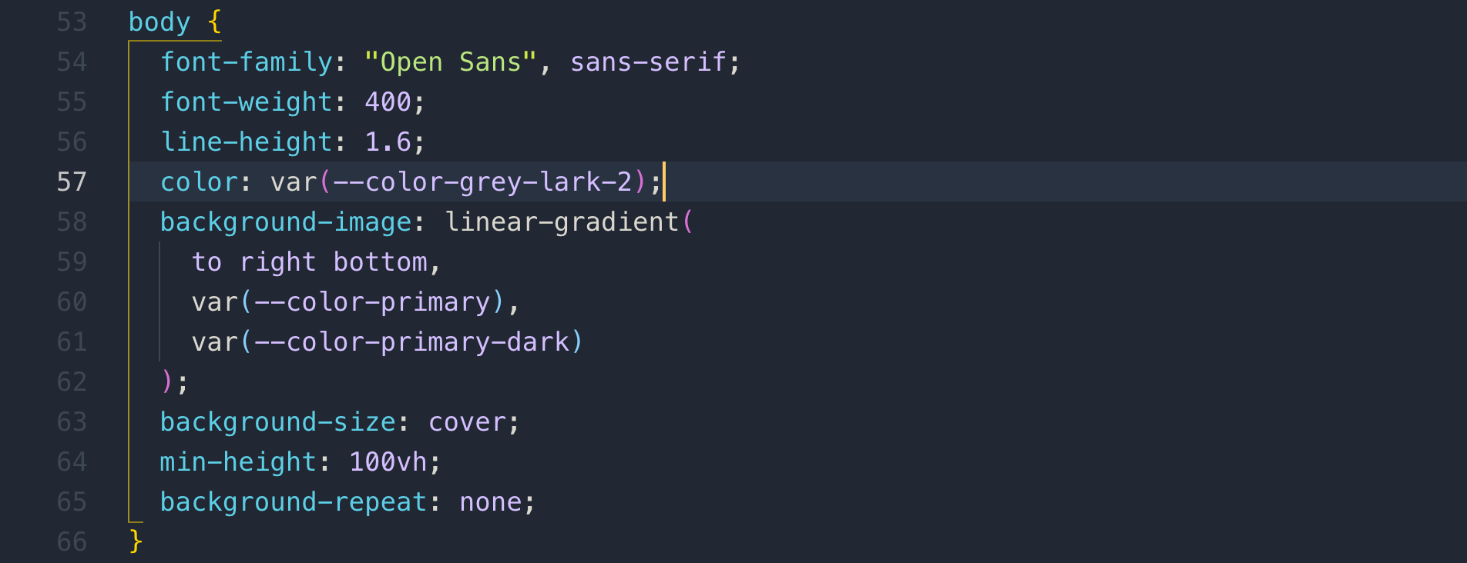

# . How and why use CSS custom properties?

**Note:** CSS custom properties are better known as CSS variable. We can use CSS variables and we don’t have to rely on SCSS variables.

We use CSS variables with **var(),** and we don’t need a pre-processor because now CSS can natively handle “**CSS variables”.** The other advantage is that they can be manipulated in JavaScript and can be edit in dev tools.

It is accessible in block and its child element so we use pseudo root to declare all the **CSS variables** a **pseudo root** has higher specificity

**Note:**

:root pseudo class => this is the same thing as html selector, but with higher specificity. html is the global parent element

We define css variable with double minus sign like --proeprtyName as shown below

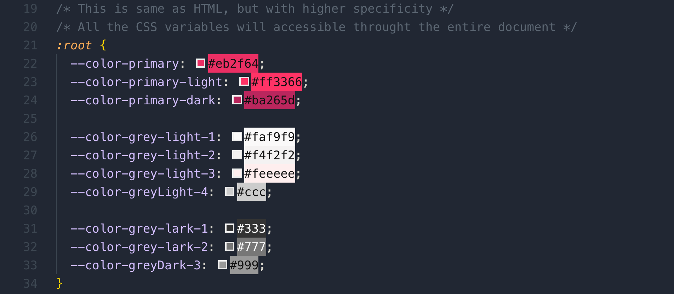

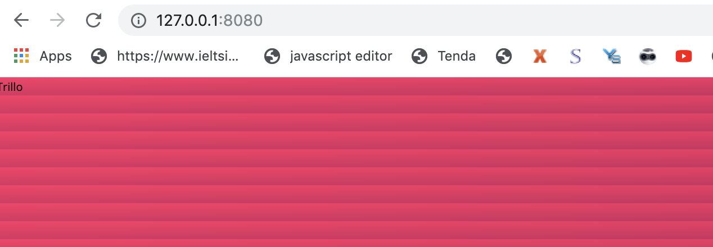

The above effect happened because the body’s height is only the height of the font so the background repeated and this is default behaviour of a browser so to look as we want make

background-repeat: no-repeat;

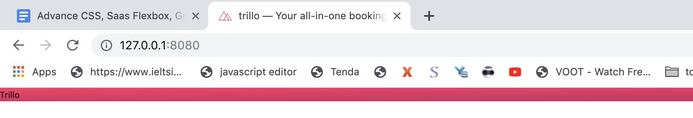

We need to add one more property to show gradient on the entire page which is

min-height: 100vh;

**074 Building the Overall Layout**

**_layout.scss**

**max-width:** if we have enough space it will take 1200px, but if don’t have enough space like viewport is less than 1200px then we simply occupy 100% of the available space.

shadow properties:

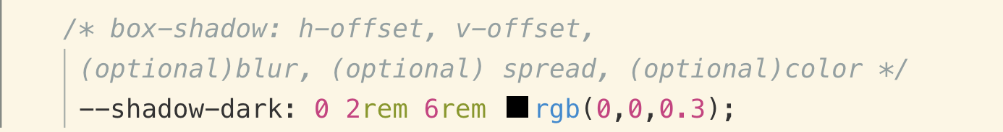

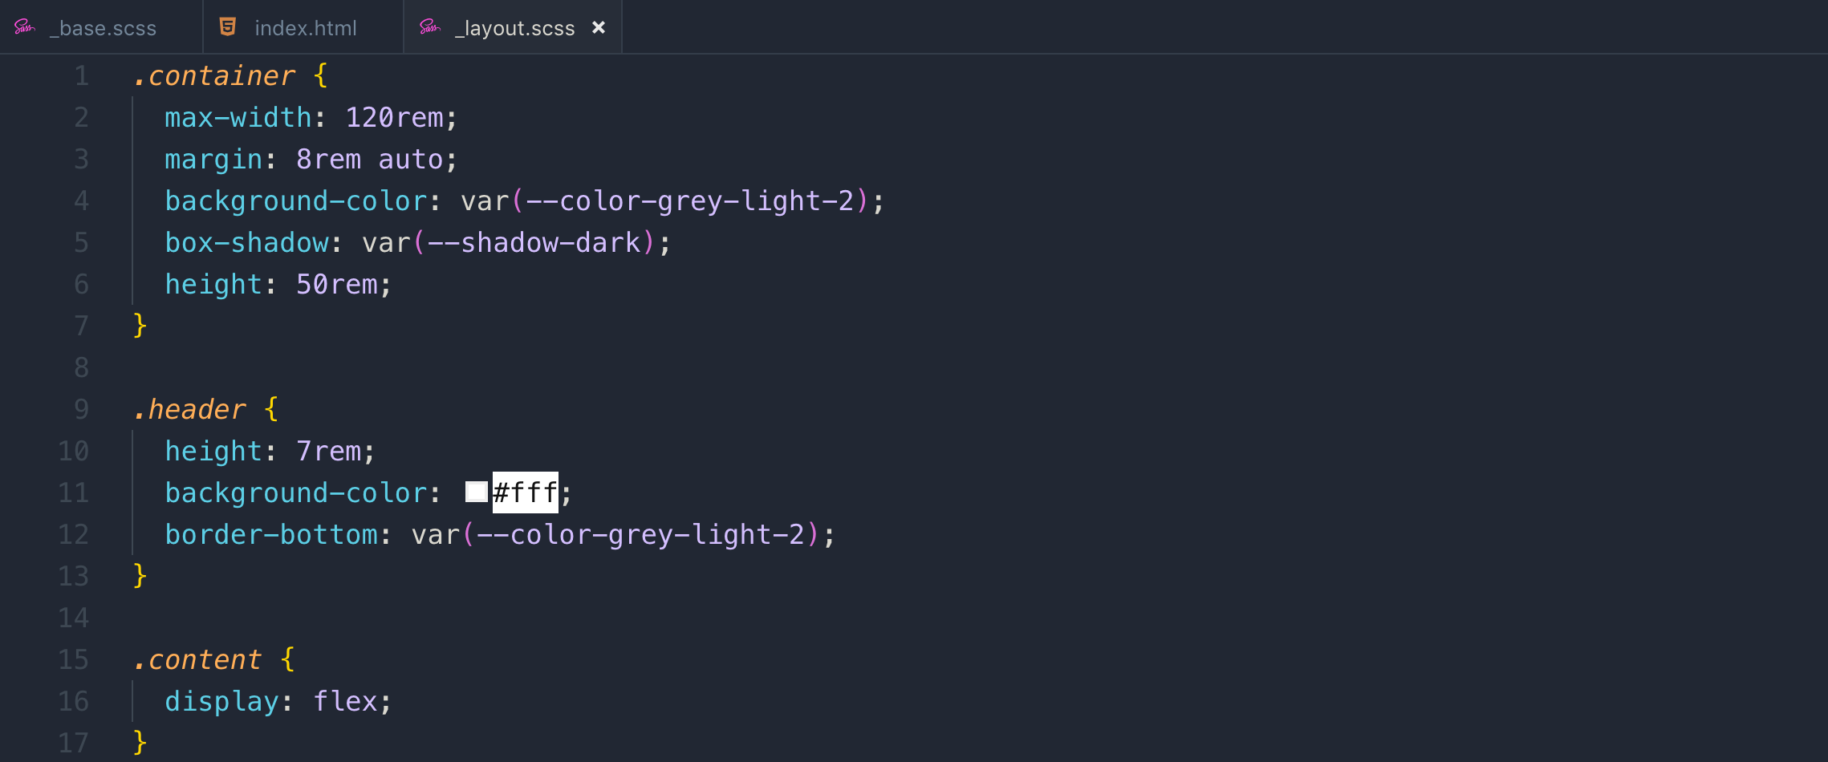

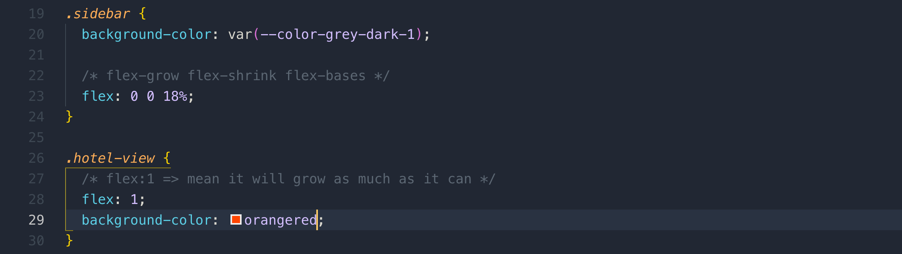

*/\**

*1. we don't want element to grow if there is space*

*2. we don't want element to shrink if there is no space*

*3. we want it's width to 18% of the viewport*

*\*/*

flex: 0 0 18%;

*/* grow element as much as it can */*

flex:1;

**index.html**

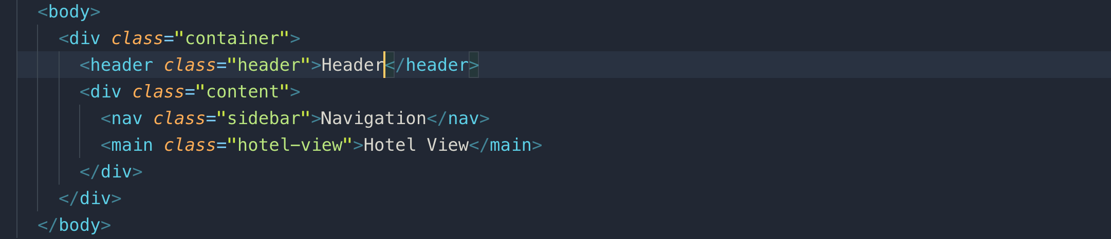

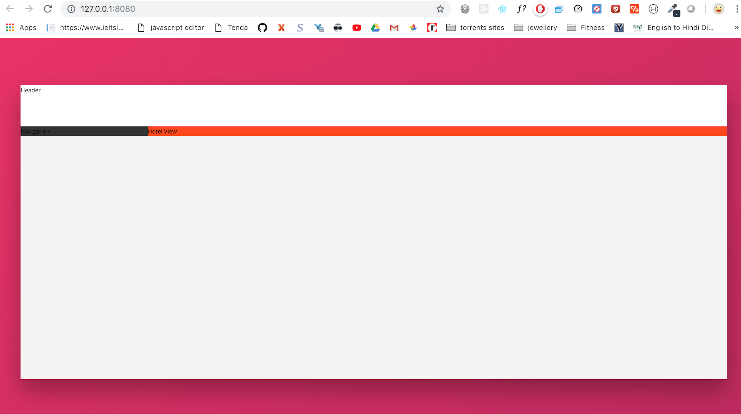

**075 Building the Header - Part 1**

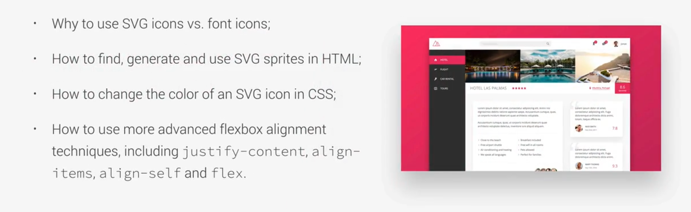

**Q Why to use SVG icons vs font icons?**

We will use SVGs instead of icon fonts. There are several problems with icon-fonts that it is just a hack which are like images using a font. Icon-fonts fail more often than you think and in the case a browser just display a black square or something like that.

There are other issues like screen readers for blind people trying to read out the icon fonts and failing to do so.

It’s a best practice to move away from icon-fonts and use SVGs instead.

**Note:** SVGs only works on a web server!!!

**SVG:** scalable vector graphics: It is a way of writing vector graphic with code.

To create SVG icons

<https://icomoon.io/>

We are choosing from Entypo+ icons. We need to copy SVG folder and svg sprite file to our project

change name “symbol-defs.svg” => sprite.svg

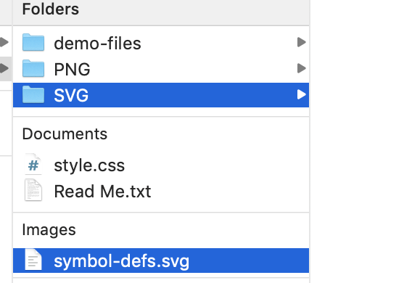

**JPEG** : in smaller image size, you get sufficient quality

**PNG**: supports transparency

**GIF** : supports 256 colors and animation

**Tiff**: raster image and provides high contrast. it is recommended for photographers, book, or broucher

**SVG**: when you zoom in “JPEG, PNG, GIF” they get blurred, because they are confined to particular dimensions and colors

**xlink:href:** => it is the way to include SVG file and reference to each separate icon in sprite image

to reference to a particular icon in the SVG sprite file => sprite.svg#icon-name

This is the way we add SVG

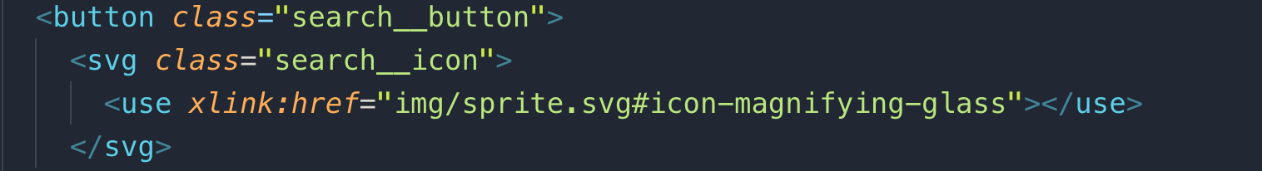

Another advantage of SVG is that we can easily format these icons.

Let’s see how do we format SVG icon. Just set height and width

&__icon {

height: 2.25rem;

width: 2.25rem;

fill: #888878;

}

to change the color of SVG icon with use “fill” property

**076 Building the Header - Part 2**

flex item can also be a flex container. This is called nested flexbox.

Select adjacent input element. It is to select sibling elements.

**Note:** input element doesn’t inherit font-family, font-size, and color of the global document so we have to manually set to to inherit it

&__input {

font-family: inherit;

font-size: inherit;

color: inherit;

}

*/* Select next sibling button input when it is focused */*

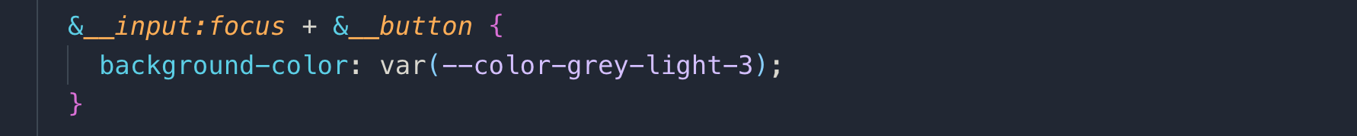

Now let’s see how to change the color of SVG icons. We do it using “fill”

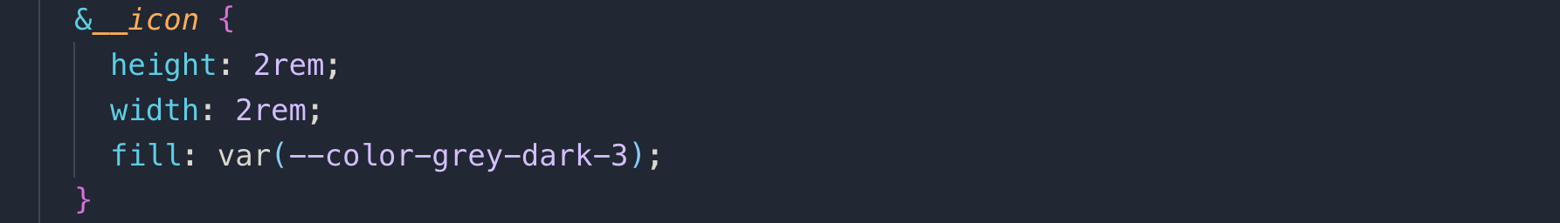

For styling placeholder text, we use “-webkit-input-placeholder” it only works with chrome and safari

&::-webkit-input-placeholder {

font-weight: 100;

color: var(--color-grey-light-4);

}

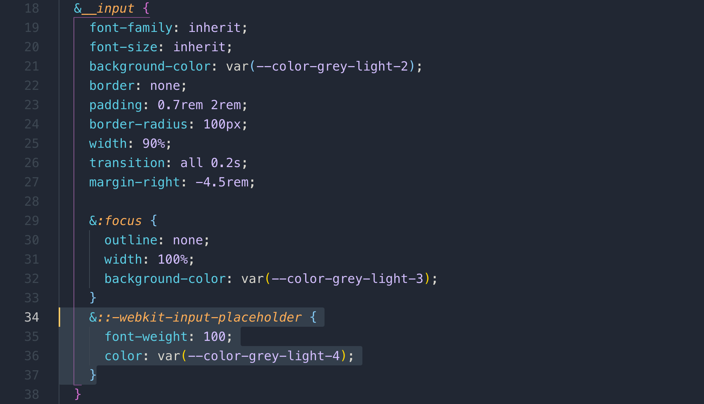

**077 Building the Header - Part 3**

Now format the right section in the below image



We will again use “nested flexbox”;

Select all the direct children and it’s hover

To take full vertical space of a specific flex-item is to use “align-item:streatch”

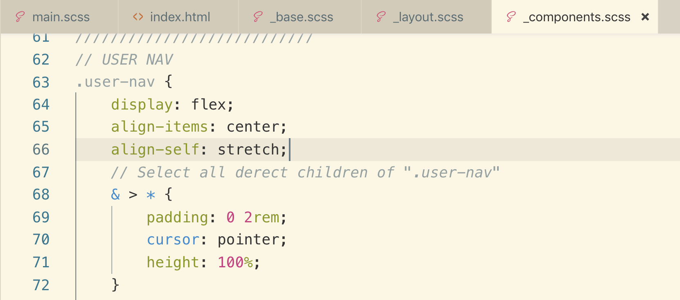

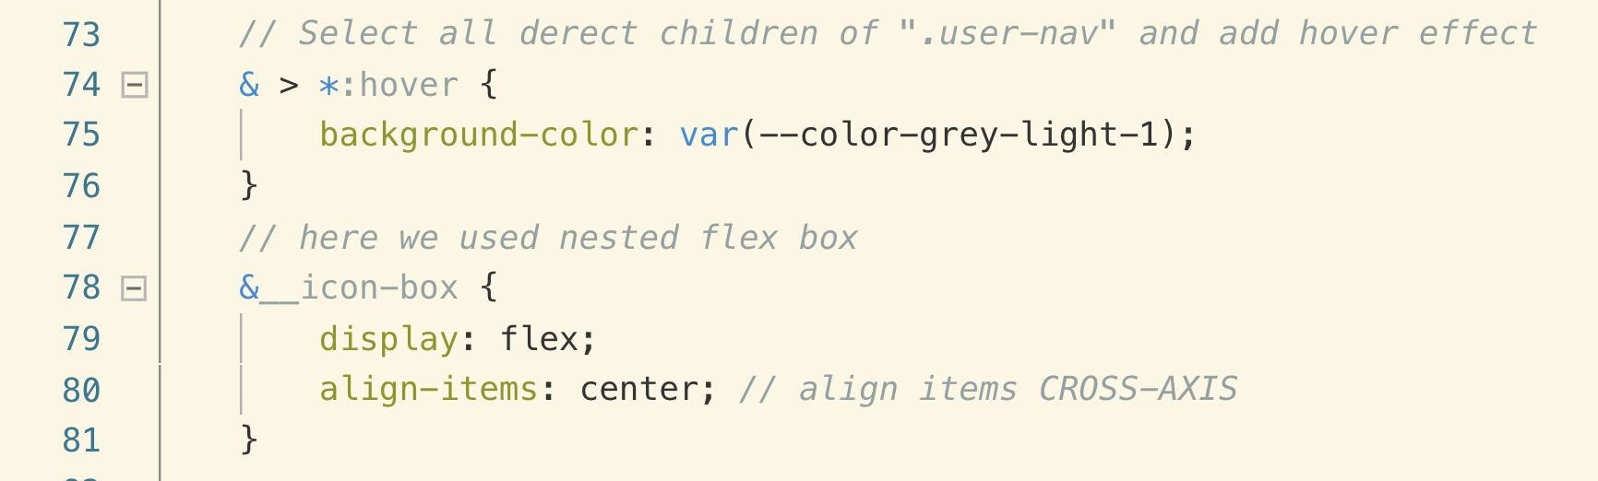



Now let’s change the icons color and notification

We will use “position:absolute” to set the notification to the top of the icons

&__icon-box {

display: flex;

align-items: center; *// align items CROSS-AXIS*

position: relative;

}

&__icon {

height: 2.25rem;

width: 2.25rem;

fill:var(--color-grey-dark-2);

}

&__notification {

background-color: var(--color-primary);

height: 1.75rem;

width: 1.75rem;

border-radius: 50%;

font-size: .8rem;

color: var(--color-white);

}

With above notification CSS it will look like this.



you notices image is not circle properly. if radius is not making proper circle you can try these things

1. adjusting the height and width will fix it
2. make sure that height and width must be of same size.
3. you can set radius in pixel with higher number like **border-radius:100px**

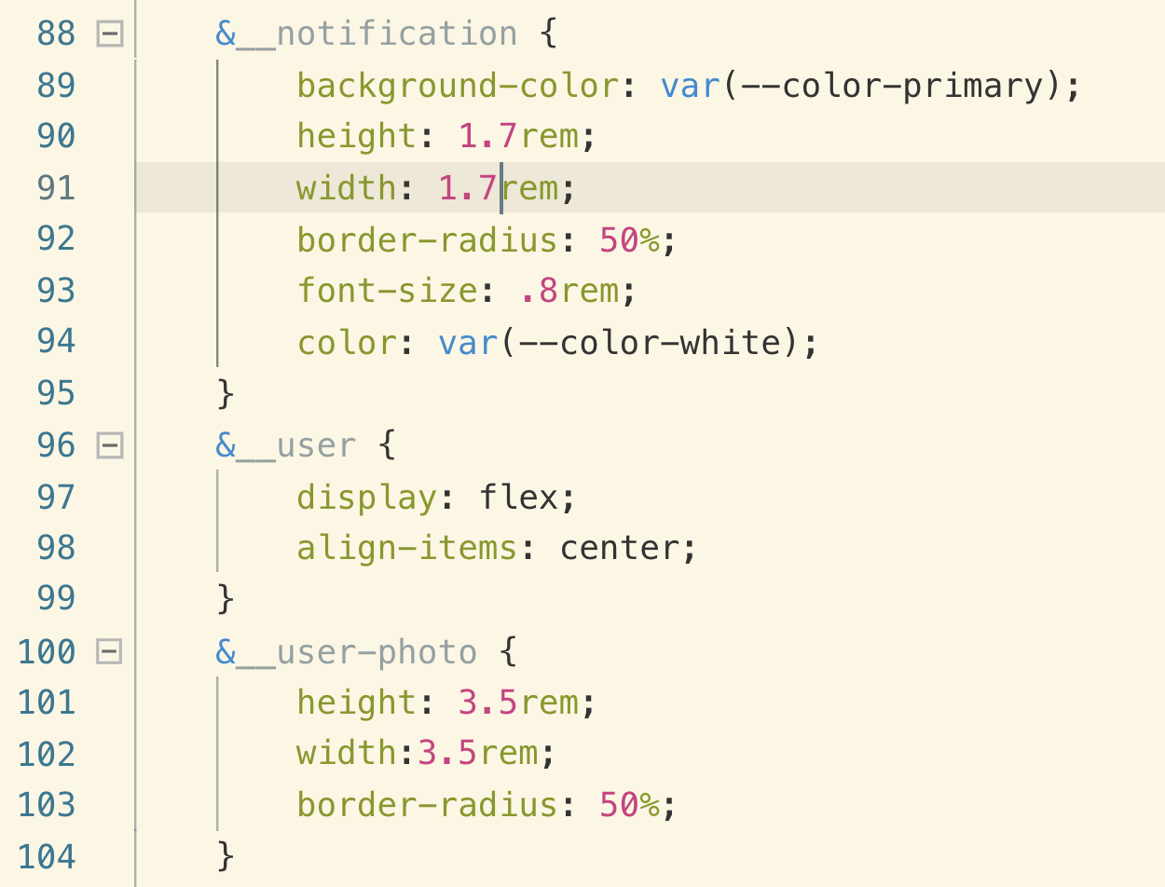



Now adjusting the position of the notification using “position:absolute”

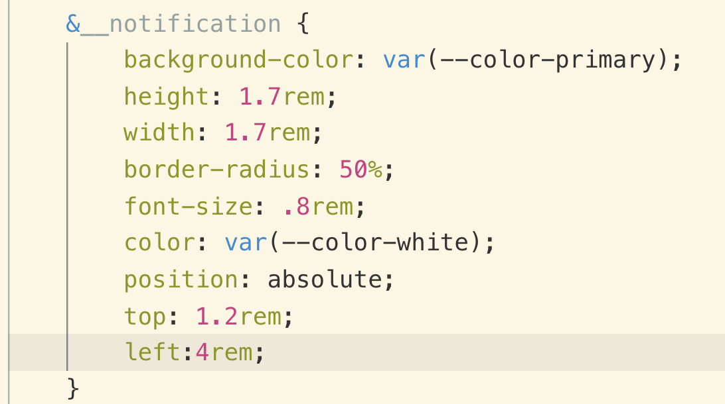

Now let’s center the notification text using “flex”

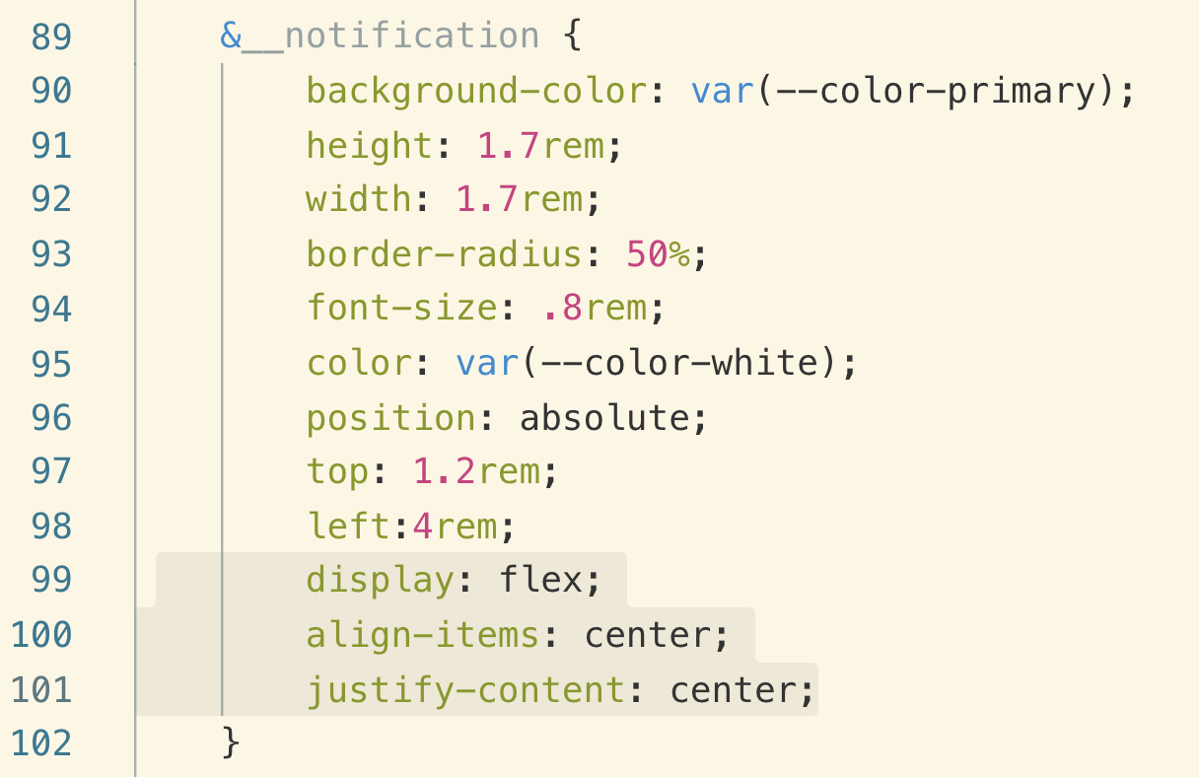



To create the space between photo and name we used margin-right

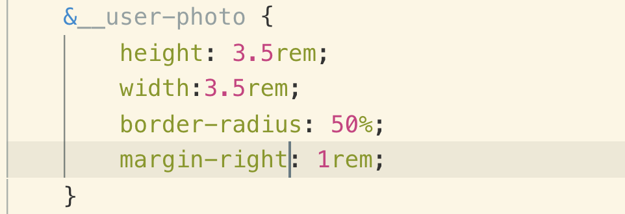



078 Building the Navigation - Part 1

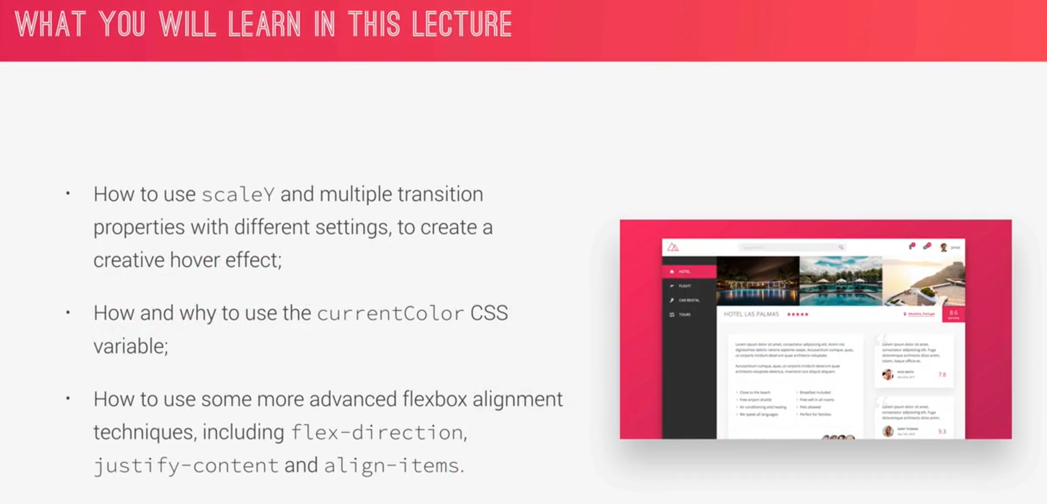

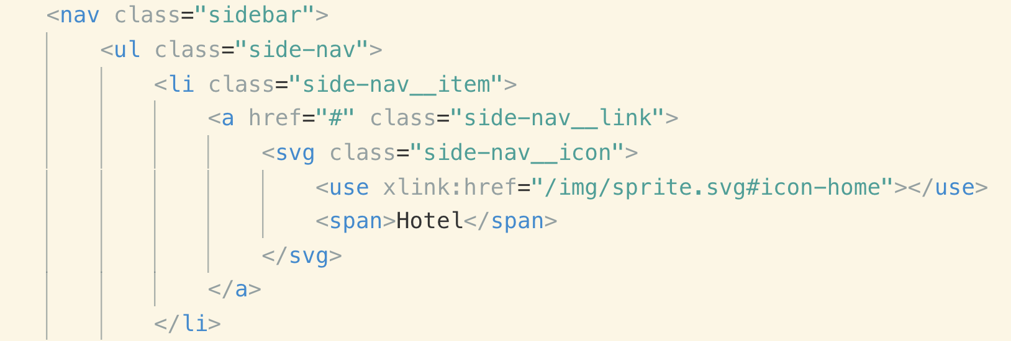

This is how they are looking with the above HTML

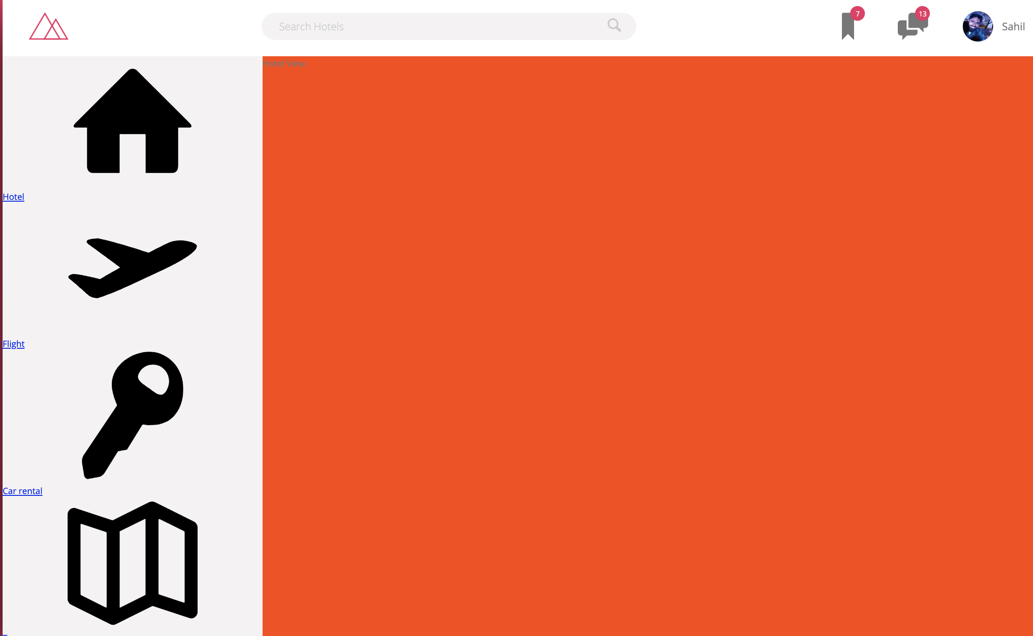

Let’s style them with CSS

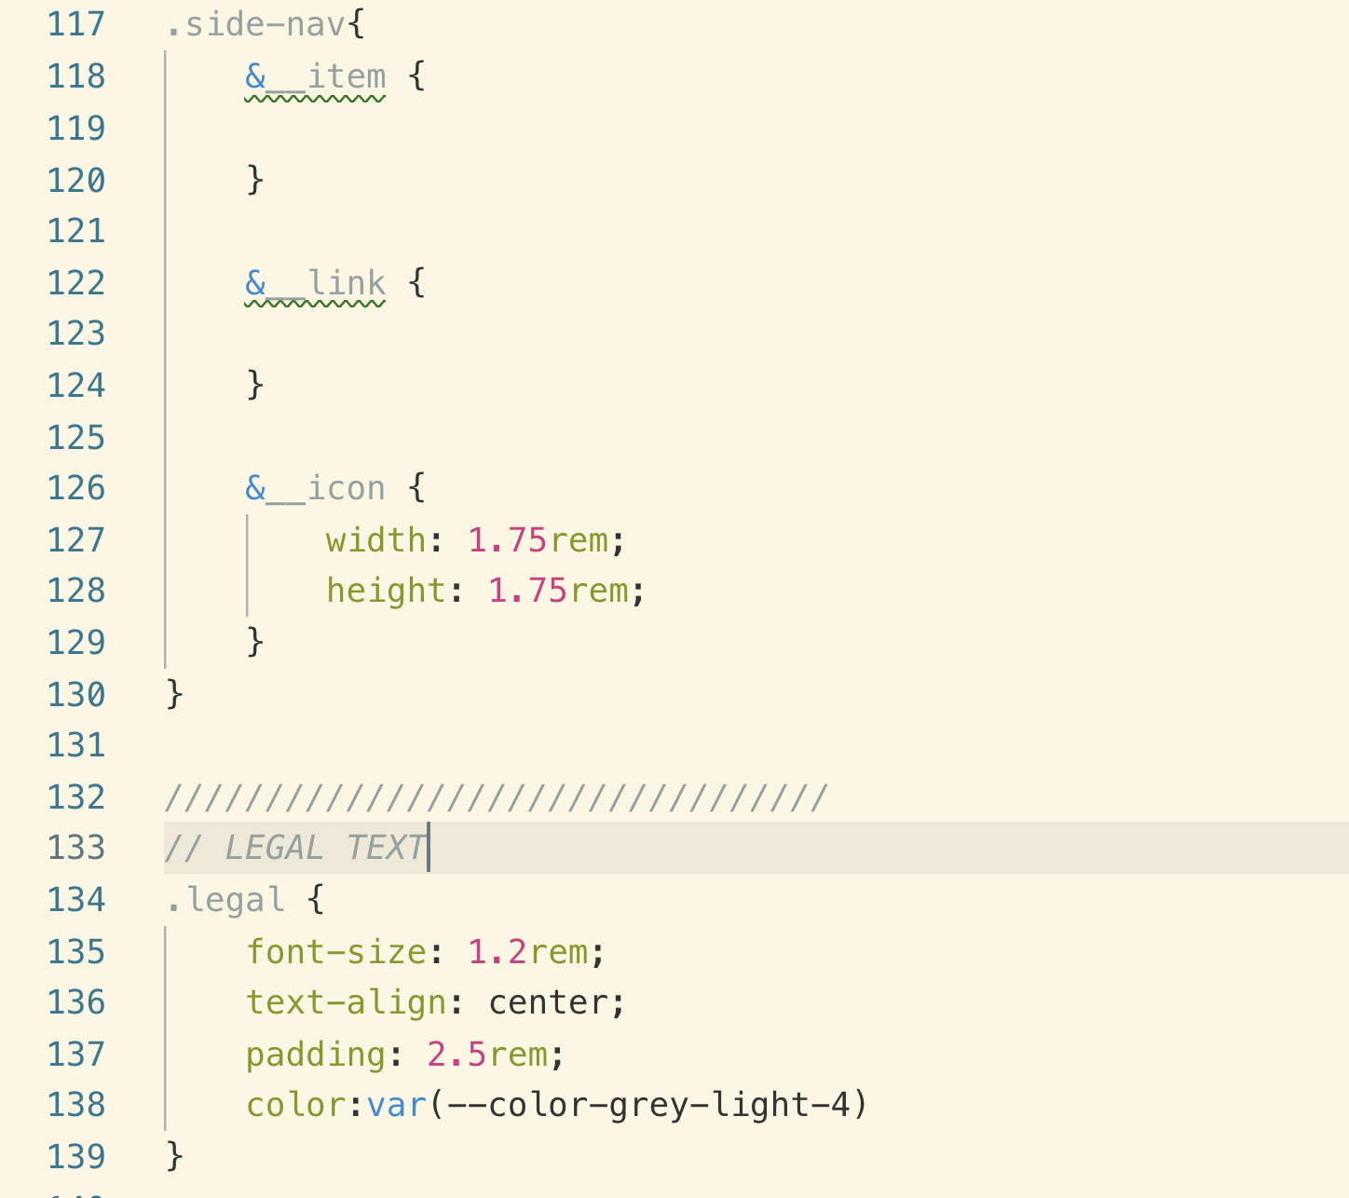

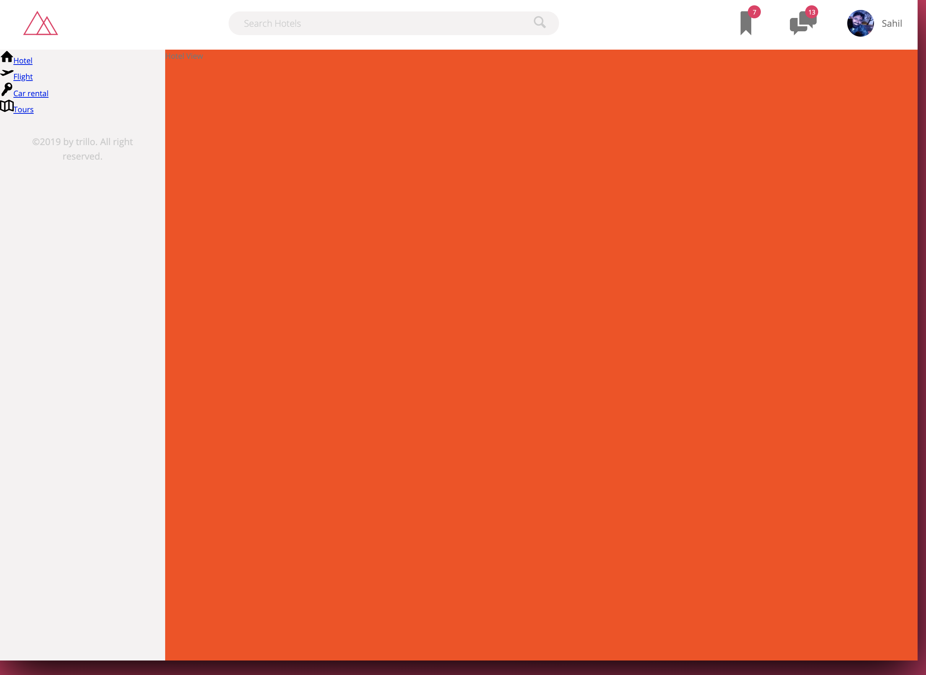

Now let’s see how to move the copywrite down to bottom using “flex-direction:column”

**_layout.scss**

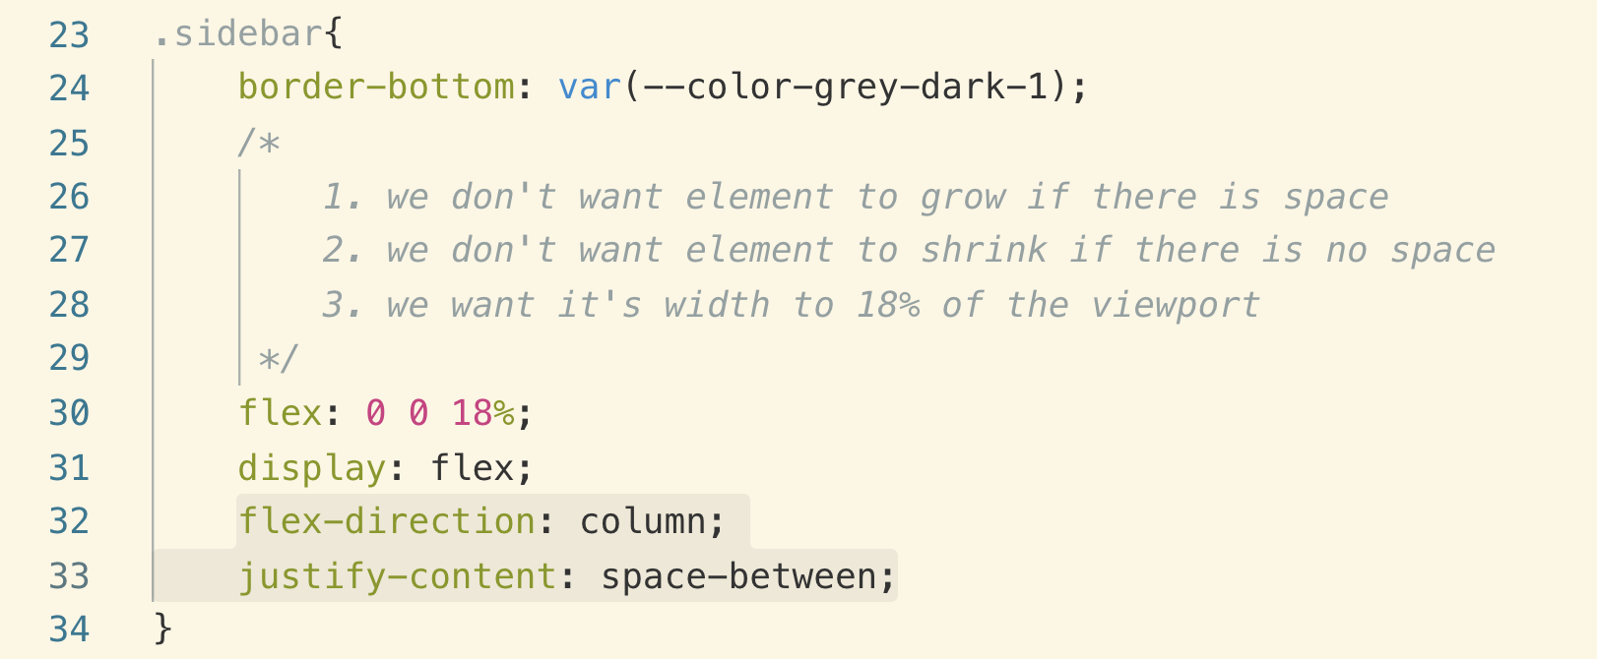

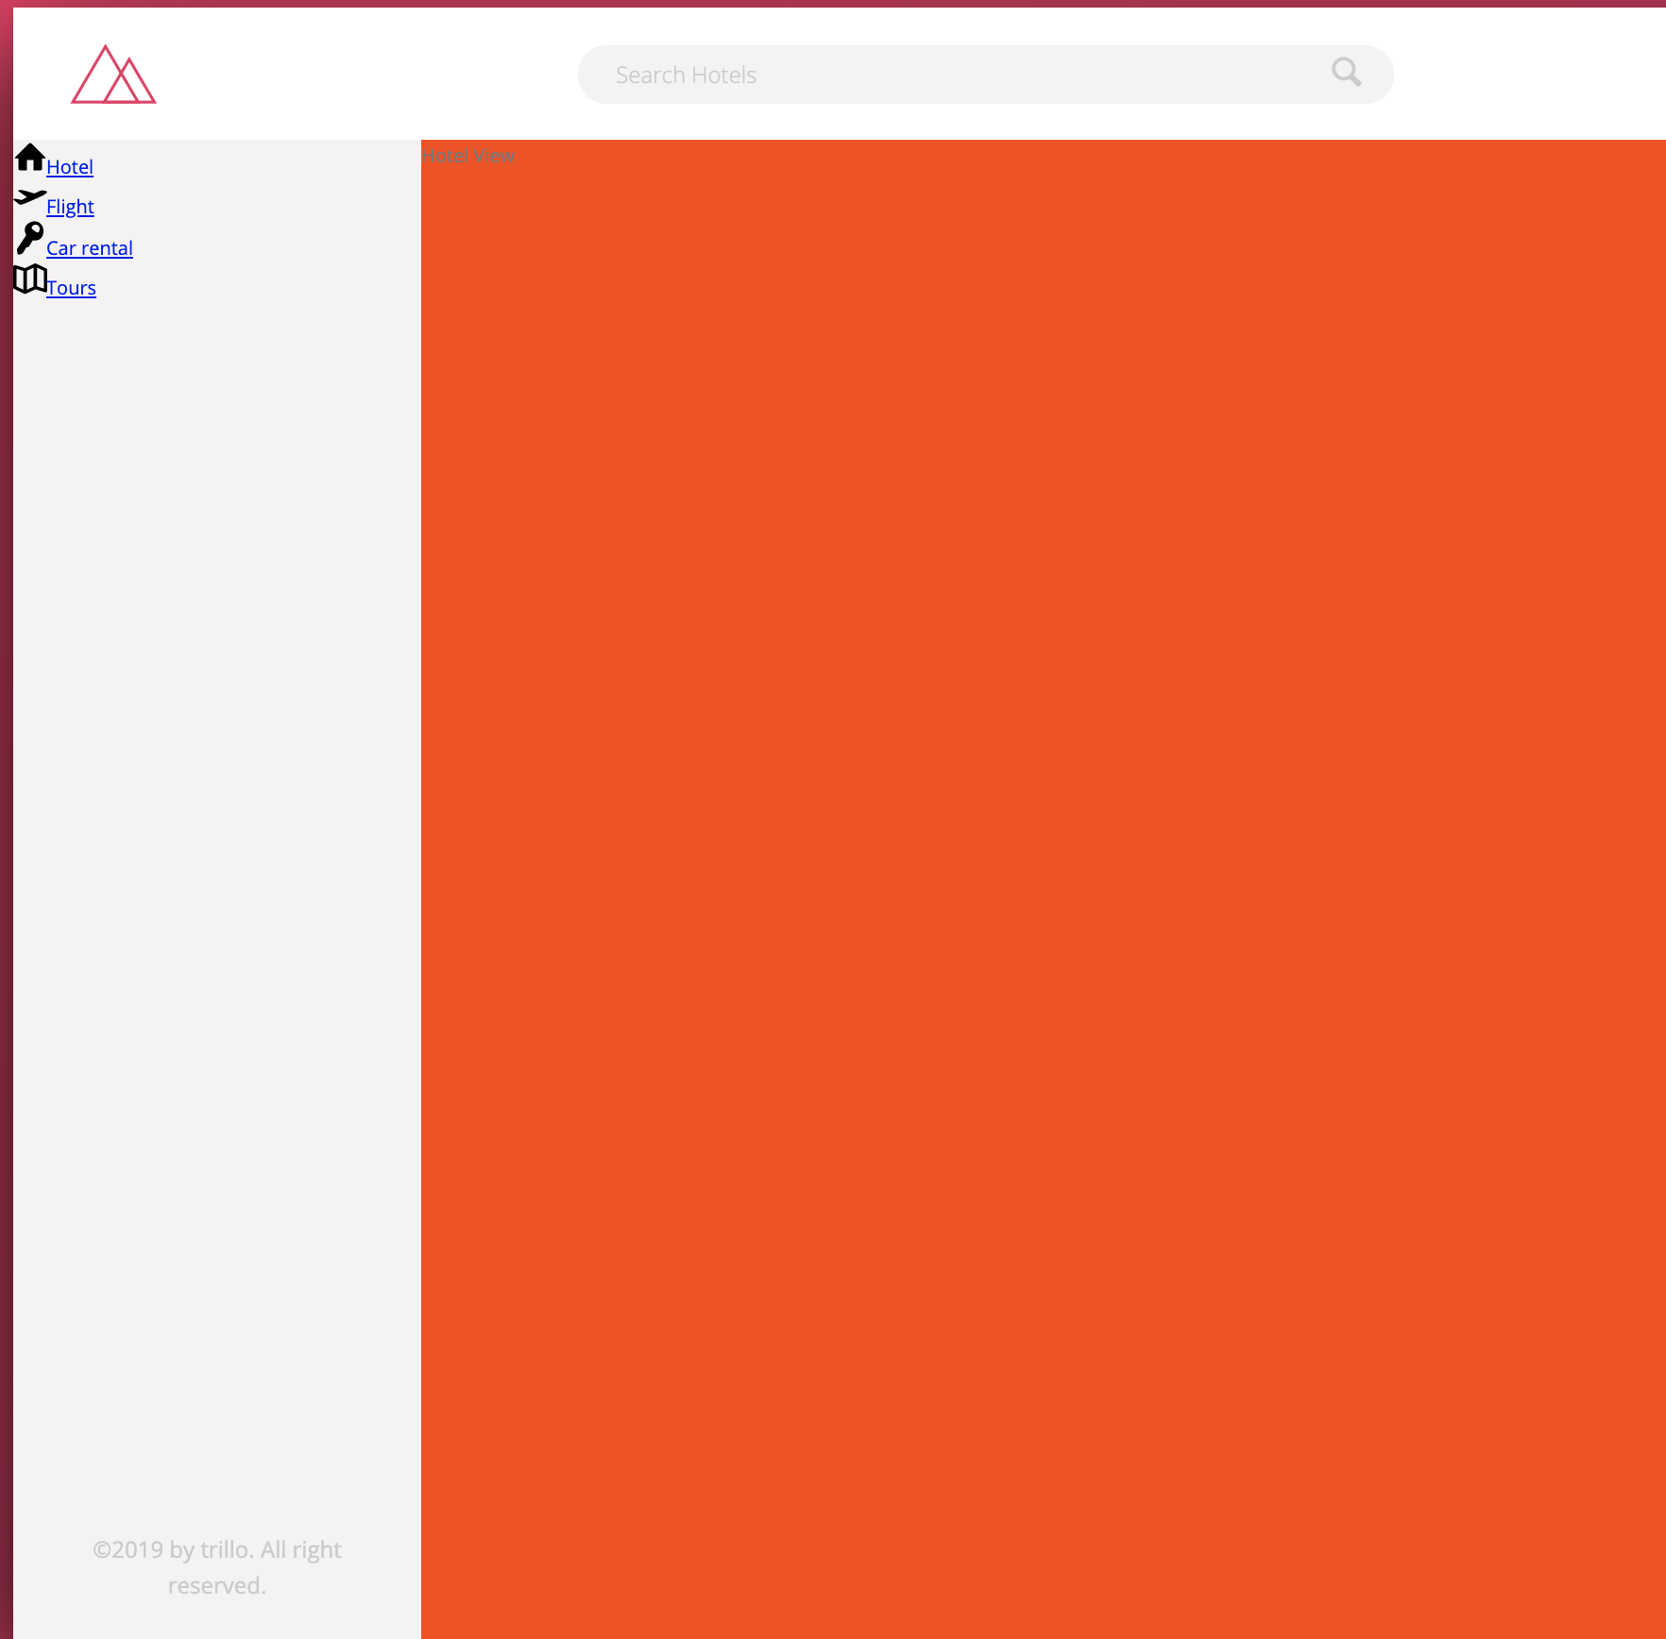

Note: Flexbox divides all the available white space between the elements.

079 Building the Navigation - Part 2

First let’s style the icon and fonts

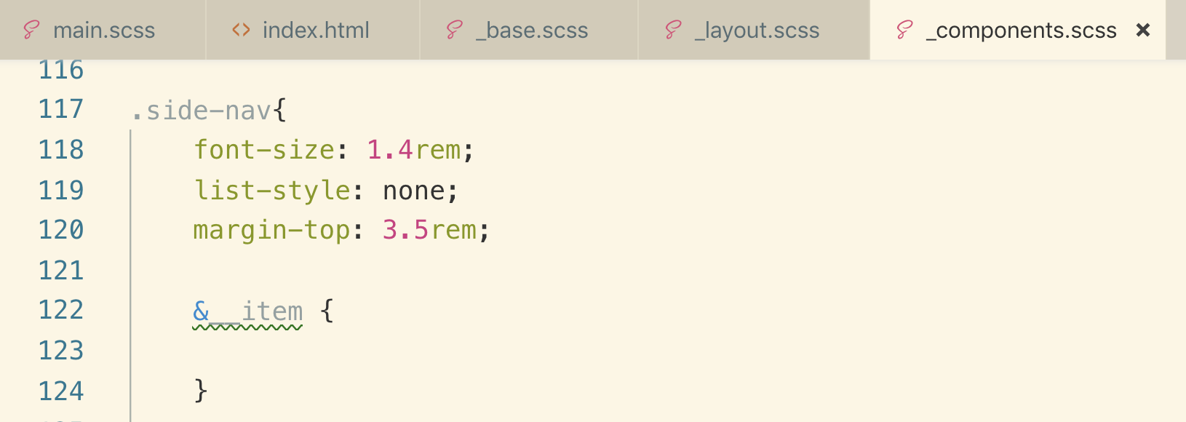

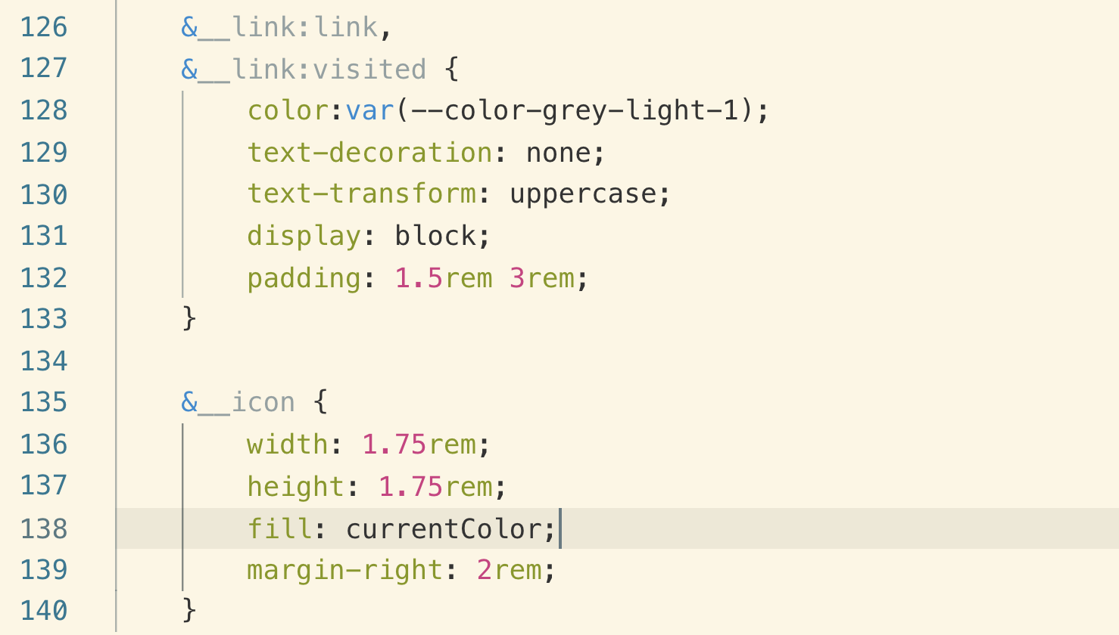

currentColor: it is just the color of the current/parent element

Example:

.box {

color: **red**;

border 1px solid **currentColor**;

box-shadow: 0 0 2px 2px **currentColor**;

}

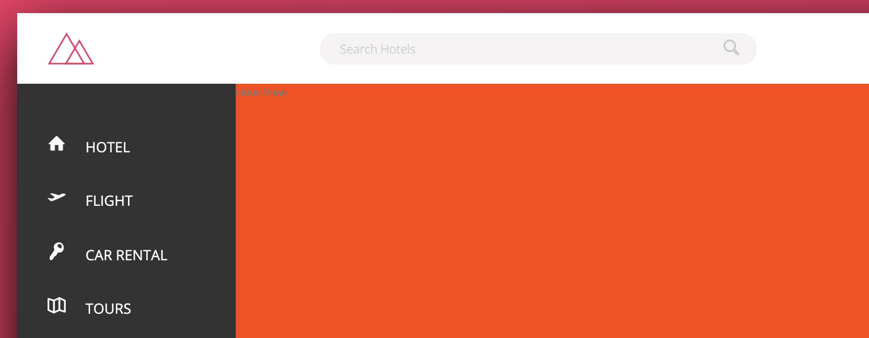

As you can see above that text and icons are not centered so gain we can use “flex” and this time on “anchor link” because it is a parent of the icon and text.

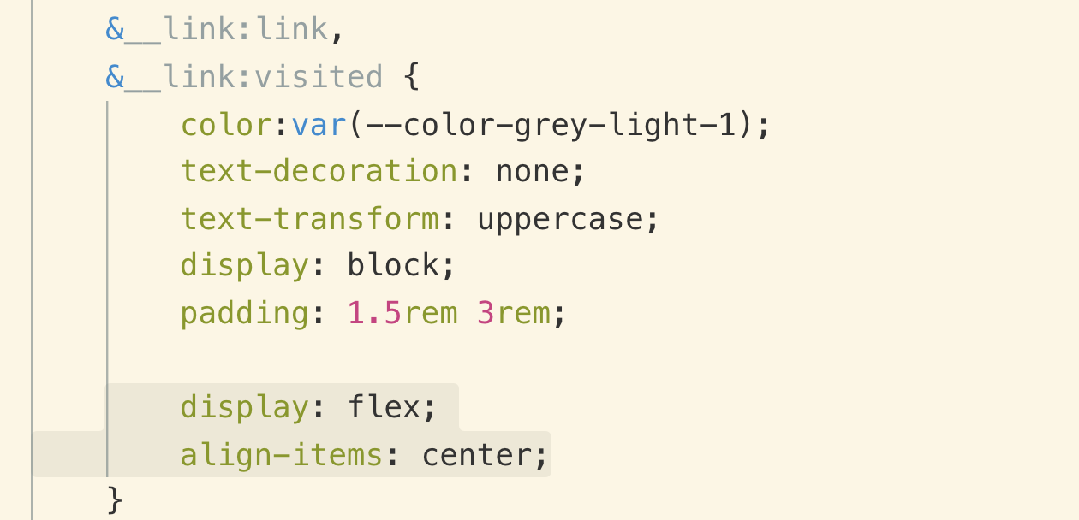

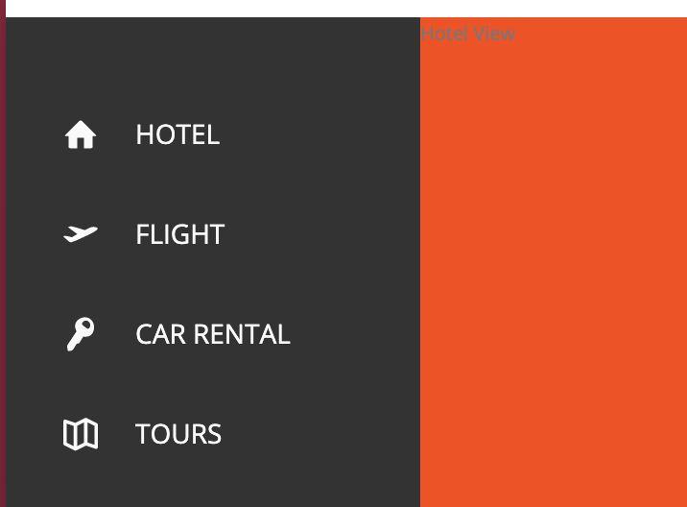

For hover and animation effect, we will use “:before” pseudo element. We will place it before the icon and then show and grow to the right side.

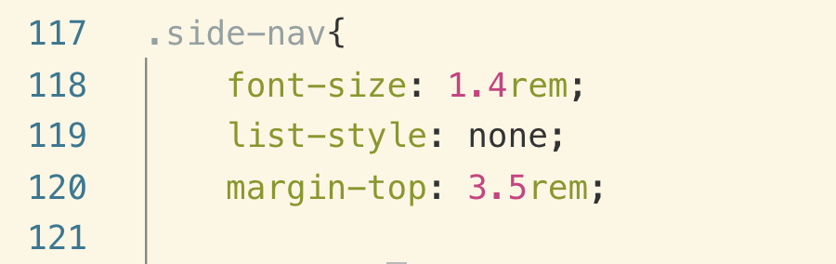

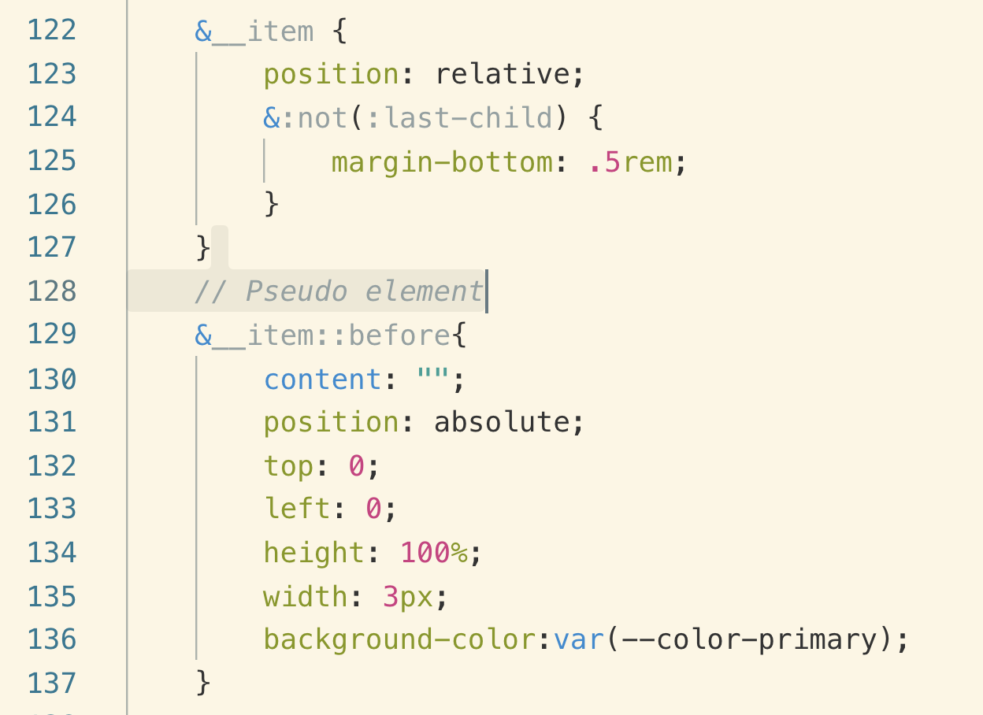

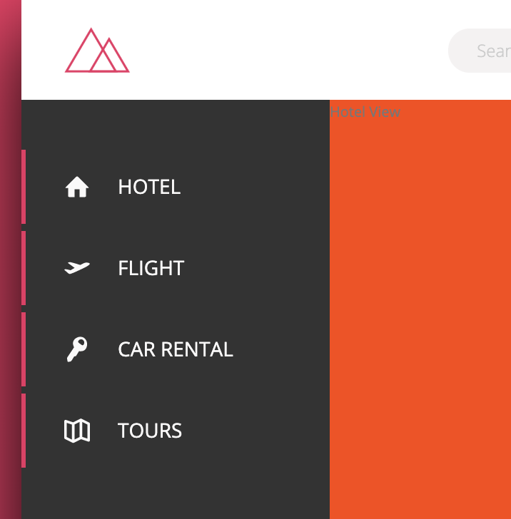

Now we will hide it and show it using transform. it starts in the center because that’s where the “transform origin” is set.

if we set “transform origin” to bottom, it will start scaling from bottom.

“transform-origin:bottom”

if we want to do multiple actions one after the other, we can delay different properties with different times like this

**.4s =>** below is the delay before it starts animation width property.

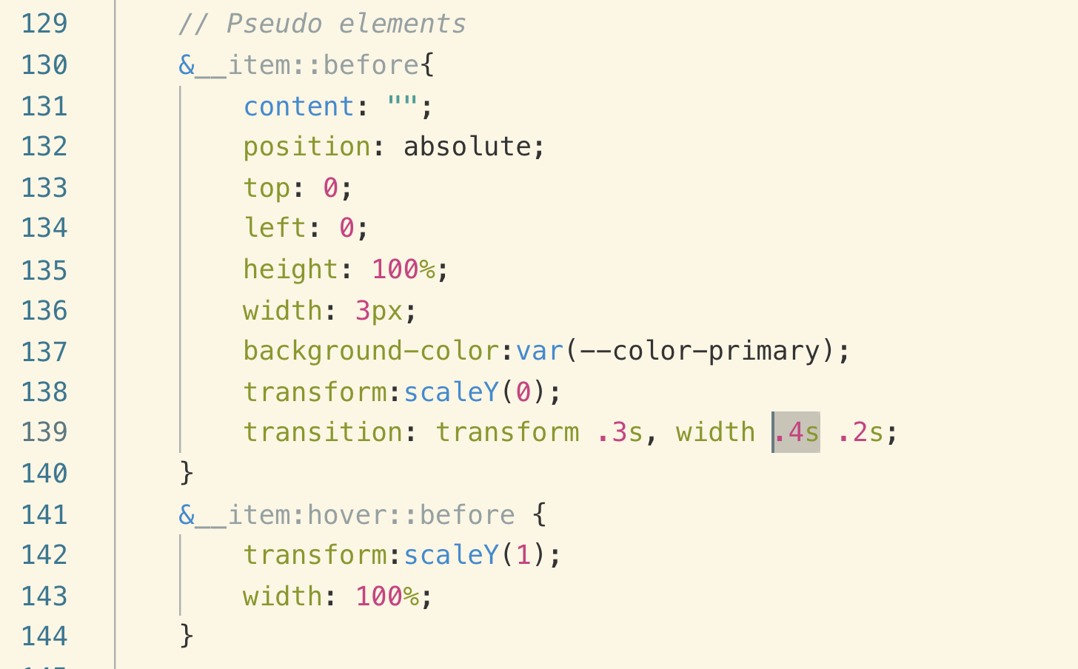

for smoother animation effects.

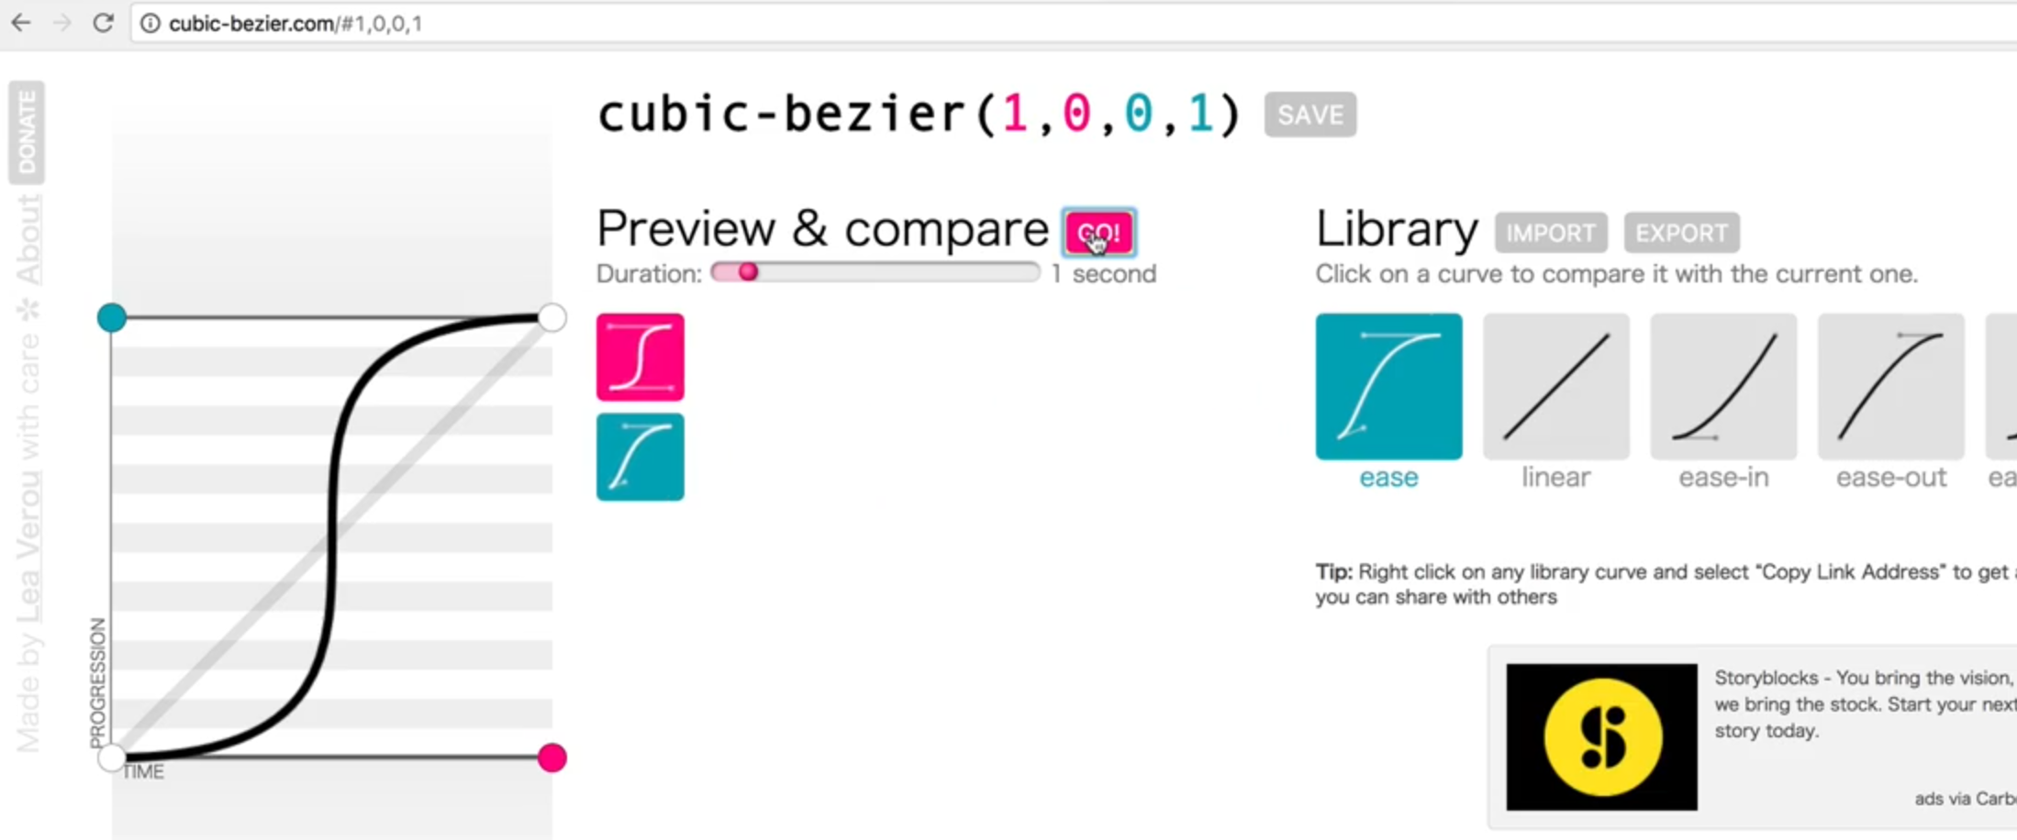

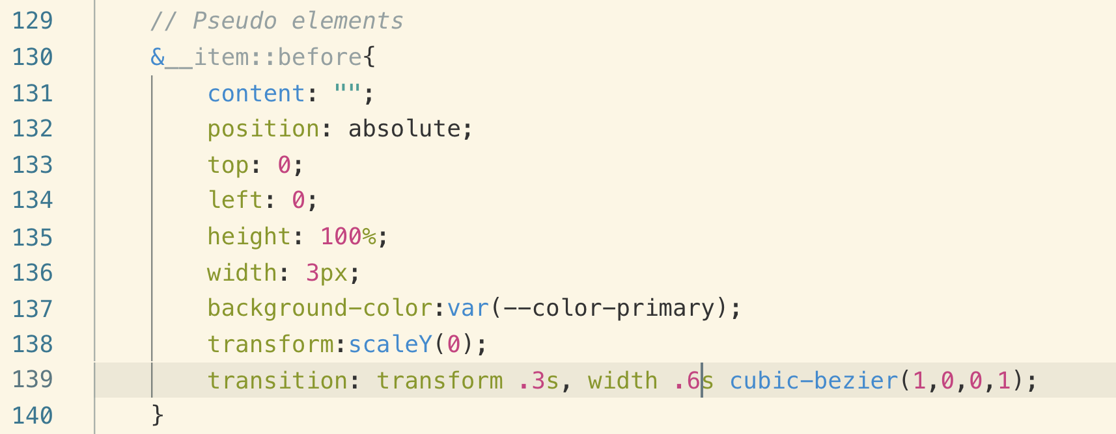

Note: z-index only works if we have specified position.

bringing the text upfront

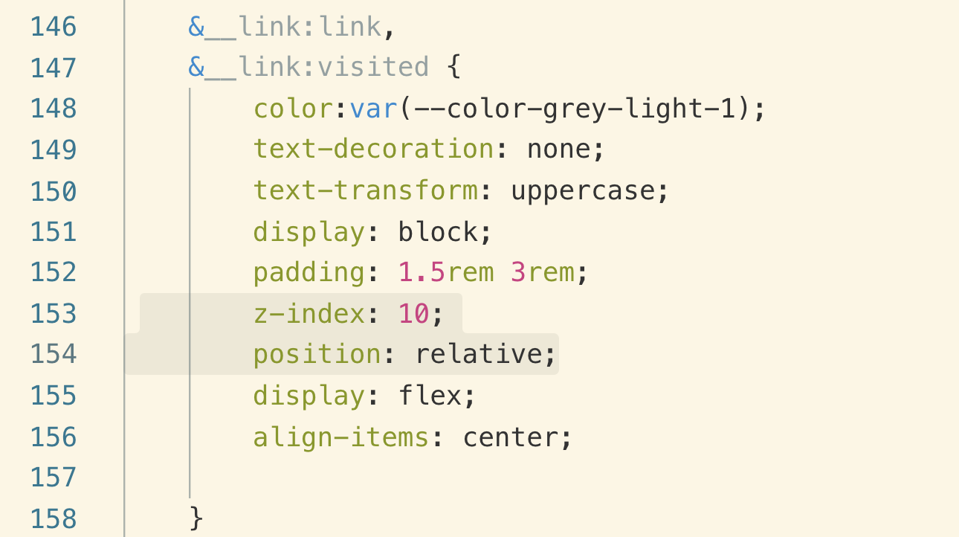

Now adding the CSS “modifier” to make the first nav link active

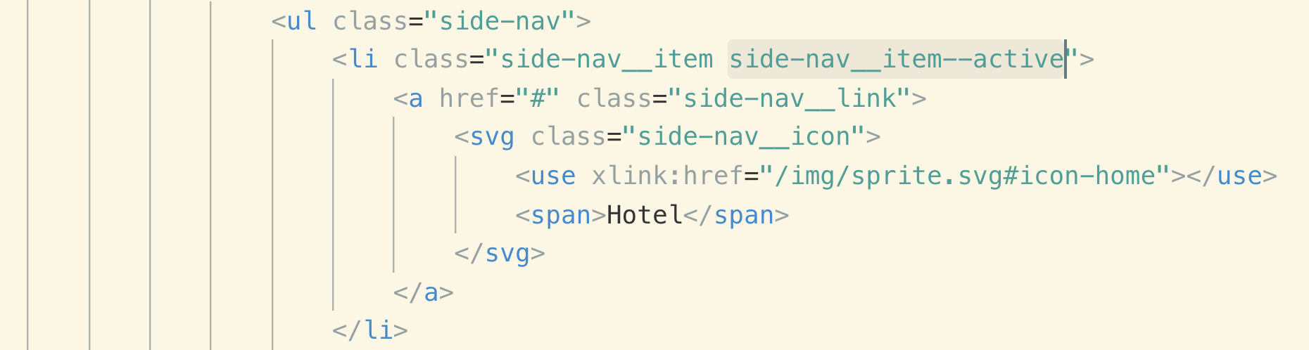

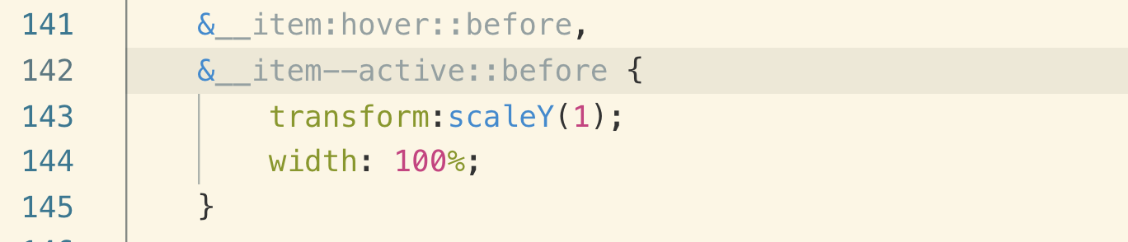

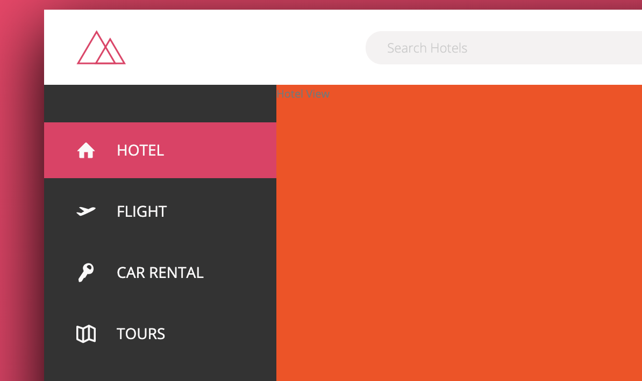

Now let’s add the “click effect”

clicking button == Active state

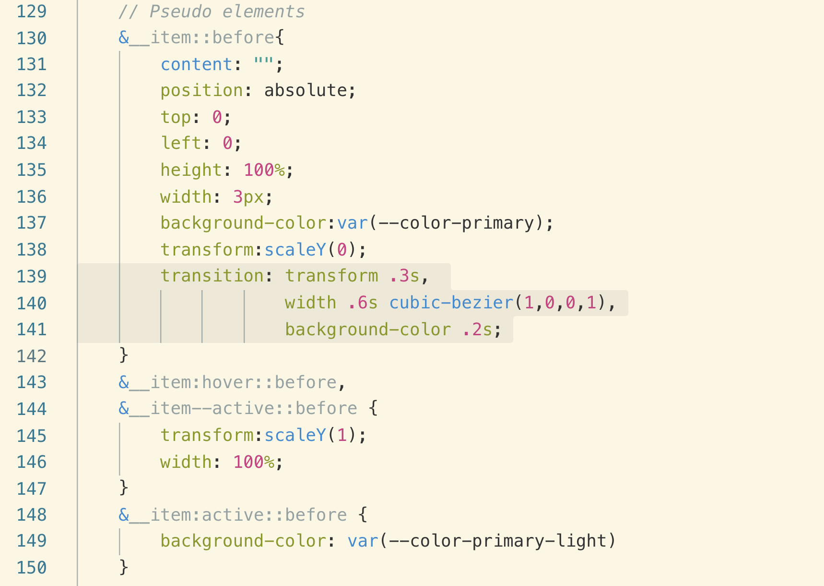

080 Building the Hotel Overview - Part 1

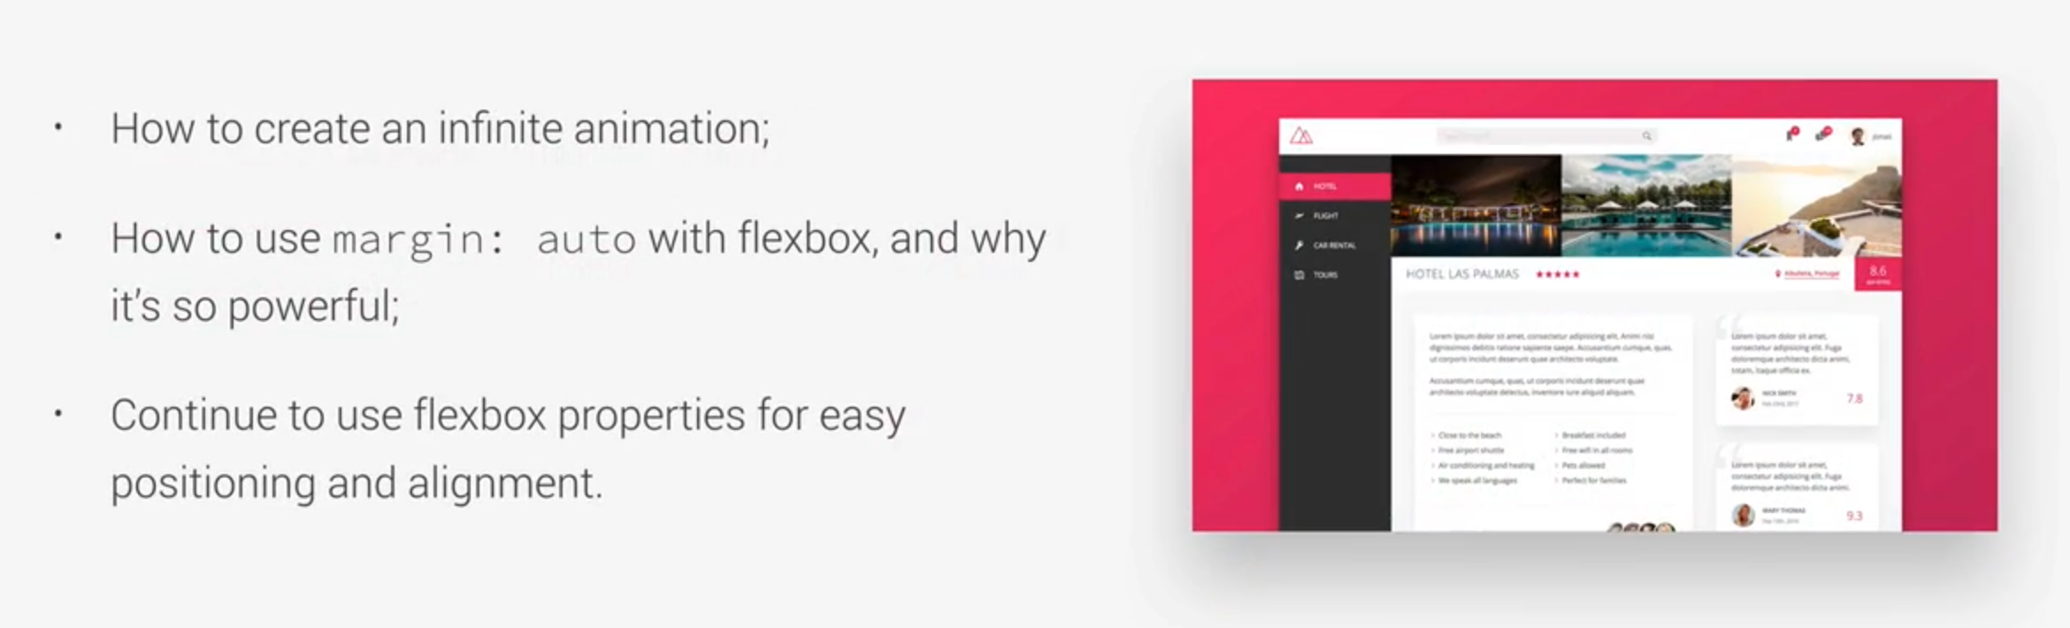

Note: we should always give height and width of an image in **percentages**

Note: image should be displayed as block or inline block and this avoid having small space underneath the image which happens when we leave it as in in-line element.

With flex and justify content it shows like this



we want it to look like



so justify-content doesn’t work here. Let’s see the different approach. The right approach here is to use “margin-right**:auto** with flex”

we give the “start” margin-right:**auto**

&__stars {

margin-right: auto;

}



081 Building the Hotel Overview - Part 2

you can see that stars are not 100% vertically aligned



The reason of the misalignment is that stars have some space at the bottom and the reason is that SVG elements behave like inline-element misalignment which behave like a text and this is the reason of not being centered.

Let’s remove this bottom space from stars

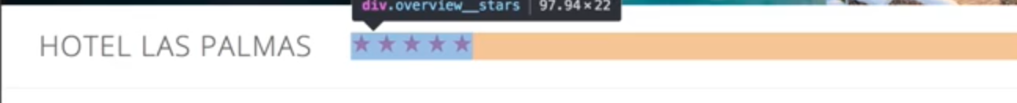

we can do it by line-height, but we will do it by flex



